

**THAI SON BAC DISTRIBUTION MANAGEMENT SYSTEM**

|  |  |  |
| --- | --- | --- |
| **Bobo Team** | | |
| **Group Members** | Nguyen Thi Lan Anh | SE04122 |
| Le Minh Hanh | SE04255 |
| Nguyen Manh Cuong | SE04273 |
| Tran Xuan Thuong | SE03568 |
| Nguyen Nam Anh | SE04387 |
| **Supervisor** | Ngo Tung Son | |
| **Capstone project code** | DMS | |

**Hoa Lac, May 2018**

**Table of contents**

1 Introduction 4

1.1 Purpose 4

1.2 Project Information 4

1.3 The People 4

1.3.1 Supervisor 4

1.3.2 Team Members 4

1.4 Background 4

1.5 The Current System 4

1.5.1 Stock Management 5

1.5.2 Distribution 5

1.5.3 Report 6

1.6 The Proposed system 7

1.6.1 The Idea 7

1.6.2 System Functions 7

1.6.3 Technical Approach 10

1.6.4 Out-of-Scope Functions 10

2 Software project management 11

2.1 Problem Definition 11

2.1.1 Name of this Capstone project 11

2.1.2 Problem Abstract 11

2.1.3 Project Overview 11

2.2 Project organization 12

2.2.1 Software Process Model 12

2.2.2 Roles and Responsibilities 13

2.2.3 Tools and Techniques 14

2.3 Project management plan 14

2.3.1 Tasks 14

2.3.2 Task Sheet: Assignments and Timetable 17

2.3.3 All Meeting Minutes 17

2.4 Coding Convention 17

2.5 Other material 17

2.5.1 Risk management plan 17

2.5.2 Project communication 17

3 Software Requirements Specifications (SRS) 19

3.1 User requirement specification 19

3.1.1 Overall Description 19

3.1.2 Functional requirement 19

3.1.3 Non-functional requirement 20

3.2 System requirement specification 20

3.2.1 Overview 21

3.2.2 Functional specification 21

3.2.3 Non-functional specification 187

4 Software Design Description (SDD) 189

4.1 Overview 189

4.2 Overall System Architectural 189

4.3 Architectural Layer Design 189

4.4 Software detailed design 195

4.4.1 Activity process 195

4.4.2 Context diagram 200

4.4.3 Detail description 203

4.5 Database Design or Data Structures 256

4.5.1 Entity Relationship diagram 256

4.5.2 Data Description 257

4.6 References 269

5 Software Test Documentation (STD) 270

5.1 INTRODUCTION 270

5.1.1 Purpose 270

5.1.2 Background information 270

5.2 Test plan 270

5.2.1 Scope of testing 270

5.2.2 Constraints 271

5.2.3 Risk list 271

5.2.4 Requirements for Test 271

5.2.5 Test strategy 272

5.2.6 Resource 276

5.2.7 Test milestones 277

5.2.8 Deliverables 277

5.3 Test Design 277

5.4 Testcase 277

5.5 Test Defect 278

5.6 Test Report 278

6 Software User’s Manual (SUM) 280

6.1 User’s Guide 280

6.1.1 Purposes 280

6.1.2 Detailed Guidelines 280

# Introduction

## Purpose

Thai Son Bac Distribution Management System is the system that helps to manage distribution and warehouse for Thai Son Bac company instead of present manual operating systems, which is expensive, inefficient, risky.

## Project Information

* Project name: **Thai Son Bac Distribution Management System**
* Project code: **DMS**
* Project group name**: Bobo Team**
* Product type: **Web application**
* Timeline: **Dec 08 th , 2017 – Nov 13 th, 2018**

## The People

### Supervisor

|  |  |  |  |  |
| --- | --- | --- | --- | --- |
|  | **Full name** | **Phone** | **E-mail** | **Title** |
| Supervisor | Ngo Tung Son | 01644576026 | [sonnt5@fe.edu.vn](mailto:sonnt5@fe.edu.vn) | Lecturer |

Table 1‑1: Supervisor’s information

### Team Members

|  |  |  |  |  |  |
| --- | --- | --- | --- | --- | --- |
|  | **Full name** | **Student ID** | **Phone** | **E-mail** | **Role** |
| 1 | Nguyen Thi Lan Anh | SE04122 | 01679607159 | [anhntlse04122@fpt.edu.vn](mailto:anhntlse04122@fpt.edu.vn) | Leader |
| 2 | Le Minh Hanh | SE04255 | 0934746474 | [hanhlmse04255@fpt.edu.vn](mailto:hanhlmse04255@fpt.edu.vn) | Tester |
| 3 | Tran Xuan Thuong | SE03568 | 0969999072 | [thuongtxse03568@fpt.edu.vn](mailto:thuongtxse03568@fpt.edu.vn) | Dev |
| 4 | Nguyen Manh Cuong | SE04273 | 0982354520 | [cuongnmse04273@fpt.edu.vn](mailto:cuongnmse04273@fpt.edu.vn) | Dev |
| 5 | Nguyen Nam Anh | SE04387 | 0934442457 | [anhnnse04387@fpt.edu.vn](mailto:anhnnse04387@fpt.edu.vn) | Dev |

Table 1‑2: Team members' information

## Background

The current management system of Thai Son Bac Company is a large-scale system, but ineffective operation still has some limitations. The system requires a large number of personnel to handle the system, but it is still high risk, too much manual and general management features have not been developed. Meanwhile, with the management system that Bobo team provides, these risks can be completely eliminated or minimize, while increasing the ability to manage the overview, timely detect issues that need to be handled as warehouse status, declining revenues, the activities of the staff, ...

## The Current System

This is their current system and some problems

### Stock Management

The current merchandise management system is a manual management system that works on Microsoft's excel, monthly manager will create a new Excel file. A management file will consist of many sheets and the sheet has a relationship with each other, that makes it difficult to manage and edit when there are errors as well as the risk of error is high.

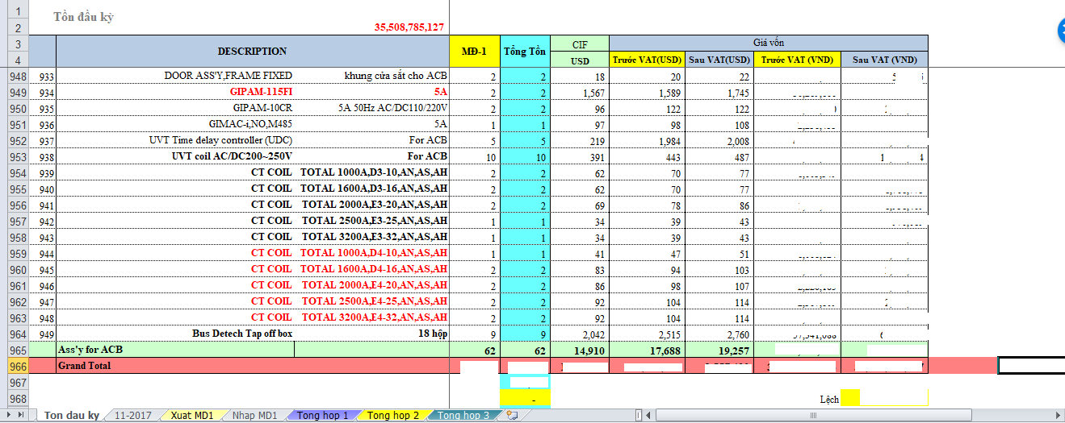

Figure 1.1: Present warehouse management system

At the same time, sellers and merchants deal with two separate files. At the end of the day, a person needs to synthesize and calibrate the data causing many unreasonable cases such as the finished warehouse to provide but the seller has not seen the data and continue to sell that product; or at the end of the day, the time to sum up the data, but the seller has unexpected orders leading to the data has not been updated in time, making the data not consistent between 2 sides.

In addition, each administrative unit contains only one order processing file so at the same time only one person can edit it. If multiple orders are pending at a time, this will cause bottlenecks leading to inefficient operation.

Managing the excel file every month a file and calibration like this also makes the management of the warehouse overview becomes more difficult, can not manage the details of the code, and difficult to look up. One old warehouse code has stopped trading.

### Distribution

The distribution system is also set up by excel. This form will have a list of all product codes, the staff will find the code and fill in the amount, discount. A large number of orders will also be reset on a monthly basis and according to each customer, which causes break and trouble for the management of orders.

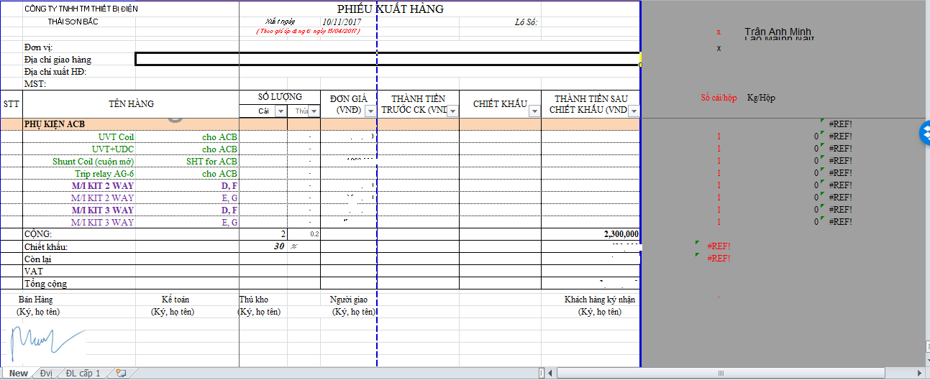

Figure 1.2: Form present create order

Customer information also has a separate sheet, staff will get information from the customer sheet to fill in the information corresponding to the slip.

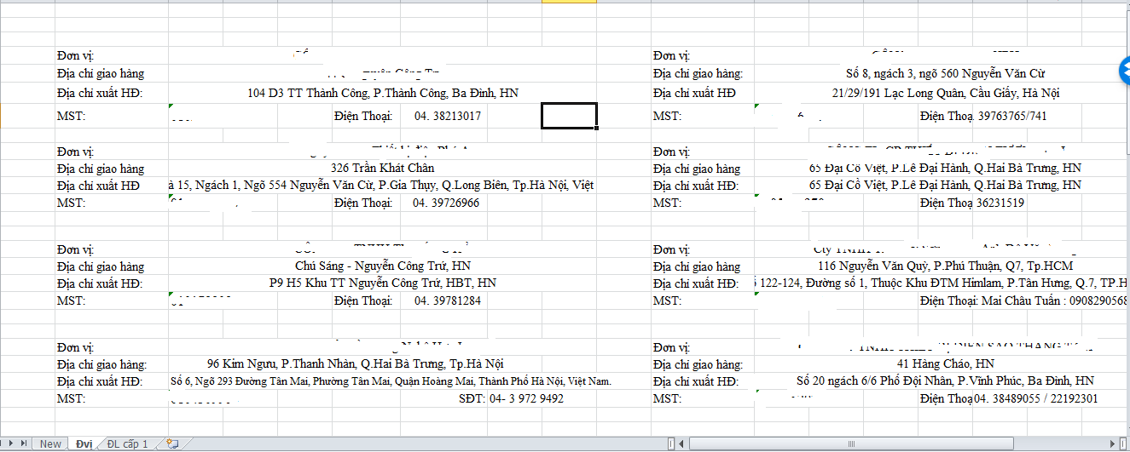

Figure 1.3: Customer information

### Report

The reporting system is the same as writing regular email by staff and sent to superiors, has not yet shown to be intuitive and exactly what to consider such as who are sellers, how to increase- decrease, what is the trend,.. Also limit the view ability of the superiors, they can only know when employees submit a report on and if that report is fake, they cannot be identified.

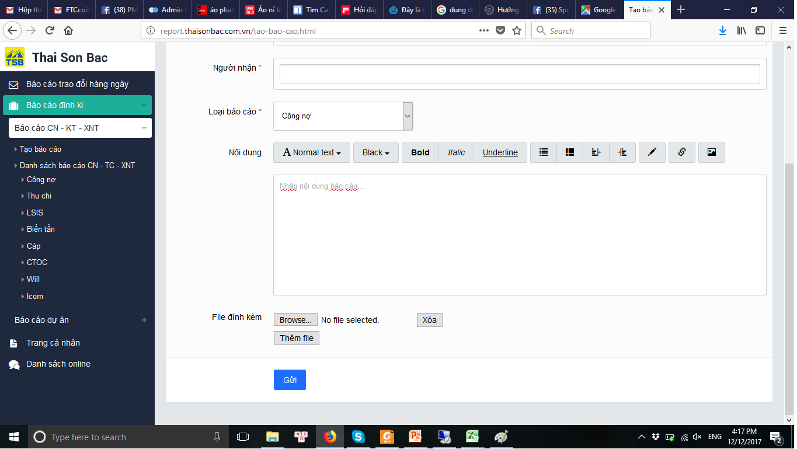

Figure 1.4: Present report system

## The Proposed system

### The Idea

Considering the problems of the current manual system, Thai Son Bac Distribution Management System was created to solve all those problems. This will be an intuitive, comprehensive management system, help the management and distribution becomes faster, multitasking, simpler, more efficient, eliminating the limitations of the system manual, improve productivity efficiency, minimize risk of error, suggest help users make decisions based on the analysis and synthesis of the available information.

### System Functions

The following list summarizes the main functions of the Thai Son Bac Distribution Management System :

* The basic functions of the account: Register, login, logout, change password, note, switch role (If there are 2 or more roles)
* For Seller:
  + Homepage
    - Statistics of the figures achieved in the month
    - Displayed trends products and categories
    - Displayed some recent orders
  + Orders
    - Create order
    - Order is prepared
    - Order is handled
    - Order is completed
    - Order is held <delay>
    - Order is cancelled
    - Delivery schedule total
    - Delivery schedule of each product code
    - Help
  + Warehouse
    - Product price
    - Inventory
    - Import request
      * Create import request
      * Input purchase invoice
      * History import request
    - Import stock
      * Create new import warehouse
      * History import warehouse
  + Debt
    - Customer debt
    - Supplier debt
  + Delivery
    - Driver information
    - Shipper
    - Delivery vehicle information
    - Locate delivery vehicle
  + Report
    - Revenue report
    - Customer debt report
    - Supplier debt report
  + Administrator
    - Customer
    - Suppliers
    - Warehouse
    - Settings
* For management :
  + - Set up order
    - Order is prepared
    - Order is handled
    - Order is completed
    - Order is held
    - Order is canceled
    - Delivery schedule total
    - Delivery schedule of each product code
    - Help
  + Warehouse
    - Price
    - Inventory
    - Import request
      * Create import request
      * Input purchase invoice
      * History import request
    - Import stock
      * Create new import warehouse
      * History import warehouse
  + Debt
    - Customer debt
    - Supplier debt
  + Delivery
    - Driver information
    - Shipper
    - Delivery vehicle information
    - Locate delivery vehicle
  + Report
    - Sales reports
    - Revenue reports
    - Customer debt reports
    - Supplier debt reports
  + Administrator
    - Customer
    - Supplier
    - User
    - Warehouse
    - Settings
* For warehouse
  + Orders
    - Orders is being waited exported from warehouse
    - Order is prepared
    - Order is being delivered
    - Returned order
    - Completed order
  + Inventory
  + Delivery
    - Driver information
    - Shipper
    - Delivery vehicle information
    - Locate delivery vehicle
* For accountant
  + Order is waiting
  + Order is exported
* For Administrator
  + User management
  + System setting
  + Other resources management
    - List of file
    - List of page

### Technical Approach

* Use MVC model
* Use entity framework

### Out-of-Scope Functions

Due to time constraints, the following features are not included in this release but will be developed in the next phase:

* Delivery management
* Business settings: KPI, USD rate,…
* Import export data
* Stock management : stock out
* Using RFID to identifies that has what product in delivery vehicle
* Import export excel, pdf

# Software project management

## Problem Definition

### Name of this Capstone project

Capstone project name is “Thai Son Bac Distribution Management System”. This is a web application to help management distribution for Thai Son Bac company.

### Problem Abstract

As an introduction to the project, the main objective of this system is to help the company manage the distribution of warehouse more easily, conveniently and efficiently. There are a lot of software that also help with software management, but those software are generally non-professional in the business, not suitable for integration with the current system of the company and more importantly, it's quite confusing to use. Employees in the company are mostly middle-aged people who want a system that is intuitive, simple, easy to use and effective.

Therefore, the system must have the following characteristics:

* Intuitive, clear interface
* Create a familiar feel, close to the current system of the company for users
* Simple, convenient, all right out of the screen, not too many pages, too much work to see or edit something.
* The report must display sufficient information for analysis and distribution management
* Good support for staff in order creation, order processing and order management

### Project Overview

#### The Current System

The current management system of Thai Son Bac Company is a large-scale system, but ineffective operation still has some limitations. The system requires a large number of personnel to handle and handle the system, but it is still high risk, too much manual and general management features have not been developed. Meanwhile, the management system that Bobo team provides, these risks can be completely eliminated or minimized errors are not worthwhile, while increasing the ability to manage the overview, timely detect issues that need to be handled as warehouse status, declining revenues, the activities of the staff, ...

#### The Proposed System

The system is a web application written by ASP .NET. It can provide product code hints, provide detailed information of each product to staff, help staff to know the product information, avoid the wrong product code and help employees can quickly provide product information to customers.

The system's timeline function helps staff and managers to clearly and visually see the progress of orders, tasks and upcoming tasks. In particular, the timeline of each item code provides the distributor with a clear view of the status of the item's inventory, how many orders are kept, the time and quantity for the next import warehouse, etc. Distributors make decisions for their Sellers.

Import and export stock management helps to know exactly the export and import of product, can find the cause if lost / missing product.

Debt management accurately records each transaction and automatically calculates, minimize errors and mistakes compared to calculating and copying in excel.

The report is represented by diagrams that provide a visual and general view to the user.

The system is a web application, users can view anywhere, anytime, on any device which can connect to the internet, bring the convenience to the user.

#### Boundaries of the System

For the duration of the capstone project, the scope includes:

* Complete all functions of orders management
* Complete all product management functions
* Complete all debt functions
* Complete report functions
* Complete product management function
* Complete customer, supplier management functions

#### Development Environment

**2.1.3.4.1. Hardware**

|  |  |
| --- | --- |
| **Processor** | Intel core i5 or higher |
| **Memory** | Minimum 4GB RAM |
| **Hard disk** | 10GB available hard-disk space for installation |

*Table 2.1 Hardware environment*

**2.1.3.4.2. Software**

|  |  |
| --- | --- |
| **Microsoft Windows** | Windows 10 |
| **IDE** | Visual Studio 2015 |
| **Web Server** | IIS 10.0 |
| **DBMS** | Microsoft SQL Server 2008 or higher |
| **Framework** | .NET Framework 4.5 , Entity Framework 6.2.0, ASP .NET MVC 5.2.4 |
| **Architecture tool** | Microsoft Visio |
| **Browsers** | Chrome, Mozilla Firefox |
| **Other** | Microsoft Project, Microsoft Office, GitHub |

*Table 2.2 Software environment*

## Project organization

### 2.2.1 Software Process Model

The incremental model has been applied to structure, plan and control the process of development and maintenance the system. Follow this model, project will have 3 cycles

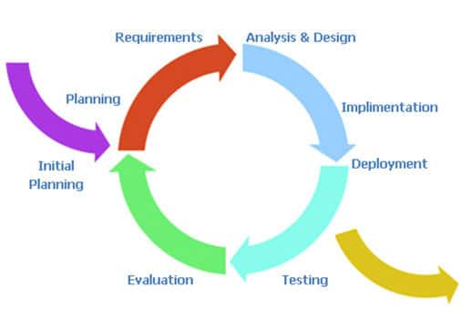

Figure 2.1: The incremental model

### Roles and Responsibilities

|  |  |  |  |
| --- | --- | --- | --- |
| **No** | **Team member** | **Role** | **Responsibility** |
| 1 | Nguyen Thi Lan Anh | PM, BA, QA | Manage process  Business analysis  Design UI and architecture  Test  Write Meeting Minutes |
| 2 | Nguyen Nam Anh | Dev, Designer | Code  Design detail architecture  Test |
| 3 | Nguyen Manh Cuong | Dev, CM | Code  Manage configuration  Deployment |
| 4 | Le Minh Hanh | Designer, Tester | Create test plan, test design and test case and test data  Test  Design detail architecture |
| 5 | Tran Xuan Thuong | Dev, Tester | Code  Test  Create test data |

*Table 2.3 Roles and responsibilities*

### Tools and Techniques

Tools: Visual Studio 2015, Visio 2013, Microsoft Office (word, excel, PowerPoint), Microsoft Project, Chrome, Firefox, Microsoft SQL Server, GitHub

## Project management plan

### Tasks

#### Initiating:

|  |  |
| --- | --- |
| **Description** | Project register  Kick-off  The original idea |
| **Output** | Report project introduction |
| **Deliverables** | Before Dec 11st, 2017 |
| **Resources Needed** | 5 persons |
| **Dependencies and Constraints** | N/A |
| **Risks** | N/A |

*Table 2.4 Initiating*

#### Planning:

|  |  |
| --- | --- |
| **Description** | * Meeting customer, preliminary evaluation of the current system * Create project plan * Project plan approved |
| **Output** | Report management plan |
| **Deliverables** | Before Dec 12th 2017 |
| **Resources Needed** | 3 persons |
| **Dependencies and Constraints** | N/A |
| **Risks** | N/A |

*Table 2.5 Planning*

#### Software requirement specification:

|  |  |
| --- | --- |
| **Description** | Analysis of customer system  Analysis of customer requirements  Create prototype  Create Software Requirement Specification (SRS) |
| **Output** | Report Software Requirement Specification (SRS) |
| **Deliverables** | * For capstone project : Before Feb 1st, 2018 * For project : Before May 4th, 2018 * Upgrade system : Before July 13th, 2018 |
| **Resources Needed** | 5 persons |
| **Dependencies and Constraints** | N/A |
| **Risks** | Customers do not know or cannot describe their system is needed and missing something also do not know what you want |

*Table 2.6 Software requirement specification*

#### Software design:

|  |  |
| --- | --- |
| **Description** | Design database  Design high-level architecture  Design detail architecture |
| **Output** | Software Design Description (SDD) |
| **Deliverables** | * For Capstone Project : Before March 7th, 2018 * For project : Before May 9th, 2018 * Upgrade system : Before July 27th, 2018 |
| **Resources Needed** | 5 persons |
| **Dependencies and Constraints** | Complete SRS |
| **Risks** | May mistakenly choose the wrong architecture type that leads to difficult system for maintains or high coding efforts |

*Table 2.7 Software design*

#### Implementation:

|  |  |
| --- | --- |
| **Description** | Coding  Create Software User’s Manual ( SUM ) |
| **Output** | Source code, SUM |
| **Deliverables** | * For Capstone Project : Before April 26th, 2018 * For project : Before June 8th, 2018 * Upgrade system : Before Oct 19th, 2018 |
| **Resources Needed** | 3 persons |
| **Dependencies and Constraints** | Complete SRS, SDD |
| **Risks** | All members is newbie in ASP .NET . It’s take a lot of time and high efforts to study and implement |

*Table 2.8 Implementation*

#### Testing:

|  |  |
| --- | --- |
| **Description** | Execute test |
| **Output** | Test report |
| **Deliverables** | * For Capstone Project : Before May 2th, 2018 * For project : Before June 22th, 2018 * Upgrade system : Before Nov 8th, 2018 |
| **Resources Needed** | 3 persons |
| **Dependencies and Constraints** | Complete SRS, SDD |
| **Risks** | N/A |

*Table 2.9 Testing*

#### Deployment:

|  |  |
| --- | --- |
| **Description** | Input current data  Deploy web to Internet |
| **Output** | Final product |
| **Deliverables** | * For Capstone Project : Before May 2th, 2018 * For project : Before June 26th, 2018 * Upgrade system : Before Nov 12th, 2018 |
| **Resources Needed** | 5 persons |
| **Dependencies and Constraints** | Complete all other task |
| **Risks** | Problem about data and server |

*Table 2.10 Deployment*

#### Closing:

|  |  |
| --- | --- |
| **Description** | Create final report, final presentation |
| **Output** | Final report, final presentation |
| **Deliverables** | * For Capstone Project : Before May 3th, 2018 * For project : Before June 27 th­, 2018 * Upgrade system : Before Nov 13 th, 2018 |
| **Resources Needed** | 5 persons |
| **Dependencies and Constraints** | Complete deploy web |
| **Risks** | N/A |

*Table 2.11 Closing*

### Task Sheet: Assignments and Timetable

* Project plan is contained in [TSB_Management_Plan](refer/TSB_Management_Plan.mpp)

### All Meeting Minutes

Contain in [folder TSB_ MeetingMinute](refer/TSB_%20MeetingMinute)

## Coding Convention

* C# coding convention <https://docs.microsoft.com/en-us/dotnet/csharp/programming-guide/inside-a-program/coding-conventions>
* JS coding convention <https://www.w3schools.com/js/js_conventions.asp>
* Html coding convention <https://github.com/xfiveco/html-coding-standards>

## Other material

### Risk management plan

Refer to [TSB_RiskPlan](risk%20plan.xlsx)

### Project communication

#### Project reporting

|  |  |  |  |
| --- | --- | --- | --- |
| Activity | Participants | Frequency/When | Method |
| Weekly Status Report | Author: CuongNM  Distribution list: Sonnt5, AnhNTL, CuongNM, ThuongTX, AnhNN, HanhLM | Thursday | Face to face  Report on Drop Box |
| Ad-hoc Discussion  (Emergency situation) | Initiator: Any participant  Participants: Sonnt5, AnhNTL, CuongNM, ThuongTX, AnhNN, HanhLM | Event-based | Skype  Facebook  Face to face |

*Table 2.12 Project reporting*

The initiator of meetings and discussions will circulate an agenda to all participants at least 24 hours before the scheduled time of the meeting or discussion.

The initiator, or another designated participant, will circulate meeting minutes to all participants within 12 hours of the conclusion of the meeting.

#### Escalation path

Thai SonBac Escalation Path

Bobo Escalation Path

Project Team

AnhNTL

Staff

La Manh Dat

*Figure 2.2: Escalation path*

#### Delivery method

Deliverables from Bobo to TSB, and vice versa, will via Dropbox and upload into Bobo’s server. The detail of server will be informed later when we use it.

On the final delivery date we will upload website to TSB’s server and delivery source code in Dropbox

# Software Requirements Specifications (SRS)

## User requirement specification

### Overall Description

#### Business overview

TSB website is a distribution management system of Thai Son Bac company. System include 3 main parts

* **Business management:** Includes functions that allow users to manage the work of the shop such as order management, delivery management, debt management…
* **Report** : report about revenue, trend, customer debt and supplier debt, indicators in month
* **System management**: this part provide for administrator to perform system management tasks such as config, delegation, resource management.

#### Product feature

* **Order management:** provide functions to create, modify, handle and tracking order
* **Debt management:** provide functions to manage, handle customer debt and supplier debt
* **Product management:** allow user to view and manage product
* **Stock management:** include functions to manage stock in stock out of warehouse
* **Report:** report about revenue, trend, customer debt and supplier debt, indicators in month, performance of employees
* **User management:** create , update user and user’s permission
* **Customer management:** is functions about customer such as create, update, overview report of customer
* **Supplier management:** is functions about customer such as create, update, overview report of supplier
* **Account management:** full basic permission of account : login, logout, view profile , change password, change profile, view notifications
* **System setting:** allow admin manage systems.

#### User classification

System has 5 kinds of user: sellers, warehouse, accountant, managers, and administrator:

* **Sellers**: have full permission to manage order, product, stock, customer, supplier, debt , and some report.
* **Warehouse**: handle order when order status in warehouse tasks.
* **Accountant**: handle order when order status in accountant tasks.
* **Management**: have highest permission in business management, have full all permissions about business management.
* **Administrator**: have permission in system management but don’t have permission in business management.

### Functional requirement

#### Order management

**Access right:** Sellers, managers, accountant, warehouse

* Sellers, managers: can create, modify, handle, and tracking order.
* Accountant: handle order when order status in tasks of the accountant.
* Warehouse: handle order when order status in tasks of the warehouse.

#### Debt

**Access right:** Sellers, managers

* Sellers, managers: manage debt and transactions of customers and supplier.

#### Product management

**Access right:** Sellers, managers

* Sellers, managers: can be create, edit, view warehouse detail and manage the product according to each criterion, as well as manage the amount of inventory.

#### Stock management

**Access right:** Sellers, managers

* Sellers, managers: ma be crate import- export request , import-export product management.

#### Report

**Access right:** Sellers, managers

* Sellers: have permission to view revenue reports, customer debt, supplier debt and the indicators were reached in the month, the trend of this month and last month report.
* Management : have permission to view sale report, revenue report, customer debt, supplier debt and the indicators were reached in the month, the trend of this month and last month report.

#### User management

**Access right:** Administrator, managers

* Management: have permission create , edit , users has sale, warehouse, accountant, manage management
* Administrator: has permission create, edit, manage the entire user.

#### Customer management

**Access right:** Sellers, managers

* Sellers, managers: Has permission to create, edit, view customer details as well as purchase reports from that customer.

#### Supplier

**Access right:** Sellers, managers

* Sellers, managers: Has permission to create, edit, view customer details as well as purchase reports from that supplier.

#### Account management

**Access right:** all users

* All user can login, logout, change password, view notifications, view profile, change information.

#### System setting

**Access right:** Administrator

* Administrator: manage resource, manage decentralized …

### Non-functional requirement

- UI clearly, friendly, easy to use and convenient

- High performance

- Easy to update and maintenance

## System requirement specification

### Overview



Figure 3.1: System overview

### Functional specification

#### Account management

##### Usecase Diagram

Figure 3.2: Account usecase

##### Usecase

###### Login:

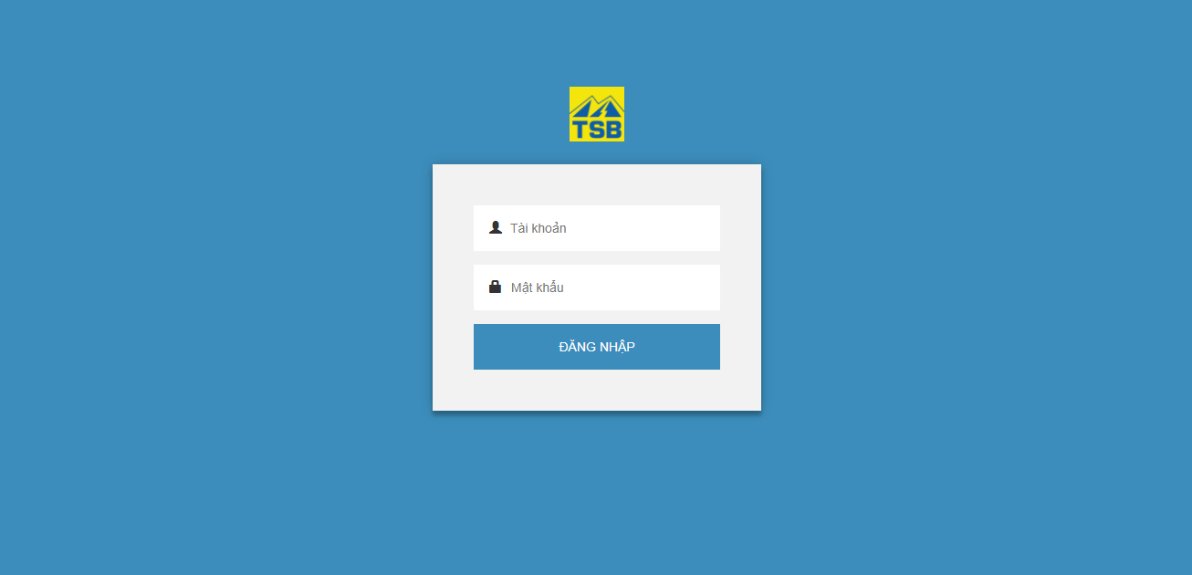

Figure 3.3: Login screen

Use case specification:

|  |  |  |  |  |
| --- | --- | --- | --- | --- |
| **USE CASE-001 SPECIFICATION : Login** | | | | |
| **Use-case No.** | <UC001> | **Use-case Version** | | <1.0> |
| **Use-case Name** | Login | | | |
| **Author** | AnhNTL | | | |
| **Date** | Jan 2nd, 2018 | **Priority** | High | |
| **Actor:**  *Sellers, managers, administrator, warehouse , accountant*  **Summary:**  *User login system by account to use another functions*  **Goal:**  *Login to system*  **Triggers**  *N/A*  **Preconditions:**  *Type URL in web browser and enter*  **Post Conditions:**  *-If user have 1 role, display index page of that role*  *-If user have more than 1 role , display Dropbox for user choose role, after that, display index page for role was chosen*  **Main Success Scenario:**   |  |  |  | | --- | --- | --- | | *Step* | *User action* | *System response* | | *1* | *Type URL in web browser and enter* | *Login page display* | | *2* | *Input username, password* |  | | *3* | *Click login button* | *-Validate input*  *-Send request login to system* | | *4* |  | *-Verify user*  *- + If user have 1 role, display index page of that role*  *+If user have more than 1 role , display Drop box for user choose role* | | *5* | *( If user have more than 1 role )*  *Choose role* | *Display index page for role was chosen* |   **Alternative Scenario:**   1. **Forgot password**  |  |  |  | | --- | --- | --- | | *Step* | *Type URL in web browser and enter* | *System response* | | *1* | *Type URL in web browser and enter* | *Login page display* | | *2* | *Click forgot password hyperlink* | *Display page to user input account name* | | *3* | *Input account name* | *Validate input* | | *4* | *Click send button* | *Notify for administrator and management to reset password for user* | | *5* | *After password reseted , login by default password* | *+ If user have 1 role, display index page of that role*  *+If user have more than 1 role , display dropbox for user choose role* | | *6* | *( If user have more than 1 role )*  *Choose role* | *Display index page for role was chosen* |   **Exceptions:**  **Business Rules:**  *- Username and password required*  *- Username is not sensitive case , password is sensitive case* | | | | |

*Table 3.1 Usecase login*

Screen description:

|  |  |  |  |  |  |  |
| --- | --- | --- | --- | --- | --- | --- |
| Field name | Description | Mandatory | Read only | Control type | Data type | Length |
| Username | Username for login on system | Y | N | Text field | Nvarchar | 50 |
| Password | Password of user on system | Y | N | Text field | Nvarchar | 50 |
| Login button | Login form’s button | - | - | Button | - | - |
| Remember me | Remember password or not |  | - | Checkbox | Boolean | - |
| Forgot password | Link to forgot password page | - | - | Hyperlink | - | - |

*Table 3.2 Screen description of usecase login*

###### Logout

Use case specification:

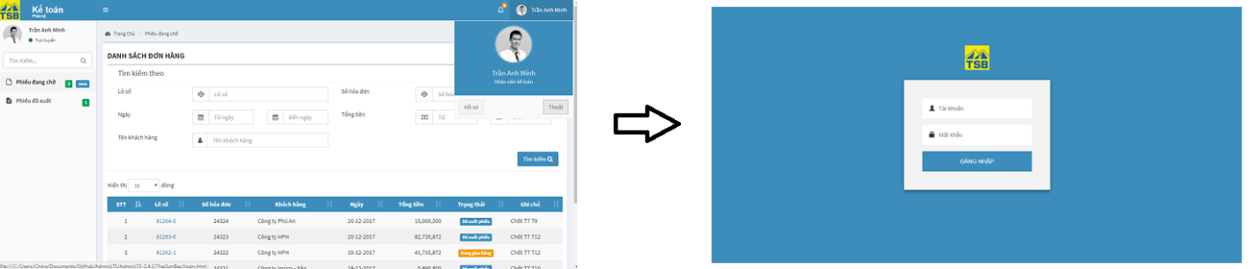

Figure 3.4: Logout screen

|  |  |  |  |  |
| --- | --- | --- | --- | --- |
| **USE CASE-002 SPECIFICATION : Logout** | | | | |
| **Use-case No.** | <UC002> | **Use-case Version** | | <1.0> |
| **Use-case Name** | Logout | | | |
| **Author** | AnhNTL | | | |
| **Date** | Jan 2 nd, 2018 | **Priority** | High | |
| **Actor:**  *Sellers, managers, administrator, warehouse , accountant*  **Summary:**  *User finish their jobs or change account*  **Goal:**  *Finish user session and redirect to login page*  **Triggers**  *User click “Thoát” button*  **Preconditions:**  *User click on “Thoát” button*  **Post Conditions:**  *Redirect to login page*  **Main Success Scenario:**   |  |  |  | | --- | --- | --- | | *Step* | *User action* | *System response* | | 1 | Click “Thoát” button | Redirect to login page |   **Alternative Scenario:**   |  |  |  | | --- | --- | --- | | *Step* | *User action* | *System response* | | 1 |  | User session timed out | | 2 |  | Logout |   **Exceptions:**  **Business Rules:** | | | | |

*Table 3.3 Usecase logout*

###### Change password

Use case specification:

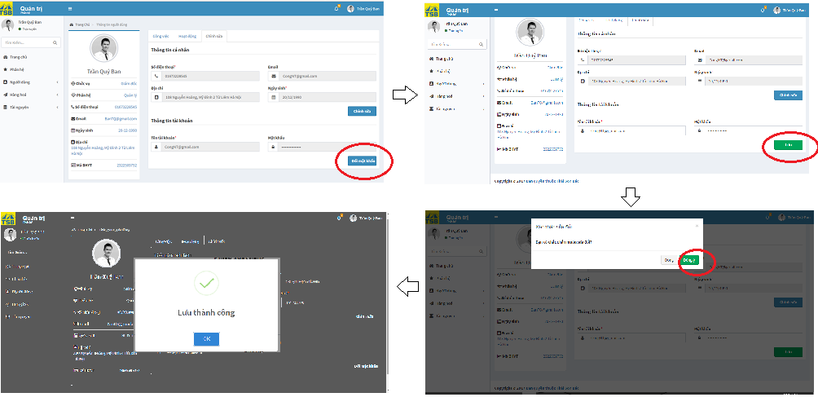

Figure 3.5: Change password screen

|  |  |  |  |  |
| --- | --- | --- | --- | --- |
| **USE CASE-003 SPECIFICATION : Change password** | | | | |
| **Use-case No.** | <UC003> | **Use-case Version** | | <1.0> |
| **Use-case Name** | Change password | | | |
| **Author** | AnhNTL | | | |
| **Date** | Jan 2 nd, 2018 | **Priority** | High | |
| **Actor:**  *Sellers, managers, administrator, warehouse, accountant*  **Summary:**  *User change their password*  **Goal:**  *Change password of user*  **Triggers**   * *On “Thông tin người dùng” page , tab “Chỉnh sửa”, click button “Đổi mật khẩu”*   **Preconditions:**  *User click on “Hồ sơ” button*  **Post Conditions:**  *Display change password success message*  *Refresh “Thông tin người dùng” page*  **Main Success Scenario:**   |  |  |  | | --- | --- | --- | | *Step* | *User action* | *System response* | | *1* | *Click on “Hồ sơ” button* | *Display “Thông tin người dùng” page* | | *2* | *Click “Chỉnh sửa” tab* | *Switch to”Chỉnh sửa” tab* | | *3* | *Click “Đổi mật khẩu” button* | *-Enable password field to change*  *-“Đổi mật khẩu” button become “Lưu” button* | | *4* | *Input password* | *Focus length and strength of new password* | | *5* | *Click button “Lưu”* | *Display pop-up or confirm new password* | | *6* | *Confirm new password* | *Send request change password to system* | | *7* | *Click “Đồng ý” button* | *Display change password success message*  *Refresh “Thông tin người dùng” page* |   **Alternative Scenario:**   |  |  |  | | --- | --- | --- | | *Step* | *User action* | *System response* | | *1* | *Administrator go to “Chi tiết người dùng” page* | *Display “Chi tiết người dùng” page* | | *2* | *Click “Chỉnh sửa” tab* | *Switch to ”Chỉnh sửa” tab* | | *3* | *Click “Reset mật khẩu” button* | *Confirm reset* | | *4* | *Click OK button* | *Reset password of user to default password* |   **Exceptions:**  **Business Rules:**  *Password has at least 8 characters and contain special characters*  *Password is sensitive case* | | | | |

*Table 3.6 Change password*

Screen description:

|  |  |  |  |  |  |  |
| --- | --- | --- | --- | --- | --- | --- |
| Field name | Description | Mandatory | Read only | Control type | Data type | Length |
| Email field | Email of user | - | Y | Text field | Nvarchar | 50 |
| Password field | Password of user | Y | N | Text field | Nvarchar | 50 |
| “Đổi mật khẩu” button | Button of form | - | - | Button | Button | - |
| “Lưu” button | Button of form | - | - | Button | Button | - |
| Confirm password field | Confirm new password | Y | N | Text field | Nvarchar | 50 |
| “Đóng” button | Button of form | - | - | Button | Button | - |
| “Đồng ý” button | Button of form | - | - | Button | Button | - |

*Table 3.7 Screen description of usecase login*

###### Notification

Use case specification:

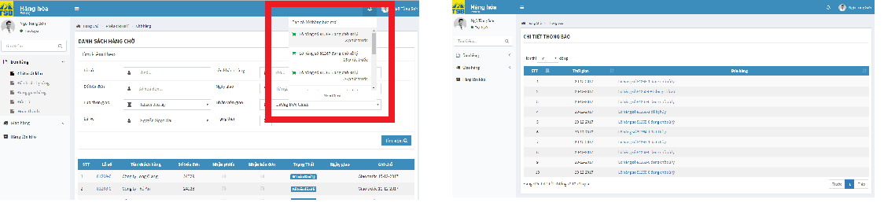

Figure 3.6: Notification screen

|  |  |  |  |  |
| --- | --- | --- | --- | --- |
| **USE CASE-004 SPECIFICATION : Notification** | | | | |
| **Use-case No.** | <UC004> | **Use-case Version** | | <1.0> |
| **Use-case Name** | Notification | | | |
| **Author** | AnhNTL | | | |
| **Date** | Jan 2 nd, 2018 | **Priority** | Normal | |
| **Actor:**  *Sellers, managers, administrator, warehouse, accountant*  **Summary:**  *When there is information related to their account*  **Goal:**  *Notification to account information related to their account*  **Triggers**  **Preconditions:**  *User click on notification icon*  **Post Conditions:**  *Redirect to page in content of notification*  **Main Success Scenario:**   |  |  |  | | --- | --- | --- | | *Step* | *User action* | *System response* | | *1* |  | *Display number of new notifications* | | *2* | *Click notification icon* | *Display dropdown list notification* | | *3* | *Click to 1 notification* | *Redirect to page in content of notification* |   **Alternative Scenario:**   |  |  |  | | --- | --- | --- | | *Step* | *User action* | *System response* | | *1* |  | *Display number of new notifications* | | *2* | *Click notification icon* | *Display dropdown list notification* | | *3* | *Click “ Xem tất cả” link* | *Display notification page* | | *4* | *Click to 1 notification* | *Redirect to page in content of notification* |  |  |  |  | | --- | --- | --- | | *Step* | *User action* | *System response* | | *1* | *Type URL of notification page on browser* | *Display notification page* | | *2* | *Click to 1 notification* | *Redirect to page in content of notification* |   **Exceptions:**  **Business Rules:** | | | | |

*Table 3.8 Usecase notification*

###### View profile

Use case specification:

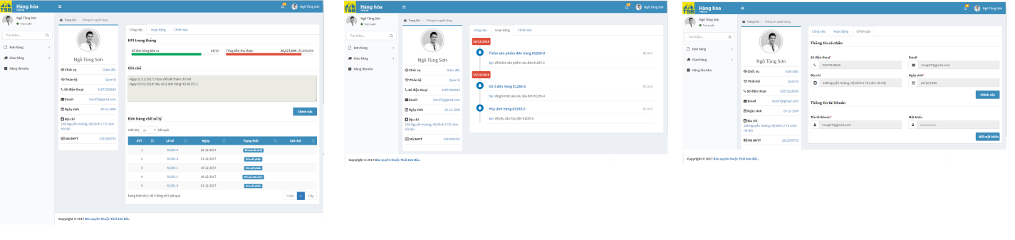

*Figure 3.7:* *View profile screen*

|  |  |  |  |  |
| --- | --- | --- | --- | --- |
| **USE CASE-005 SPECIFICATION : View profile** | | | | |
| **Use-case No.** | <UC005> | **Use-case Version** | | <1.0> |
| **Use-case Name** | View profile | | | |
| **Author** | AnhNTL | | | |
| **Date** | Jan 2 nd, 2018 | **Priority** | Low | |
| **Actor:**  *Sellers, managers, administrator, warehouse, accountant*  **Summary:**  *User view their profile and some indicators*  **Goal:**  *Show user’s information*  **Triggers**  *N/A*  **Preconditions:**  *User click “Hồ sơ” button*  **Post Conditions:**  *Display “ Thông tin người dùng” page*  **Main Success Scenario:**   |  |  |  | | --- | --- | --- | | *Step* | *User action* | *System response* | | *1* | *On dropdown user’s information , click “Hồ sơ” button* | *Display “ Thông tin người dùng” page* |   **Alternative Scenario:**  **Exceptions:**  **Business Rules:** | | | | |

*Table 3.9 Usecase view profile*

###### Change information

Use case specification:

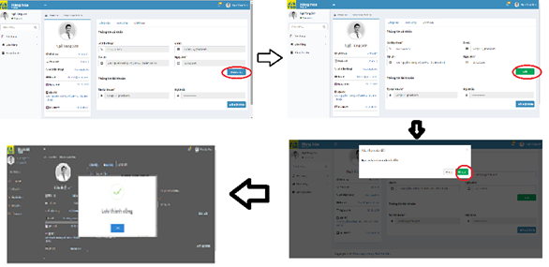

*Figure 3.8: Change information screen*

|  |  |  |  |  |
| --- | --- | --- | --- | --- |
| **USE CASE-006 SPECIFICATION : Change information** | | | | |
| **Use-case No.** | <UC006> | **Use-case Version** | | <1.0> |
| **Use-case Name** | Change information | | | |
| **Author** | AnhNTL | | | |
| **Date** | Jan 2 nd, 2018 | **Priority** | High | |
| **Actor:**  *Sellers, managers, administrator, warehouse, accountant*  **Summary:**  *User change their information*  **Goal:**  *Change information of user*  **Triggers**  *-On “Thông tin người dùng” page , “Chỉnh sửa” tab , click “Chỉnh sửa” button*  **Preconditions:**  *User in “Thông tin người dùng” page*  **Post Conditions:**  *Display change information successfully message. Refresh “Thông tin người dùng” page*  **Main Success Scenario:**   |  |  |  | | --- | --- | --- | | *Step* | *User action* | *System response* | | *1* | *On user profile page , click on “Hồ sơ” button* | *Display “Thông tin người dùng” page* | | *2* | *Click “Chỉnh sửa” tab* | *Switch to”Chỉnh sửa” tab* | | *3* | *Click “Chỉnh sửa” button* | *- Enable fields to change*  *-“Chỉnh sửa” button change “Lưu” button* | | *4* | *Input new information* | *Focus length* | | *5* | *Click button “Lưu”* | *Display pop-up for confirm save change* | | *6* | *Click “Đồng ý” button* | *-Update user’s information*  *-Display change success message*  *- Refresh “ Thông tin người dùng” page* |   **Alternative Scenario:**  **Exceptions:**  **Business Rules:** | | | | |

*Table 3.10 Usecase change information*

Screen description:

|  |  |  |  |  |  |  |
| --- | --- | --- | --- | --- | --- | --- |
| Field name | Description | Mandatory | Read only | Control type | Data type | Length |
| Email field | Email of user | Y | N | Text field | Nvarchar | 50 |
| Phone field | Phone of user | Y | N | Text field | Nvarchar | 50 |
| Address field | Address of user | Y | N | Text field | Nvarchar | MAX |
| Date of birth field | DOB of user | Y | N | Text field | Date | 50 |
| “Chỉnh sửa” button | Button of form | - | - | Button | Button | - |
| “Lưu” button | Button of form | - | - | Button | Button | - |
| “Đóng” button | Button of form | - | - | Button | Button | - |
| “Đồng ý” button | Button of form | - | - | Button | Button | - |

*Table 3.11 Screen description of usecase change information*

#### Order management

##### Usecase diagram



*Figure 3.9:* *Usecase diagram*

##### Usecase

###### Create order

Use case specification:

- Create order

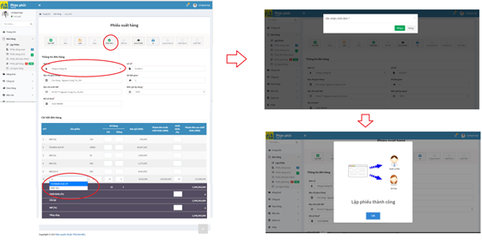

*Figure 3.10:* *Create new order screen*

- Save order

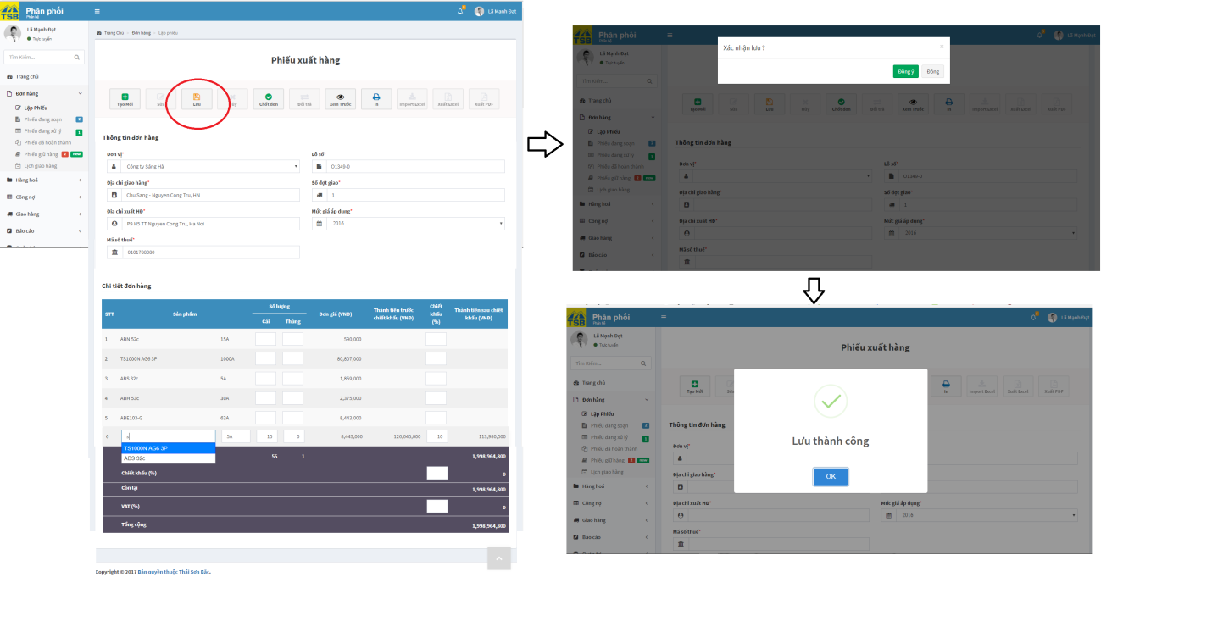

*Figure 3.11:* *Save order screen*

|  |  |  |  |  |
| --- | --- | --- | --- | --- |
| **USE CASE-007 SPECIFICATION : Create order** | | | | |
| **Use-case No.** | <UC007> | **Use-case Version** | | <1.0> |
| **Use-case Name** | Create order | | | |
| **Author** | AnhNTL | | | |
| **Date** | Jan 2 nd, 2018 | **Priority** | High | |
| **Actor:**  *Sellers, managers*  **Summary:**  *Create new order*  **Goal:**  *New order created*  **Triggers**  **Preconditions:**  *User in click “Lập phiếu” on tab “Đơn hàng” on left menu*  **Post Conditions:**  *Display created success message. Redirect to “Chi tiết phiếu” page*  **Main Success Scenario:**   |  |  |  | | --- | --- | --- | | *Step* | *User action* | *System response* | | *1* | *User in click “Lập phiếu” on tab “Đơn hàng” on left menu* | *Display “Lập phiếu” page* | | *2* | *Select customer name* | *Auto fill customer’s information* | | *3* | *Select number of deliveries* | *Display table for total and table for each delivery* | | *4* | *Input product name* | *Suggest the product name* | | *5* | *Select product* | *Auto fill product price* | | *6* | *Input quantity and discount( if have)* | *Calculate total price of that product and price of total order* | | *7* | *Input VAT and discount for order* | *Calculate price of total* | | *8* | *Click “Chốt đơn” button* | *Display pop-up to confirm* | | *9* | *Click “ Đồng ý” button* | *-Check request stock out is today*  *-Save order to list of in progress orders*  *-Display created success message*  *Redirect to “Chi tiết phiếu” page* |   **Alternative Scenario:**   1. **Quantity not enough in stock**  |  |  |  | | --- | --- | --- | | *Step* | *User action* | *System response* | | *1* | *Select customer name* | *Auto fill customer’s information* | | *2* | *Select number of deliveries* | *Display table for total and table for each delivery* | | *3* | *Input product name* | *Suggest the product name* | | *4* | *Select product* |  | | *5* | *Input quantity and discount( if have)* | *Quantity of product in stock not enough : display pop-up to borrow product from another order* | | *6* | *Input quantity borrow* |  | | *7* | *Click “OK” button* | *Close pop-up, note and minus quantity in order borrowed* | | *8* | *Continue input order* |  | | *9* | *Input VAT and discount for order* | *Calculate price of total* | | *10* | *Click “Chốt đơn” button* | *Display pop-up to confirm* | | *11* | *Click “ Đồng ý” button* | *Save order to list of in progress orders*  *Display created success message* |  1. **Save order to creating order list**  |  |  |  | | --- | --- | --- | | *Step* | *User action* | *System response* | | *1* | *Select customer name* | *Auto fill customer’s information* | | *2* | *Select number of deliveries* | *Display table for total and table for each delivery* | | *3* | *Input product name* | *Suggest the product name* | | *4* | *Select product* |  | | *5* | *Input quantity and discount( if have)* | *Calculate price of that product and price of total order* | | *6* | *Input VAT and discount for order* | *Calculate price of total* | | *7* | *Click “Lưu” button* | *Display pop-up to confirm* | | *8* | *Click “Đồng ý” button* | *Display saved success message*  *Redirect to Chi tiết phiếu” page* |  1. **Save order to list of waiting order**  |  |  |  | | --- | --- | --- | | *Step* | *User action* | *System response* | | *1* | *User in click “Lập phiếu” on tab “Đơn hàng” on left menu* | *Display “Lập phiếu” page* | | *2* | *Select customer name* | *Auto fill customer’s information* | | *3* | *Select number of deliveries* | *Display table for total and table for each delivery* | | *4* | *Input product name* | *Suggest the product name* | | *5* | *Select product* | *Auto fill product price* | | *6* | *Input quantity and discount( if have)* | *Calculate total price of that product and price of total order* | | *7* | *Input VAT and discount for order* | *Calculate price of total* | | *8* | *Click “Chốt đơn” button* | *Display pop-up to confirm* | | *9* | *Click “ Đồng ý” button* | *-Check request stock out is not today*  *-Save order to list of in waiting orders*  *-Display created success message*  *Redirect to “Chi tiết phiếu” page* |   **Exceptions:**  **Business Rules:**  *- Product and customer must exist in system*  *- If product in quantity not enough , can borrow product from another order in list of delivery waiting orders*  *- If date delivery requested is not today, after click “Chốt đơn” button, save to list of waiting orders* | | | | |

*Table 3.12 Usecase create order*

Screen description:

|  |  |  |  |  |  |  |
| --- | --- | --- | --- | --- | --- | --- |
| Field name | Description | Mandatory | Read only | Control type | Data type | Length |
| Customer field | Name of customer | Y | N | Text field autocomplete | Nvarchar | MAX |
| Delivery address field | Address to delivery | Y | N | Text field | Nvarchar | MAX |
| Receive invoice address field | Address to receive invoice | Y | N | Text field | Nvarchar | MAX |
| Tax_code field | Tax code of customer | Y | N | Text field | Nvarchar | 20 |
| Order id field | Order id | Y | N | Text field | Nvarchar | 10 |
| Number of deliveries field | Number of deliveries | Y | N | Input type=”number” | INT | 10 |
| Rate price applied field | Rate price apply for items in order | Y | N | Dropbox | Nvarchar | - |
| Product name fields | Name of product | Y | N | Text field autocomplete | Nvarchar | MAX |
| Product parameter fields | Parameter of product | Y | N | Text field autocomplete | Nvarchar | 100 |
| Quantity of product fields | Quantity of product | Y | N | Input type=”number” | INT | MAX |
| Quantity of carton fields | Quantity carton of product | Y | Y | Input type=”number” | Double | MAX |
| Price of product fields | Price of product | - | - | Output | - | - |
| Total price of product before discount fields | Total price before discount | - | - | Output | - | - |
| Discount of product fields | Discount of product | N | N | Input type=”number” | INT | 100 |
| Total price of product after discount fields | Total price before discount | - | - | Output | - | - |
| Total price of order before discount field | Total price of order before discount | - | - | Output | - | - |
| discount of order field | discount of order | N | N | Input type=”number” | INT | 100 |
| Total price of order after discount field | Total price of order after discount | - | - | Output | - | - |
| VAT of order field | VAT of order | N | N | Input type=”number” | INT | 100 |
| Total price of order after VAT field | Total price of order after VAT | - | - | Output | - | - |
| “Tạo mới” button | Button of form | - | - | Button | - | - |
| “Chốt đơn” button | Button of form | - | - | Button | - | - |
| “Lưu” button | Button of form | - | - | Button | - | - |
| “Xem trước” button | Button of form | - | - | Button | - | - |

*Table 3.13 Screen description of usecase login*

###### Modify order

Use case specification:

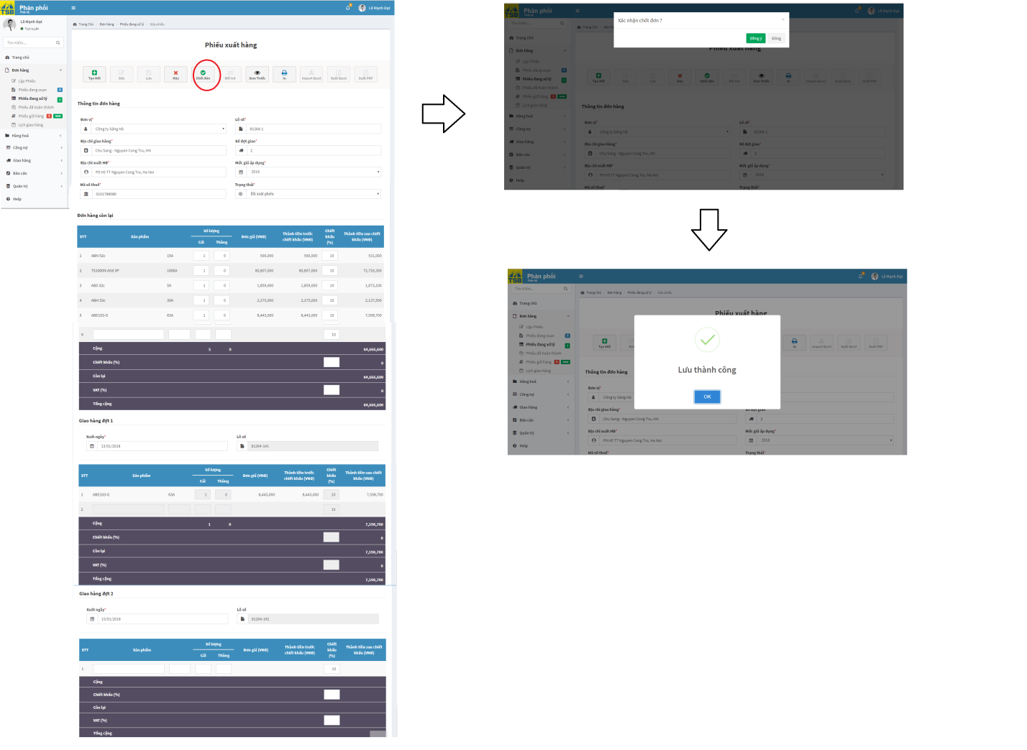

*Figure 3.12:* *Modify order screen*

|  |  |  |  |  |
| --- | --- | --- | --- | --- |
| **USE CASE-008 SPECIFICATION : Modify order** | | | | |
| **Use-case No.** | <UC008> | **Use-case Version** | | <1.0> |
| **Use-case Name** | Modify order | | | |
| **Author** | AnhNTL | | | |
| **Date** | Jan 2 nd, 2018 | **Priority** | High | |
| **Actor:**  *Sellers, managers*  **Summary:**  *Change order*  **Goal:**  *Changed order*  **Triggers**  *N/A*  **Preconditions:**  *User click “Sửa đơn” button*  **Post Conditions:**  *Display save success message. Redirect detail order page*  **Main Success Scenario:**   |  |  |  | | --- | --- | --- | | *Step* | *User action* | *System response* | | *1* | *Click “Sửa đơn” buton* | *Display “Sửa đơn” page* | | *2* | *Change order* | *Change order* | | *3* | *Click “Chốt đơn” button* | *Update order*  *Display changed success message*  *Redirect detail order page* |   **Alternative Scenario:**  **Exceptions:**  **Business Rules:**  *Modify only when order in list status : “Bản nháp”,”Chưa xuất phiếu”,“ Đã xuất phiếu” , ” Đổi trả”* | | | | |

*Table 3.14 Usecase Modify order*

Screen description:

|  |  |  |  |  |  |  |
| --- | --- | --- | --- | --- | --- | --- |
| Field name | Description | Mandatory | Read only | Control type | Data type | Length |
| Customer field | Name of customer | Y | N | Text field autocomplete | Nvarchar | MAX |
| Delivery address field | Address to delivery | Y | N | Text field | Nvarchar | MAX |
| Receive invoice address field | Address to receive invoice | Y | N | Text field | Nvarchar | MAX |
| Tax_code field | Tax code of customer | Y | N | Text field | Nvarchar | 20 |
| Order id field | Order id | Y | N | Text field | Nvarchar | 10 |
| Number of deliveries field | Number of deliveries | Y | N | Input type=”number” | INT | 10 |
| Rate price applied field | Rate price apply for items in order | Y | N | Dropbox | Nvarchar | - |
| Product name field | Name of product | Y | N | Text field autocomplete | Nvarchar | MAX |
| Product parameter field | Parameter of product | Y | N | Text field autocomplete | Nvarchar | 100 |
| Quantity of product field | Quantity of product | Y | N | Input type=”number” | INT | MAX |
| Quantity of carton field | Quantity carton of product | Y | Y | Input type=”number” | Double | MAX |
| Price of product field | Price of product | - | - | Output | - | - |
| Total price of product before discount field | Total price before discount | - | - | Output | - | - |
| Discount of product field | Discount of product | N | N | Input type=”number” | INT | 100 |
| Total price of product after discount field | Total price before discount | - | - | Output | - | - |
| Total price of order before discount field | Total price of order before discount | - | - | Output | - | - |
| Discount of order field | discount of order | N | N | Input type=”number” | INT | 100 |
| Total price of order after discount field | Total price of order after discount | - | - | Output | - | - |
| VAT of order field | VAT of order | N | N | Input type=”number” | INT | 100 |
| Total price of order after VAT field | Total price of order after VAT | - | - | Output | - | - |
| “Tạo mới” button | Button of form | - | - | Button | - | - |
| “Chốt đơn” button | Button of form | - | - | Button | - | - |
| “Xem trước” button | Button of form | - | - | Button | - | - |

*Table 3.15 Screen description of usecase modify order*

###### Order handling

Use case specification:

- Handling of accountancy



*Figure 3.13:* *Handling of accountancy screen*

-Handling of warehouse

+ Prepare product

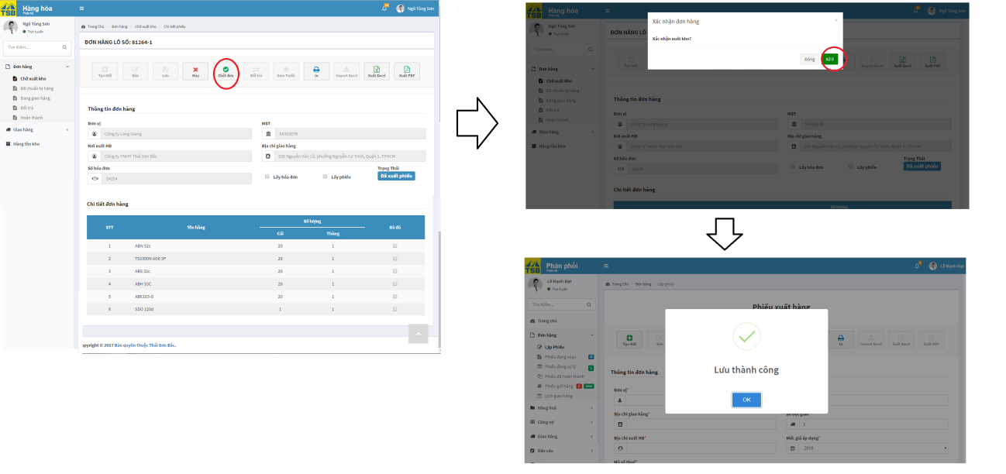

*Figure 3.14:* *Handling of warehouse screen*

- Deliver product

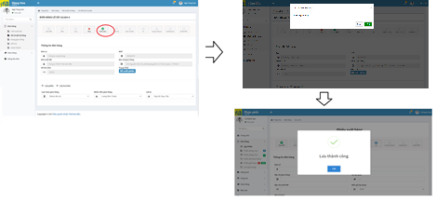

*Figure 3.15:* *Deliver product*

- Finish order 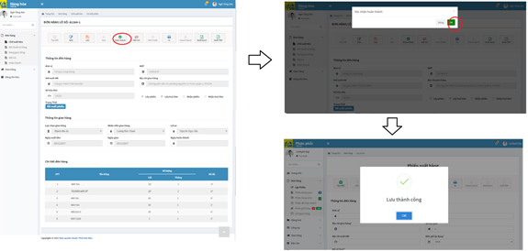

*Figure 3.16:* *Finish order*

|  |  |  |  |  |
| --- | --- | --- | --- | --- |
| **USE CASE-009 SPECIFICATION : Order handling** | | | | |
| **Use-case No.** | <UC009> | **Use-case Version** | | <1.0> |
| **Use-case Name** | Order handling | | | |
| **Author** | AnhNTL | | | |
| **Date** | Jan 2 nd, 2018 | **Priority** | High | |
| **Actor:**  *Accountant, Stock*  **Summary:**  *User handle orders*  **Goal:**  *User handle orders, order change status*  **Triggers**  **Preconditions:**  *User in “Chi tiết đơn hàng” page*  **Post Conditions:**  *Display handled success message*  *Refresh “Chi tiết đơn hàng” page*  **Main Success Scenario:**   1. **Handle of accountant**  |  |  |  | | --- | --- | --- | | *Step* | *User action* | *System response* | | *1* | *User input invoice number and VAT* | *Validate value* | |  | *Click “Chốt đơn” button* | *Change value of order*  *Display handled success message*  *Refresh “Chi tiết đơn hàng” page* |  1. **Handle of warehouse**  |  |  |  | | --- | --- | --- | | *Step* | *User action* | *System response* | | *1* | *On “Danh sách đơn hàng chờ xuất kho” page, click to order id* | *Display “Chi tiết phiếu xuất kho” page* | | *2* | *On “Chi tiết phiếu xuất kho” page, click “Chốt đơn” button* | *Display pop-up confirm* | | *3* | *Confirm “OK”* | *Change status of order*  *Display handled success message* | | *4* | *On “Danh sách đã chuẩn bị hàng” page, click order id* | *Display “Chi tiết vận chuyển” page* | | *5* | *On “Chi tiết vận chuyển page”, select delivery methods, shipper, driver, receive invoice and order* |  | | *6* | *Click “Chốt đơn” button* | *Display pop-up confirm* | | *7* | *Confirm “OK”* | *Change status of order*  *Display handled success message* | | *8* | *On “Danh sách đang giao hàng” page , click to order id* | *Display “Chi tiết phiếu full” page* | | *9* | *On “Chi tiết phiếu full” page, click button “Hoàn thành”* | *Display pop-up confirm* | | *10* | *Confirm “OK”* | *Change status of order*  *Display “xử lý” success message*  *Refresh “Chi tiết đơn hàng” page* |   **Alternative Scenario:**   * **Return order in warehouse**  |  |  |  | | --- | --- | --- | | *Step* | *User action* | *System response* | | *1* | *On “Danh sách đơn hàng chờ xuất kho” page, click to order id* | *Display “Chi tiết phiếu xuất kho” page* | | *2* | *On “Chi tiết phiếu xuất kho” page, click “Chốt đơn” button* | *Display pop-up confirm* | | *3* | *Confirm “OK”* | *Change status of order*  *Display handled success message* | | *4* | *On “Danh sách đã chuẩn bị hàng” page, click order id* | *Display “Chi tiết vận chuyển” page* | | *5* | *On “Chi tiết vận chuyển page”, select delivery methods, shipper, driver, receive invoice and order* |  | | *6* | *Click “Chốt đơn” button* | *Display pop-up confirm* | | *7* | *Confirm “OK”* | *Change status of order*  *Display handled success message* | | *8* | *On “Danh sách đang giao hàng” page , click to order id* | *Display “Chi tiết phiếu full” page* | | *9* | *On “Chi tiết phiếu full” page, click button “ Đổi trả”* | *Display pop-up confirm* | | *10* | *Input reason* |  | | *11* | *Confirm “OK”* | *Change status of order*  *Display handled success message* |   **Exceptions:**  *-If accountant not yet handled, warehouse handled, status of order is status + “warning” and Warehouse cannot finish order*   * *“Cảnh báo đã xuất kho”* * *“Cảnh báo đang giao hàng”*   *-Warehouse can handle order in order list pages*  **Business Rules:**  *- Stock out only when all product enough quantity*  *- Because order after created will notify at the same time to warehouse and accountant. If prodcut stock out before accountant handled, status of order will be “Đã xuất kho warning”, “Đã giao hàng warning”. After accountant handle , status of order will change to “Đã xuất kho”, “Đã giao hàng” as normal*  *- Before deliver, shipper must take invoice and order list. If have any reason make shipper can not take full 2 sheet or accountant not handle (order must be delivered urgently), order will be delivered with status is ”Đang giao hàng warning”*  *-To finish order, accountant have to handled order and shipper must give company all sheets they have taken before deliver. User will note what they was received by checkbox and save until enough.*  *-To return order, shipper must give company all sheets they have taken before deliver. User will note what they was received by checkbox and save until enough. Order after returned will be notified for creator to cancel or modify* | | | | |

*Table 3.16 Usecase order handling*

###### View order



*Figure 3.17:* *View order usecase diagram*

View order for accountant

Use case specification:

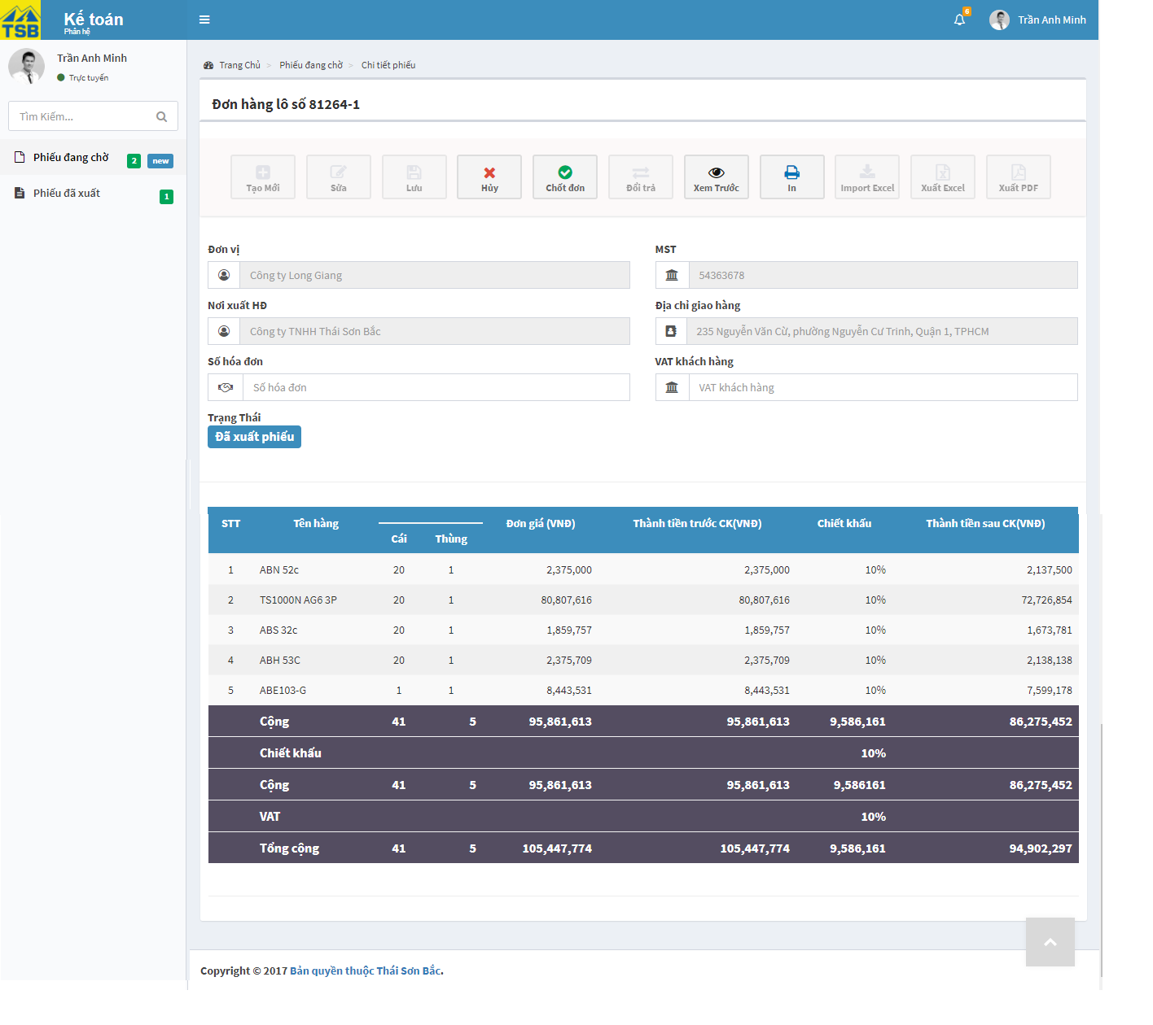

*Figure 3.18:* *View order of accountancy screen*

|  |  |  |  |  |
| --- | --- | --- | --- | --- |
| **USE CASE-010 SPECIFICATION : View of order for accountant** | | | | |
| **Use-case No.** | <UC010> | **Use-case Version** | | <1.0> |
| **Use-case Name** | View order of accountant | | | |
| **Author** | AnhNTL | | | |
| **Date** | Jan 2 nd, 2018 | **Priority** | High | |
| **Actor:**  *Accountant*  **Summary:**  *User view order detail*  **Goal:**  *Display detail order*  **Triggers**  **Preconditions:**  *Click on order id in list orders page*  **Post Conditions:**  *Display detail order page*  **Main Success Scenario:**   |  |  |  | | --- | --- | --- | | *Step* | *User action* | *System response* | | *1* | *On list orders page, click on order id* | *Display detail order page* |   **Alternative Scenario:**   |  |  |  | | --- | --- | --- | | *Step* | *User action* | *System response* | | *1* | *Click on notification about order* | *Display detail order page* |   **Exceptions:**  **Business Rules:** | | | | |

*Table 3.17 Usecase view of order for accountant*

Screen description:

|  |  |  |  |  |  |  |
| --- | --- | --- | --- | --- | --- | --- |
| Field name | Description | Mandatory | Read only | Control type | Data type | Length |
| “In” button | Button of page | - | - | Button | - | - |
| “Xuất excel” button | Button of page | - | - | Button | - | - |
| “Xuất pdf” button | Button of page | - | - | Button | - | - |
| Customer field | Name of customer | Y | Y | Text field autocomplete | Nvarchar | MAX |
| Delivery address field | Address to delivery | Y | Y | Text field | Nvarchar | MAX |
| Receive invoice address field | Address to receive invoice | Y | Y | Text field | Nvarchar | MAX |
| Tax_code field | Tax code of customer | Y | Y | Text field | Nvarchar | 20 |
| Invoice number field | Invoice number | y | N | Text field | Nvarchar | 10 |
| VAT for customer field | VAT for customer | Y | N | Text field | Double | 100 |
| Status label | Status of order | - | - | Label | - | - |
| Order detail table | Detail of order | - | - | Table | - | - |
| “Chốt đơn” button | Button of form | - | - | Button | - | - |
| “Huỷ” button | Button of form | - | - | Button | - | - |

*Table 3.18 Screen description of usecase view of order for accountant*

View order for warehouse

Use case specification:

- Detail order for stock out

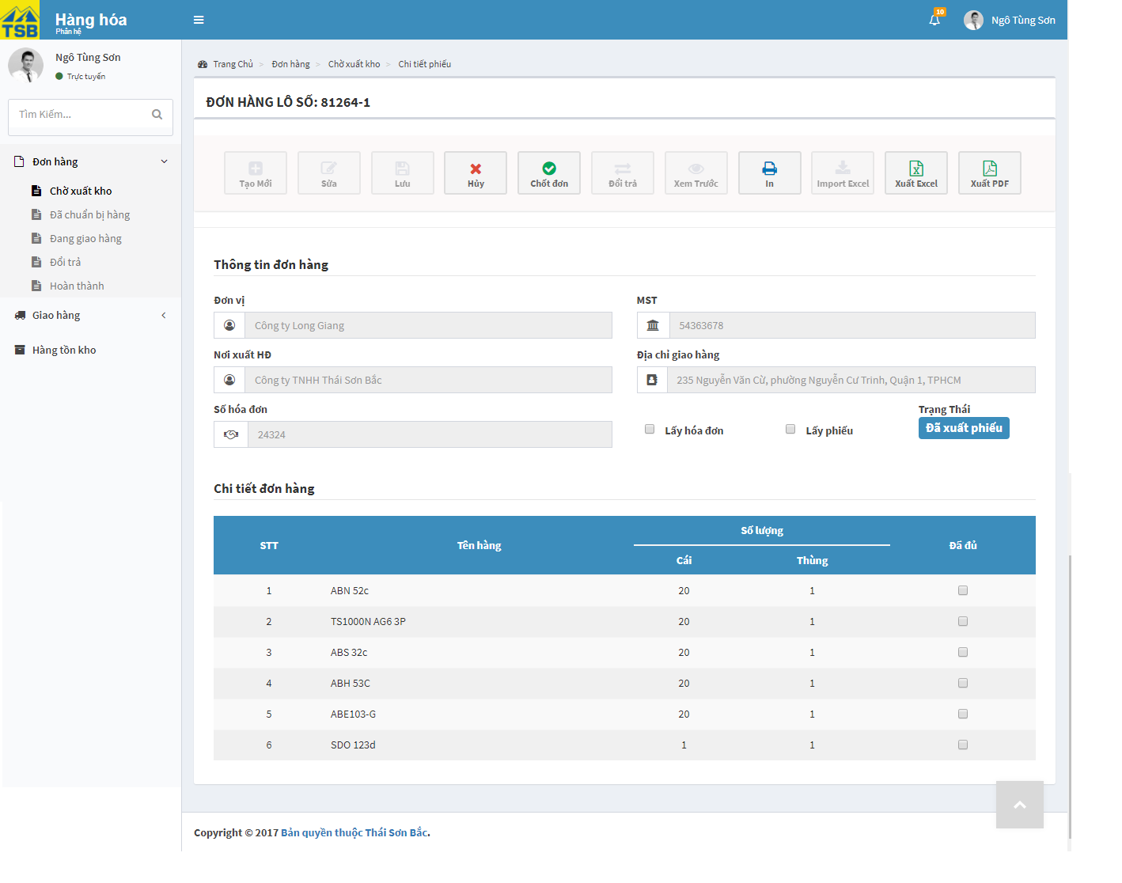

*Figure 3.19:* *View detail of stock screen*

- Detail order to delivery

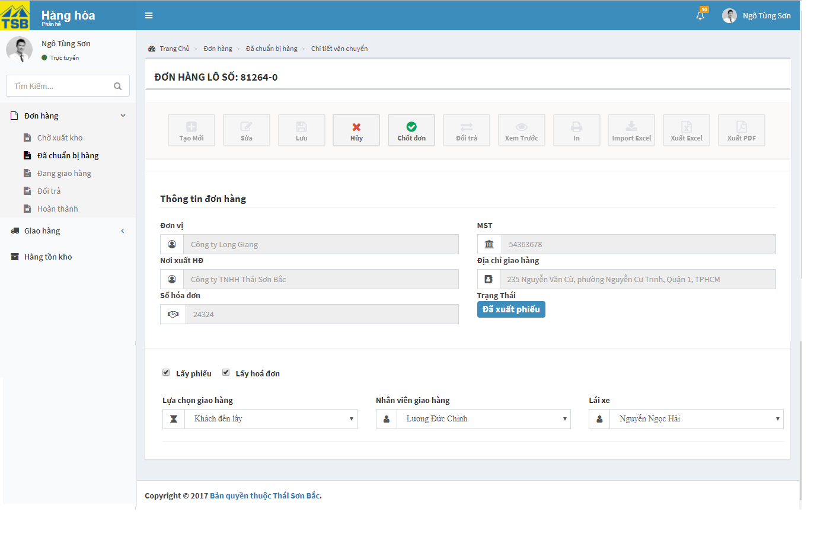

*Figure 3.20:* *Detail order to delivery*

-Detail orders are being delivery

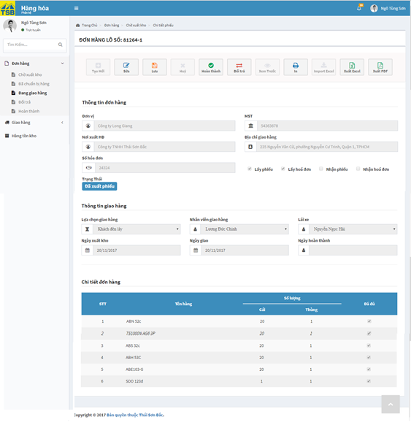

*Figure 3.21:* *Detail order are being delivery screen*

|  |  |  |  |  |
| --- | --- | --- | --- | --- |
| **USE CASE-011 SPECIFICATION : View detail order of warehouse** | | | | |
| **Use-case No.** | <UC011> | **Use-case Version** | | <1.0> |
| **Use-case Name** | View detail order for stock out of warehouse | | | |
| **Author** | AnhNTL | | | |
| **Date** | Jan 2 nd, 2018 | **Priority** | High | |
| **Actor:**  *Warehouse*  **Summary:**  *User view detail order*  **Goal:**  *Display detail order for stock out*  **Triggers**  **Preconditions:**  *User click on order id in order list pages*  **Post Conditions:**  *Display order detail page* *respectively*  **Main Success Scenario:**   |  |  |  | | --- | --- | --- | | *Step* | *User action* | *System response* | | *1* | *User click on order id in order list pages* | *Display order detail pages* *respectively* |   **Alternative Scenario:**   |  |  |  | | --- | --- | --- | | *Step* | *User action* | *System response* | | *1* | *Click on notification about order* | *Display order detail page* *respectively* |   **Exceptions:**  **Business Rules:** | | | | |

*Table 3.19 Usecase view detail order of warehouse*

Screen description:

- Detail order for stock out

|  |  |  |  |  |  |  |
| --- | --- | --- | --- | --- | --- | --- |
| Field name | Description | Mandatory | Read only | Control type | Data type | Length |
| “In” button | Button of page | - | - | Button | - | - |
| “Xuất excel” button | Button of page | - | - | Button | - | - |
| “Xuất pdf” button | Button of page | - | - | Button | - | - |
| Customer field | Name of customer | Y | Y | Text field autocomplete | Nvarchar | MAX |
| Delivery address field | Address to delivery | Y | Y | Text field | Nvarchar | MAX |
| Receive invoice address field | Address to receive invoice | Y | Y | Text field | Nvarchar | MAX |
| Tax_code field | Tax code of customer | Y | Y | Text field | Nvarchar | 20 |
| Invoice number field | Invoice number | y | N | Text field | Nvarchar | 10 |
| Take invoice checkbox | Take invoice | N | N | Checkbox | Boolean | - |
| Take order list checkbox | Take invoice | N | N | Checkbox | Boolean | - |
| Status label | Status of order | - | - | Label | - | - |
| Order detail table | Detail of order | - | - | Table | - | - |
| Ready for product checkbox | Check box to check product’s quantity enough | Y | N | Checkbox | Boolean | - |
| “Chốt đơn” button | Button of form | - | - | Button | - | - |
| “Huỷ” button | Button of form | - | - | Button | - | - |

*Table 3.20 Screen description detail order of stock out*

-Detail order to delivery

|  |  |  |  |  |  |  |
| --- | --- | --- | --- | --- | --- | --- |
| Field name | Description | Mandatory | Read only | Control type | Data type | Length |
| “In” button | Button of page | - | - | Button | - | - |
| “Xuất excel” button | Button of page | - | - | Button | - | - |
| “Xuất pdf” button | Button of page | - | - | Button | - | - |
| Customer field | Name of customer | Y | Y | Text field autocomplete | Nvarchar | MAX |
| Delivery address field | Address to delivery | Y | Y | Text field | Nvarchar | MAX |
| Receive invoice address field | Address to receive invoice | Y | Y | Text field | Nvarchar | MAX |
| Tax_code field | Tax code of customer | Y | Y | Text field | Nvarchar | 20 |
| Invoice number field | Invoice number | Y | N | Text field | Nvarchar | 10 |
| Take invoice checkbox | Take invoice | N | N | Checkbox | Boolean | - |
| Take order list checkbox | Take invoice | N | N | Checkbox | Boolean | - |
| Status label | Status of order | - | - | Label | - | - |
| Shipper field | Shipper of order | Y | N | Dropbox | Nvarchar | 50 |
| Driver field | Driver of order | Y | N | Dropbox | Nvarchar | 50 |
| Delivery method field | Delivery method of order | Y | N | Dropbox | Nvarchar | 50 |
| “Chốt đơn” button | Button of form | - | - | Button | - | - |
| “Huỷ” button | Button of form | - | - | Button | - | - |

*Table 3.21 Screen description of detail order to delivery*

-Detail order are being delivery

|  |  |  |  |  |  |  |
| --- | --- | --- | --- | --- | --- | --- |
| Field name | Description | Mandatory | Read only | Control type | Data type | Length |
| “In” button | Button of page | - | - | Button | - | - |
| “Xuất excel” button | Button of page | - | - | Button | - | - |
| “Xuất pdf” button | Button of page | - | - | Button | - | - |
| Customer field | Name of customer | Y | Y | Text field autocomplete | Nvarchar | MAX |
| Delivery address field | Address to delivery | Y | Y | Text field | Nvarchar | MAX |
| Receive invoice address field | Address to receive invoice | Y | Y | Text field | Nvarchar | MAX |
| Tax_code field | Tax code of customer | Y | Y | Text field | Nvarchar | 20 |
| Invoice number field | Invoice number | y | N | Text field | Nvarchar | 10 |
| Take invoice checkbox | Take invoice | N | N | Checkbox | Boolean | - |
| Take invoice checkbox | Take invoice | N | N | Checkbox | Boolean | - |
| Receive order list checkbox | Receive invoice | N | N | Checkbox | Boolean | - |
| Receive order list checkbox | Receive invoice | N | N | Checkbox | Boolean | - |
| Status label | Status of order | - | - | Label | - | - |
| Shipper field | Shipper of order | Y | Y | Dropbox | Nvarchar | 50 |
| Driver field | Driver of order | Y | Y | Dropbox | Nvarchar | 50 |
| Delivery method field | Delivery method of order | Y | Y | Dropbox | Nvarchar | 50 |
| Stock in date field | Stock in date | Y | Y | Text field | Date | 50 |
| Deliver date field | Deliver date | Y | Y | Text field | Date | 50 |
| Finish date field | Finish date | N | Y | Text field | Date | 50 |
| Order detail table | Order detail | - | - | Table | - | - |
| “ Sửa” button | Button of form | - | - | Button | - |  |
| “Chốt đơn” button | Button of form | - | - | Button | - | - |
| “Đổi trả” button | Button of form | - | - | Button | - | - |

*Table 3.22 Screen description of detail order are being delivery*

View order of sellers and managers

Use case specification:

- Creating order

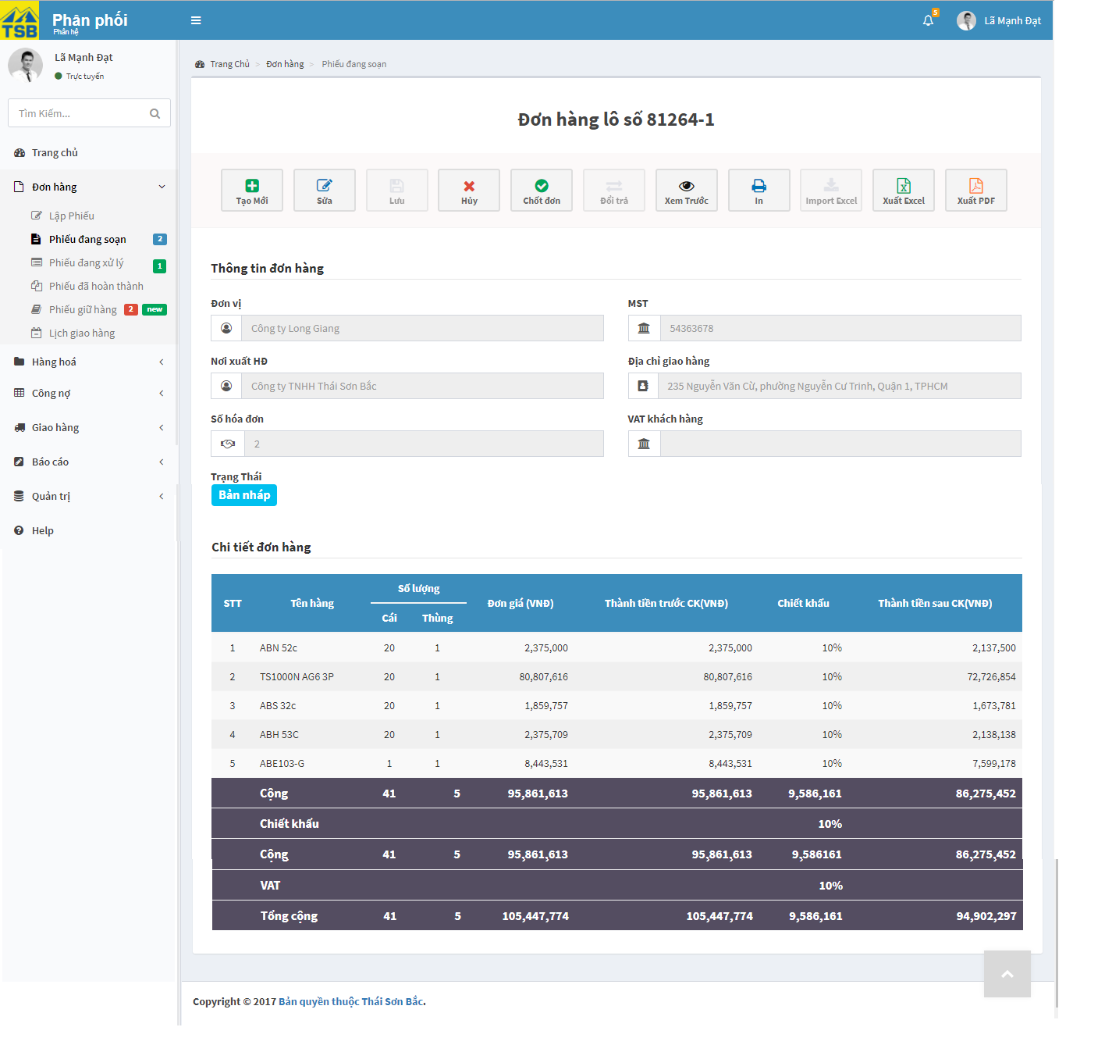

*Figure 3.22:* *Creating new order screen*

- One-time delivery order

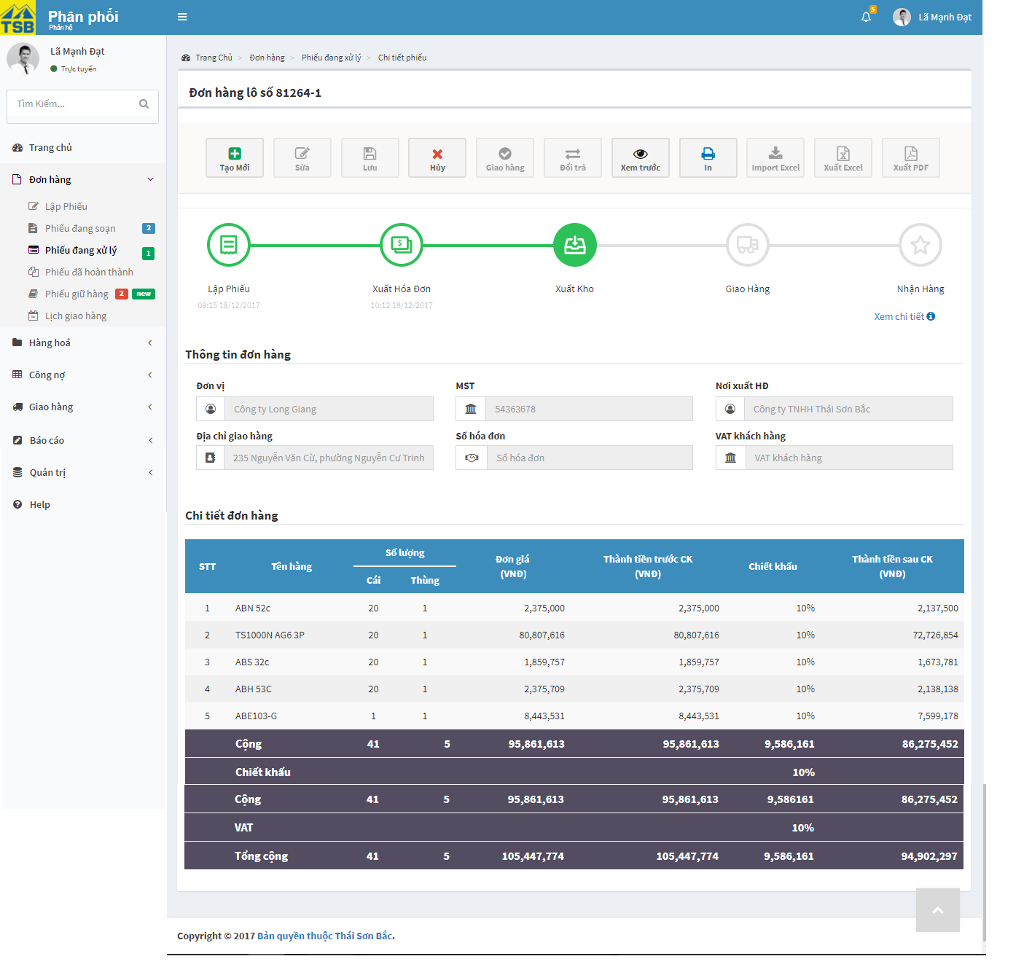

*Figure 3.23:* *Detail one-time delivery screen*

- Multiple-time delivery order

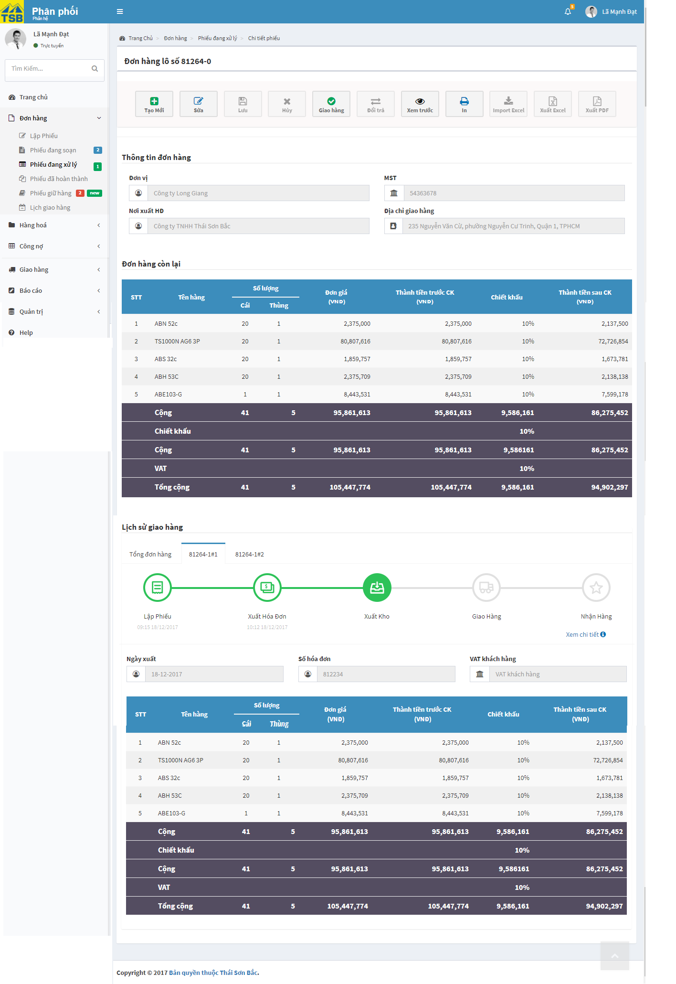

*Figure 3.24:* *Detail multiple-time delivery screen*

* History edit of order

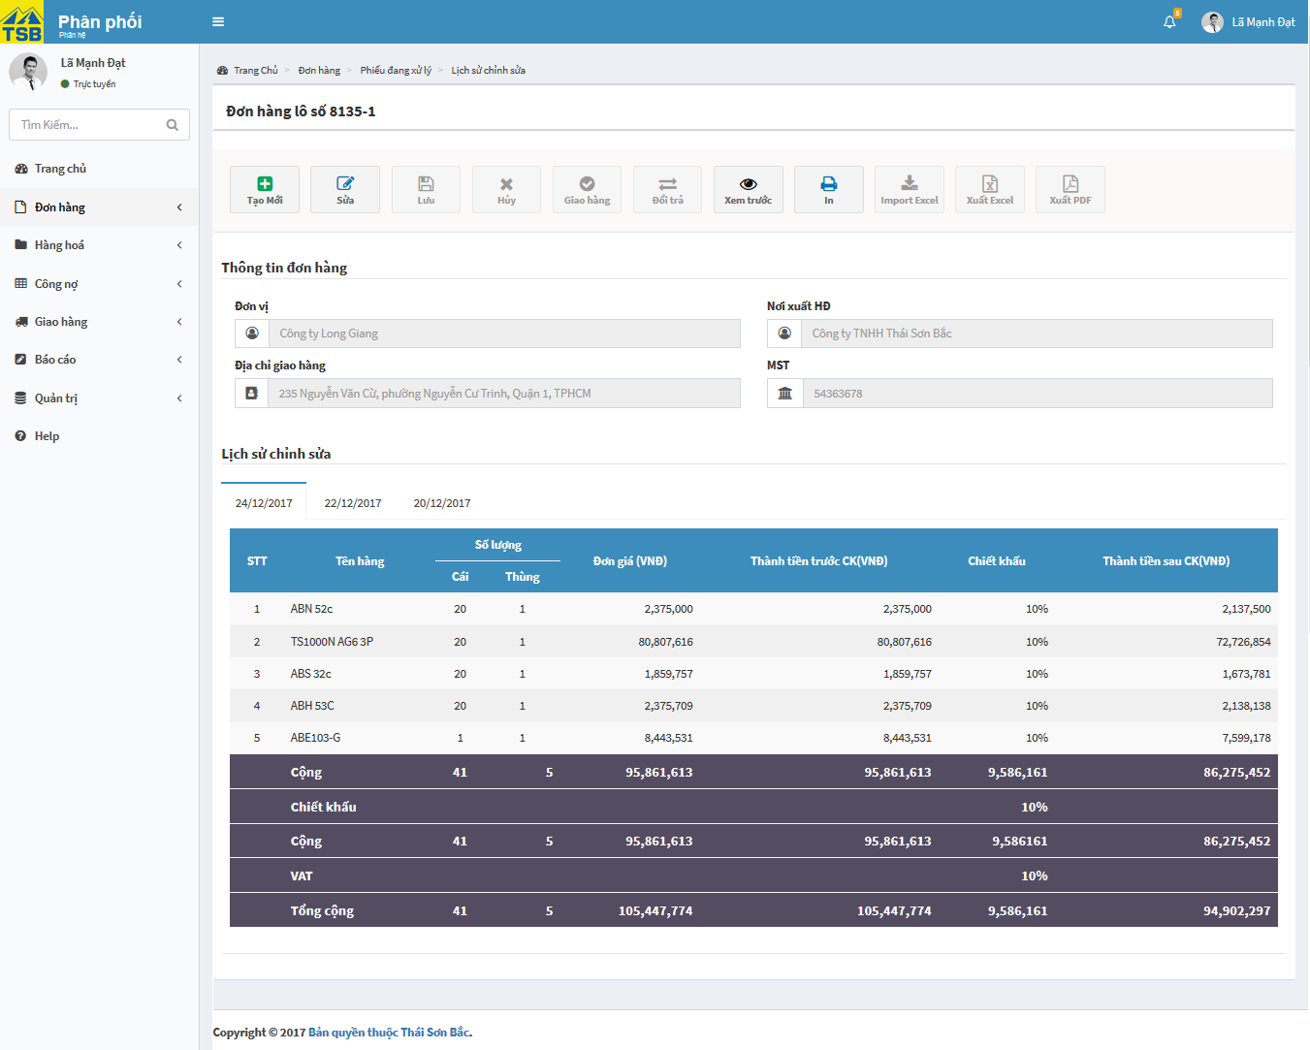

*Figure 3.25:* *Detail History edit of order screen*

|  |  |  |  |  |
| --- | --- | --- | --- | --- |
| **USE CASE-012 SPECIFICATION : View order of Sellers and managers** | | | | |
| **Use-case No.** | <UC012> | **Use-case Version** | | <1.0> |
| **Use-case Name** | View order of Sellers and managers | | | |
| **Author** | AnhNTL | | | |
| **Date** | Jan 2 nd, 2018 | **Priority** | High | |
| **Actor:**  *Sellers, managers*  **Summary:**  *User view detail order*  **Goal:**  *Display order detail page*  **Triggers**  **Preconditions:**  *On order list pages , click on order id*  **Post Conditions:**  *Display order detail page respectively*  **Main Success Scenario:**   |  |  |  | | --- | --- | --- | | *Step* | *User action* | *System response* | | *1* | *On order list pages , click on order id* | *Display order detail page respectively* |   **Alternative Scenario:**   1. **View edit history**  |  |  |  | | --- | --- | --- | | *Step* | *Useraction* | *System response* | | *1* | *On order detail page , click “xem lịch sử chỉnh sửa” hyperlink* | *Display edit history page* |   **Exceptions:**  **Business Rules:** | | | | |

*Table 3.23 Usecase view order of sales or management*

Screen description:

-Creating order

|  |  |  |  |  |  |  |
| --- | --- | --- | --- | --- | --- | --- |
| Field name | Description | Mandatory | Read only | Control type | Data type | Length |
| Customer field | Name of customer | N | Y | Text field autocomplete | Nvarchar | MAX |
| Delivery address field | Address to delivery | N | Y | Text field | Nvarchar | MAX |
| Receive invoice address field | Address to receive invoice | N | Y | Text field | Nvarchar | MAX |
| Tax_code field | Tax code of customer | N | Y | Text field | Nvarchar | 20 |
| Order id field | Order id | Y | Y | Text field | Nvarchar | 10 |
| Number of deliveries field | Number of deliveries | Y | N | Input type=”number” | INT | 10 |
| Rate price applied field | Rate price apply for items in order | Y | N | dropbox | Nvarchar | - |
| Status field | Status of order | Y | Y | Label | Nvarchar | 50 |
| Order detail table | Detail of order | Y | Y | Table | - |  |
| “Huỷ” button | Button of form | - | - | Button |  | - |
| “Tạo mới” button | Button of form | - | - | Button | - | - |
| “Chốt đơn” button | Button of form | - | - | Button | - | - |
| “Sửa” button | Button of form | - | - | Button | - | - |
| “Xem trước” button | Button of form | - | - | Button | - | - |

*Table 3.24 Screen description creating order*

-Order one-time delivery

|  |  |  |  |  |  |  |
| --- | --- | --- | --- | --- | --- | --- |
| Field name | Description | Mandatory | Read only | Control type | Data type | Length |
| “ Tạo mới” button | Button of form | - | - | Button | - | - |
| “Huỷ“ button | Button of form | - | - | Button | - | - |
| “Sửa” button | Button of form | - | - | Button |  | - |
| “Xem trước” button | Button of form | - | - | Button | - | - |
| “In” button | Button of page | - | - | Button | - | - |
| “Xuất excel” button | Button of page | - | - | Button | - | - |
| “Xuất pdf” button | Button of page | - | - | Button | - | - |
| Stepper diagram | Progress of order | - | - | Diagram | - | - |
| View detail progress link | Link to detail progress of order page | - | - | Hyperlink | - | - |
| Customer name field | Name of customer | Y | Y | Text field | Nvarchar | 50 |
| Tax_code field | Tax code of customer | Y | Y | Text field | Nvarchar | 50 |
| Delivery address field | Delivery address | Y | Y | Text field | Nvarchar | MAX |
| Receive invoice address field | Receive invoice address | Y | Y | Text field | Nvarchar | MAX |
| Invoice number field | Invoice number of order | N | Y | Text field | Nvarchar | 50 |
| VAT field | VAT of order | N | Y | Text field | Nvarchar | 50 |
| Order detail table | Detail of order | - | - | Table | - | - |

*Table 3.25 Screen description order one-time delivery*

-Order multiple-time delivery

|  |  |  |  |  |  |  |
| --- | --- | --- | --- | --- | --- | --- |
| Field name | Description | Mandatory | Read only | Control type | Data type | Length |
| “ Tạo mới” button | Button of form | - | - | Button | - | - |
| “Huỷ“ button | Button of form | - | - | Button | - | - |
| “Sửa” button | Button of form | - | - | Button |  | - |
| “Xem trước” button | Button of form | - | - | Button | - | - |
| Customer name field | Name of customer | Y | Y | Text field | Nvarchar | 50 |
| Tax_code field | Tax code of customer | Y | Y | Text field | Nvarchar | 50 |
| Delivery address field | Delivery address | Y | Y | Text field | Nvarchar | MAX |
| Receive invoice address field | Receive invoice address | Y | Y | Text field | Nvarchar | MAX |
| Detail list product not deliverd of order table | Detail list product not deliverd | - | - | Table | - | - |
| Detail order table | Detail order | - | - | Table | - | - |
| Created date of Order field | Created date of order | Y | y | Text field | Date | 10 |
| Order part tab | Order part tab | - | - | Tab | - | - |
| Stepper of order part diagram | Progess of order part | - | - | Diagram | - | - |
| View detail progress link | Link to detail progress of orderpart page | - | - | Hyperlink | - | - |
| Created date of order part field | Created date of order part | Y | y | Text field | Date | 10 |
| Invoice number field | Invoice number of order | N | Y | Text field | Nvarchar | 50 |
| VAT field | VAT of order | N | Y | Text field | Nvarchar | 50 |
| Detail order part table | Detail order part | - | - | Table | - | - |

*Table 3.26 Screen description multiple-time delivery*

-History edit

|  |  |  |  |  |  |  |
| --- | --- | --- | --- | --- | --- | --- |
| Field name | Description | Mandatory | Read only | Control type | Data type | Length |
| Customer name field | Name of customer | Y | Y | Text field | Nvarchar | 50 |
| Tax_code field | Tax code of customer | Y | Y | Text field | Nvarchar | 50 |
| Delivery address field | Delivery address | Y | Y | Text field | Nvarchar | MAX |
| Receive invoice address field | Receive invoice address | Y | Y | Text field | Nvarchar | MAX |
| History tab | Tab for each modify | - | - | Tab | - | - |
| Detail modify table | Detail modify of order | - | - | Table | - | - |

*Table 3.27 Screen description history edit*

###### Cancel order

Use case specification:

|  |  |  |  |  |
| --- | --- | --- | --- | --- |
| **USE CASE-013 SPECIFICATION : Cancel order** | | | | |
| **Use-case No.** | <UC013> | **Use-case Version** | | <1.0> |
| **Use-case Name** | Cancel order | | | |
| **Author** | AnhNTL | | | |
| **Date** | Jan 2 nd, 2018 | **Priority** | High | |
| **Actor:**  *Sellers, managers, warehouse , accountant*  **Summary:**  *User cancel order*  **Goal:**  *Order canceled ,system notify for user who was handled order*  **Triggers**  **Preconditions:**  *On detail order pages, click on “Huỷ” button*  **Post Conditions:**  *Display cancel success message. Refresh detail order page*  **Main Success Scenario:**     |  |  |  | | --- | --- | --- | | *Step* | *User action* | *System response* | | *1* | *On detail order pages, click on “Huỷ” button* | *Display pop-up confirm* | | *2* | *Input reason* |  | | *3* | *Click “OK” button* | *Change status of order*  *Notify for users who was handle order*  *Display cancel success message*  *Refresh detail order page* |   **Alternative Scenario:**  **Exceptions:**  **Business Rules:** | | | | |

*Table 3.28 Usecase cancel order*

###### View detail progress

Use case specification:

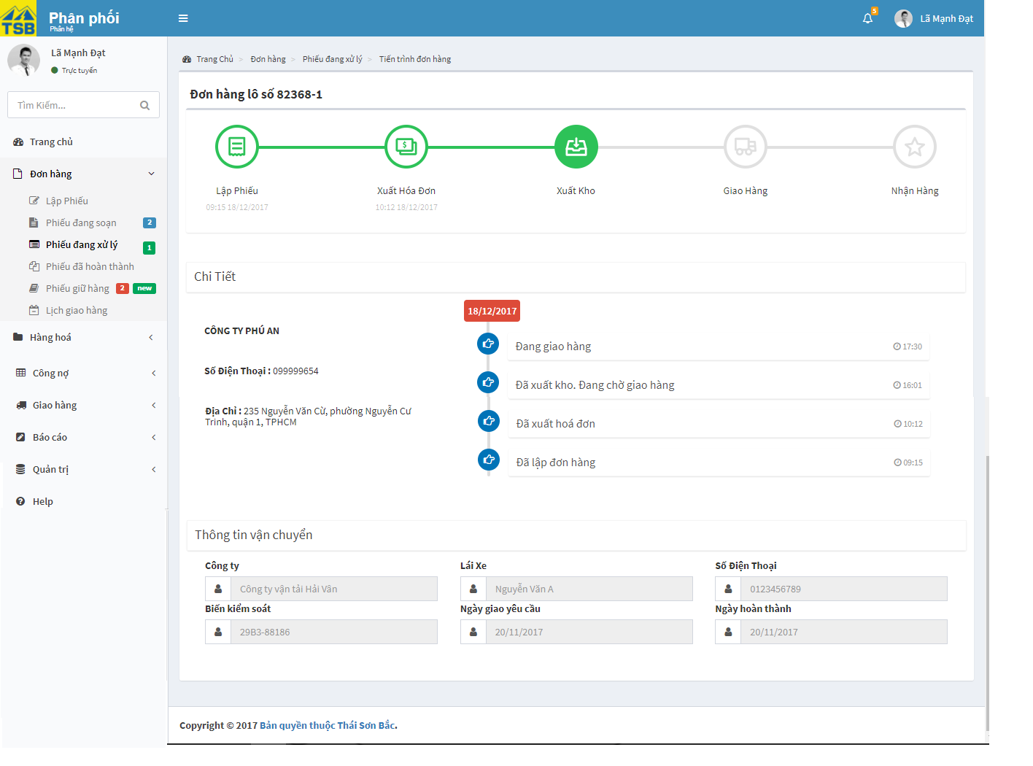

*Figure 3.26:* *View detail progress screen*

|  |  |  |  |  |
| --- | --- | --- | --- | --- |
| **USE CASE-014 SPECIFICATION : View detail progress** | | | | |
| **Use-case No.** | <UC014> | **Use-case Version** | | <1.0> |
| **Use-case Name** | View detail progress | | | |
| **Author** | AnhNTL | | | |
| **Date** | Jan 2 nd, 2018 | **Priority** | Low | |
| **Actor:**  *Sellers, managers*  **Summary:**  *User view detail progress of order*  **Goal:**  *Display detail progress of order page*  **Triggers**  **Preconditions:**  *On detail order pages, click on view progress link*  **Post Conditions:**  *Display “Tiến trình đơn hàng” page*  **Main Success Scenario:**   |  |  |  | | --- | --- | --- | | *Step* | *User action* | *System response* | | *1* | *On detail order pages, click on view progress link* | *Display “Tiến trình đơn hàng” page* |   **Alternative Scenario:**  **Exceptions:**  **Business Rules:** | | | | |

*Table 3.29 Usecase view detail progress*

Screen description:

|  |  |  |  |  |  |  |
| --- | --- | --- | --- | --- | --- | --- |
| Field name | Description | Mandatory | Read only | Control type | Data type | Length |
| Stepper diagram | Step of order | - | - | Diagram | - | - |
| Activity diagram | Activity diagram of order | - | - | Timeline diagram | - | - |
| Information of customer div | Information of customer | - | - | Text | Nvarchar | MAX |
| Customer name field | Customer name | Y | Y | Text field | Nvarchar | 50 |
| Shipper field | Shipper name | N | Y | Text field | Nvarchar | 50 |
| Driver field | Driver name | N | Y | Text field | Nvarchar | 50 |
| Deliver method field | Deliver method | N | Y | Text field | Nvarchar | 50 |
| Created date field | Created date | Y | Y | Text field | Date | 20 |
| Finish date field | Finish date | N | Y | Text field | Date | 20 |

*Table 3.31 Screen description view detail progress*

###### View timeline of product

Use case specification:

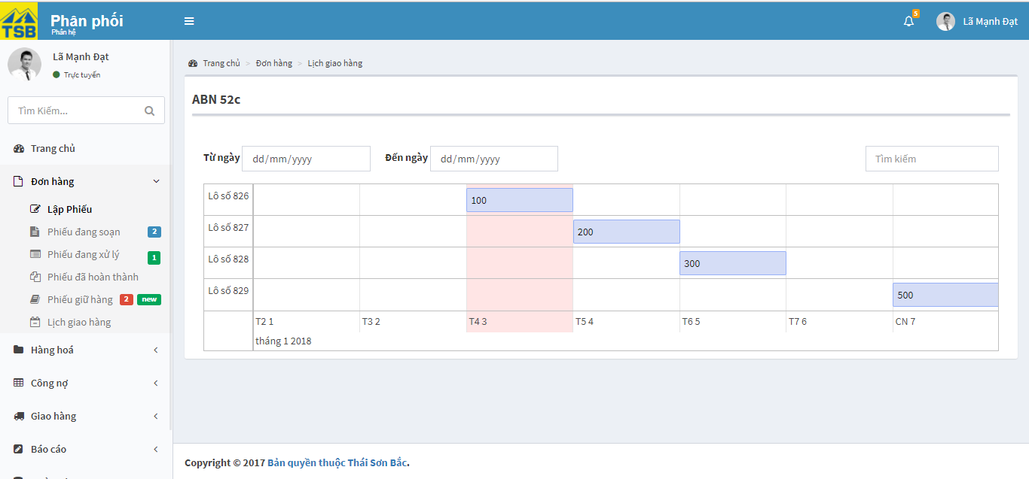

*Figure 3.27:* *Detail timeline product screen*

|  |  |  |  |  |
| --- | --- | --- | --- | --- |
| **USE CASE-015 SPECIFICATION : View timeline of product** | | | | |
| **Use-case No.** | <UC015> | **Use-case Version** | | <1.0> |
| **Use-case Name** | View timeline of product | | | |
| **Author** | AnhNTL | | | |
| **Date** | Jan 2 nd, 2018 | **Priority** | Low | |
| **Actor:**  *Sellers, managers*  **Summary:**  *User view timeline of product*  **Goal:**  *Display timeline of product page*  **Triggers**  **Preconditions:**  *User click on view timeline product link on pop-up notify not enough quantity in stock*  **Post Conditions:**  *Display timeline of product page*  **Main Success Scenario:**   |  |  |  | | --- | --- | --- | | *Step* | *User action* | *System response* | | *1* | *On pop-up notify not enough quantity in stock, click on view timeline product link* | *Display timeline of product page* |   **Alternative Scenario:**  **Exceptions:**  **Business Rules:**  *If date is today, date have background red* | | | | |

*Table 3.32 Usecase view timeline of product*

###### View timeline of orders

Use case specification:

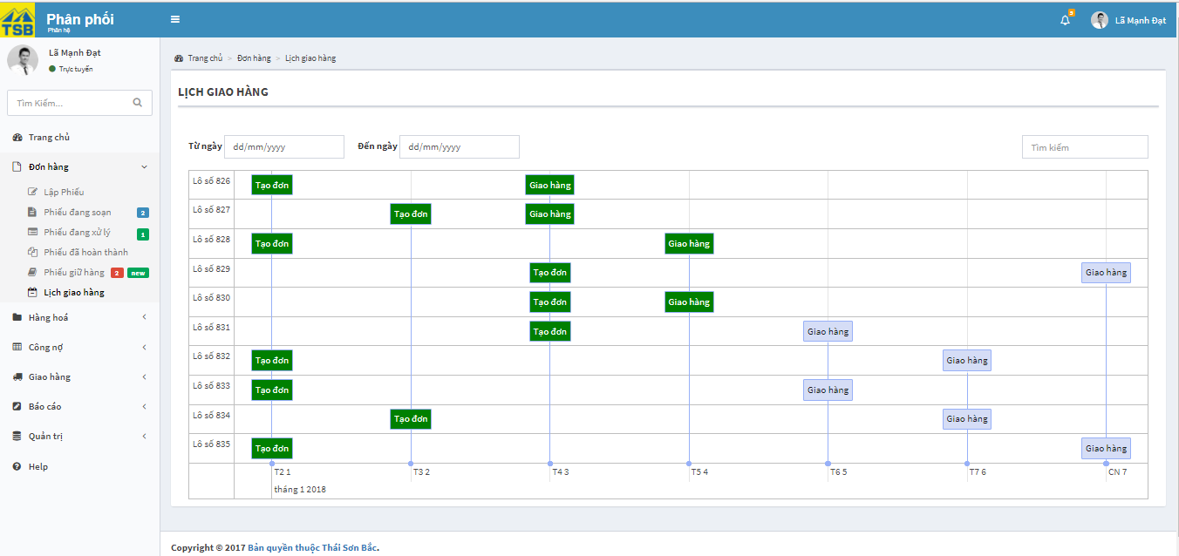

*Figure 3.28:* *Detail timeline order screen*

|  |  |  |  |  |
| --- | --- | --- | --- | --- |
| **USE CASE-016 SPECIFICATION : View timeline of orders** | | | | |
| **Use-case No.** | <UC016> | **Use-case Version** | | <1.0> |
| **Use-case Name** | View timeline of orders | | | |
| **Author** | AnhNTL | | | |
| **Date** | Jan 2 nd, 2018 | **Priority** | Low | |
| **Actor:**  *Sellers, managers*  **Summary:**  *User view timeline of orders*  **Goal:**  *Display timeline of orders page*  **Triggers**  **Preconditions:**  *User click on “Lịch giao hàng” on “Đơn hàng” menu on menu*  **Post Conditions:**  *Display timeline of order page*  **Main Success Scenario:**   |  |  |  | | --- | --- | --- | | *Step* | *User action* | *System response* | | *1* | *User click on “Lịch giao hàng” on tab “Đơn hàng” on left menu* | *Display timeline of orders page* |   **Alternative Scenario:**  **Exceptions:**  **Business Rules:**  *Activities passed have background green* | | | | |

*Table 3.33 Usecase view timeline of order*

###### View order list

Use case specification:

-Order list page of sellers and managers

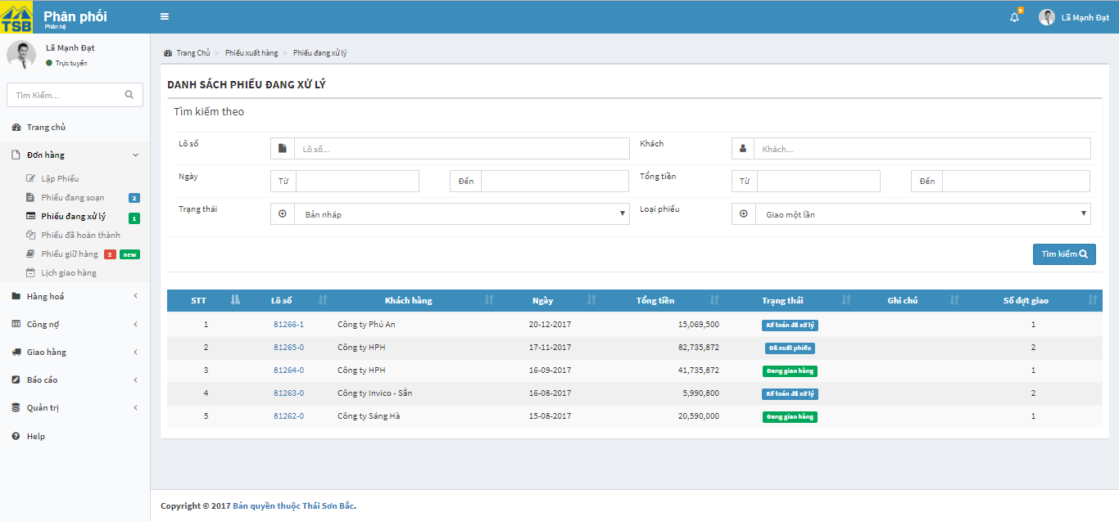

*Figure 3.29:* *Order list page of Sellers and managers screen*

-Order list page of warehouse

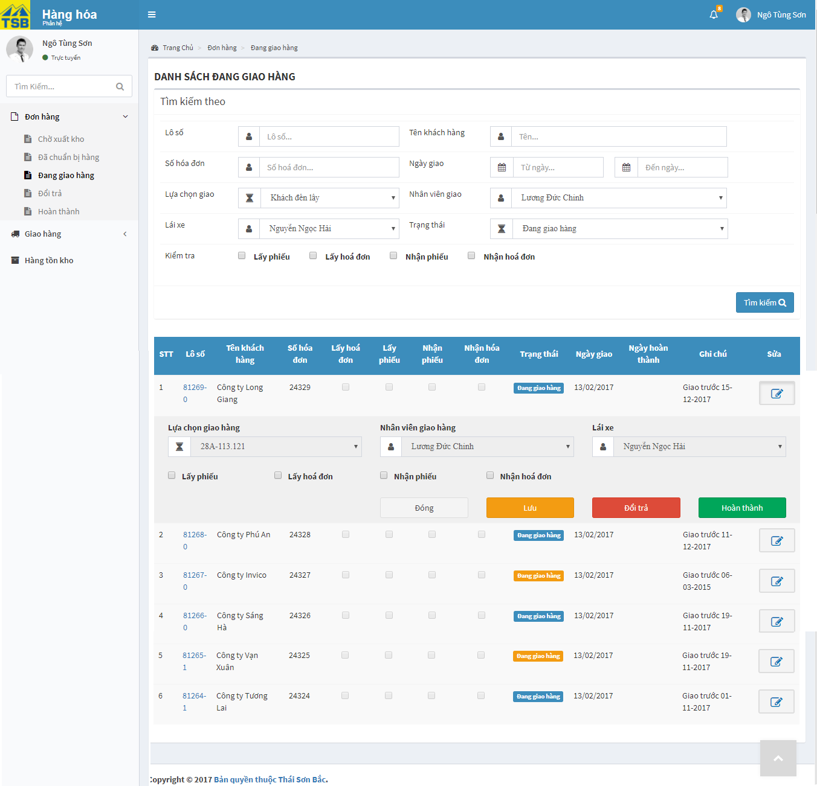

*Figure 3.30:* *Order list page of warehouse screen*

- Order list page of accountant

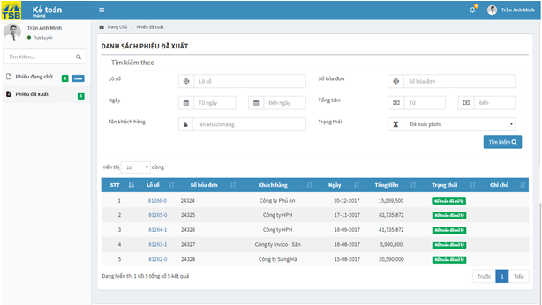

*Figure 3.31:* *Order list page of accountant screen*

|  |  |  |  |  |
| --- | --- | --- | --- | --- |
| **USE CASE-017 SPECIFICATION : View order list** | | | | |
| **Use-case No.** | <UC017> | **Use-case Version** | | <1.0> |
| **Use-case Name** | View order list | | | |
| **Author** | AnhNTL | | | |
| **Date** | Jan 2 nd, 2018 | **Priority** | High | |
| **Actor:**  *Sellers, managers, warehouse, accountant*  **Summary:**  *User view order list*  **Goal:**  *Display list of orders*  **Triggers**  **Preconditions:**  *Click on order list link on menu*  **Post Conditions:**  *Display order list page respectively*  **Main Success Scenario:**   |  |  |  | | --- | --- | --- | | *Step* | *User action* | *System response* | | *1* | *Click on order list link on menu* | *Display order list page respectively* |   **Alternative Scenario:**  **Exceptions:**  **Business Rules:**   * *Sellers and management view : creating order list, in progressing order list, returned order list, finished order list, canceled order list* * *Accountant view : waiting order list, handled order list* * *Warehouse view : waiting stock out order list, waiting delivery order list, list of order being delivered, returned order list, completed order list* * *In order list pages of warehouse have panel to warehouse employees and handle order in order list page* | | | | |

*Table 3.34 Usecase view order list*

Screen description:

-Order list of Sellers and management

|  |  |  |  |  |  |  |
| --- | --- | --- | --- | --- | --- | --- |
| Field name | Description | Mandatory | Read only | Control type | Data type | Length |
| Order id search field | Field to input search value for order id | N | N | Text field | Nvarchar | 50 |
| Customer search field | Field to input search value for customer | N | N | Text field | Nvarchar | 50 |
| Create date – from filed | Field to input search value for create date | N | N | Datepicker | Date | 20 |
| Create date – to field | Field to input search value for create date | N | N | Datepicker | Date | 20 |
| Total price – from field | Field to input search value for total price | N | N | Input type = ”number” | Float | 20 |
| Total priced – to field | Field to input search value for total price | N | N | Input type = ”number” | Float | 20 |
| Status field | Fieldto input search value for order of status | N | N | Dropbox | Nvarchar | 20 |
| Type of order field | Field to input search value for type of order | N | N | Dropbox | Nvarchar | 20 |
| Search button | Button of form | - | - | Button | - | - |
| Order list table | Orders list | - | - | Table | - | - |

*Table 3.35 Screen description order list of Sellers and management*

-Order list page of warehouse

|  |  |  |  |  |  |  |
| --- | --- | --- | --- | --- | --- | --- |
| Field name | Description | Mandatory | Read only | Control type | Data type | Length |
| Order id search field | Field to input search value for order id | N | N | Text field | Nvarchar | 50 |
| Customer search field | Field to input search value for customer | N | N | Text field | Nvarchar | 50 |
| Create date – from filed | Field to input search value for create date | N | N | Datepicker | Date | 20 |
| Create date – to field | Field to input search value for create date | N | N | Datepicker | Date | 20 |
| Invoice number seach field | Invoice number for search | N | N | Text field | Nvarchar | 20 |
| Status search ield | Status for search | N | N | Dropbox | Nvarchar | 20 |
| Take order search check box | Took order for search | N | N | Checkbox | Boolean | - |
| Receive invoice searchcheckbox | Receive invoice  for search | N | N | Checkbox | Boolean | - |
| Receive order search check box | Receive order for search | N | N | Checkbox | Boolean | - |
| Take invoice search checkbox | Took invoice  for search | N | N | Checkbox | Boolean | - |
| Deliver method search field | Deliver method for search | N | N | Dropbox | Nvarchar | 50 |
| Driver search field | Driver for search | N | N | Dropbox | Nvarchar | 50 |
| Shipper search field | Shipper for search | N | N | Dropbox | Nvarchar | 50 |
| Search button | Button of form | - | - | Button | - | - |
| Order list table | Orders list | - | - | Table | - | - |
| “Sửa” button | Button of form for each order | - | - | Button | - | - |
| Deliver method field | Deliver method of order | Y | Y | Dropbox | Nvarchar | 50 |
| Driver field | Driver of order | Y | Y | Dropbox | Nvarchar | 50 |
| Shipper field | Shipper of order | Y | Y | Dropbox | Nvarchar | 50 |
| Take order checkbox | Took order of order or not | N | N | Checkbox | Boolean | - |
| Take invoice checkbox | Took invoice or not | N | N | Checkbox | Boolean | - |
| Receive order checkbox | Received order of order or not | N | N | Checkbox | Boolean | - |
| Receive invoice checkbox | Received invoice or not | N | N | Checkbox | Boolean | - |
| “Đóng” button | Button of form | - | - | Button | - | - |
| “Đổi trả” button | Button of form | - | - | Button | - | - |
| “Lưu” button | Button of form | - | - | Button | - | - |
| “Giao hàng” button | Button of form | - | - | Button | - | - |

*Table 3.36 Screen description order list of warehouse*

-Order list page of accountant

|  |  |  |  |  |  |  |
| --- | --- | --- | --- | --- | --- | --- |
| Field name | Description | Mandatory | Read only | Control type | Data type | Length |
| Order id search field | Field to input search value for order id | N | N | Text field | Nvarchar | 50 |
| Customer search field | Field to input search value for customer | N | N | Text field | Nvarchar | 50 |
| Create date – from filed | Field to input search value for create date | N | N | Datepicker | Date | 20 |
| Create date – to field | Field to input search value for create date | N | N | Datepicker | Date | 20 |
| Total price – from field | Field to input search value for total price | N | N | Input type = ”number” | Float | 20 |
| Total priced – to field | Field to input search value for total price | N | N | Input type = ”number” | Float | 20 |
| Status | Field to input search value for status | N | N | Dropbox | Nvarchar | 20 |
| Search button | Button of form | - | - | Button | - | - |
| Order list table | Orders list | - | - | Table | - | - |

*Table 3.37 Screen description order list of accountant*

###### View workflow

Use case specification:

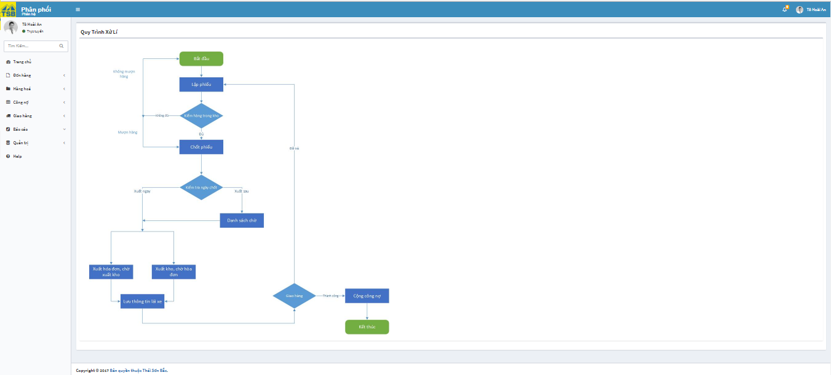

*Figure 3.32:* *View workflow screen*

|  |  |  |  |  |
| --- | --- | --- | --- | --- |
| **USE CASE-018 SPECIFICATION : View workflow** | | | | |
| **Use-case No.** | <UC018> | **Use-case Version** | | <1.0> |
| **Use-case Name** | View workflow | | | |
| **Author** | AnhNTL | | | |
| **Date** | Jan 2 nd, 2018 | **Priority** | Low | |
| **Actor:**  *Sellers, managers*  **Summary:**  *User view workflow*  **Goal:**  *Display workflow page*  **Triggers**  **Preconditions:**  *User click on “Help” in tab ”Đơn hàng” on left menu*  **Post Conditions:**  *Display workflow page*  **Main Success Scenario:**   |  |  |  | | --- | --- | --- | | *Step* | *User action* | *System response* | | *1* | *User click on “Help” on ”đơn hàng” menu on menu* | *Display workflow page* |   **Alternative Scenario:**  **Exceptions:**  **Business Rules:** | | | | |

*Table 3.38 Usecase view workflow*

###### Search order

Use case specification:

|  |  |  |  |  |
| --- | --- | --- | --- | --- |
| **USE CASE-019 SPECIFICATION : Search order** | | | | |
| **Use-case No.** | <UC019> | **Use-case Version** | | <1.0> |
| **Use-case Name** | Search order | | | |
| **Author** | AnhNTL | | | |
| **Date** | Jan 2 nd, 2018 | **Priority** | High | |
| **Actor:**  *Sellers, managers, accountant, warehouse*  **Summary:**  *User search order*  **Goal:**  *Display list of orders match with search request in order list page* *respectively*  **Triggers**  **Preconditions:**  *On order list pages,user input search value*  **Post Conditions:**  *Display list of orders match with search request* *in order list page respectively*  **Main Success Scenario:**   |  |  |  | | --- | --- | --- | | *Step* | *User action* | *System response* | | *1* | *On order list page,user input search value* | *Validate* | | *2* | *Click “Search” button* | *Display list of orders match with search request in order list page respectively* |   **Alternative Scenario:**  **Exceptions:**  **Business Rules:** | | | | |

*Table 3.39 Usecase search order*

#### Debt management

##### Usecase diagram



*Figure 3.33:* *View debt usercase diagram*

##### Usecase

###### View list of customer debt

Use case specification:

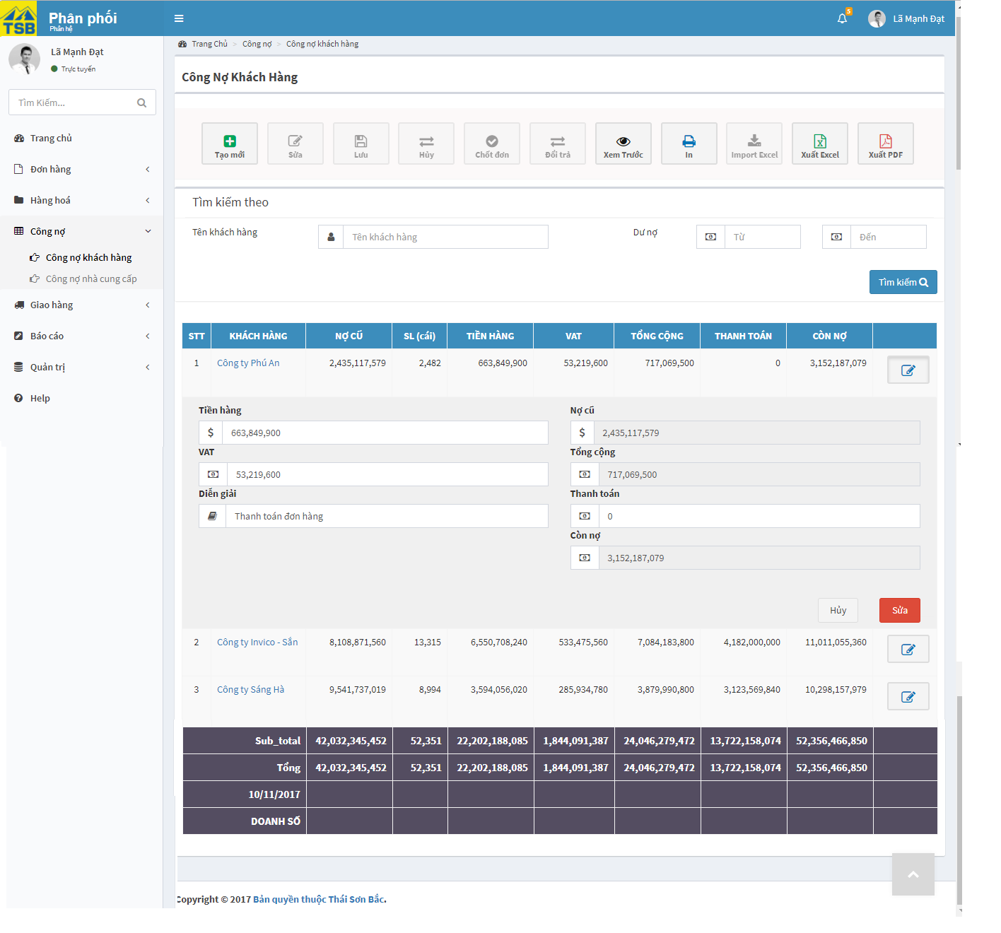

*Figure 3.34:* *View list of customer debt screen*

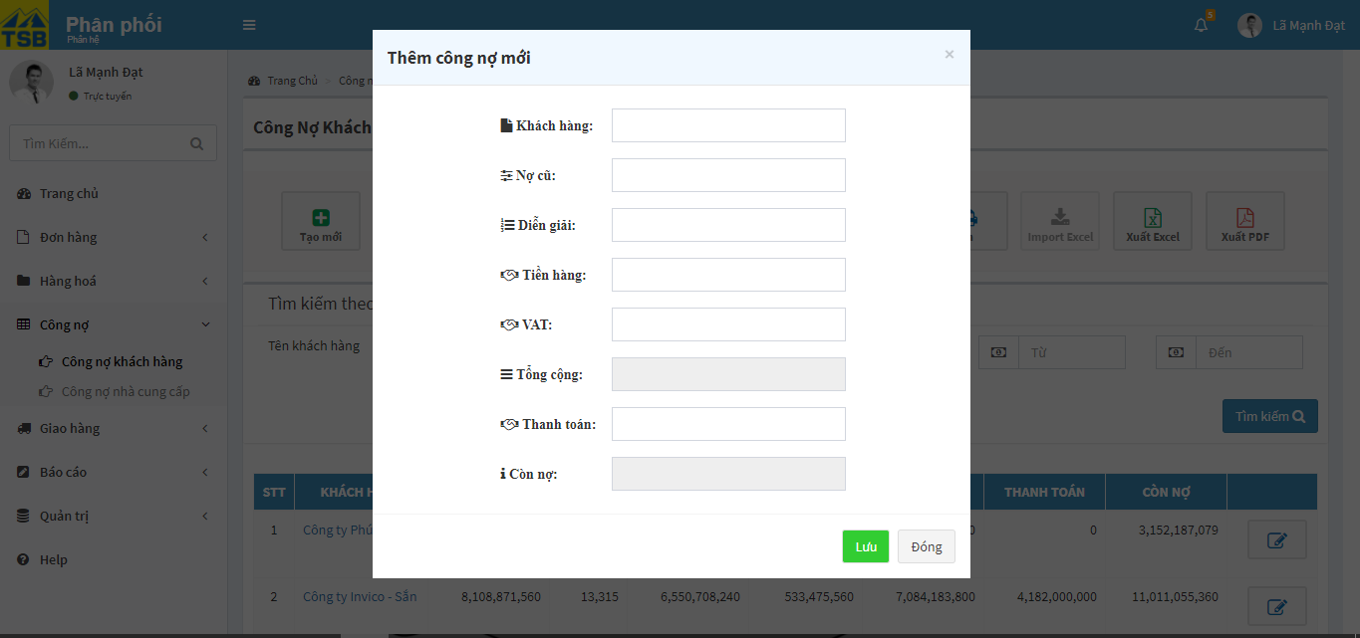

*Figure 3.35:* *View list of customer debt (add new) screen*

|  |  |  |  |  |
| --- | --- | --- | --- | --- |
| **USE CASE-020 SPECIFICATION :** **View list of customer debt** | | | | |
| **Use-case No.** | <UC020> | **Use-case Version** | | <1.0> |
| **Use-case Name** | View list of customer debt | | | |
| **Author** | AnhNTL | | | |
| **Date** | Jan 2 nd, 2018 | **Priority** | High | |
| **Actor:**  *Sellers, managers*  **Summary:**  *User view list of customer debt*  **Goal:**  *Display list of customer debt page*  **Triggers**  **Preconditions:**  *User click on “Công nợ khách hàng” on left menu*  **Post Conditions:**  *Display “Danh sách công nợ khách hàng” page*  **Main Success Scenario:**   |  |  |  | | --- | --- | --- | | *Step* | *User action* | *System response* | | *1* | *On menu , click on “Công nợ khách hàng”* | *Display “Danh sách công nợ khách hàng” page* |   **Alternative Scenario:**  **Exceptions:**  **Business Rules:**  *-Click “Sửa” button of customer, a panel display to add new transaction of customer*  *- Click “Huỷ” button on panel, panel will be closed*  *- Click “Sửa” button on panel, a new transaction will be added* | | | | |

*Table 3.40 View list of customer debt*

Screen description:

- “Danh sách công nợ khách hàng” page

|  |  |  |  |  |  |  |
| --- | --- | --- | --- | --- | --- | --- |
| Field name | Description | Mandatory | Read only | Control type | Data type | Length |
| “Tạo” button | Button of page | - | - | Button | - | - |
| “ Xem trước” button | Button of page | - | - | Button | - | - |
| “In” button | Button of page | - | - | Button | - | - |
| “Xuất excel” button | Button of page | - | - | Button | - | - |
| “Xuất pdf” button | Button of page | - | - | Button | - | - |
| Customer name field | Customer name for search | N | N | Text field | Nvarchar | 50 |
| Debt from field | Debt for search | N | N | Input type=”number” | MONEY | - |
| Debt to field | Debt for search | N | N | Input type=”number” | MONEY | - |
| “Search” button | Button of form | - | - | Button | - | - |
| Customer debt list table | Customer debt list | - | - | Table | - | - |
| “Sửa” button of customer | Button of table for each customer | - | - | Button | - | - |

*Table 3.41 Screen description list of customer debt*

- Panel to add new transaction

|  |  |  |  |  |  |  |
| --- | --- | --- | --- | --- | --- | --- |
| Field name | Description | Mandatory | Read only | Control type | Data type | Length |
| “Nợ cũ” field | Current debt | Y | Y | Input type=”number” | MONEY | - |
| “Tiền hàng“ field | Price of new transaction | N | N | Input type=”number” | MONEY | - |
| “VAT” field | VAT | N | N | Input type=”number” | MONEY | - |
| “Tổng cộng” field | Total price of new transaction | Y | Y | Input type=”number” | MONEY | - |
| “Thanh toán” field | Pay for transaction | N | N | Input type=”number” | MONEY | - |
| “Còn nợ” field | New debt after new transaction | Y | Y | Input type=”number” | MONEY |  |
| “Diễn giải field | Desciption of transaction | N | N | Text field | Nvarchar | MAX |
| “Sửa” button of panel | Button of panel | - | - | Button | - |  |
| “Huỷ” button of panel | Button of panel | - | - | Button | - | - |

*Table 3.42 Screen description pop up add new transaction*

-Pop-up to create new customer debt

|  |  |  |  |  |  |  |
| --- | --- | --- | --- | --- | --- | --- |
| Field name | Description | Mandatory | Read only | Control type | Data type | Length |
| Customer name field | Customer name | Y | N | Text field | Nvarchar | 50 |
| “ Nợ cũ” field | Current debt of customer | Y | Y | Input type=”number” | MONEY | - |
| “Tiền hàng “ field | Price of transaction | N | N | Input type=”number” | MONEY | - |
| “VAT” field | VAT of transaction | N | N | Input type=”number” | MONEY | - |
| “Tổng cộng” field | Total price of transaction | Y | Y | Input type=”number” | MONEY | - |
| “Thanh toán” field | Pay of transaction | N | N | Input type=”number” | MONEY | - |
| “Còn nợ” field | New debt after transaction | Y | Y | Input type=”number” | MONEY | - |
| “Diễn giải field | Description of transaction | N | N | Text field | Nvarchar | MAX |
| “Lưu” button of panel | Button of form | - | - | Button | - | - |
| “Đóng” button of panel | Button of form | - | - | Button | - | - |

*Table 3.43 Screen description create new customer debt*

###### Customer debt handling

Use case specification:

- On “Chi tiết nợ khách hàng” page

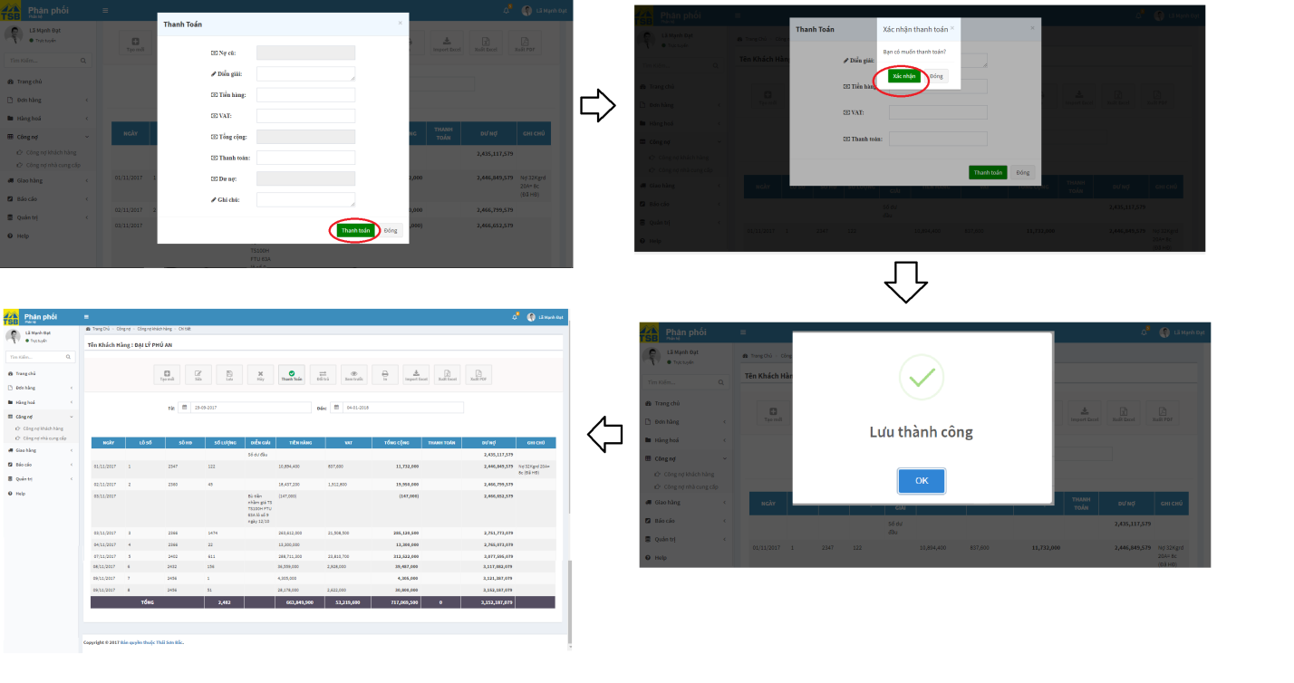

*Figure 3.36:* *View customer debt handlingscreen*

- On “Danh sách công nơ khách hàng” page

*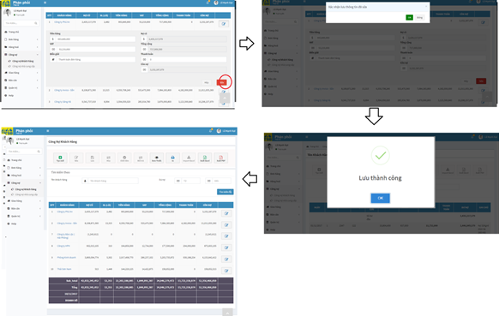Figure 3.37:* *View customer debt handlingscreen*

|  |  |  |  |  |
| --- | --- | --- | --- | --- |
| **USE CASE-021 SPECIFICATION : Customer debt handling** | | | | |
| **Use-case No.** | <UC021> | **Use-case Version** | | <1.0> |
| **Use-case Name** | Customer debt handling | | | |
| **Author** | AnhNTL | | | |
| **Date** | Jan 2 nd, 2018 | **Priority** | High | |
| **Actor:**  *Sellers, managers*  **Summary:**  *User handle customer debt*  **Goal:**  *A new transaction of customer be added*  **Triggers**  **Preconditions:**  *User click on “Thanh toán” button in “Chi tiết công nợ khách hàng” page*  **Post Conditions:**  *Display add success message*  *Refresh “Chi tiết công nợ khách hàng” page*  **Main Success Scenario:**   |  |  |  | | --- | --- | --- | | *Step* | *User action* | *System response* | | *1* | *On “Chi tiết công nợ khách hàng” page, click on “Thanh toán” button* | *Display pop-up to input new transaction* | | *2* | *Input new transaction* | *Validate* | | *3* | *Click “Thanh toán” button* | *Display confirm* | | *4* | *Click “Xác nhận” button* | *Add new transaction*  *Display pop-up success message*  *Refresh “Chi tiết danh sách công nợ khách hàng” page* |   **Alternative Scenario:**   |  |  |  | | --- | --- | --- | | *Step* | *User action* | *System response* | | *1* | *On “Danh sách customer debt” page, click on “ Sửa ” button* | *Display panel pop-up to input new transaction* | | *2* | *Input new transaction* | *Validate* | | *3* | *Click “Sửa” button on panel* | *Display confirm* | | *4* | *Click OK button* | *Add new transaction*  *Display pop-up success message*  *Refresh “Danh sách công nợ khách hàng” page* |   **Exceptions:**  **Business Rules:** | | | | |

*Table 3.44 Usecase customer debt handling*

Screen description:

- “Chi tiết công nợ khách hàng” page

|  |  |  |  |  |  |  |
| --- | --- | --- | --- | --- | --- | --- |
| Field name | Description | Mandatory | Read only | Control type | Data type | Length |
| “ Thanh toán” button | Button of page | - | - | Button | - | - |
| “In” button | Button of page | - | - | Button | - | - |
| “Xuất excel” button | Button of page | - | - | Button | - | - |
| “Xuất pdf” button | Button of page | - | - | Button | - | - |
| View date from - field | Limit date for view | Y | N | Datepicker | DATE | 20 |
| View date to - field | Limit date for view | Y | N | Datepicker | DATE | 20 |
| Transactions list table | Transaction list of customer | - | - | Table | - | - |

*Table 3.45 Screen description customer debt detail*

- Pop-up to add new transaction

|  |  |  |  |  |  |  |
| --- | --- | --- | --- | --- | --- | --- |
| Field name | Description | Mandatory | Read only | Control type | Data type | Length |
| “ Nợ cũ” field | Current debt | Y | Y | Input type=”number” | MONEY | - |
| “Diễn giải field | Desciption of transaction | N | N | Text area | Nvarchar | MAX |
| “Tiền hàng“ field | Price of new transaction | N | N | Input type=”number” | MONEY | - |
| “VAT” field | VAT | N | N | Input type=”number” | MONEY | - |
| “Tổng cộng” field | Total price of new transaction | Y | Y | Input type=”number” | MONEY | - |
| “Thanh toán” field | Pay for transaction | N | N | Input type=”number” | MONEY | - |
| “Còn nợ” field | New debt after new transaction | Y | Y | Input type=”number” | MONEY | - |
| “Ghi chú field | Note of transaction | N | N | Text area | Nvarchar | MAX |
| “Thanh toán” button of panel | Button of panel | - | - | Button | - | - |
| “Đóng” button of panel | Button of panel | - | - | Button | - | - |

*Table 3.46 Screen description pop up add new transaction*

###### View list of supplier debt

Use case specification:

- “Danh sách công nợ nhà cung cấp” page

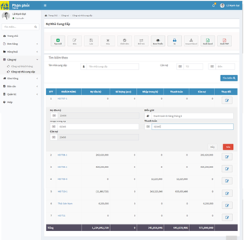

*Figure 3.38:* *View list of supplier debt handling screen*

- Pop-up “Tạo mới” button

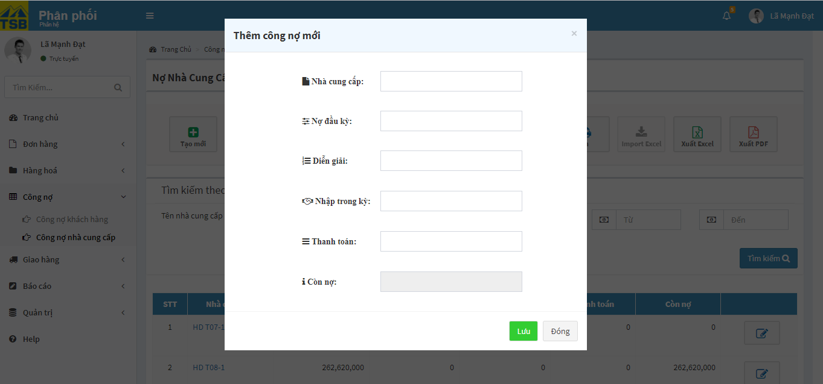

*Figure 3.39:* *View list of supplier debt handling screen*

|  |  |  |  |  |
| --- | --- | --- | --- | --- |
| **USE CASE-022 SPECIFICATION : View list of suppliers debt** | | | | |
| **Use-case No.** | <UC022> | **Use-case Version** | | <1.0> |
| **Use-case Name** | View list of supplier debt | | | |
| **Author** | AnhNTL | | | |
| **Date** | Jan 2 nd, 2018 | **Priority** | High | |
| **Actor:**  *Sellers, managers*  **Summary:**  *User view list of suppliers debt*  **Goal:**  *Display “Danh sachs công nợ nhà cung cấp” page*  **Triggers**  **Preconditions:**  *User click on “Công nợ nhà cung cấp” on menu*  **Post Conditions:**  *Display “Danh sách công nợ nhà cung cấp” page*  **Main Success Scenario:**   |  |  |  | | --- | --- | --- | | *Step* | *User action* | *Sstem response* | | *1* | *User click on “Công nợ nhà cung cấp” on menu* | *Display “Danh sách công nợ nhà cung cấp” page* |   **Alternative Scenario:**  **Exceptions:**  **Business Rules:**  *-When user click on “Tạo mới” button, a pop-up to add new supplier transaction will be displayed*  *- When user click on “Sửa” button, a panel to add new transaction for that supplier will be display* | | | | |

*Table 3.47 Usecase view list of supplier debt*

Screen description:

- “Danh sách công nợ nhà cung cấp” page

|  |  |  |  |  |  |  |
| --- | --- | --- | --- | --- | --- | --- |
| Field name | Description | Mandatory | Read only | Control type | Data type | Length |
| “Tạo” button | Button of page | - | - | Button | - | - |
| “Xem trước” button | Button of page | - | - | Button | - | - |
| “In” button | Button of page | - | - | Button | - | - |
| “Xuất excel” button | Button of page | - | - | Button | - | - |
| “Xuất pdf” button | Button of page | - | - | Button | - | - |
| Supplier name field | Customer name for search | N | N | Text field | Nvarchar | 50 |
| Debt from field | Debt for search | N | N | Input type=”number” | MONEY | - |
| Debt to field | Debt for search | N | N | Input type=”number” | MONEY | - |
| “Search” button | Button of form | - | - | Button | - | - |
| Suppliers debt list table | Suppliers debt list | - | - | Table | - | - |
| “Sửa” button of suppliers | Button of table for each supplier | - | - | Button | - | - |

*Table 3.48 Screen description view list of supplier debt*

-Panel add new transaction for supplier

|  |  |  |  |  |  |  |
| --- | --- | --- | --- | --- | --- | --- |
| Field name | Description | Mandatory | Read only | Control type | Data type | Length |
| Current debt field | Current debt of supplier | Y | Y | Input type=”number” | MONEY | - |
| Description field | Description of transaction | N | N | Text field | Nvarchar | MAX |
| Total price field | Total price  of transaction | N | N | Input type=”number” | MONEY | - |
| Pay field | Pay of transaction | N | N | Input type=”number” | MONEY | - |
| New debt field | New debt after transaction | Y | Y | Input type=”number” | MONEY | - |
| “Sửa” button | Button of form | - | - | Button | - | - |
| “Huỷ” button | Button of form | - | - | Button | - | - |

*Table 3.49 Screen description add new transaction for supplier*

-Pop-up add new supplier transaction

|  |  |  |  |  |  |  |
| --- | --- | --- | --- | --- | --- | --- |
| Field name | Description | Mandatory | Read only | Control type | Data type | Length |
| Supplier name field | Supplier name | Y | N | Text field | Nvarchar | 50 |
| Current debt field | Current debt of supplier | Y | N | Input type=”number” | MONEY | - |
| Description field | Description of transaction | N | N | Text field | Nvarchar | MAX |
| Total price field | Total price  of transaction | N | N | Input type=”number” | MONEY | - |
| Pay field | Pay of transaction | N | N | Input type=”number” | MONEY | - |
| New debt field | New debt after transaction | Y | Y | Input type=”number” | MONEY | - |
| “Lưu” button | Button of form | - | - | Button | - | - |
| “Đóng” button | Button of form | - | - | Button | - | - |

*Table 3.50 Screen description add new supplier transaction*

###### Supplier debt handling

Use case specification

- On “Danh sách công nợ nhà cung cấp” page

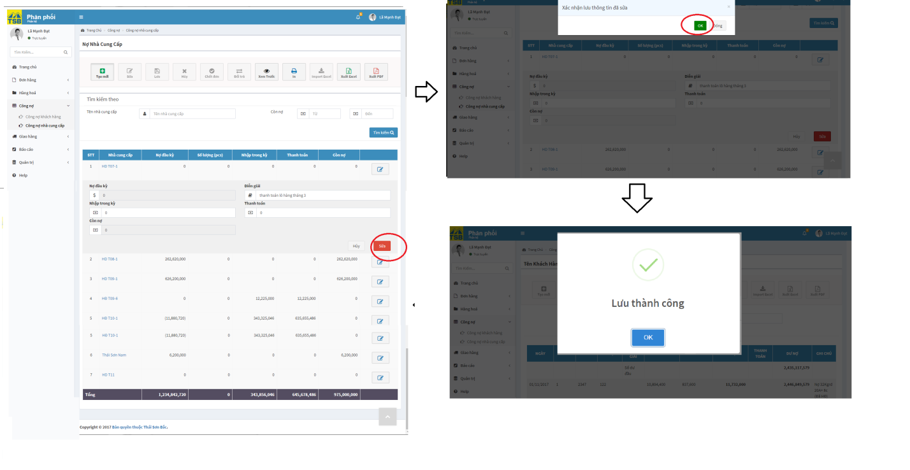

*Figure 3.40:* *View Supplier debt handling screen*

- On “Chi tiết công nợ nhà cung cấp” page

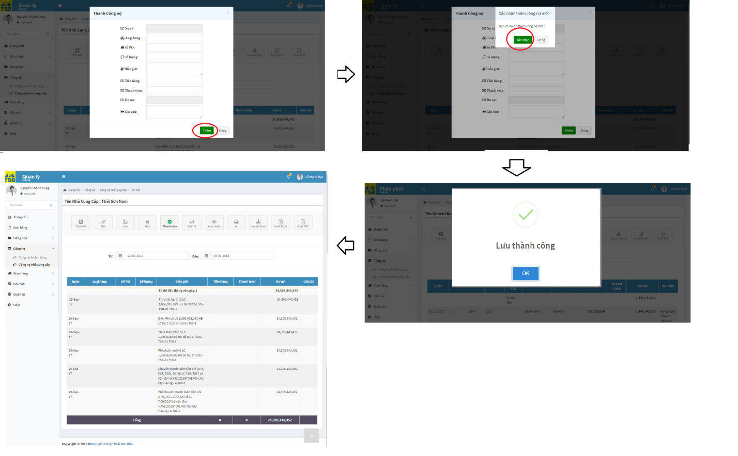

*Figure 3.41:* *View Supplier debt handling screen*

|  |  |  |  |  |
| --- | --- | --- | --- | --- |
| **USE CASE-023 SPECIFICATION : Supplier debt handling** | | | | |
| **Use-case No.** | <UC023> | **Use-case Version** | | <1.0> |
| **Use-case Name** | Supplier debt handling | | | |
| **Author** | AnhNTL | | | |
| **Date** | Jan 2 nd, 2018 | **Priority** | High | |
| **Actor:**  *Sellers, managers*  **Summary:**  *User supplier debt handling*  **Goal:**  *Add new transaction for supplier*  **Triggers**  **Preconditions:**  *On “Danh sách công nợ nhà cung cấp” page, click on supplier name*  **Post Conditions:**  *Display added success message*  *Refresh “Chi tiết công nợ nhà cung cấp” page*  **Main Success Scenario:**   |  |  |  | | --- | --- | --- | | *Step* | *User action* | *System response* | | *1* | *On “Chi tiết công nợ nhà cung cấp” page, click on “Thanh toán” button* | *Display pop-up to input new transaction* | | *2* | *Input new transaction* | *Validate* | | *3* | *Click “Thanh toán” button* | *Display confirm* | | *4* | *Click “Xác nhận” button* | *Add new transaction*  *Display pop-up success message*  *Refresh “Chi tiết công nợ nhà cung cấp” page* |   **Alternative Scenario:**   |  |  |  | | --- | --- | --- | | *Step* | *User action* | *System response* | | *1* | *On “Danh sách công nợ nhà cung cấp” page, click on “Sửa” button* | *Display panel pop-up to input new transaction* | | *2* | *Input new transaction* | *Validate* | | *3* | *Click “Sửa” button on panel* | *Display confirm* | | *4* | *Click “OK” button* | *Add new transaction*  *Display pop-up success message*  *Refresh “Danh sách công nợ nhà cung cấp” page* |   **Exceptions:**  **Business Rules:** | | | | |

*Table 3.51 Usecase supplier debt handling*

Screen description:

- “Chi tiết công nợ nhà cung cấp” page

|  |  |  |  |  |  |  |
| --- | --- | --- | --- | --- | --- | --- |
| Field name | Description | Mandatory | Read only | Control type | Data type | Length |
| “ Thanh toán” button | Button of page | - | - | Button | - | - |
| “In” button | Button of page | - | - | Button | - | - |
| “Xuất excel” button | Button of page | - | - | Button | - | - |
| “Xuất pdf” button | Button of page | - | - | Button | - | - |
| View date from - field | Limit date for view | Y | N | Datepicker | DATE | 20 |
| View date to - field | Limit date for view | Y | N | Datepicker | DATE | 20 |
| Transactions list table | Transaction list of supplier | - | - | Table | - | - |

*Table 3.52 Screen description supplier debt detail*

- Pop-up to add new transaction

|  |  |  |  |  |  |  |
| --- | --- | --- | --- | --- | --- | --- |
| Field name | Description | Mandatory | Read only | Control type | Data type | Length |
| “ Nợ cũ” field | Current debt | Y | Y | Input type=”number” | MONEY | - |
| “Loại hàng” field | Type of product | N | N | Text field | Nvarchar | 50 |
| “Số PO” field | PO number | N | N | Text field | Nvarchar | 20 |
| “Số lượng” field | Total quantity of product | N | N | Input type=”number” | INT | - |
| “Diễn giải field | Desciption of transaction | N | N | Text area | Nvarchar | MAX |
| “Tiền hàng“ field | Price of new transaction | N | N | Input type=”number” | MONEY | - |
| “Thanh toán” field | Pay for transaction | N | N | Input type=”number” | MONEY | - |
| “Còn nợ” field | New debt after new transaction | Y | Y | Input type=”number” | MONEY | - |
| “Ghi chú field | Note of transaction | N | N | Text area | Nvarchar | MAX |
| “Thêm” button of panel | Button of panel | - | - | Button | - | - |
| “Đóng” button of panel | Button of panel | - | - | Button | - | - |

*Table 3.53 Screen description pop up add new transaction*

#### Product management

##### Usecase diagram



*Figure 3.41:* *Product management usercase diagram*

##### Usecase

###### View product list

Use case specification:

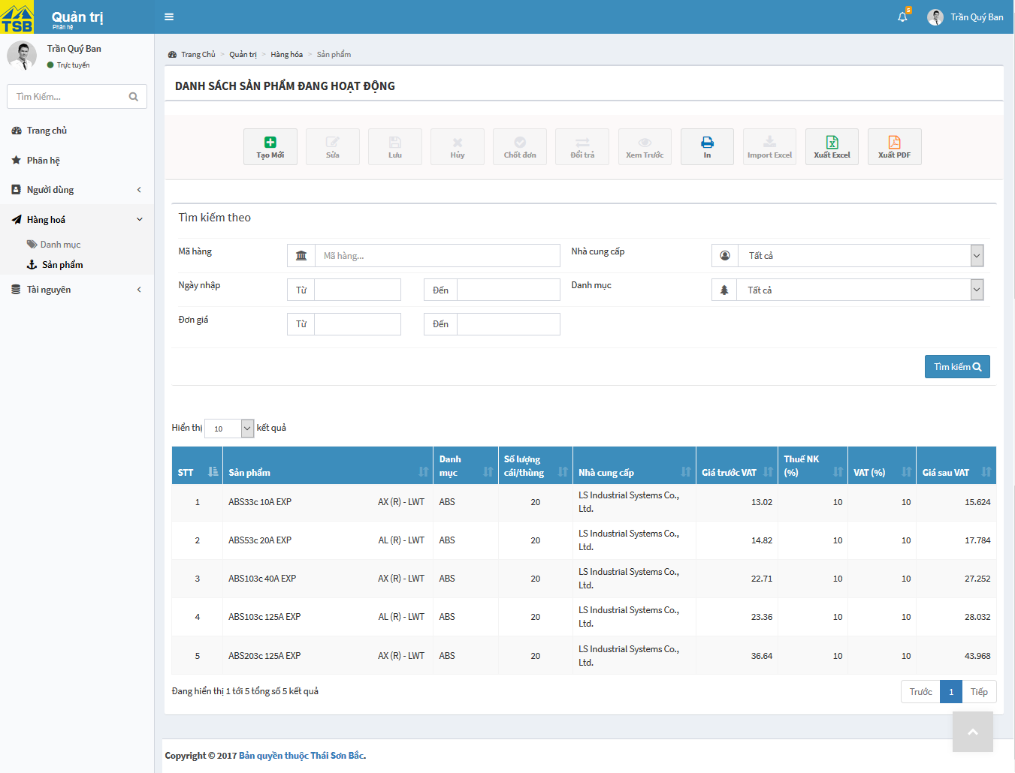

*Figure 3.42:* *View list of products screen*

|  |  |  |  |  |
| --- | --- | --- | --- | --- |
| **USE CASE-024 SPECIFICATION : View list of products** | | | | |
| **Use-case No.** | <UC024> | **Use-case Version** | | <1.0> |
| **Use-case Name** | View list of products | | | |
| **Author** | AnhNTL | | | |
| **Date** | Jan 2nd,2018 | **Priority** | Normal | |
| **Actor:**  *Sellers, managers*  **Summary:**  *User view list of products*  **Goal:**  *Display order list page*  **Triggers**  **Preconditions:**  *User click on product list link on menu*  **Post Conditions:**  *Display order list page respectively*  **Main Success Scenario:**   |  |  |  | | --- | --- | --- | | *Step* | *User action* | *System response* | | *1* | *User click on product list link on menu* | *Display order list page respectively* |   **Alternative Scenario:**  **Exceptions:**  **Business Rules:**  *- Have 2 list product : list of products are trading and list of products stopped trading*  *- Product name is hyperlink to “Chi tiết sản phẩm” page* | | | | |

*Table 3.54 Usecase view list of products*

Screen description:

|  |  |  |  |  |  |  |
| --- | --- | --- | --- | --- | --- | --- |
| Field name | Description | Mandatory | Read only | Control type | Data type | Length |
| “Tạo mới” button | Button of page | - | - | Button | - | - |
| “In” button | Button of page | - | - | Button | - | - |
| “Xuất excel” button | Button of page | - | - | Button | - | - |
| “Xuất pdf” button | Button of page | - | - | Button | - | - |
| Product name for search field | Product name for search | N | N | Text field autocomplete | Nvarchar | 50 |
| Supplier name for search field | Supplier name for search | N | N | Dropbox | Nvarchar | 50 |
| Category for search field | Category for search | N | N | Dropbox | Nvarchar | 50 |
| Date stock in – from, for search field | Limit for search by date | N | N | Datepicker | Date | 20 |
| Date stock in – to, for search field | Limit for search by date | N | N | Datepicker | Date | 20 |
| Price – from, for search field | Limit for search by price | N | N | Input type=”number” | INT | - |
| Price – to , for search field | Limit for search by price | N | N | Input type=”number” | INT | - |
| Search button | Button of form | - | - | Button | - | - |
| Entries of table | Variable of table | Y | N | Dropbox | - | - |
| Product list table | Product list table | - | - | Table | - | - |
| Page of table | Button of table | - | - | Button | - | - |

*Table 3.58 Screen description view list of products*

###### View list of products price

Use case specification:

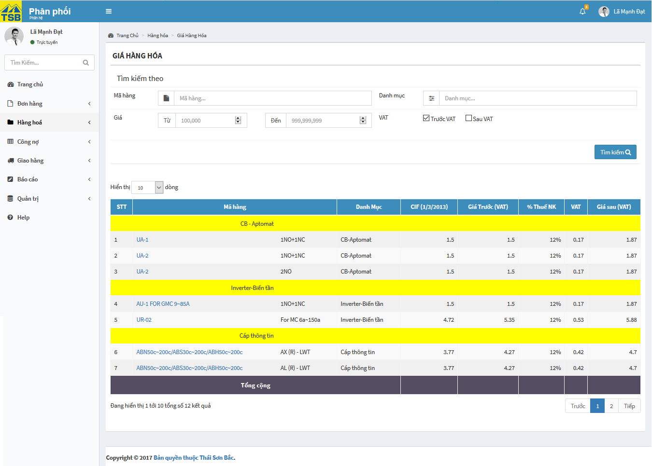

*Figure 3.43:* *View list of products price screen*

|  |  |  |  |  |
| --- | --- | --- | --- | --- |
| **USE CASE-025 SPECIFICATION : View list of products price** | | | | |
| **Use-case No.** | <UC025> | **Use-case Version** | | <1.0> |
| **Use-case Name** | View list of products price | | | |
| **Author** | AnhNTL | | | |
| **Date** | Jan 2nd,2018 | **Priority** | High | |
| **Actor:**  *Sellers, managers*  **Summary:**  *User view list of products price*  **Goal:**  *Display “Giá hàng hoá” page*  **Triggers**  **Preconditions:**  *On menu , click on “Giá hàng hoá” link*  **Post Conditions:**  *Display “Giá hàng hoá” page*  **Main Success Scenario:**   |  |  |  | | --- | --- | --- | | *Step* | *User action* | *System response* | | *1* | *On menu , click on “Giá hàng hoá” link* | *Display “Giá hàng hoá” page* |   **Alternative Scenario:**  **Exceptions:**  **Business Rules:**  *Product name is hyperlink to “Chi tiết sản phẩm” page* | | | | |

*Table 3.59 Usecase product price*

Screen description:

|  |  |  |  |  |  |  |  |
| --- | --- | --- | --- | --- | --- | --- | --- |
| Field name | | Description | Mandatory | Read only | Control type | Data type | Length |
| “In” button | Button of page | | - | - | Button | - | - |
| “Xuất excel” button | Button of page | | - | - | Button | - | - |
| “Xuất pdf” button | Button of page | | - | - | Button | - | - |
| Product name field | | Product name for searh | N | N | Text field autocomplete | Nvarchar | 50 |
| Category field | | Category for search | N | N | Text field autocomplete | Nvarchar | 50 |
| Price from - field | | Limit price for search | N | N | Input type=”number” | INT | - |
| Price to - field | | Limit price for search | N | N | Input type=”number” | INT | - |
| VAT | | Type of price for search | Y | Y | Toggle switch | Boolean | - |
| Search button | | Button of form | - | - | Button | - | - |
| Products price list table | | Products price list table | - | - | Table | - | - |

*Table 3.60 Screen description product price page*

###### View list of product in stock

Use case specification:

|  |  |  |  |  |
| --- | --- | --- | --- | --- |
| **USE CASE-026 SPECIFICATION : View list of product in stock** | | | | |
| **Use-case No.** | <UC026> | **Use-case Version** | | <1.0> |
| **Use-case Name** | View list of products in stock | | | |
| **Author** | AnhNTL | | | |
| **Date** | Jan 2nd,2018 | **Priority** | High | |
| **Actor:**  *Sellers, managers, warehouse*  **Summary:**  *User view list of product in stock*  **Goal:**  *Display list of product’s quantity in stock page*  **Triggers**  **Preconditions:**  *User click on “Hàng tồn kho” on menu*  **Post Conditions:**  *Display “Hàng tồn kho” page*  **Main Success Scenario:**   |  |  |  | | --- | --- | --- | | *Step* | *User action* | *System response* | | *1* | *User click on “Hàng tồn kho” on menu* | *Display “Hàng tồn kho” page* |   **Alternative Scenario:**  **Exceptions:**  **Business Rules:**  *Product name is hyperlink to “Chi tiết sản phẩm” page* | | | | |

*Table 3.61 Usecase view list of product in stock*

Screen description:

|  |  |  |  |  |  |  |
| --- | --- | --- | --- | --- | --- | --- |
| Field name | Description | Mandatory | Read only | Control type | Data type | Length |
| “Xem trước” button | Button of page | - | - | Button | - | - |
| “In” button | Button of page | - | - | Button | - | - |
| “Xuất excel” button | Button of page | - | - | Button | - | - |
| “Xuất pdf” button | Button of page | - | - | Button | - | - |
| Product name for search field | Product name for search | N | N | Text field autocomplete | Nvarchar | 50 |
| Category for search field | Category for search | N | N | Dropbox | Nvarchar | 50 |
| Quantity – from, for search field | Limit for search by quantity | N | N | Input type=”number” | INT | - |
| Quantity – to , for search field | Limit for search by quantity | N | N | Input type=”number” | INT | - |
| Search button | Button of form | - | - | Button | - | - |
| Products quantity list table | Product list table | - | - | Table | - | - |

###### View product detail

Use case specification:

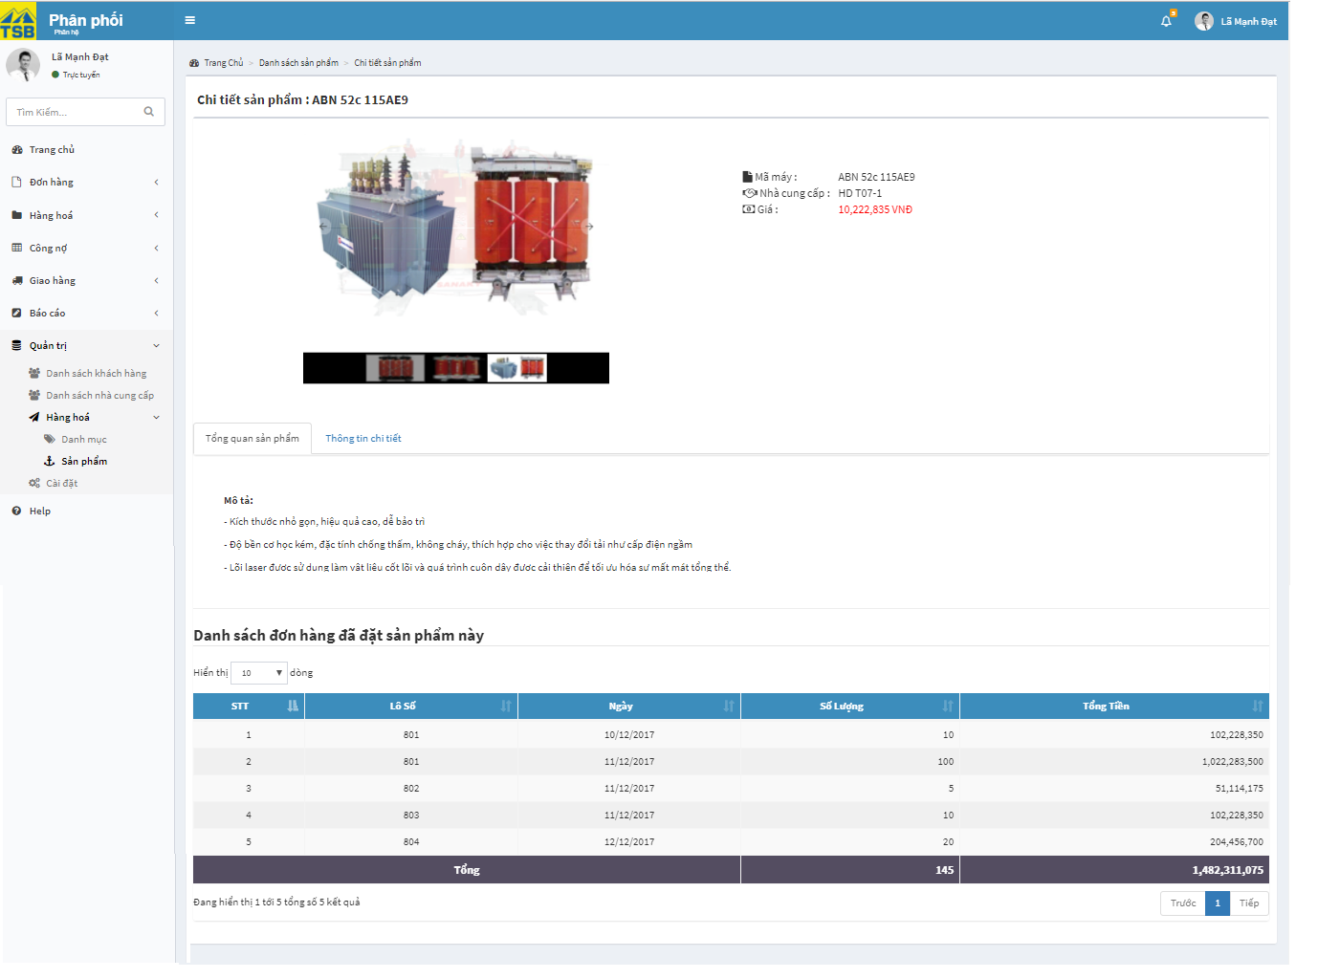

*Figure 3.44:* *View product detail screen*

|  |  |  |  |  |
| --- | --- | --- | --- | --- |
| **USE CASE-027 SPECIFICATION : View product detail** | | | | |
| **Use-case No.** | <UC027> | **Use-case Version** | | <1.0> |
| **Use-case Name** | View product detail | | | |
| **Author** | AnhNTL | | | |
| **Date** | Jan 2nd,2018 | **Priority** | High | |
| **Actor:**  *Sellers, managers, warehouse*  **Summary:**  *User view product detail*  **Goal:**  *Display detail of product page*  **Triggers**  **Preconditions:**  *On product list pages, click on product link*  **Post Conditions:**  *Display “Chi tiết sản phẩm” page*  **Main Success Scenario:**   |  |  |  | | --- | --- | --- | | *Step* | *User action* | *System response* | | *1* | *On product list pages, click on product link* | *Display “Chi tiết sản phẩm” page* |   **Alternative Scenario:**  **Exceptions:**  **Business Rules:** | | | | |

*Table 3.62 Usecase view product detail*

Screen description:

|  |  |  |  |  |  |  |
| --- | --- | --- | --- | --- | --- | --- |
| Field name | Description | Mandatory | Read only | Control type | Data type | Length |
| Product image slide | Product image slide | - | - | Slider image | - | - |
| Information of product div | Information of product | - | - | Text | - | - |
| Overview product tab | Overview product | - | - | Tab | - | - |
| Detail product tab | Detail product | - | - | Tab | - | - |
| Entries number of table | Variable of table | - | - | Dropbox | - | - |
| List of order contain product table | List of order contain product | - | - | Table | - | - |
| Page number button | Button of table | - | - | Button | - | - |

*Table 3.63 Screen description view product detail*

###### Create new product

Use case specification:

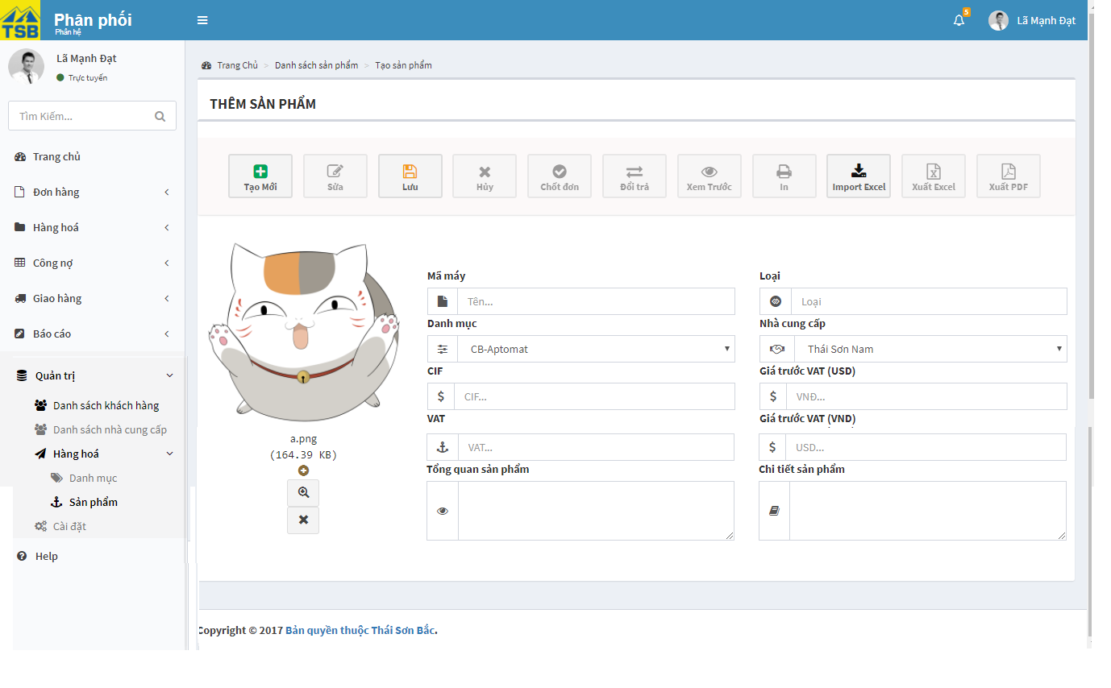

*Figure 3.45:* *Create new product screen*

|  |  |  |  |  |
| --- | --- | --- | --- | --- |
| **USE CASE-028 SPECIFICATION : Create new product** | | | | |
| **Use-case No.** | <UC028> | **Use-case Version** | | <1.0> |
| **Use-case Name** | Create new product | | | |
| **Author** | AnhNTL | | | |
| **Date** | Jan 2nd,2018 | **Priority** | High | |
| **Actor:**  *Sellers, managers*  **Summary:**  *User create new product*  **Goal:**  *New product created*  **Triggers**  **Preconditions:**  *On product list , click “Tạo mới” button*  **Post Conditions:**  *Display “Chi tiết sản phẩm” of new product*  **Main Success Scenario:**   |  |  |  | | --- | --- | --- | | *Step* | *User action* | *System response* | | *1* | *On product list , click “Tạo mới” button* | *Dislay “Tạo sản phẩm” page* | | *2* | *Input value* | *Validate value* | | *3* | *Click “Lưu” button* | *Display pop-up confirm* | | *4* | *Click “OK” button* | *Create new product*  *Display create success message*  *Redirect to “Chi tiết sản phẩm” page of product* |   **Alternative Scenario:**  **Exceptions:**  **Business Rules:** | | | | |

*Table 3.64 Usecase create new product*

Screen description:

|  |  |  |  |  |  |  |
| --- | --- | --- | --- | --- | --- | --- |
| Field name | Description | Mandatory | Read only | Control type | Data type | Length |
| “Tạo mới” button | Button of page | - | - | Button | - | - |
| “ Lưu” button | Button of page | - | - | Button | - | - |
| “Import” button | Button of page | - | - | Button | - | - |
| Product name field | Name of product | Y | N | Text field | Nvarchar | 50 |
| Product parameter field | Parameter of product | Y | N | Text field | Nvarchar | 50 |
| Category field | Category of product | Y | N | Dropbox | Nvarchar | 50 |
| Suppliers name field | Suppliers for product | Y | N | Text field autocomplete multiselect | Nvarchar | MAX |
| CIF field | CIF of product | Y | N | Input type=”number” | INT | - |
| Price before VAT VND field | Price before VAT VND of product | Y | N | Input type=”number” | INT | - |
| Price before VAT USD field | Price before VAT USD of product | Y | N | Input type=”number” | INT | - |
| VAT field | VAT field of product | Y | N | Input type=”number” | INT | - |
| Overview field | Overview of product | N | N | Text area | Nvarchar | MAX |
| Describe field | Describe of product | N | N | Text area | Nvarchar | MAX |

*Table 3.65 Screen description create new product*

###### Edit product

Use case specification:

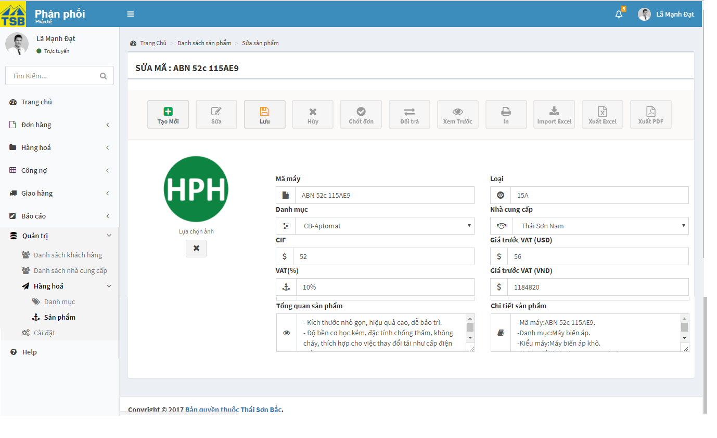

*Figure 3.46:* *Edit product screen*

|  |  |  |  |  |
| --- | --- | --- | --- | --- |
| **USE CASE-029 SPECIFICATION : Edit product** | | | | |
| **Use-case No.** | <UC029> | **Use-case Version** | | <1.0> |
| **Use-case Name** | Edit product | | | |
| **Author** | AnhNTL | | | |
| **Date** | Jan 2nd,2018 | **Priority** | High | |
| **Actor:**  *Sellers, managers*  **Summary:**  *User edit product infomation*  **Goal:**  *Product updated*  **Triggers**  **Preconditions:**  *On product list pages, click on”Sửa” button*  **Post Conditions:**  *Display “Chi tiết sản phẩm” page of product after updated*  **Main Success Scenario:**   |  |  |  | | --- | --- | --- | | *Step* | *User action* | *System response* | | *1* | *On product list pages, click on”Sửa” button* | *Display “Sửa sản phẩm” page* | | *2* | *Change information of product* | *Validate* | | *3* | *Click “Lưu“ button* | *Display pop-up confirm* | | *4* | *Click “OK” button* | *Update product*  *Display updated success message*  *Redirect to “Chi tiết sản phẩm” of product* |   **Alternative Scenario:**  **Exceptions:**  **Business Rules:** | | | | |

*Table 3.66 Usecase edit product*

Screen description:

|  |  |  |  |  |  |  |
| --- | --- | --- | --- | --- | --- | --- |
| Field name | Description | Mandatory | Read only | Control type | Data type | Length |
| “Tạo mới” button | Button of page | - | - | Button | - | - |
| “ Lưu” button | Button of page | - | - | Button | - | - |
| Product name field | Name of product | Y | N | Text field | Nvarchar | 50 |
| Product parameter field | Parameter of product | Y | N | Text field | Nvarchar | 50 |
| Category field | Category of product | Y | N | Dropbox | Nvarchar | 50 |
| Suppliers name field | Suppliers for product | Y | N | Text field autocomplete multiselect | Nvarchar | MAX |
| CIF field | CIF of product | Y | N | Input type=”number” | INT | - |
| Price before VAT VND field | Price before VAT VND of product | Y | N | Input type=”number” | INT | - |
| Price before VAT USD field | Price before VAT USD of product | Y | N | Input type=”number” | INT | - |
| VAT field | VAT field of product | Y | N | Input type=”number” | INT | - |
| Overview field | Overview of product | N | N | Text area | Nvarchar | MAX |
| Describe | Describe of product | N | N | Text area | Nvarchar | MAX |

*Table 3.67 Screen description edit product*

###### View category

Use case specification:

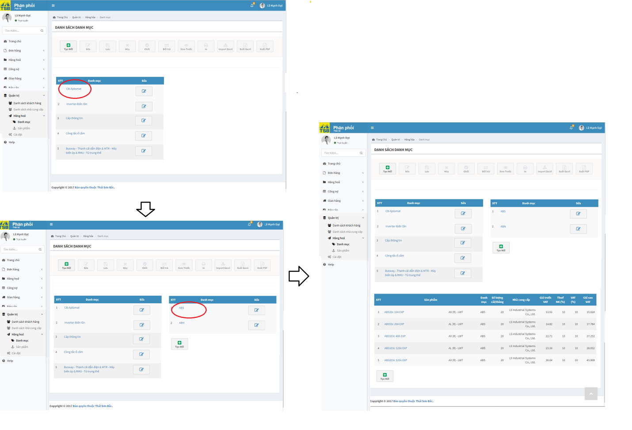

*Figure 3.47:* *View category screen*

|  |  |  |  |  |
| --- | --- | --- | --- | --- |
| **USE CASE-030 SPECIFICATION :View category** | | | | |
| **Use-case No.** | <UC030> | **Use-case Version** | | <1.0> |
| **Use-case Name** | View category | | | |
| **Author** | AnhNTL | | | |
| **Date** | Jan 2nd,2018 | **Priority** | High | |
| **Actor:**  *Sellers, managers*  **Summary:**  *View list of category*  **Goal:**  *Display category list and information*  **Triggers**  **Preconditions:**  *Click on “Danh mục” link on menu*  **Post Conditions:**  *Display “Danh sách danh mục” page*  **Main Success Scenario:**   |  |  |  | | --- | --- | --- | | *Step* | *User action* | *System response* | | *1* | *Click on “Danh mục” link on menu* | *Display “Danh sách danh mục” page* | | *2* | *Click on category link* | *Display sub-category of that category table* | | *2* | *Click on sub-category link* | *Display list of product of that sub-category* |   **Alternative Scenario:**  **Exceptions:**  **Business Rules:**  **-** On category table click “Sửa” button, display a panel to edit category  - On sub-category table click “Sửa” button, display a panel to edit sub-category  - On category table click “Tạo mới” button, display a new row to add new sub-category | | | | |

*Table 3.67 Usecase view category*

Screen description:

|  |  |  |  |  |  |  |
| --- | --- | --- | --- | --- | --- | --- |
| Field name | Description | Mandatory | Read only | Control type | Data type | Length |
| “Tạo mới” button | Button of form | - | - | Button | - | - |
| “Sửa” button of category table | Button of category table | - | - | Button | - | - |
| “Sửa” button of sub-category table | Button of sub-category table | - | - | Button | - | - |
| “Tạo mới” button of sub-category table | Button of sub-category table | - | - | Button | - | - |
| Category list table | Category list | - | - | Table | - | - |
| Sub-category list table | Sub-category of category list | - | - | Table | - | - |
| Product list table | Product of sub-category list | - | - | Table | - | - |

*Table 3.68 Screen description view category*

###### Create category

Use case specification:

- Create category

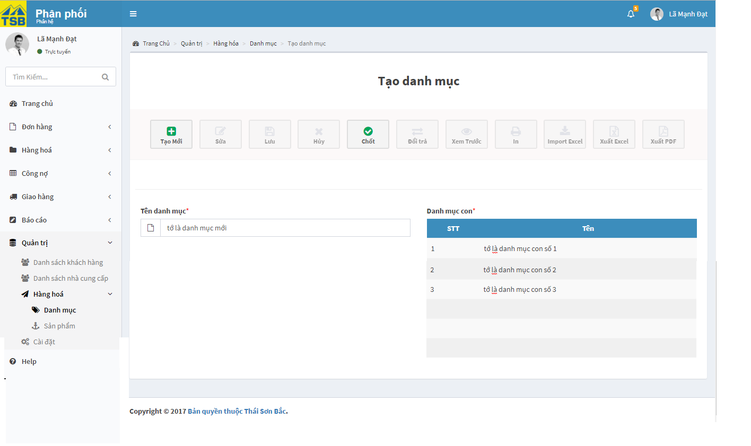

*Figure 3.48:* *Create new category screen*

-Create sub-category

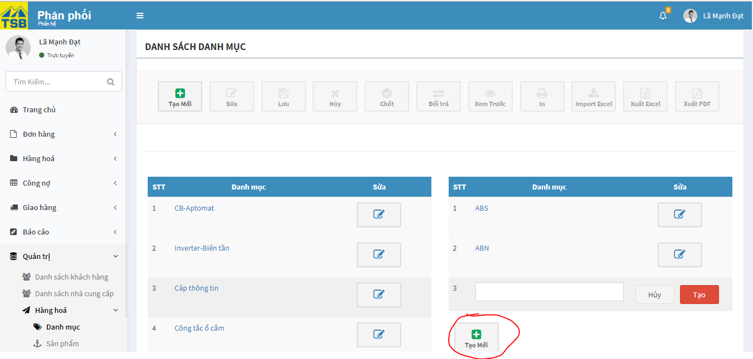

*Figure 3.49:* *Create new sub-category screen*

|  |  |  |  |  |
| --- | --- | --- | --- | --- |
| **USE CASE-031 SPECIFICATION : Create new category** | | | | |
| **Use-case No.** | <UC031> | **Use-case Version** | | <1.0> |
| **Use-case Name** | Create new category | | | |
| **Author** | AnhNTL | | | |
| **Date** | Jan 2nd,2018 | **Priority** | Normal | |
| **Actor:**  *Sellers, managers*  **Summary:**  *User create new category*  **Goal:**  *New category created*  **Triggers**  **Preconditions:**  *On “Danh sách danh mục” page, click on “Tạo mới” button*  **Post Conditions:**  *Redirect to “Danh sách danh mục” page*  **Main Success Scenario:**   |  |  |  | | --- | --- | --- | | *Step* | *User action* | *System response* | | *1* | *On “Danh sách danh mục” page, click on “Tạo mới” button* | *Display “Tạo danh mục” page* | | *2* | *Input data* | *Validate* | | *3* | *Click”Chốt” button* | *Display pop-up to confirm* | | *4* | *Click “ Đồng ý” button* | *Add new category and sub-category*  *Display added success message*  *Redirect to “Danh sách danh mục” page* |   **Alternative Scenario:**   1. **Create sub-category**  |  |  |  | | --- | --- | --- | | *Stp* | *User action* | *System response* | | *1* | *On “Danh sách danh mục” page, click on “Tạo mới” button of sub-category table* | *Display new row for add new sub-category* | | *2* | *Input data* | *Validate* | | *3* | *Click “Tạo” button* | *Display pop-up confirm* | | *4* | *Click “OK” button* | *Add sub-category*  *Display success message*  *Refresh “Danh sách danh mục” page* |   **Exceptions:**  *If category name or sub-category name already exist , notify user and cannot create new category*  **Business Rules:** | | | | |

*Table 3.69 Usecase create new category*

Screen description:

- Create category page

|  |  |  |  |  |  |  |
| --- | --- | --- | --- | --- | --- | --- |
| Field name | Description | Mandatory | Read only | Control type | Data type | Length |
| “Tạo mới” button | Button of page | - | - | Button | - | - |
| “Chốt” button | Button of page | - | - | Button | - | - |
| Category name field | Name of new category | Y | N | Text field | Nvarchar | 50 |
| Sub-category table | Name of new sub-category | - | - | Table | - | - |
| Serial field | numerical order of sub-category | Y | Y | Input type=”number” | INT | 20 |
| Sub-category name field | Sub-category name | Y | N | Text field | Nvarchar | 50 |

*Table 3.70 Screen description create new category*

-Create sub-category

|  |  |  |  |  |  |  |
| --- | --- | --- | --- | --- | --- | --- |
| Field name | Description | Mandatory | Read only | Control type | Data type | Length |
| Sub-category name field | Name of new sub-category | Y | N | Text field | Nvarchar | 50 |
| “Huỷ” button | Button of form | - | - | Button | - | - |
| “Tạo” button | Button of form | - | - | Button | - | - |

*Table 3.71 Screen description create sub category*

Row to add new sub-category

|  |  |  |  |  |  |  |
| --- | --- | --- | --- | --- | --- | --- |
| Field name | Description | Mandatory | Read only | Control type | Data type | Length |
| Sub-category name field | Sub-category name | y | N | Text field | Nvarchar | 50 |
| Category field | Category of sub-category | Y | N | Dropbox | Nvarchar | - |
| Status toggle switch | Active/deactive category | y | N | Toggle switch | Boolean | - |
| “Huỷ” button | Button of form | - | - | Button | - | - |
| “Sửa” button | Buttom of form | - | - | Button | - | - |

*Table 3.72 Screen description row to add new sub-category*

###### Edit category

Use case specification:

- Panel edit category

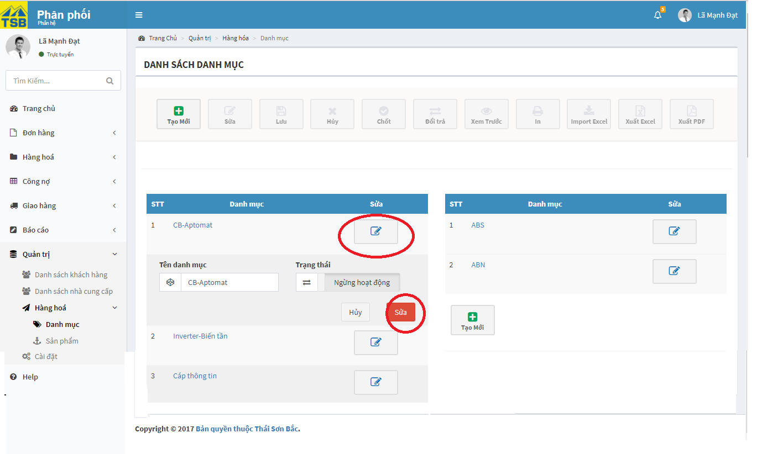

*Figure 3.50:* *Edit category screen*

- Message if deactive category

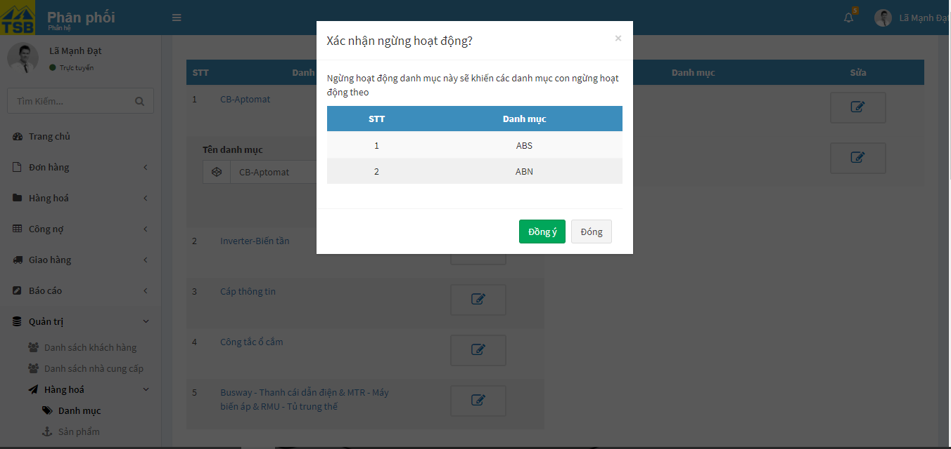

*Figure 3.51:* *Edit category screen*

- Panel edit sub-category

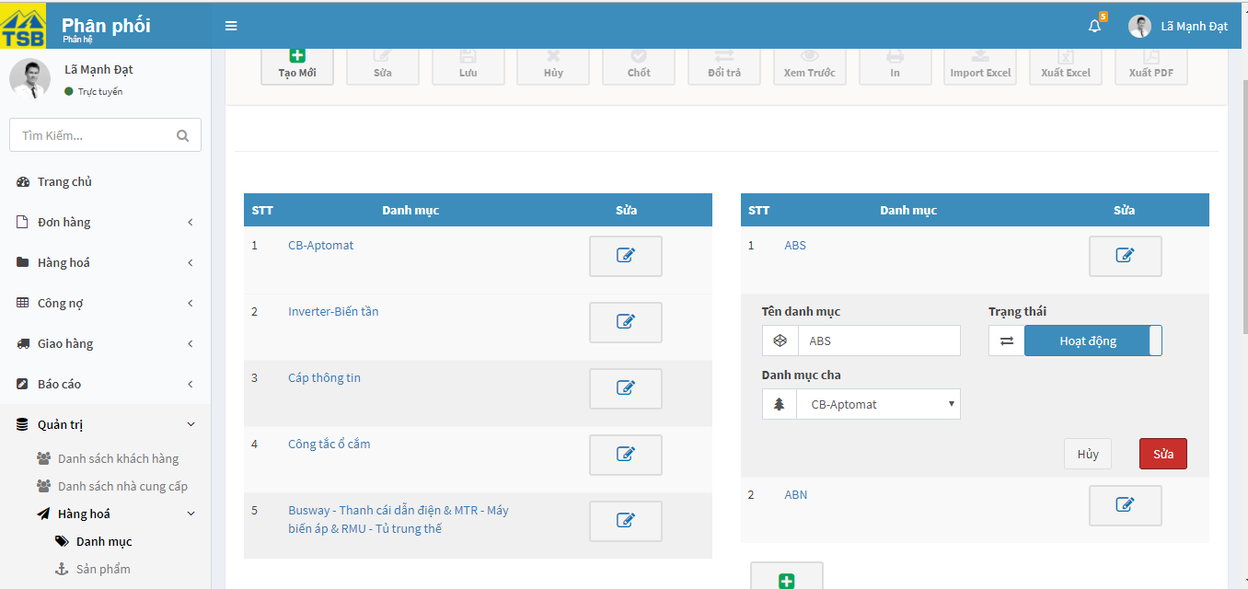

*Figure 3.52:* *Edit category screen*

-Pop-up notify if deactive sub-category

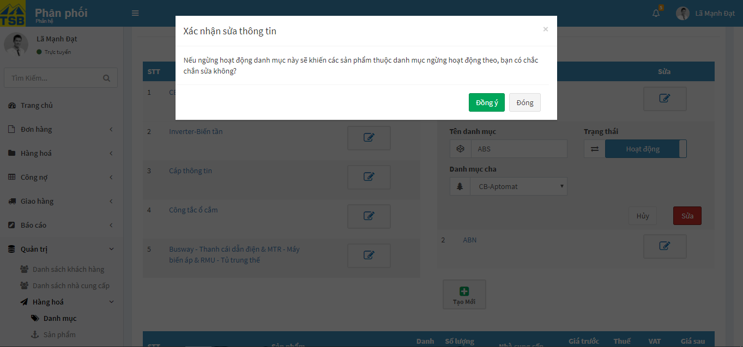

*Figure 3.53:* *Edit category screen*

|  |  |  |  |  |
| --- | --- | --- | --- | --- |
| **USE CASE-032 SPECIFICATION :** **Edit category** | | | | |
| **Use-case No.** | <UC032> | **Use-case Version** | | <1.0> |
| **Use-case Name** | Edit category | | | |
| **Author** | AnhNTL | | | |
| **Date** | Jan 2nd,2018 | **Priority** | Normal | |
| **Actor:**  *Sellers, managers*  **Summary:**  *User edit name or deactivate/active category*  **Goal:**  *Category edited*  **Triggers**  **Preconditions:**  *On “Danh sách danh mục” page, user click on “Sửa” button of category on category table*  **Post Conditions:**  *Refresh “Danh sách danh mục” page*  **Main Success Scenario:**   |  |  |  | | --- | --- | --- | | *Step* | *User action* | *System response* | | *1* | *On “Danh sách danh mục” page, user click on “Sửa” button category on category table* | *Display panel to edit category* | | *2* | *Input data* | *Validate data* | | *3* | *Click “Sửa” button* | *Display pop-up confirm* | | *4* | *Click “OK” button* | *Update category*  *Display success message*  *Refresh “Danh sách danh mục” page* |   **Alternative Scenario:**   1. **Edit sub-category**  |  |  |  | | --- | --- | --- | | *Step* | *User action* | *System response* | | *1* | *On “Danh sách danh mục” page, user click on “Sửa” button of sub-category on sub-category table* | *Display panel to edit sub-category* | | *2* | *Input data* | *Validate data* | | *3* | *Click “Sửa” button* | *Display pop-up confirm* | | *4* | *Click “OK” button* | *Update sub-category*  *Display success message*  *Refresh “Danh sách danh mục” page* |   **Exceptions:**  **Business Rules:**   * *If user deactivate category, pop-up notify user that all sub-category in category and all product in category will also be deactivate* * *If user deactivate category, pop-up notify user that all product in sub-category will also be deactivate* | | | | |

*Table 3.73 Usecase edit category*

Screen description:

- Edit category

|  |  |  |  |  |  |  |
| --- | --- | --- | --- | --- | --- | --- |
| Field name | Description | Mandatory | Read only | Control type | Data type | Length |
| Category name field | Category name | y | N | Text field | Nvarchar | 50 |
| Status toggle switch | Active/deactive category | y | N | Toggle switch | Boolean | - |
| “Huỷ” button | Button of form | - | - | Button | - | - |
| “Sửa” button | Buttom of form | - | - | Button | - | - |

*Table 3.74 Screen description edit category*

-Edit sub-category

|  |  |  |  |  |  |  |
| --- | --- | --- | --- | --- | --- | --- |
| Field name | Description | Mandatory | Read only | Control type | Data type | Length |
| Sub-category name field | Sub-category name | y | N | Text field | Nvarchar | 50 |
| Category field | Category of sub-category | Y | N | Dropbox | Nvarchar | - |
| Status toggle switch | Active/deactive category | y | N | Toggle switch | Boolean | - |
| “Huỷ” button | Button of form | - | - | Button | - | - |
| “Sửa” button | Buttom of form | - | - | Button | - | - |

*Table 3.75 Screen description edit sub-category*

###### Search product

Use case specification:

|  |  |  |  |  |
| --- | --- | --- | --- | --- |
| **USE CASE-033 SPECIFICATION : Search product** | | | | |
| **Use-case No.** | <UC033> | **Use-case Version** | | <1.0> |
| **Use-case Name** | Search product | | | |
| **Author** | AnhNTL | | | |
| **Date** | Jan 2nd,2018 | **Priority** | High | |
| **Actor:**  *Sellers, managers, warehouse , administrator*  **Summary:**  *User search product list*  **Goal:**  *Search product correct conditions*  **Triggers**  **Preconditions:**  *User select value for search conditions*  **Post Conditions:**  *Display list of products fit with conditions on respective product list page*  **Main Success Scenario:**   |  |  |  | | --- | --- | --- | | *Step* | *User action* | *System response* | | *1* | *User select value for search conditions* | *Validate* | | *2* | *Click “Tìm kiếm” button* | *Display list of products fit with conditions on respective product list page* |   **Alternative Scenario:**  **Exceptions:**  **Business Rules:** | | | | |

*Table 3.76 Usecase search product*

#### Report

##### Usecase diagram



*Figure 3.53:* *Report usercase diagram*

##### Usecase

###### View revenue report

Use case specification:

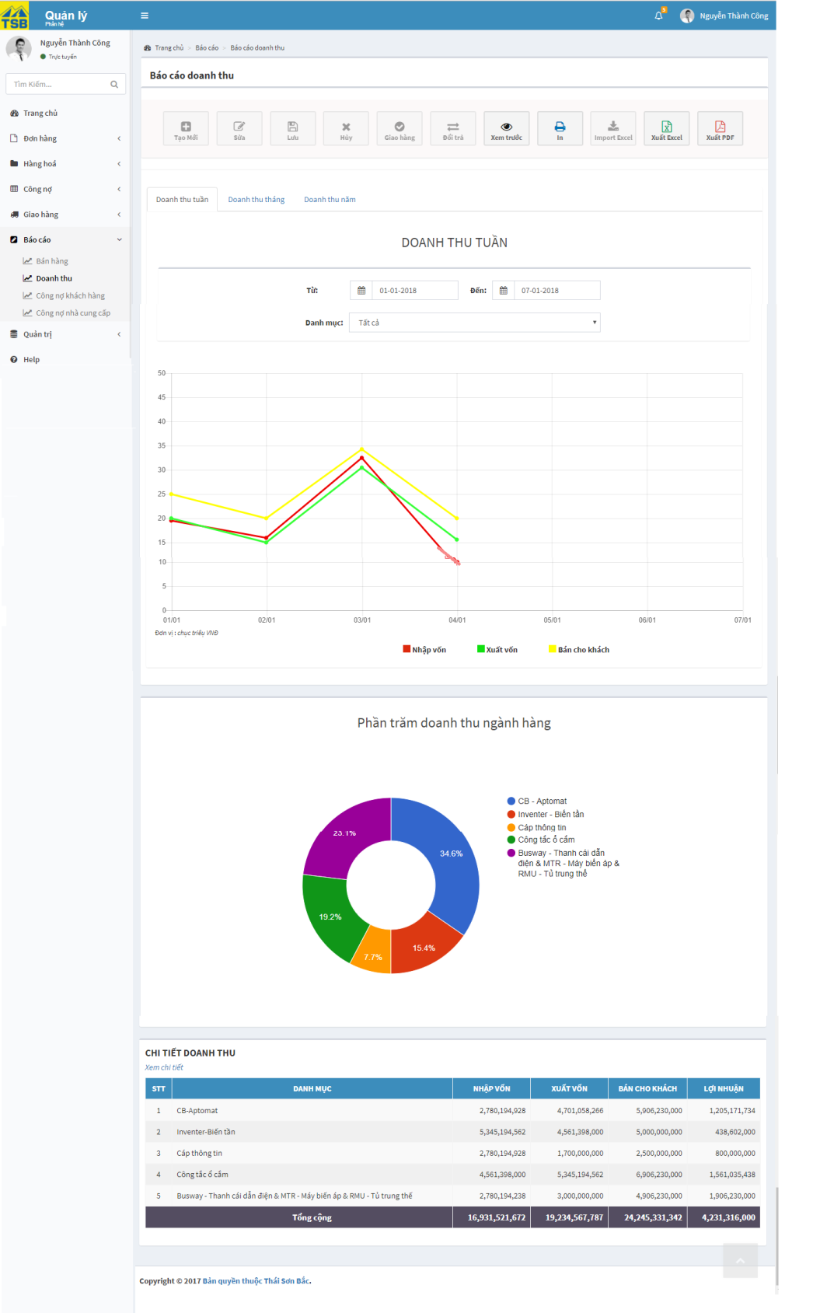

*Figure 3.54:* *View revenue report screen*

|  |  |  |  |  |
| --- | --- | --- | --- | --- |
| **USE CASE-034 SPECIFICATION : View revenue report** | | | | |
| **Use-case No.** | <UC034> | **Use-case Version** | | <1.0> |
| **Use-case Name** | View revenue report | | | |
| **Author** | AnhNTL | | | |
| **Date** | Jan 2nd,2018 | **Priority** | High | |
| **Actor:**  *Sellers, managers*  **Summary:**  *User view revenue report*  **Goal:**  *Provide for user a revenue overview : total has sold in 3 price chart(CIF, price of capital, price sale for customer) , percent has sold of categories chart, detail revenue of categories table*  **Triggers**  **Preconditions:**  *User click on “Doanh thu” from”Báo cáo” menu on menu*  **Post Conditions:**  *Display “Báo cáo doanh thu” page*  **Main Success Scenario:**   |  |  |  | | --- | --- | --- | | *Step* | *User action* | *System response* | | *1* | *User click on “Doanh thu” in tab ”Báo cáo” on left menu* | *Display “Báo cáo doanh thu” page* |   **Alternative Scenario:**  **Exceptions:**  **Business Rules:**  *On “Báo cáo doanh thu” page, user can select timeframe to view*  *In total has sold in 3 price chart , user can select category to view* | | | | |

*Table 3.77 Usecase view revenue report*

Screen description:

|  |  |  |  |  |  |  |
| --- | --- | --- | --- | --- | --- | --- |
| Field name | Description | Mandatory | Read only | Control type | Data type | Length |
| Print button | Button of page | - | - | Button | - | - |
| Export excel button | Button of page | - | - | Button | - | - |
| Export pdf button | Button of page | - | - | Button | - | - |
| Year field | Year of timeframe | Y | N | Dropbox | Date | 10 |
| Month field | Month of timeframe | Y | N | Dropbox | Date | 10 |
| Week field | Week of timefram | Y | N | Dropbox | Date | 10 |
| Total has sold in 3 price chart | total has sold in 3 price | - | - | Line chart | - | - |
| Percent has sold of categories chart | percent has sold of categories | - | - | Donut chart | - | - |
| Detail revenue of categories table | detail revenue of categories | - | - | Table | - | - |

*Table 3.78 Screen description view revenue report*

###### View revenue detail report

Use case specification:

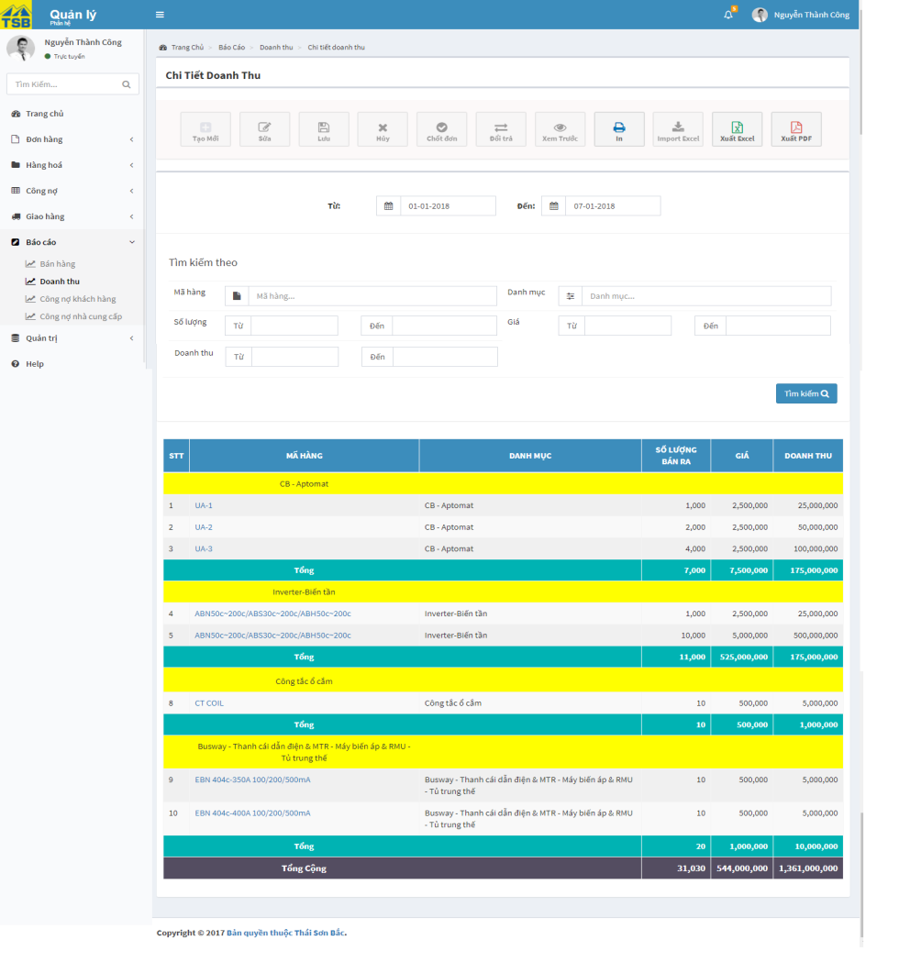

*Figure 3.55:* *View revenue detail report screen*

|  |  |  |  |  |
| --- | --- | --- | --- | --- |
| **USE CASE-035 SPECIFICATION : View revenue detail report** | | | | |
| **Use-case No.** | <UC035> | **Use-case Version** | | <1.0> |
| **Use-case Name** | View revenue detail report | | | |
| **Author** | AnhNTL | | | |
| **Date** | Jan 2nd,2018 | **Priority** | High | |
| **Actor:**  *Sellers, managers*  **Summary:**  *User view revenue detail report*  **Goal:**  *Display detail quantitly, total price has sold of product and category, group by category*  **Triggers**  **Preconditions:**  *On “Báo cáo doanh thu” page, click on “Xem chi tiết” link on “Xem chi tiết doanh thu” table*  **Post Conditions:**  *Display “Báo cáo chi tiết doanh thu” page*  **Main Success Scenario:**   |  |  |  | | --- | --- | --- | | *Step* | *User action* | *System response* | | *1* | *On “Báo cáo doanh thu” page, click on “Xem chi tiết” link on “Xem chi tiết doanh thu” table* | *Display “Báo cáo chi tiết doanh thu” page* | | *2* | *“Báo cáo chi tiết doanh thu” page , change time frame* | *Display“Báo cáo chi tiết doanh thu” page* |   **lternative Scenario:**   |  |  |  | | --- | --- | --- | | *Step* | *User action* | *System response* | | *1* | *On “Báo cáo doanh thu” page, click on “Xem chi tiết” link on “Xem chi tiết doanh thu” table* | *Display “Báo cáo chi tiết doanh thu” page* | | *2* | *“Báo cáo chi tiết doanh thu” page , input value to search* | *Validate* | | *3* | *Click search button* | *Display “Báo cáo chi tiết doanh thu” page* |   **Exceptions:**  **Business Rules:**  *User can select timeframe to view* | | | | |

*Table 3.79 Usecase view revenue detail report*

Screen description:

|  |  |  |  |  |  |  |
| --- | --- | --- | --- | --- | --- | --- |
| Field name | Description | Mandatory | Read only | Control type | Data type | Length |
| Year field | Year of timeframe | Y | N | Dropbox | Date | 10 |
| Month field | Month of timeframe | Y | N | Dropbox | Date | 10 |
| Week field | Week of timefram | Y | N | Dropbox | Date | 10 |
| Product name search field | Name of product to search | N | N | Text field autocomplete | Nvarchar | 50 |
| Category search field | Category to search | N | N | Text field autocomplete multilselect | Nvarchar | 100 |
| Quantity (from) search field | Limit quantity to search | N | N | Input type = “number” | INT | - |
| Quantity (to) search field | Limit quantity to search | N | N | Input type = “number” | INT | - |
| Product price (from) search field | Limit price to search | N | N | Input type = “number” | MONEY | - |
| Product price (to) search field | Limit price to search | N | N | Input type = “number” | MONEY | - |
| Revenue (from) search field | Limit revenue to search | N | N | Input type = “number” | MONEY | - |
| Revenue (to) search field | Limit revenue to search | N | N | Input type = “number” | MONEY | - |
| Search button | Button of form | - | - | Button | - | - |
| Detail table |  |  |  |  |  |  |
| Print button | Button of page | - | - | Button | - | - |
| Export excel button | Button of page | - | - | Button | - | - |
| Export pdf button | Button of page | - | - | Button | - | - |

*Table 3.80 Screen description view revenue detail report*

###### View customers debt report

Use case specification:

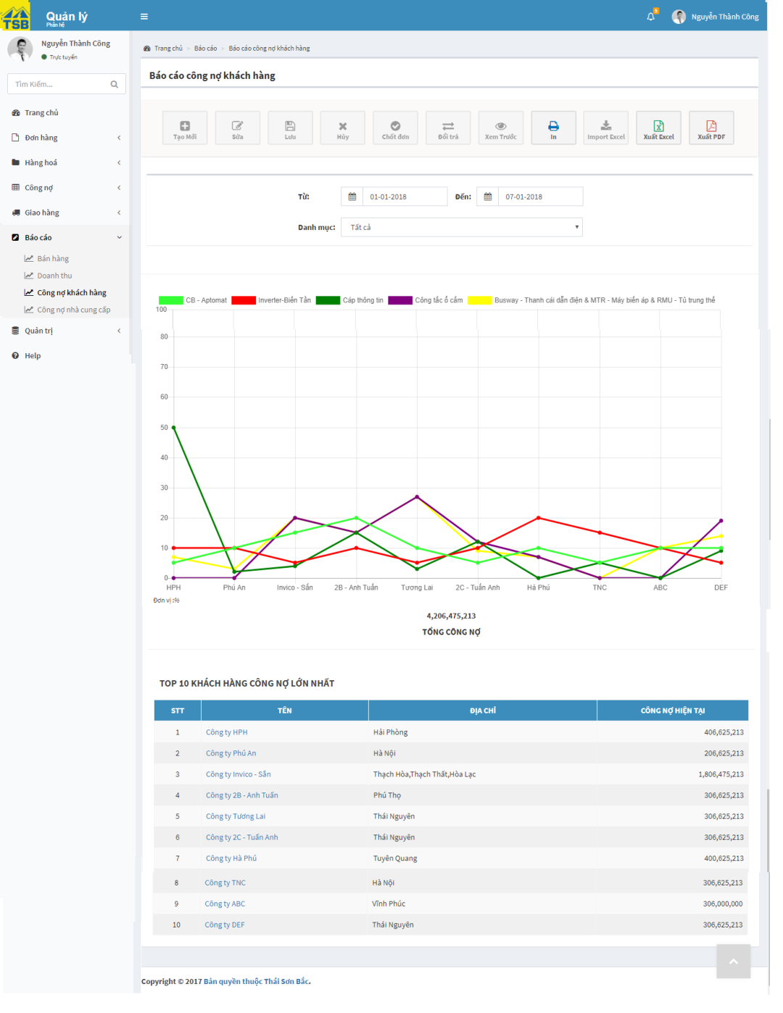

*Figure 3.56:* *View customers debt report screen*

|  |  |  |  |  |
| --- | --- | --- | --- | --- |
| **USE CASE-036 SPECIFICATION : View customers debt report** | | | | |
| **Use-case No.** | <UC036> | **Use-case Version** | | <1.0> |
| **Use-case Name** | View customers debt report | | | |
| **Author** | AnhNTL | | | |
| **Date** | Jan 2nd,2018 | **Priority** | High | |
| **Actor:**  *Sellers, managers*  **Summary:**  *User view customers debt report*  **Goal:**  *Display report about total price of category has been sold for each customer ( line chart with each line is each category , horizontal axis is customer , vertical axis is total price )*  *Display top 10 customer have debt largest*  **Triggers**  **Preconditions:**  *User click on “Công nợ khách hàng” on menu*  **Post Conditions:**  *Display “Báo cáo công nợ khách hàng” page*  **Main Success Scenario:**   |  |  |  | | --- | --- | --- | | *Step* | *User action* | *System response* | | *1* | *User click on “Công nợ khách hàng” in tab ”Báo cáo” onleft menu* | *Display “Báo cáo công nợ khách hàng”page* |   **Alternative Scenario:**  **Exceptions:**  **Business Rules:**  *On “Báo cáo công nợ khách hàng” page, user can select timeframe to view*  *In linechart , user can select category to view* | | | | |

*Table 3.81 Usecase customer debt report*

Screen description:

|  |  |  |  |  |  |  |
| --- | --- | --- | --- | --- | --- | --- |
| Field name | Description | Mandatory | Read only | Control type | Data type | Length |
| Print button | Button of page | - | - | Button | - | - |
| Export excel button | Button of page | - | - | Button | - | - |
| Export pdf button | Button of page | - | - | Button | - | - |
| Year field | Year of timeframe | Y | N | Dropbox | Date | 10 |
| Month field | Month of timeframe | Y | N | Dropbox | Date | 10 |
| Week field | Week of timefram | Y | N | Dropbox | Date | 10 |
| Total price of category has been sold chart | Total price of category has been sold for each customer | - | - | Line chart | - | - |
| Top 10 customer debt table | Top 10 customer debt | - | - | Table | - | - |

*Table 3.82 Screen description customer debt report*

###### View supplier debt report

Use case specification:

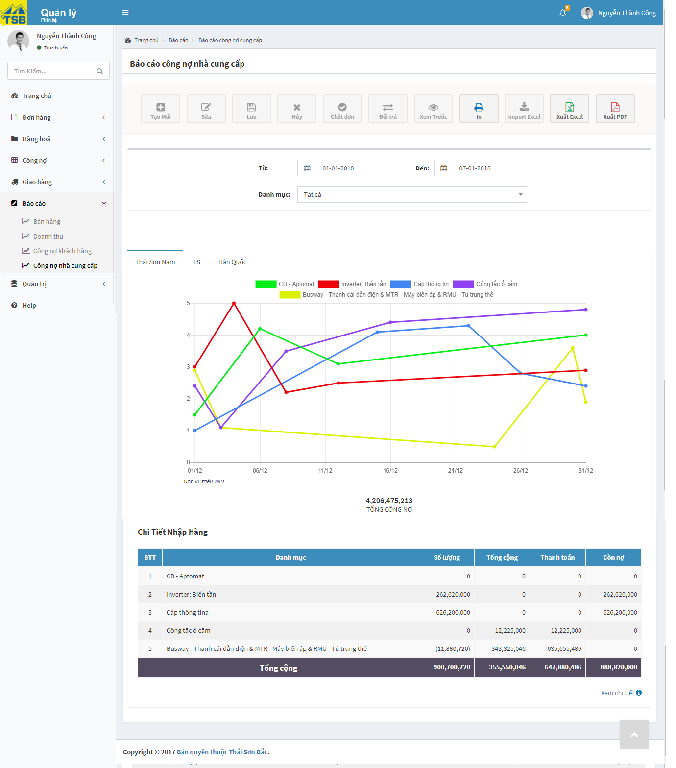

*Figure 3.57:* *View supplier debt report screen*

|  |  |  |  |  |
| --- | --- | --- | --- | --- |
| **USE CASE-037 SPECIFICATION : View supplier debt report** | | | | |
| **Use-case No.** | <UC037> | **Use-case Version** | | <1.0> |
| **Use-case Name** | View supplier debt report | | | |
| **Author** | AnhNTL | | | |
| **Date** | Jan 2nd,2018 | **Priority** | High | |
| **Actor:**  *Sellers, managers*  **Summary:**  *User view supplier debt report*  **Goal:**  *Display total price of categories purchased from the supplier (line chart with each line is each category , horizontal axis is date , vertical axis is total price ) and detail purchased of category for each supplier*  **Triggers**  **Preconditions:**  *User click on “Công nợ nhà cung cấp” in tab ”Báo cáo” on left menu*  **Post Conditions:**  *Display “Báo cáo công nợ nhà cung cấp” page*  **Main Success Scenario:**   |  |  |  | | --- | --- | --- | | *Step* | *User action* | *System response* | | *1* | *User click on “Công nợ nhà cung cấp” in tab ”Báo cáo” on left menu* | *Display “Báo cáo công nợ nhà cung cấp” page* |   **Alternative Scenario:**  **Exceptions:**  **Business Rules:**  *On “Báo cáo công nợ nhà cung cấp” page, user can select timeframe to view*  *In line chart , user can select category to view* | | | | |

*Table 3.83 Use supplier debt report*

Screen description:

|  |  |  |  |  |  |  |
| --- | --- | --- | --- | --- | --- | --- |
| Field name | Description | Mandatory | Read only | Control type | Data type | Length |
| Print button | Button of page | - | - | Button | - | - |
| Export excel button | Button of page | - | - | Button | - | - |
| Export pdf button | Button of page | - | - | Button | - | - |
| Year field | Year of timeframe | Y | N | Dropbox | Date | 10 |
| Month field | Month of timeframe | Y | N | Dropbox | Date | 10 |
| Week field | Week of timefram | Y | N | Dropbox | Date | 10 |
| Supplier tab | Tab of supplier, each tab is each supplier | - | - | Tab | - | - |
| Total price of category has been purchased chart | Total price of category has been purchased chart for each supplier | - | - | Line chart | - | - |
| Detail purchased of category for each supplier | Detail purchased of category for each supplier | - | - | Table | - | - |

*Table 3.84 Screen description supplier debt report*

###### View purchase of supplier detail

Use case specification:

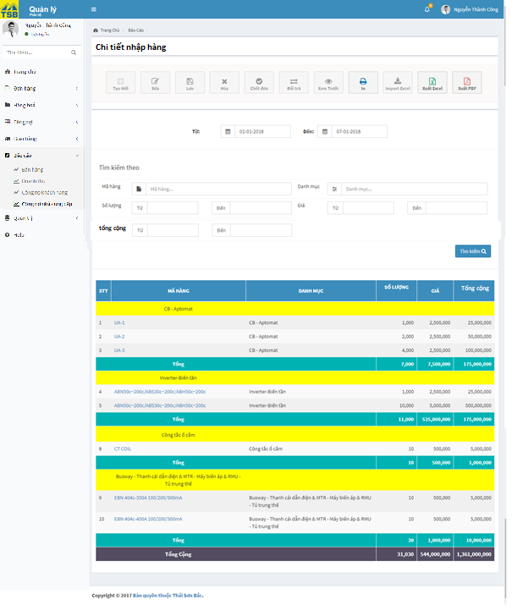

*Figure 3.58:* *View purchased of supplier detail screen*

|  |  |  |  |  |
| --- | --- | --- | --- | --- |
| **USE CASE-038 SPECIFICATION : View purchased of supplier detail** | | | | |
| **Use-case No.** | <UC038> | **Use-case Version** | | <1.0> |
| **Use-case Name** | View purchased of supplier detail | | | |
| **Author** | AnhNTL | | | |
| **Date** | Jan 2nd,2018 | **Priority** | High | |
| **Actor:**  *Sellers, managers*  **Summary:**  *User view purchased of supplier detail*  **Goal:**  *Display detail purchased of product from supplier group by category*  **Triggers**  **Preconditions:**  *On “ Báo cáo công nợ nhà cung cấp” page, click on “Xem chi tiết” link in “Chi tiết nhập hàng” table*  **Post Conditions:**  *Display “Chi tiết nhập hàng” page of supplier was choosen*  **Main Success Scenario:**   |  |  |  | | --- | --- | --- | | *Step* | *User action* | *System response* | | *1* | *On “Báo cáo công nợ nhà cung cấp” page, click on “ Xem chi tiết” link in “Chi tiết nhập hàng” table* | *Display “Chi tiết nhập hàng” page of supplier was choosen* | | *2* | *“Chi tiết nhập hàng” page , change time frame* | *Display “Chi tiết nhập hàng” page* |   **Alternative Scenario:**  **Exceptions:**  **Business Rules:** | | | | |

*Table 3.85 Usecase view purchase of supplier detail*

Screen description:

|  |  |  |  |  |  |  |
| --- | --- | --- | --- | --- | --- | --- |
| Field name | Description | Mandatory | Read only | Control type | Data type | Length |
| Year field | Year of timeframe | Y | N | Dropbox | Date | 10 |
| Month field | Month of timeframe | Y | N | Dropbox | Date | 10 |
| Week field | Week of timefram | Y | N | Dropbox | Date | 10 |
| Product name search field | Name of product to search | N | N | Text field autocomplete | Nvarchar | 50 |
| Category search field | Category to search | N | N | Text field autocomplete multilselect | Nvarchar | 100 |
| Quantity (from) search field | Limit quantity to search | N | N | Input type = “number” | INT | - |
| Quantity (to) search field | Limit quantity to search | N | N | Input type = “number” | INT | - |
| Product price (from) search field | Limit price to search | N | N | Input type = “number” | MONEY | - |
| Product price (to) search field | Limit price to search | N | N | Input type = “number” | MONEY | - |
| Total price (from) search field | Limit revenue to search | N | N | Input type = “number” | MONEY | - |
| Total price (to) search field | Limit revenue to search | N | N | Input type = “number” | MONEY | - |
| Search button | Button of form | - | - | Button | - | - |
| Detail table |  |  |  |  |  |  |
| Print button | Button of page | - | - | Button | - | - |
| Export excel button | Button of page | - | - | Button | - | - |
| Export pdf button | Button of page | - | - | Button | - | - |

*Table 3.86 Screen description view purchase of supplier detail*

###### View indicators in month

Use case specification:

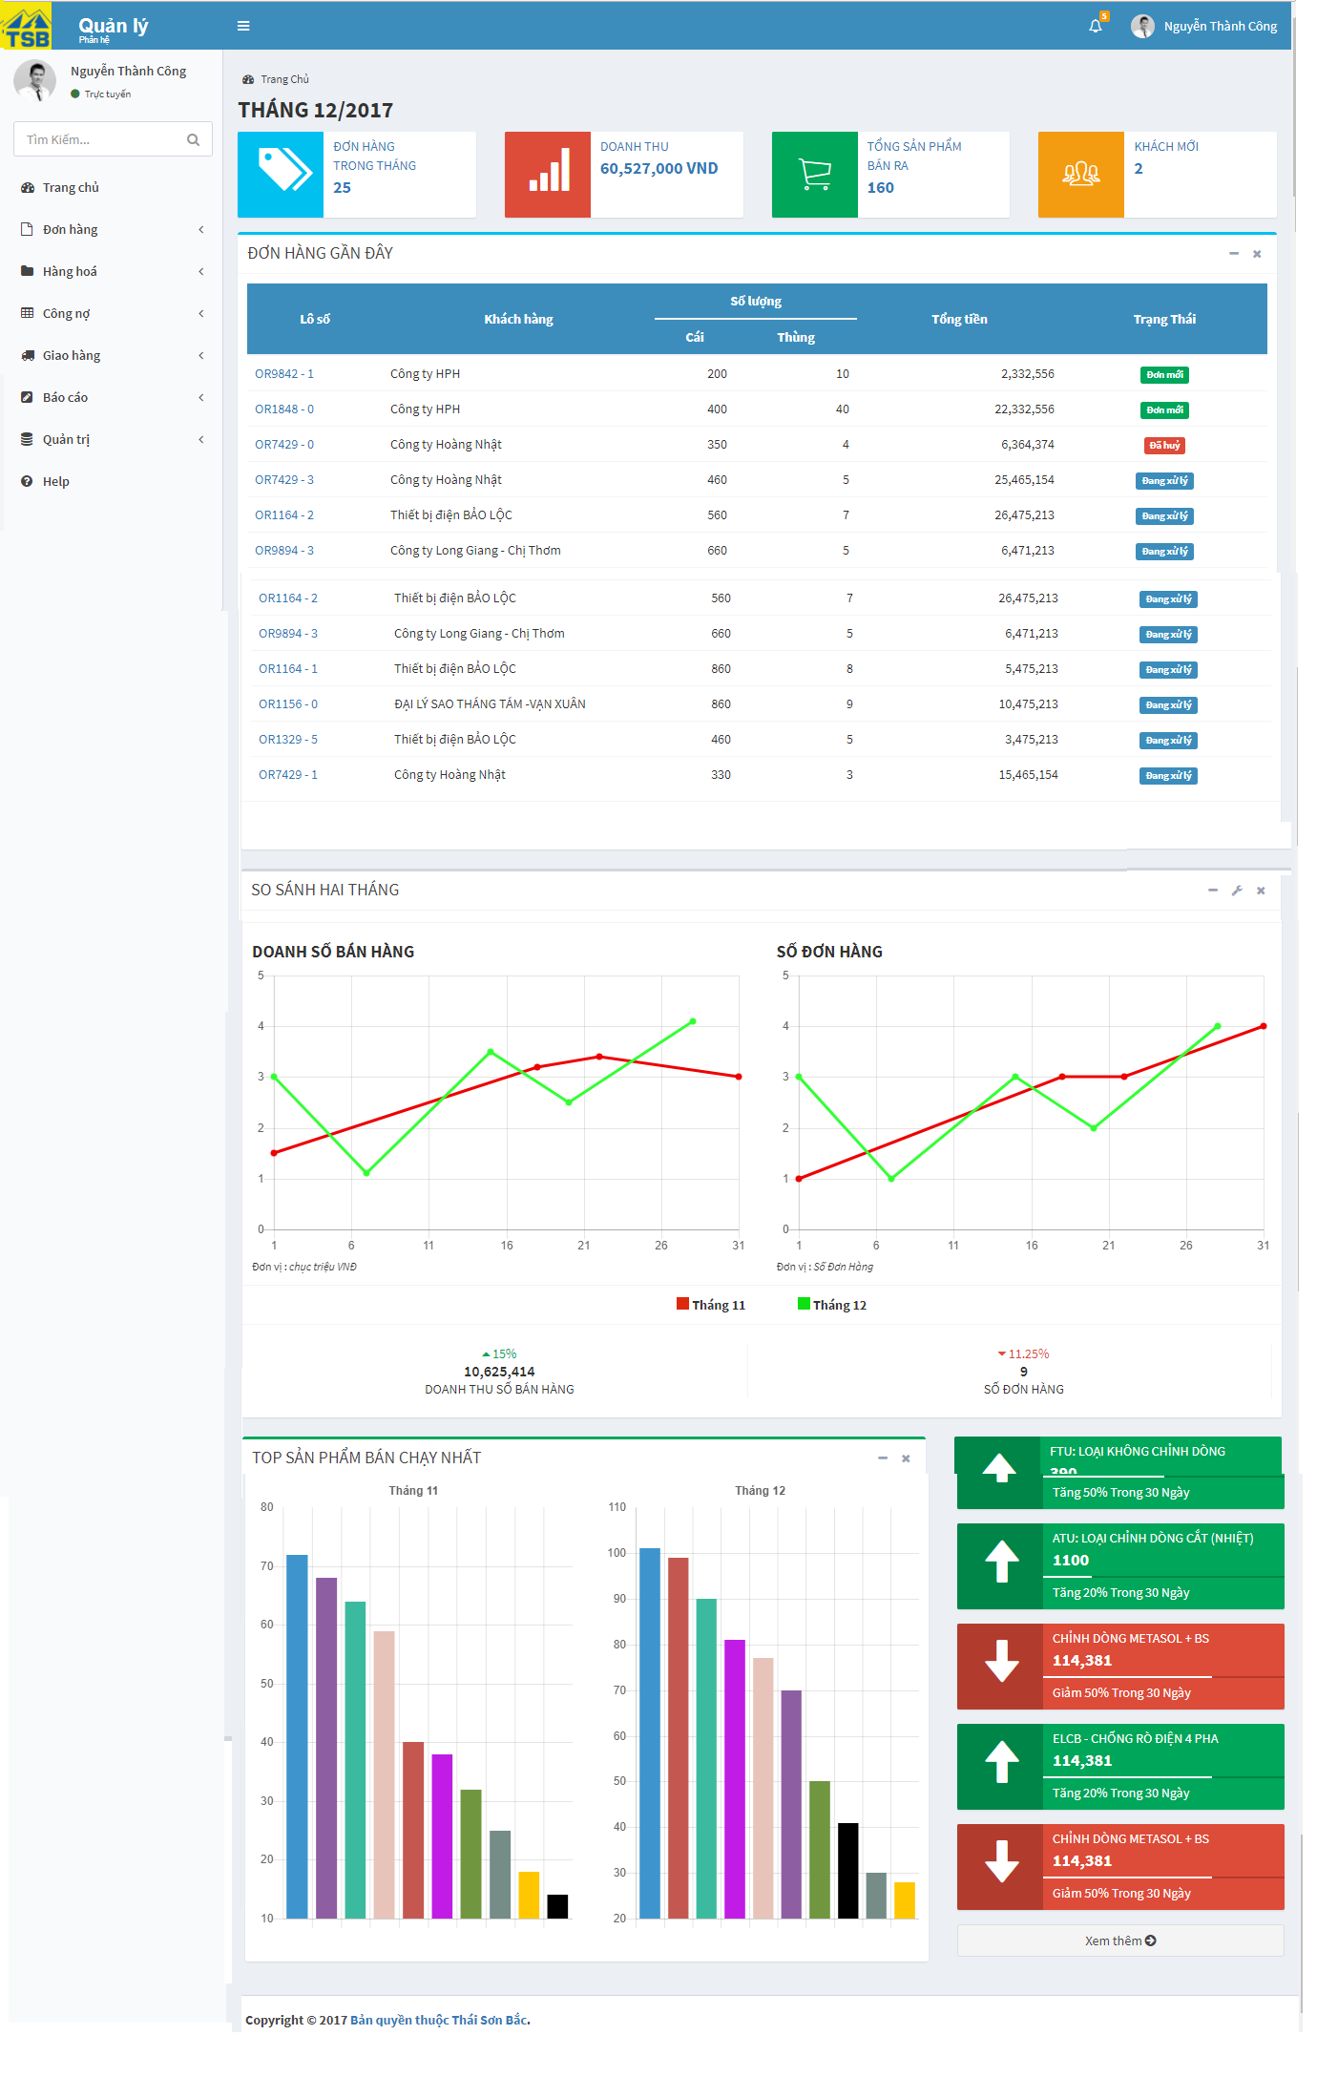

*Figure 3.59:* *View indicators in month screen*

|  |  |  |  |  |
| --- | --- | --- | --- | --- |
| **USE CASE-039 SPECIFICATION : View indicators in month** | | | | |
| **Use-case No.** | <UC039> | **Use-case Version** | | <1.0> |
| **Use-case Name** | View indicators in month | | | |
| **Author** | AnhNTL | | | |
| **Date** | Jan 2nd,2018 | **Priority** | High | |
| **Actor:**  *Sellers, managers*  **Summary:**  *User view indicators in month*  **Goal:**  *Provide for user an overview about indicators in month*  **Triggers**  **Preconditions:**  *User click on “Trang chủ” in tab ”Báo cáo” on left menu*  **Post Conditions:**  *Display “Trang chủ” page*  **Main Success Scenario:**   |  |  |  | | --- | --- | --- | | *Step* | *User action* | *System response* | | *1* | *User click on “Trang chủ” in tab ”Báo cáo” on left menu* | *Display “Trang chủ” page*  *display “Báo cáo doanh thu” page* |   **Alternative Scenario:**  **Exceptions:**  **Business Rules:** | | | | |

*Table 3.87 Usecase view indicators in month*

Screen description:

|  |  |  |  |  |  |  |
| --- | --- | --- | --- | --- | --- | --- |
| Field name | Description | Mandatory | Read only | Control type | Data type | Length |
| Indicator of order field | Indicator of order until today | - | - | Div info-box | - | - |
| Indicator of revenue field | Indicator of revenue until today | - | - | Div info-box | - | - |
| Indicator of total quantity products sold field | Indicator of total quantity products sold until today | - | - | Div info-box | - | - |
| Indicator of new customer field | Indicator of new customer until today | - | - | Div info-box | - | - |
| Recent orders table | List of recent orders | - | - | Table | - | - |
| Compare 2 month of revenue | Chart compare 2 month of revenue | - | - | Line chart | - | - |
| Comment about revenue | Comment about revenue in this month | - | - | Text | - | - |
| Compare 2 month of quantity order | Chart compare 2 month of quantity order | - | - | Line chart | - | - |
| Comment about quantity order | Comment about quantity order in this month | - | - | Text | - | - |
| Top 10 products in pre month | Top 10 products in pre month | - | - | Bar chart | - | - |
| Top 10 products in this month | Top 10 products in this month | - | - | Bar chart | - | - |
| Comment about trend of categories | Comment about trend of categories | - | - | Div info-box | - | - |

*Table 3.88 Screen description view indicators in month*

###### View Sales activities report

Use case specification:

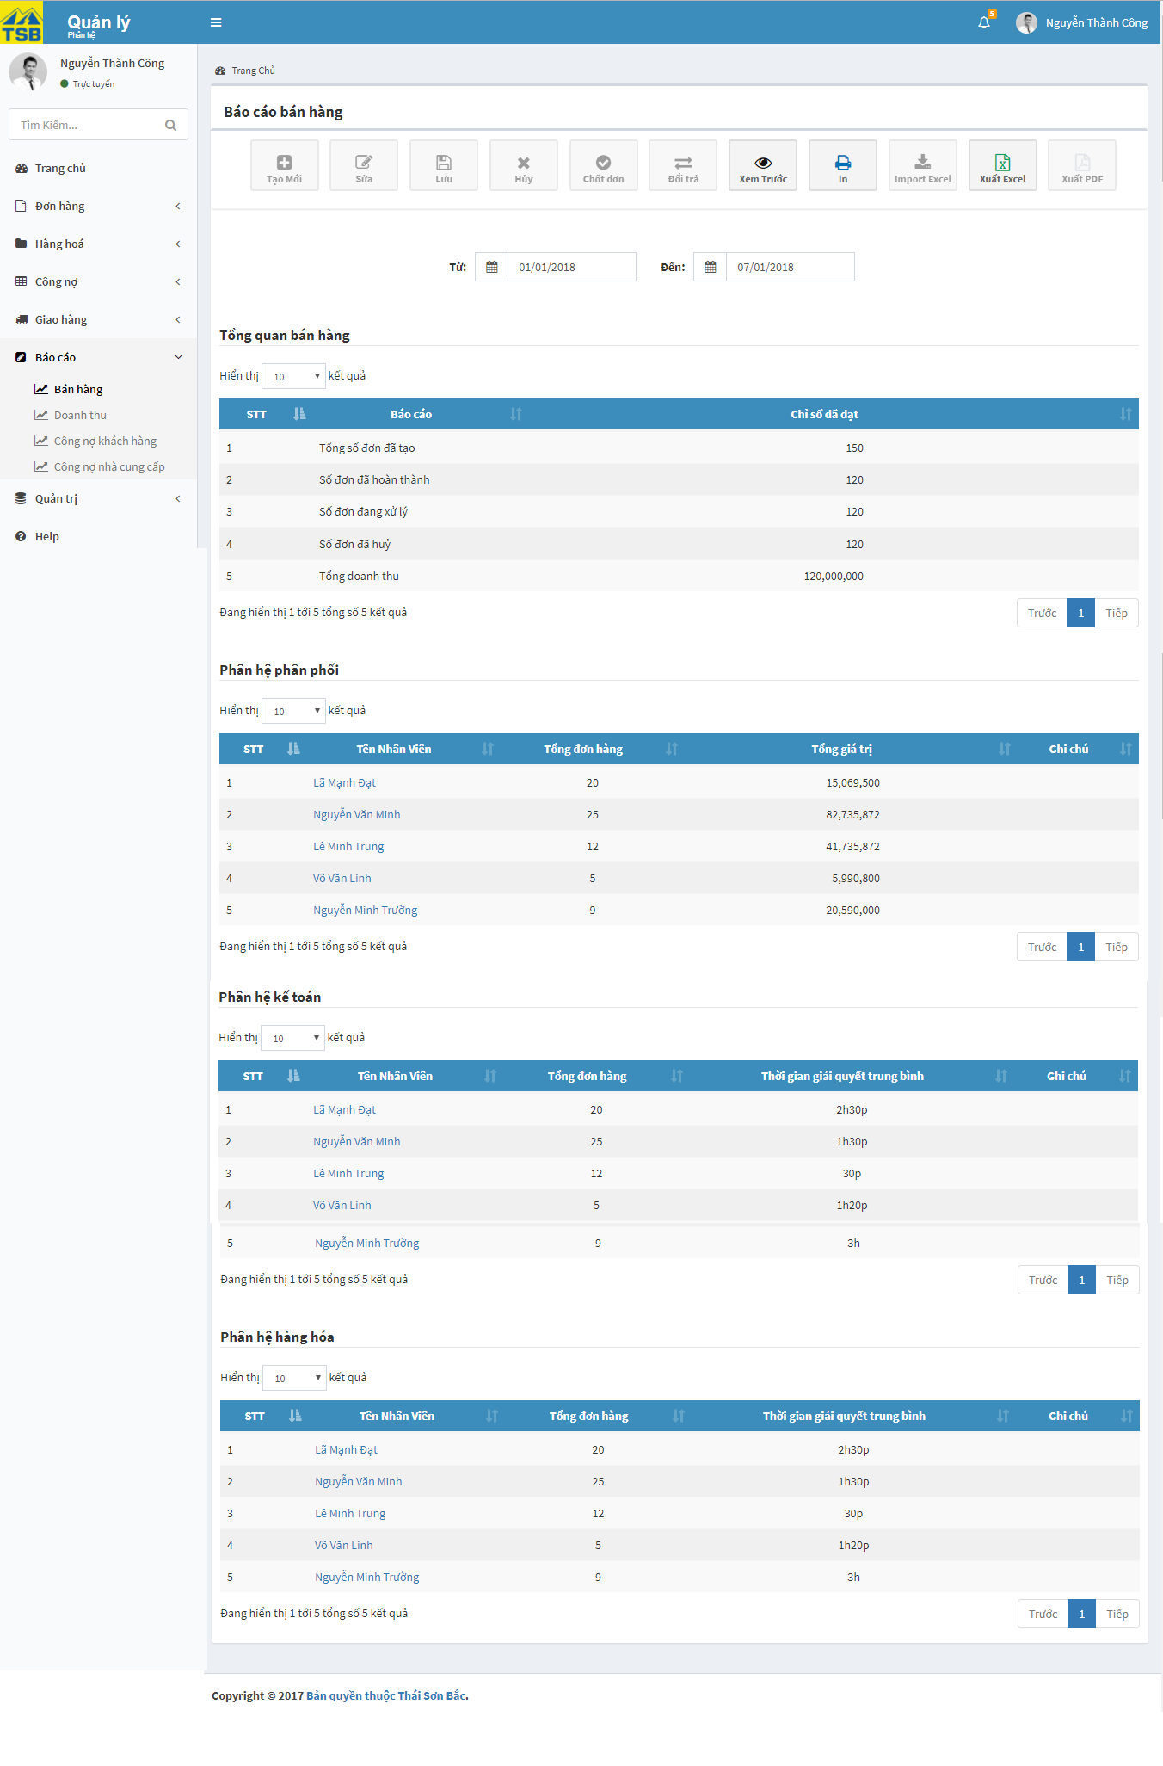

*Figure 3.60:* *View Sales activities report screen*

|  |  |  |  |  |
| --- | --- | --- | --- | --- |
| **USE CASE-040 SPECIFICATION : View Sales activities report** | | | | |
| **Use-case No.** | <UC040> | **Use-case Version** | | <1.0> |
| **Use-case Name** | View Sales activities report | | | |
| **Author** | AnhNTL | | | |
| **Date** | Jan 2nd,2018 | **Priority** | High | |
| **Actor:**  *Management*  **Summary:**  *User view Sales activities report*  **Goal:**  *Display Sales activities report and performance of employees*  **Triggers**  **Preconditions:**  *User click on “Bán hàng” in tab ”Báo cáo” on left menu*  **Post Conditions:**  *Display “Báo cáo bán hàng” page*  **Main Success Scenario:**   |  |  |  | | --- | --- | --- | | *Step* | *User action* | *System response* | | *1* | *User click on “Bán hàng” in tab ”Báo cáo” on left menu* | *Display “Báo cáo bán hàng” page* |   **Alternative Scenario:**  **Exceptions:**  **Business Rules:**  *On “Báo cáo doanh thu” page, user can select timeframe to view* | | | | |

*Table 3.89 View sale activities report*

Screen description:

|  |  |  |  |  |  |  |
| --- | --- | --- | --- | --- | --- | --- |
| Field name | Description | Mandatory | Read only | Control type | Data type | Length |
| Print button | Button of page | - | - | Button | - | - |
| Export excel button | Button of page | - | - | Button | - | - |
| Export pdf button | Button of page | - | - | Button | - | - |
| Date (from) search field | Limit time to search | Y | B | Datepicker | Date | 20 |
| Date (from) search field | Limit time to search | Y | B | Datepicker | Date | 20 |
| Main indicators table | Main indicators | - | - | Table | - | - |
| Performance of role sale table | performance of employees in role phân phối | - | - | Table | - | - |
| Performance of role warehouse table | performance of employees in role hàng hoá | - | - | Table | - | - |
| Performance of role accountant table | performance of employees in role Accountant | - | - | Table | - | - |

*Table 3.90 Screen description view sale activities report*

###### Search revenue detail

Use case specification:

|  |  |  |  |  |
| --- | --- | --- | --- | --- |
| **USE CASE-041 SPECIFICATION : Search revenue detail** | | | | |
| **Use-case No.** | <UC041> | **Use-case Version** | | <1.0> |
| **Use-case Name** | Search revenue detail | | | |
| **Author** | AnhNTL | | | |
| **Date** | Jan 2nd,2018 | **Priority** | High | |
| **Actor:**  *Sellers, managers*  **Summary:**  *User search evenue detail*  **Goal:**  *Search product revenue correct conditions*  **Triggers**  **Preconditions:**  *On” Chi tiết doanh thu” page, user select value for search conditions*  **Post Conditions:**  *Display list of products revenue fit with conditions*  **Main Success Scenario:**   |  |  |  | | --- | --- | --- | | *Step* | *User action* | *System response* | | *1* | *On ”Chi tiết doanh thu” page, user select value for search conditions* | *Validate* | | *2* | *Click “Tìm kiếm” button* | *Display list of products revenue fit with conditions* |   **Alternative Scenario:**  **Exceptions:**  **Business Rules:** | | | | |

*Table 3.91 Usecase search revenue detail*

###### Search product purchase

Use case specification:

|  |  |  |  |  |
| --- | --- | --- | --- | --- |
| **USE CASE-042 SPECIFICATION : Search product purchase** | | | | |
| **Use-case No.** | <UC042> | **Use-case Version** | | <1.0> |
| **Use-case Name** | Search product purchase | | | |
| **Author** | AnhNTL | | | |
| **Date** | Jan 2nd,2018 | **Priority** | High | |
| **Actor:**  *Sellers, managers*  **Summary:**  *User search producst purchase list*  **Goal:**  *Search products purchase correct conditions*  **Triggers**  **Preconditions:**  *On “Chi tiết nhập hàng” page, user select value for search conditions*  **Post Conditions:**  *Display list of products purchase fit with conditions on respective product list page*  **Main Success Scenario:**   |  |  |  | | --- | --- | --- | | *Step* | *User action* | *System response* | | *1* | *On “Chi tiết nhập hàng” page, user select value for search conditions* | *Validate* | | *2* | *Click “Tìm kiếm” button* | *Display list of products purchase fit with conditions* |   **Alternative Scenario:**  **Exceptions:**  **Business Rules:** | | | | |

*Table 3.92 Usecase search product purchase*

#### Customer management

##### Usecase diagram



*Figure 3.61:* *Usecase customer diagram*

##### Usecase

###### Create customer

Use case specification:

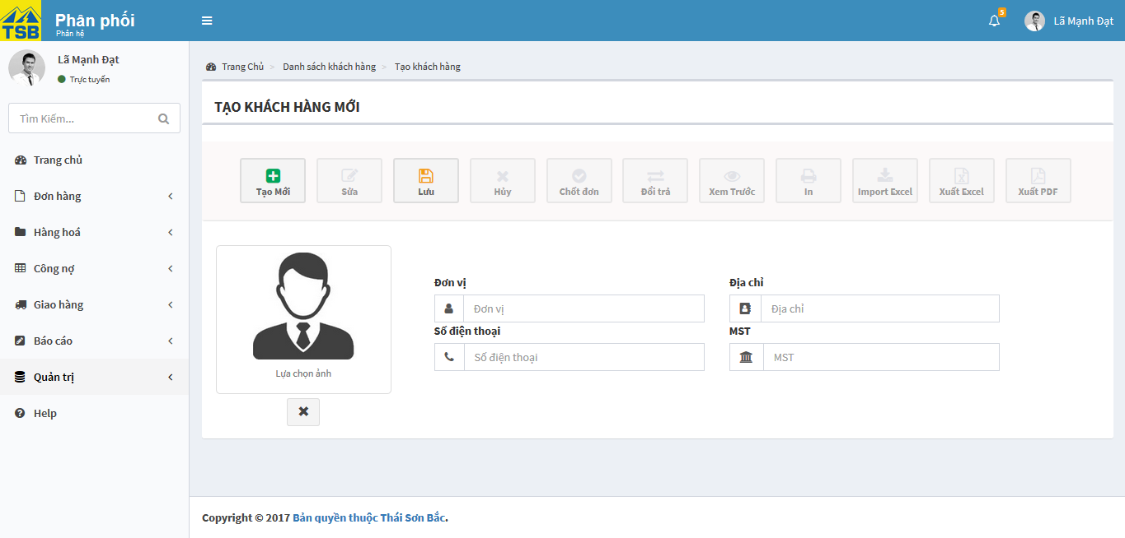

*Figure 3.62:* *Create customer screen*

|  |  |  |  |  |
| --- | --- | --- | --- | --- |
| **USE CASE-043 SPECIFICATION : Create customer** | | | | |
| **Use-case No.** | <UC043> | **Use-case Version** | | <1.0> |
| **Use-case Name** | Create customer | | | |
| **Author** | AnhNTL | | | |
| **Date** | Jan 2nd,2018 | **Priority** | HIgh | |
| **Actor:**  *Sellers, managers*  **Summary:**  *User create new customer*  **Goal:**  *New customer created*  **Triggers**  **Preconditions:**  *On “ Danh sách khách hàng” page click on “Tạo mới” button*  **Post Conditions:**  *Redirect to “Chi tiết khách hàng” page*  **Main Success Scenario:**   |  |  |  | | --- | --- | --- | | *Step* | *User action* | *System response* | | *1* | *On “ Danh sách khách hàng” page click on “Tạo mới” button* | *Display “Tạo mới khách hàng” page* | | *2* | *Input data* | *Validate* | | *3* | *Click “Lưu” button* | *Display pop-up confirm* | | *4* | *Click “OK” button* | *Add new customer*  *Display created success message*  *Redirect to “Chi tiết khách hàng” page* |   **Alternative Scenario:**   |  |  |  | | --- | --- | --- | | *Step* | *User action* | *System response* | | *1* | *In “ Công nợ khách hàng” page, click “Tạo mới” button* | *Display pop-up to input new customer debt* | |  | *Input new customer debt* | *Validate* | |  | *Click “Lưu” button* | *Display pop-up confirm* | |  | *Click “OK” button* | *Create new customer*  *Add new transaction for that customer*  *Display success message*  *Notify user edit information of customer* |   **Exceptions:**  **Business Rules:**  *Validate by name, phone, email, tax code* | | | | |

Table 3.92 Usecase create customer

Screen description:

|  |  |  |  |  |  |  |
| --- | --- | --- | --- | --- | --- | --- |
| Field name | Description | Mandatory | Read only | Control type | Data type | Length |
| “Tạo mới” button | Button of page | - | - | Button | - | - |
| “Lưu” button | Button of page | - | - | Button | - | - |
| Customer avatar field | Customer avatar | N | N | Image upload | File | - |
| Name field | Customer name | Y | N | Text field | Nvarchar | 50 |
| Phone field | Customer phone | Y | N | Text field | Nvarchar | 50 |
| Email field | Customer email | N | N | Text field | Nvarchar | 50 |
| Delivery address field | Customer delivery address | Y | N | Text field | Nvarchar | MAX |
| Receive invoice address field | Customer receive address | Y | N | Text field | Nvarchar | MAX |
| Tax code field | Customer tax code | Y | N | Text field | Nvarchar | 50 |

###### Edit customer

Use case specification:

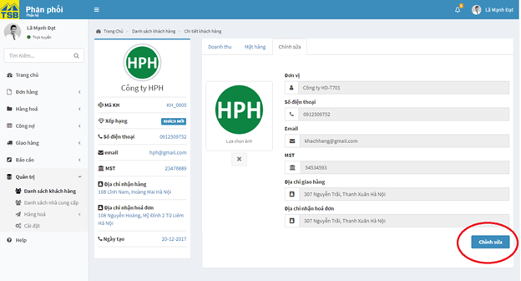

*Figure 3.63:* *Edit customer screen*

|  |  |  |  |  |
| --- | --- | --- | --- | --- |
| **USE CASE-044 SPECIFICATION : Edit customer** | | | | |
| **Use-case No.** | <UC044> | **Use-case Version** | | <1.0> |
| **Use-case Name** | Edit customer | | | |
| **Author** | AnhNTL | | | |
| **Date** | Jan 2nd,2018 | **Priority** | Normal | |
| **Actor:**  *Sellers, managers*  **Summary:**  *User edit customer*  **Goal:**  *Customer information updated*  **Triggers**  **Preconditions:**  *On “Chi tiết khách hàng” page, “Chỉnh sửa” tab, click on “Chỉnh sửa” button*  **Post Conditions:**  *Refresh “Chi tiết khách hàng” page*  **Main Success Scenario:**   |  |  |  | | --- | --- | --- | | *Step* | *User action* | *System response* | |  | *On “Chi tiết khách hàng” page, click “Chỉnh sửa” tab* | *Display “Chỉnh sửa” tab* | |  | *Click on “Chỉnh sửa” button* | *Enable fields to eidt*  *“Chỉnh sửa”button change “Lưu”button* | |  | *Edit informations* | *Validate* | |  | *Click “Lưu” button* | *Display pop-up confirm* | |  | *Confirm” OK”* | *Update customer*  *Display update success message*  *Refresh “Chi tiết khách hàng” page* |   **Alternative Scenario:**  **Exceptions:**  **Business Rules:** | | | | |

*Table 3.93 Usecase edit customer*

Screen description:

- “Chi tiết khách hàng” page, “Chỉnh sửa” tab

|  |  |  |  |  |  |  |
| --- | --- | --- | --- | --- | --- | --- |
| Field name | Description | Mandatory | Read only | Control type | Data type | Length |
| Customer avatar field | Customer avatar | N | N | Image upload | File | - |
| Name field | Customer name | Y | N | Text field | Nvarchar | 50 |
| Phone field | Customer phone | Y | N | Text field | Nvarchar | 50 |
| Email field | Customer email | N | N | Text field | Nvarchar | 50 |
| Delivery address field | Customer delivery address | Y | N | Text field | Nvarchar | MAX |
| Receive invoice address field | Customer receive address | Y | N | Text field | Nvarchar | MAX |
| Tax code field | Customer tax code | Y | N | Text field | Nvarchar | 50 |
| “Chỉnh sửa” button | Button of form | - | - | Button | - | - |
| “Lưu” button | Button of form | - | - | Button | - | - |

*Table 3.94 Screen description edit customer*

###### View customer

Use case specification:

- “Doanh thu” tab

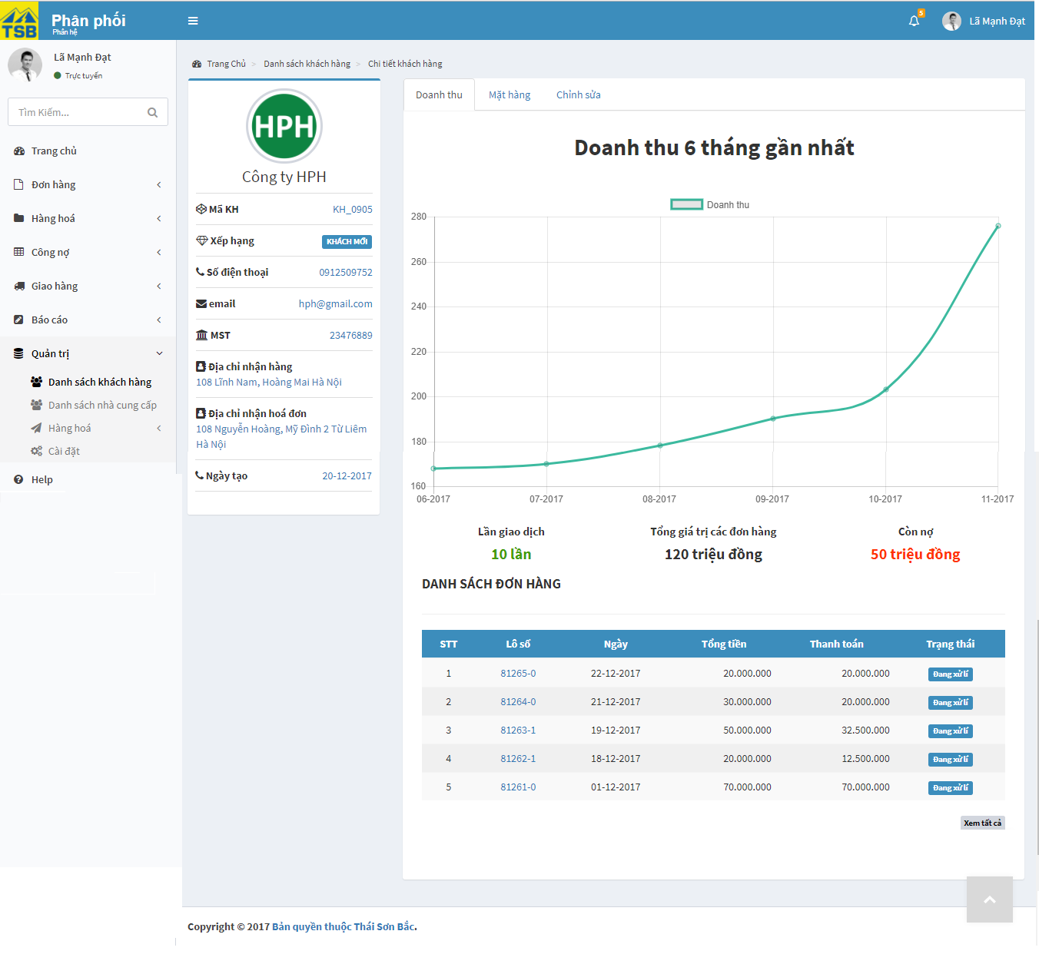

*Figure 3.64:* *View customer screen*

- “Mặt hàng” tab

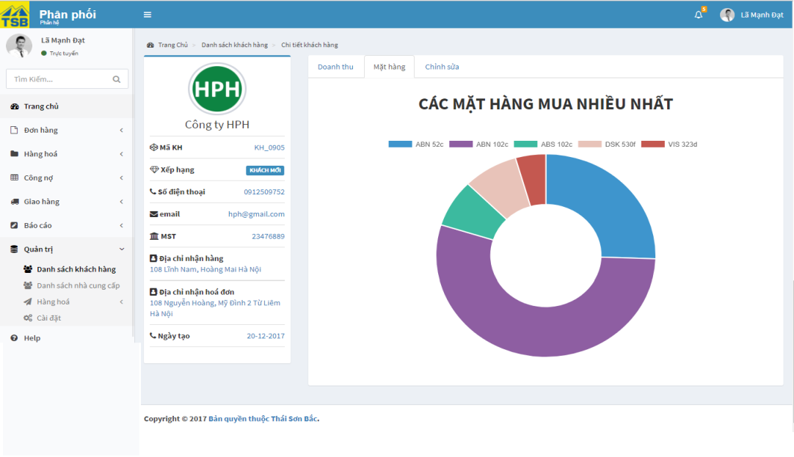

*Figure 3.65:* *View customer screen*

|  |  |  |  |  |
| --- | --- | --- | --- | --- |
| **USE CASE-045 SPECIFICATION : View customer** | | | | |
| **Use-case No.** | <UC045> | **Use-case Version** | | <1.0> |
| **Use-case Name** | View customer | | | |
| **Author** | AnhNTL | | | |
| **Date** | Jan 2nd,2018 | **Priority** | Normal | |
| **Actor:**  *Sellers, managers*  **Summary:**  *User view detail customer*  **Goal:**  *Display detail customer*  **Triggers**  **Preconditions:**  *On “Danh sách khách hàng” click on customer name or click on view button*  **Post Conditions:**  *Display “Chi tiết khách hàng” page*  **Main Success Scenario:**   |  |  |  | | --- | --- | --- | | *Step* | *User action* | *System response* | | *1* | *On “Danh sách khách hàng” click on customer name* | *Display “Chi tiết khách hàng” page* |   **Alternative Scenario:**   |  |  |  | | --- | --- | --- | | *Step* | *User action* | *System response* | | *1* | *On “Danh sách khách hàng” click on “Xem” button* | *Display “Chi tiết khách hàng” page* |  |  |  |  | | --- | --- | --- | | *Step* | *User action* | *System response* | | *1* | *On “Báo cáo công nợ khách hàng” , top 10 customer debt table, click in customer name* | *Display “Chi tiết khách hàng” page* |   **Exceptions:**  **Business Rules:**  *When user click “Xem tất cả” button on “Doanh thu” tab, list order of customer will be displayed* | | | | |

*Table 3.95 Usecase view customer*

Screen description:

- “ Chi tiết khách hàng” page

|  |  |  |  |  |  |  |
| --- | --- | --- | --- | --- | --- | --- |
| Field name | Description | Mandatory | Read only | Control type | Data type | Length |
| Customer avatar field | Customer avatar | N | Y | Image upload | File | - |
| Name field | Customer name | Y | Y | Text field | Nvarchar | 50 |
| Phone field | Customer phone | Y | Y | Text field | Nvarchar | 50 |
| Email field | Customer email | N | Y | Text field | Nvarchar | 50 |
| Delivery address field | Customer delivery address | Y | Y | Text field | Nvarchar | MAX |
| Receive invoice address field | Customer receive address | Y | Y | Text field | Nvarchar | MAX |
| Tax code field | Customer tax code | Y | Y | Text field | Nvarchar | 50 |
| Date create field | Date create customer | Y | Y | Text field | Date | 20 |
| “Doanh thu” tab | Revenue form customer | - | - | Tab | - | - |
| “Mặt hàng” tab | Products are bought by customer | - | - | Tab | - | - |
| “Chỉnh sửa” tab | Edit customer | - | - | Tab | - | - |

*Table 3.96 Screen description customer detail*

- “Doanh thu” tab

|  |  |  |  |  |  |  |
| --- | --- | --- | --- | --- | --- | --- |
| Field name | Description | Mandatory | Read only | Control type | Data type | Length |
| Revenue linechart | Revenue from customer in 6 month | - | - | Line chart | - | - |
| Some information about transaction | Some information about transaction | - | - | Text | Nvarchar | MAX |
| Order list table | Order list of customer | - | - | Table | - | - |
| “Xem tất cả” button | Button of form | - | - | Button | - | - |

*Table 3.97 Screen description revenue from customer*

- “Mặt hàng” tab

|  |  |  |  |  |  |  |
| --- | --- | --- | --- | --- | --- | --- |
| Field name | Description | Mandatory | Read only | Control type | Data type | Length |
| Donut chart percent product was bought | Percent product was bought | - | - | Donut chart | - | - |

*Table 3.98 Screen description “Mặt hàng” tab*

###### View list of customer

Use case specification:

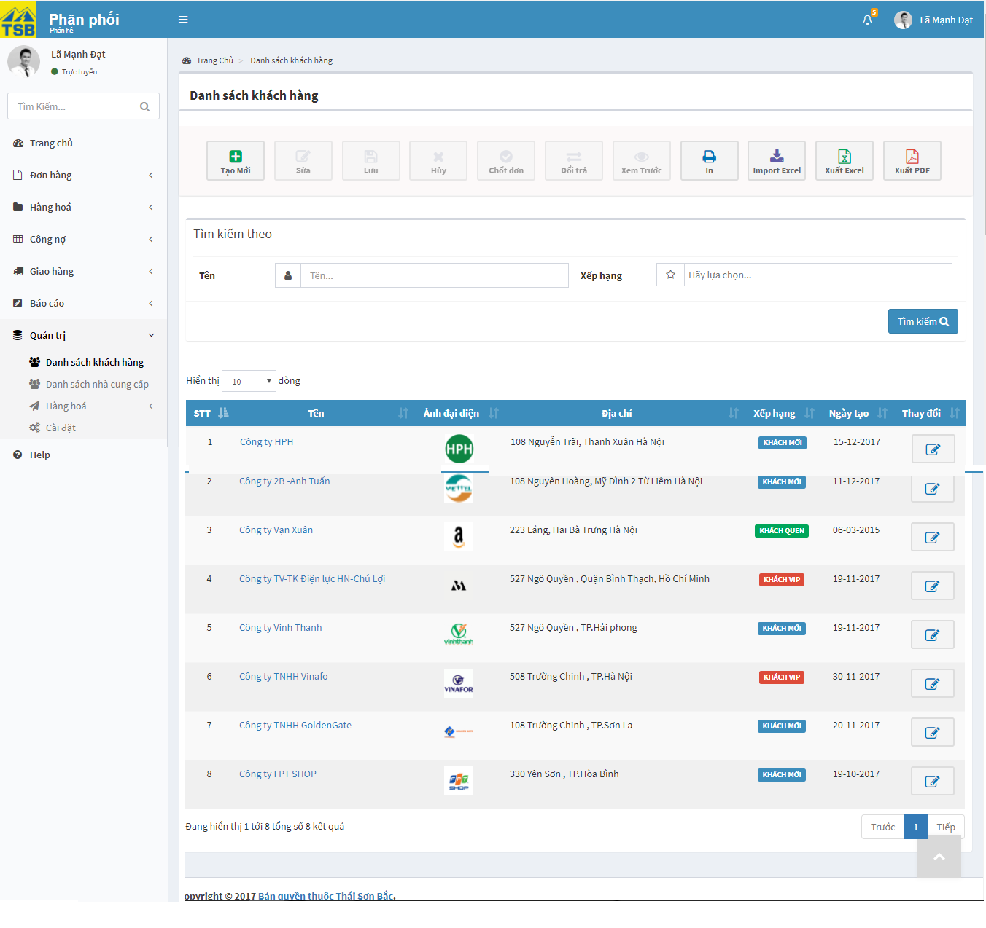

*Figure 3.66: View list of customer screen*

|  |  |  |  |  |
| --- | --- | --- | --- | --- |
| **USE CASE-046 SPECIFICATION : View list of customer** | | | | |
| **Use-case No.** | <UC046> | **Use-case Version** | | <1.0> |
| **Use-case Name** | View list of customer | | | |
| **Author** | AnhNTL | | | |
| **Date** | Jan 2nd,2018 | **Priority** | Normal | |
| **Actor:**  *Sellers, managers*  **Summary:**  *User view customer list*  **Goal:**  *Display customer list*  **Triggers**  **Preconditions:**  *Click “Danh sách khách hàng” in tab “Quản trị” on left menu*  **Post Conditions:**  *Display “Danh sách khách hàng” page*  **Main Success Scenario:**   |  |  |  | | --- | --- | --- | | *Step* | *User action* | *System response* | | *1* | *Click “Danh sách khách hàng” in tab “Quản trị” on left menu* | *Display “Danh sách khách hàng” page* |   **Alternative Scenario:**  **Exceptions:**  **Business Rules:** | | | | |

*Table 3.99 Usecase view list of customer*

Screen description:

|  |  |  |  |  |  |  |
| --- | --- | --- | --- | --- | --- | --- |
| Field name | Description | Mandatory | Read only | Control type | Data type | Length |
| “Tạo” button | Button of page | - | - | Button | - | - |
| “ Xem trước” button | Button of page | - | - | Button | - | - |
| “In” button | Button of page | - | - | Button | - | - |
| “Xuất excel” button | Button of page | - | - | Button | - | - |
| “Xuất pdf” button | Button of page | - | - | Button | - | - |
| Customer name search field | Customer name for search | N | N | Text field | Nvarchar | 50 |
| Customer rank search field | Customer rank for search | N | N | Dropbox | Nvarchar | 50 |
| Search button | Button of form | - | - | Button | - | - |
| Customer list table | Customer list table | - | - | Table | - | - |

*Table 3.100 Screen description view list of customer*

###### Search customer

Use case specification:

|  |  |  |  |  |
| --- | --- | --- | --- | --- |
| **USE CASE-047 SPECIFICATION : Search customer** | | | | |
| **Use-case No.** | <UC047> | **Use-case Version** | | <1.0> |
| **Use-case Name** | Search customer | | | |
| **Author** | AnhNTL | | | |
| **Date** | Jan 2nd,2018 | **Priority** | Low | |
| **Actor:**  *Sellers, managers*  **Summary:**  *User search customer*  **Goal:**  *Display list customer fit with conditions*  **Triggers**  **Preconditions:**  *On “Danh sách khách hàng” page , user select conditions*  **Post Conditions:**  *Display user user fir with conditions on “Danh sách khách hàng” page*  **Main Success Scenario:**   |  |  |  | | --- | --- | --- | | *Step* | *User action* | *System response* | | *1* | *On “Danh sách khách hàng” page , user select conditions* | *Validate* | | *2* | *Click “Search” button* | *Display user user fir with conditions on “Danh sách khách hàng” page* |   **Alternative Scenario:**  **Exceptions:**  **Business Rules:** | | | | |

*Table 3.101 Usecase search customer*

#### Supplier management

##### Usecase diagram



*Figure 3.68: Supplier usercase diagram*

##### Usecase

###### Create supplier

Use case specification:

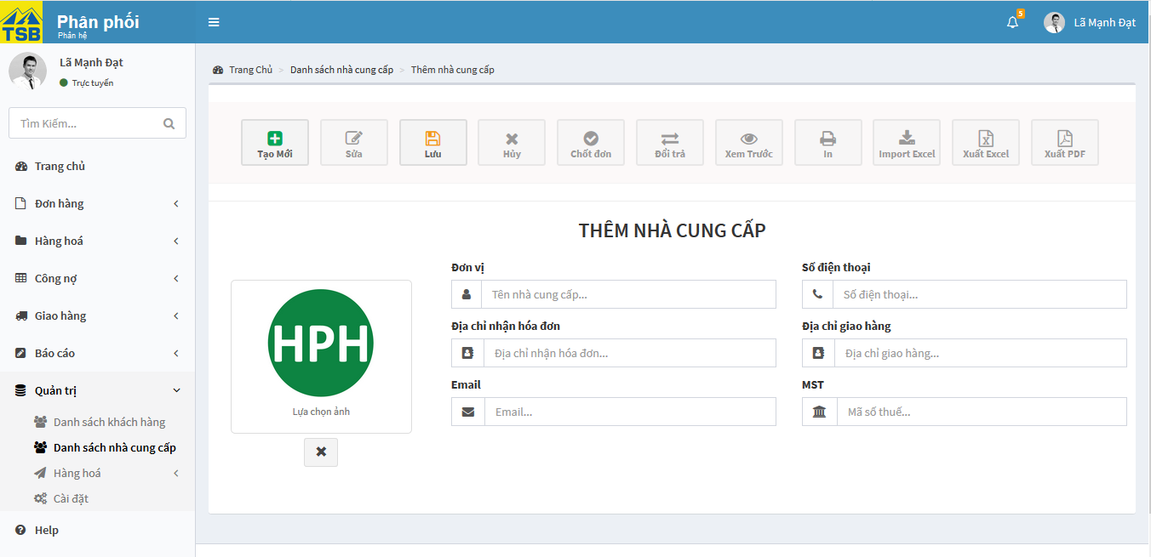

*Figure 3.69: Create supplier screen*

|  |  |  |  |  |
| --- | --- | --- | --- | --- |
| **USE CASE-048 SPECIFICATION : Create supplier** | | | | |
| **Use-case No.** | <UC048> | **Use-case Version** | | <1.0> |
| **Use-case Name** | Create supplier | | | |
| **Author** | AnhNTL | | | |
| **Date** | Jan 2nd,2018 | **Priority** | High | |
| **Actor:**  *Sellers, managers*  **Summary:**  *User create new supplier*  **Goal:**  *New supplier created*  **Triggers**  **Preconditions:**  *On “Danh sách nhà cung cấp” page click on “Tạo mới” button*  **Post Conditions:**  *Redirect to “Chi tiết khách hàng” page*  **Main Success Scenario:**   |  |  |  | | --- | --- | --- | | *Step* | *User action* | *System response* | | *1* | *On “ Danh sách nhà cung cấp” page click on “Tạo mới” button* | *Display “Tạo mới nhà cung cấp” page* | | *2* | *Input data* | *Validate* | | *3* | *Click “Lưu” button* | *Display pop-up confirm* | | *4* | *Click “OK” button* | *Add new supplier*  *Display created success message*  *Redirect to “Chi tiết nhà cung cấp” page* |   **Alternative Scenario:**   |  |  |  | | --- | --- | --- | | *Step* | *User action* | *System response* | | *1* | *In “ Công nợ nhà cung cấp” page, click “Tạo mới” button* | *Display pop-up to input new supplier debt* | | *2* | *Input new supplier debt* | *Validate* | | *3* | *Click “Lưu” button* | *Display pop-up confirm* | | *4* | *Click “OK” button* | *Create new supplier*  *Add new transaction for that supplier*  *Display success message*  *Notify user edit information of supplier* |   **Exceptions:**  **Business Rules:**  *Validate by name, phone, email, tax code* | | | | |

*Table 3.102 Usecase create supplier*

Screen description:

|  |  |  |  |  |  |  |
| --- | --- | --- | --- | --- | --- | --- |
| Field name | Description | Mandatory | Read only | Control type | Data type | Length |
| “Tạo mới” button | Button of page | - | - | Button | - | - |
| “Lưu” button | Button of page | - | - | Button | - | - |
| Supplier avatar field | Supplier avatar | N | N | Image upload | File | - |
| Name field | Supplier name | Y | N | Text field | Nvarchar | 50 |
| Phone field | Supplier phone | Y | N | Text field | Nvarchar | 50 |
| Email field | Supplier email | N | N | Text field | Nvarchar | 50 |
| Address field | Supplier address | Y | N | Text field | Nvarchar | MAX |
| Tax code field | Supplier tax code | Y | N | Text field | Nvarchar | 50 |

*Table 3.103 Screen description create supplier*

###### Edit supplier

Use case specification:

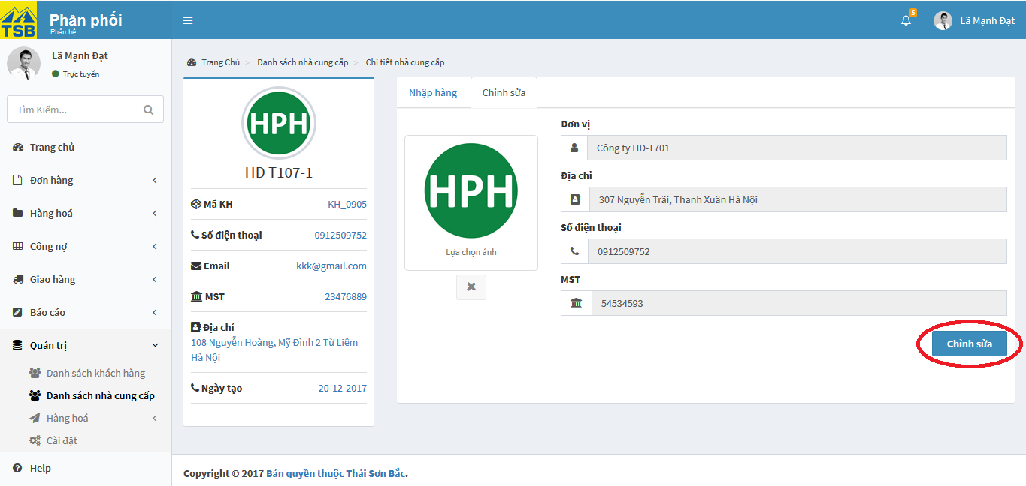

*Figure 3.70: Edit supplier screen*

|  |  |  |  |  |
| --- | --- | --- | --- | --- |
| **USE CASE-049 SPECIFICATION : Edit supplier** | | | | |
| **Use-case No.** | <UC049> | **Use-case Version** | | <1.0> |
| **Use-case Name** | Edit supplier | | | |
| **Author** | AnhNTL | | | |
| **Date** | Jan 2nd,2018 | **Priority** | Normal | |
| **Actor:**  *Sellers, managers*  **Summary:**  *User edit supplier*  **Goal:**  *Supplier information updated*  **Triggers**  **Preconditions:**  *On “Chi tiết nhà cung cấp” page, “Chỉnh sửa” tab, click on “Chỉnh sửa” button*  **Post Conditions:**  *Refresh “ Chi tiết nhà cung cấp” page*  **Main Success Scenario:**   |  |  |  | | --- | --- | --- | | *Step* | *User action* | *System response* | | *1* | *On “Chi tiết nhà cung cấp” page, click “Chỉnh sửa” tab* | *Display “Chỉnh sửa” tab* | | *2* | *Click on “Chỉnh sửa” button* | *Enable fields to eidt*  *“Chỉnh sửa”button change “Lưu”button* | | *3* | *Edit informations* | *Validate* | | *4* | *Click “Lưu” button* | *Display pop-up confirm* | | *5* | *Confirm” OK”* | *Update supplier*  *Display update success message*  *Refresh “Chi tiết nhà cung cấp” page* |   **Alternative Scenario:**  **Exceptions:**  **Business Rules:** | | | | |

*Table 3.105 Usecase edit supplier*

Screen description:

|  |  |  |  |  |  |  |
| --- | --- | --- | --- | --- | --- | --- |
| Field name | Description | Mandatory | Read only | Control type | Data type | Length |
| Supplier avatar field | Supplier avatar | N | N | Image upload | File | - |
| Name field | Supplier name | Y | N | Text field | Nvarchar | 50 |
| Phone field | Supplier phone | Y | N | Text field | Nvarchar | 50 |
| Email field | Supplier email | N | N | Text field | Nvarchar | 50 |
| Address field | Supplier delivery address | Y | N | Text field | Nvarchar | MAX |
| Tax code field | Supplier tax code | Y | N | Text field | Nvarchar | 50 |
| “Chỉnh sửa” button | Button of form | - | - | Button | - | - |
| “Lưu” button | Button of form | - | - | Button | - | - |

*Table 3.106 Screen description edit supplier*

###### View supplier

Usecase specification:

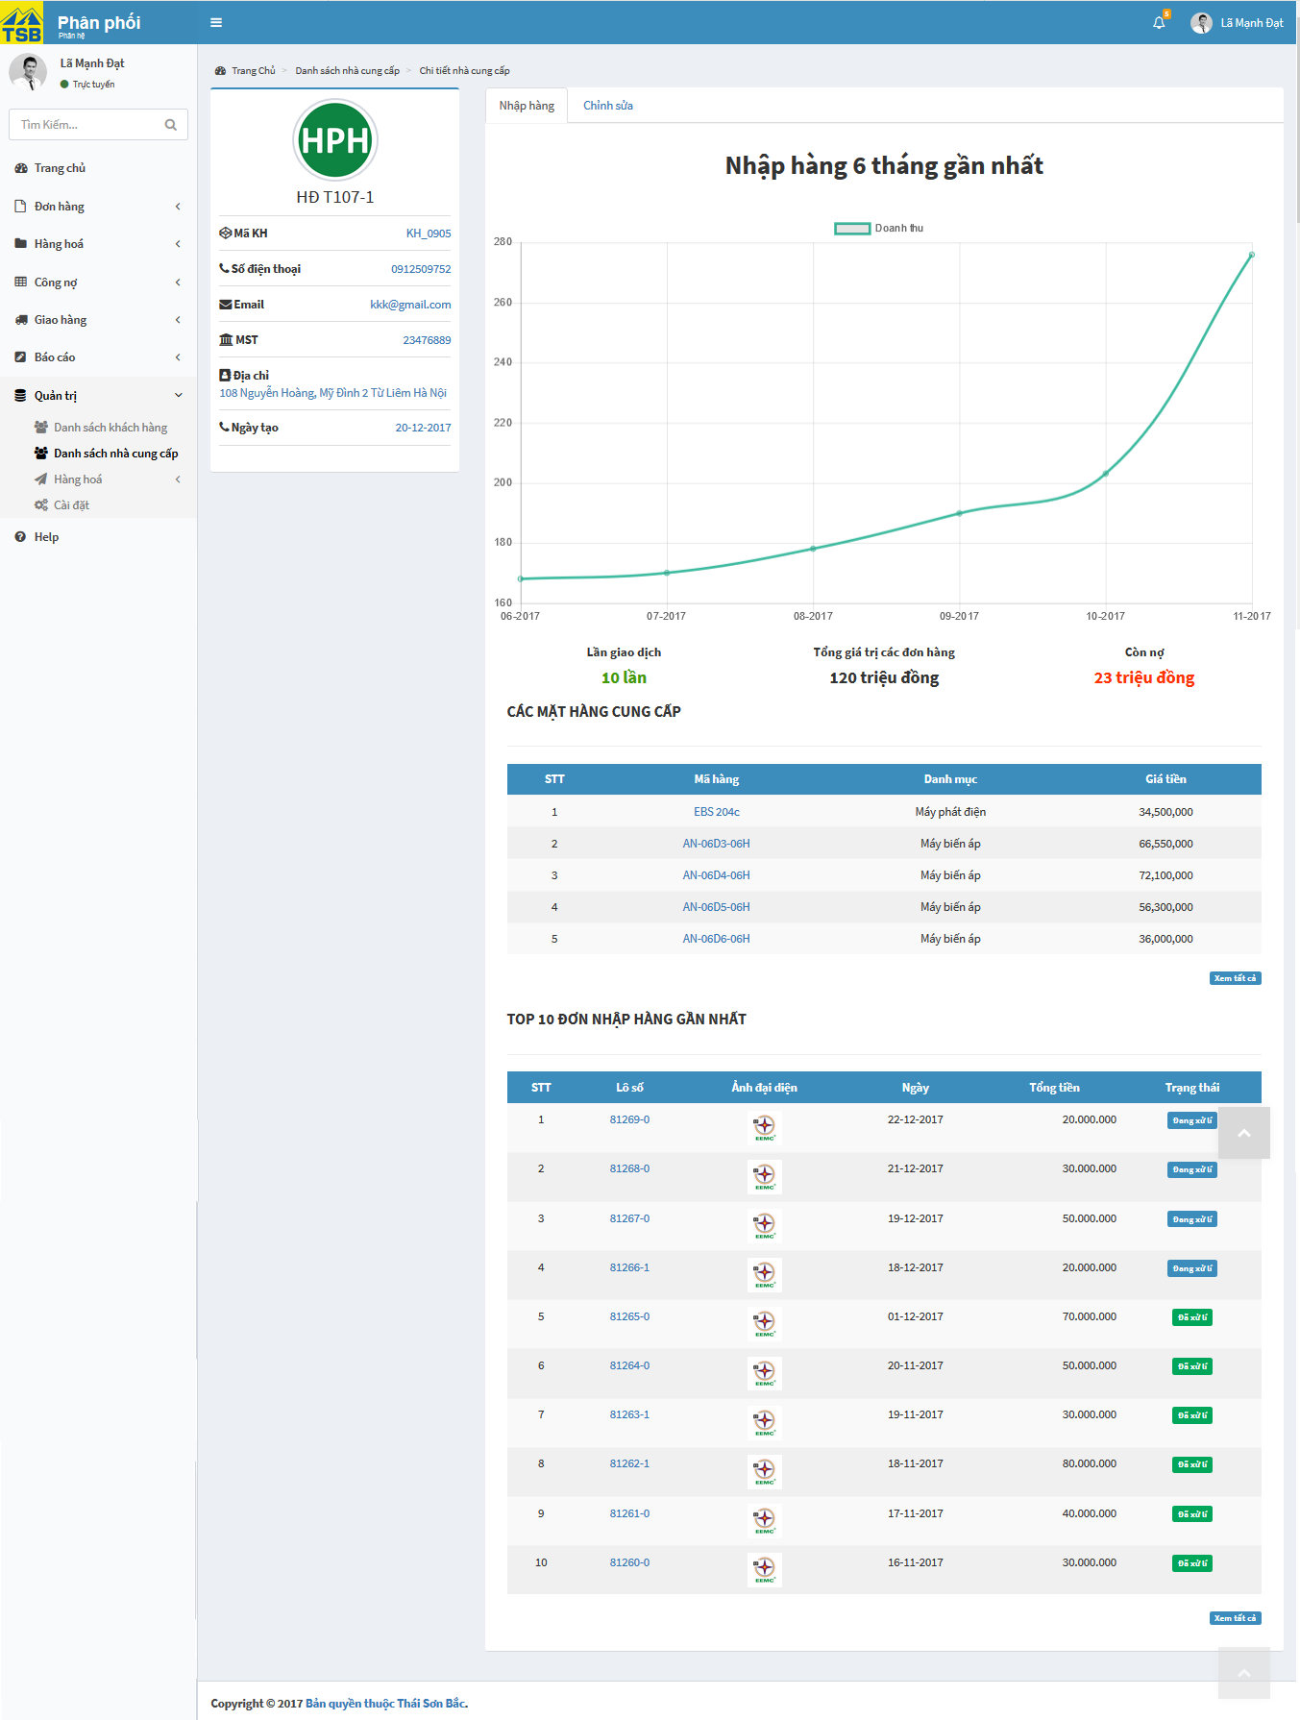

*Figure 3.71: View supplier screen*

|  |  |  |  |  |
| --- | --- | --- | --- | --- |
| **USE CASE-050 SPECIFICATION View supplier** | | | | |
|  | | | | |
| **Use-case No.** | <UC050> | **Use-case Version** | | <1.0> |
| **Use-case Name** | View supplier | | | |
| **Author** | AnhNTL | | | |
| **Date** | Jan 2nd,2018 | **Priority** | Normal | |
| **Actor:**  *Sellers, managers*  **Summary:**  *User view detail supplier*  **Goal:**  *Display detail supplier*  **Triggers**  **Preconditions:**  *On “Danh sách nhà cung cấp” click on supplier name or click on view button*  **Post Conditions:**  *Display “Chi tiết nhà cung cấp” page*  **Main Success Scenario:**   |  |  |  | | --- | --- | --- | | *Step* | *User action* | *System response* | | *1* | *On “Danh sách nhà cung cấp” click on supplier name* | *Display “Chi tiết nhà cung cấp” page* |   **Alternative Scenario:**   |  |  |  | | --- | --- | --- | | *Step* | *User action* | *System response* | | *1* | *On “Danh sách nhà cung cấp” click on “Xem” button* | *Display “Chi tiết nhà cung cấp” page* |   **Exceptions:**  **Business Rules:**  *When user click “Xem tất cả” button on “Nhập hàng” tab, list purchase order of supplier will be displayed* | | | | |

*Table 3.107 Usecase view supplier*

Screen description:

- “Chi tiết nhà cung cấp” page

|  |  |  |  |  |  |  |
| --- | --- | --- | --- | --- | --- | --- |
| Field name | Description | Mandatory | Read only | Control type | Data type | Length |
| Supplier avatar field | Supplier avatar | N | Y | Image upload | File | - |
| Name field | Supplier name | Y | Y | Text field | Nvarchar | 50 |
| Phone field | Supplier phone | Y | Y | Text field | Nvarchar | 50 |
| Email field | Supplier email | N | Y | Text field | Nvarchar | 50 |
| Delivery address field | Supplier delivery address | Y | Y | Text field | Nvarchar | MAX |
| Address field | Supplier address | Y | Y | Text field | Nvarchar | MAX |
| Tax code field | Customer tax code | Y | Y | Text field | Nvarchar | 50 |
| Date create field | Date create supplier | Y | Y | Text field | Date | 20 |
| “Nhập hàng” tab | Purchase form supplier | - | - | Tab | - | - |
| “Mặt hàng” tab | Products supplier purchase | - | - | Tab | - | - |
| “Chỉnh sửa” tab | Edit customer | - | - | Tab | - | - |

*Table 3.108 Screen description supplier detail*

- “Nhập hàng” tab

|  |  |  |  |  |  |  |
| --- | --- | --- | --- | --- | --- | --- |
| Field name | Description | Mandatory | Read only | Control type | Data type | Length |
| Total price of purchase linechart | Total price of purchase from supplier in 6 month | - | - | Line chart | - | - |
| Some information about transaction | Some information about transaction | - | - | Text | Nvarchar | MAX |
| Purchase order list table | Purchase order list of supplier | - | - | Table | - | - |
| “Xem tất cả” button | Button of form | - | - | Button | - | - |

*Table 3.109 Screen description “Nhập hàng”*

- “Mặt hàng” tab

|  |  |  |  |  |  |  |
| --- | --- | --- | --- | --- | --- | --- |
| Field name | Description | Mandatory | Read only | Control type | Data type | Length |
| List of products provide by supplier table | List of products provide by supplier | - | - | Table | - | - |

*Table 3.110 Screen description “Mặt hàng”*

###### View list of supplier

Use case specification:

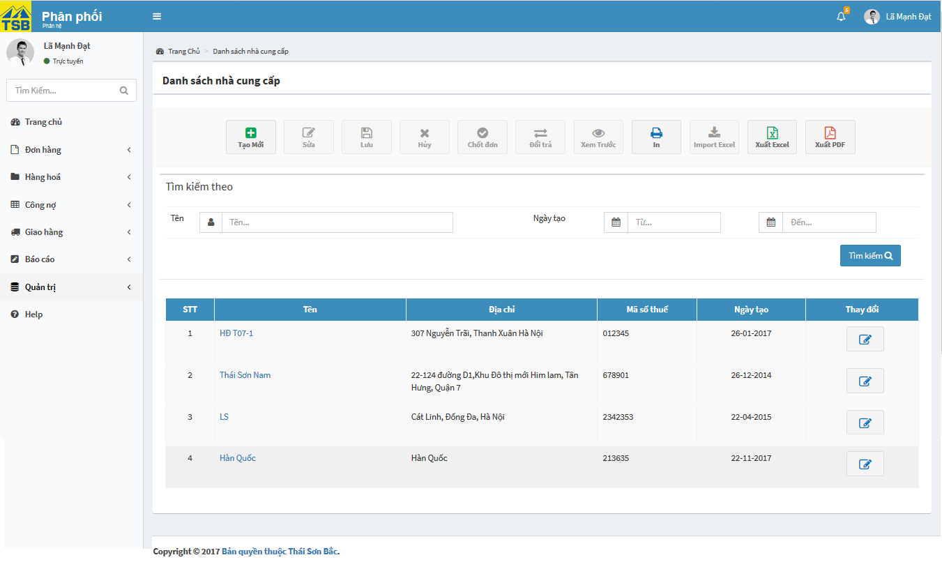

*Figure 3.72: View list of supplier screen*

|  |  |  |  |  |
| --- | --- | --- | --- | --- |
| **USE CASE-051 SPECIFICATION : View list of supplier** | | | | |
| **Use-case No.** | <UC051> | **Use-case Version** | | <1.0> |
| **Use-case Name** | View list of supplier | | | |
| **Author** | AnhNTL | | | |
| **Date** | Jan 2nd,2018 | **Priority** | Normal | |
| **Actor:**  *Sellers, managers*  **Summary:**  *User view list of supplier*  **Goal:**  *Display list of supplier page*  **Triggers**  **Preconditions:**  *Click “danh sách nhà cung cấp” in tab “Quản trị” on left menu*  **Post Conditions:**  *Display “Danh sách nhà cung cấp” page*  **Main Success Scenario:**   |  |  |  | | --- | --- | --- | | *Step* | *User action* | *System response* | | *1* | *Click “Danh sách nhà cung cấp” in tab “Quản trị” on left menu* | *Display “Danh sách nhà cung cấp” page* |   **Alternative Scenario:**  **Exceptions:**  **Business Rules:** | | | | |

*Table 3.111 Usecase view list of supplier*

Screen description:

|  |  |  |  |  |  |  |
| --- | --- | --- | --- | --- | --- | --- |
| Field name | Description | Mandatory | Read only | Control type | Data type | Length |
| “Tạo” button | Button of page | - | - | Button | - | - |
| “ Xem trước” button | Button of page | - | - | Button | - | - |
| “In” button | Button of page | - | - | Button | - | - |
| “Xuất excel” button | Button of page | - | - | Button | - | - |
| “Xuất pdf” button | Button of page | - | - | Button | - | - |
| Supplier name search field | Supplier name for search | N | N | Text field | Nvarchar | 50 |
| Date create (from) search field | Limit for search by date create | N | N | Datepicker | Date | 20 |
| Date create (to) search field | Limit for search by date create | N | N | Datepicker | Date | 20 |
| Search button | Button of form | - | - | Button | - | - |
| Supplier list table | Supplier list table | - | - | Table | - | - |

*Table 3.112 Screen description list of supplier*

###### Search supplier

Use case specification:

|  |  |  |  |  |
| --- | --- | --- | --- | --- |
| **USE CASE-052 SPECIFICATION : Search supplier** | | | | |
| **Use-case No.** | <UC052> | **Use-case Version** | | <1.0> |
| **Use-case Name** | Search supplier | | | |
| **Author** | AnhNTL | | | |
| **Date** | Jan 2nd,2018 | **Priority** | Low | |
| **Actor:**  *Sellers, managers*  **Summary:**  *User search supplier*  **Goal:**  *Display list supplier fit with conditions*  **Triggers**  **Preconditions:**  *On “Danh sách nhà cung cấp” page , user select conditions*  **Post Conditions:**  *Display user user fit with conditions on “Danh sách nhà cung cấp” page*  **Main Success Scenario:**   |  |  |  | | --- | --- | --- | | *Step* | *User action* | *System response* | | *1* | *On “Danh sách nhà cung cấp” page , user select conditions* | *Validate* | | *2* | *Click “Search” button* | *Display user user fir with conditions on “Danh sách nhà cung cấp” page* |   **Alternative Scenario:**  **Exceptions:**  **Business Rules:** | | | | |

*Table 3.113 Usecase search supplier*

#### User management

##### Usecase diagram



*Figure 3.73: User usercase diagram*

##### Usecase

###### Create user

Use case specification:

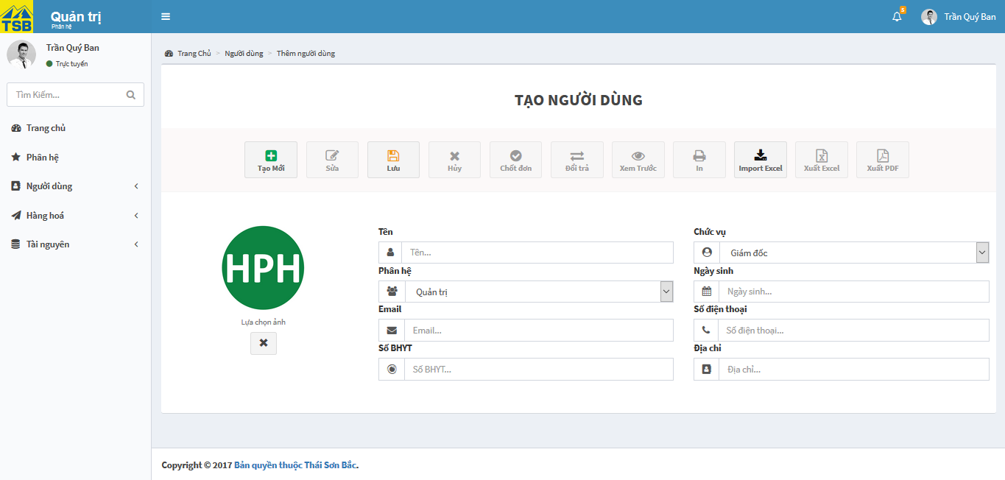

*Figure 3.74: Create user screen*

|  |  |  |  |  |
| --- | --- | --- | --- | --- |
| **USE CASE-053 SPECIFICATION : Create user** | | | | |
| **Use-case No.** | <UC053> | **Use-case Version** | | <1.0> |
| **Use-case Name** | Create user | | | |
| **Author** | AnhNTL | | | |
| **Date** | Jan 2nd,2018 | **Priority** | High | |
| **Actor:**  *Sellers, managers*  **Summary:**  *Create new user*  **Goal:**  *New user created*  **Triggers**  **Preconditions:**  *On “Danh sách người dùng đang hoạt động” page click on “Tạo mới” button*  **Post Conditions:**  *Redirect to “Chi tiết người dùng” page*  **Main Success Scenario:**   |  |  |  | | --- | --- | --- | | *Step* | *User action* | *System response* | | *1* | *On “Danh sách người dùng đang hoạt động” page click on “Tạo mới” button* | *Display “Tạo người dùng” page* | | *2* | *Input data* | *Validate* | | *3* | *Click “Lưu” button* | *Display pop-up confirm* | | *4* | *Click “OK” button* | *Add new user*  *Display created success message*  *Redirect to “Chi tiết người dùng” page* |   **Alternative Scenario:**   |  |  |  | | --- | --- | --- | | *Step* | *User ation* | *System response* | | *1* | *On “Danh sách người dùng dừng hoạt động” page click on “Tạo mới” button* | *Display “Tạo người dùng” page* | | *2* | *Input data* | *Validate* | | *3* | *Click “Lưu” button* | *Display pop-up confirm* | | *4* | *Click “OK” button* | *Add new user*  *Display created success message*  *Redirect to “Chi tiết người dùng” page* |   **Exceptions:**  **Business Rules:**  *Management can not create user with administrator role* | | | | |

*Table 3.114 Usecase create user*

Screen description:

|  |  |  |  |  |  |  |
| --- | --- | --- | --- | --- | --- | --- |
| Field name | Description | Mandatory | Read only | Control type | Data type | Length |
| “Tạo mới” button | Button of page | - | - | Button | - | - |
| “Lưu” button | Button of page | - | - | Button | - | - |
| User avatar field | User avatar | N | N | Image upload | File | - |
| Name field | User name | Y | N | Text field | Nvarchar | 50 |
| Phone field | User phone | Y | N | Text field | Nvarchar | 50 |
| Email field | Supplier email | Y | N | Text field | Nvarchar | 50 |
| Address field | User address | Y | N | Text field | Nvarchar | MAX |
| BHYT field | BHYT of user | N | N | Text field | Nvarchar | 50 |
| DOB field | Date of birth of customer | N | N | Datepicker | Date | 20 |
| Role field | Role of user | Y | N | Dropbox | Nvarchar | 50 |
| Office field | Office of user | Y | N | Dropbox | Nvarchar | 50 |

*Table 3.115 Screen description create user*

###### Edit user

Use case specification:

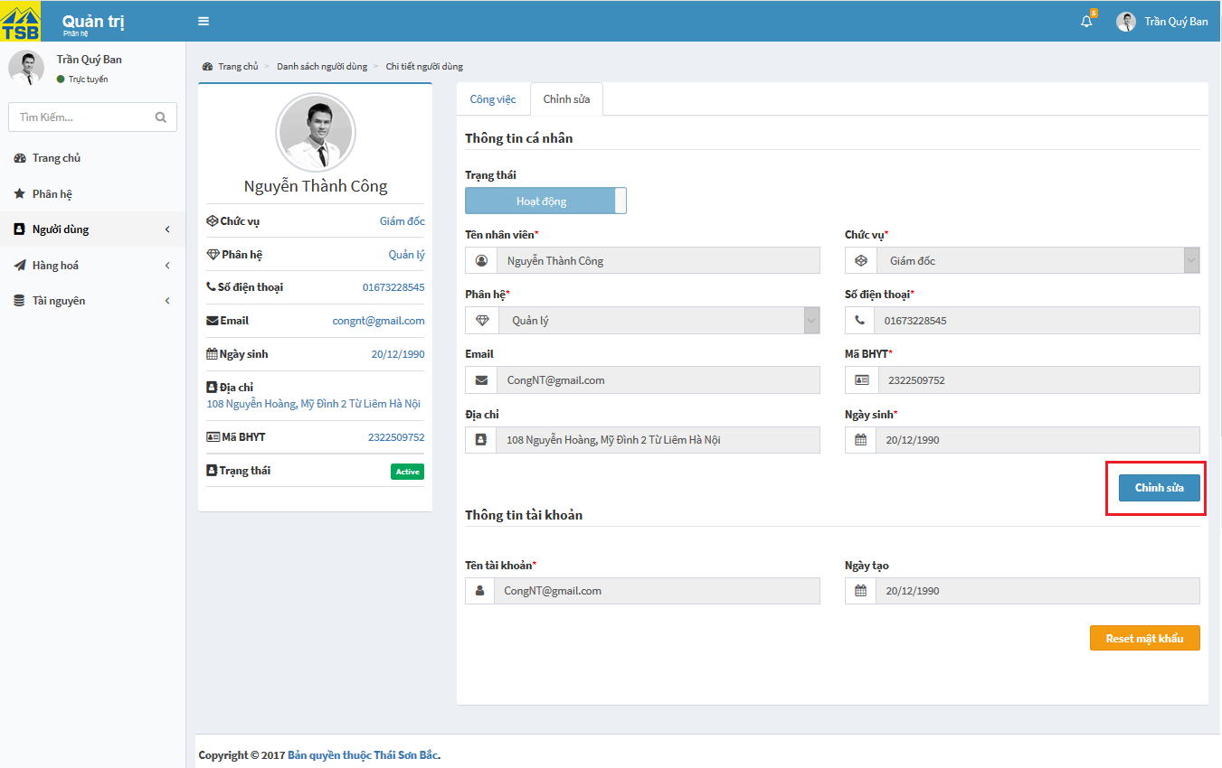

*Figure 3.75: Edit user screen*

|  |  |  |  |  |
| --- | --- | --- | --- | --- |
| **USE CASE-054 SPECIFICATION : Edit user** | | | | |
| **Use-case No.** | <UC054> | **Use-case Version** | | <1.0> |
| **Use-case Name** | Edit user | | | |
| **Author** | AnhNTL | | | |
| **Date** | Jan 2nd,2018 | **Priority** | Normal | |
| **Actor:**  *Management, administrator*  **Summary:**  *User edit user*  **Goal:**  *User information updated*  **Triggers**  **Preconditions:**  *On “Chi tiết người dùng” page, “Chỉnh sửa” tab, click on “Chỉnh sửa” button*  **Post Conditions:**  *Refresh “Chi tiết người dùng” page*  **Main Success Scenario:**   |  |  |  | | --- | --- | --- | | *Step* | *User action* | *System response* | | *1* | *On “Chi tiết người dùng” page, click “Chỉnh sửa” tab* | *Display “Chỉnh sửa” tab* | | *2* | *Click on “Chỉnh sửa” button* | *Enable fields to eidt*  *“Chỉnh sửa”button change “Lưu”button* | | *3* | *Edit informations* | *Validate* | | *4* | *Click “Lưu” button* | *Display pop-up confirm* | | *5* | *Confirm” OK”* | *Update user*  *Display update success message*  *Refresh “Chi tiết người dùng” page* |   **Alternative Scenario:**  **Exceptions:**  **Business Rules:** | | | | |

*Table 3.116 Usecase edit user*

Screen description:

- “Chi tiết người dùng” page, “Chỉnh sửa” tab

|  |  |  |  |  |  |  |
| --- | --- | --- | --- | --- | --- | --- |
| Field name | Description | Mandatory | Read only | Control type | Data type | Length |
| User avatar field | User avatar | Y | Y | Image upload | File | - |
| Name field | User name | Y | Y | Text field | Nvarchar | 50 |
| Phone field | User phone | Y | Y | Text field | Nvarchar | 50 |
| Email field | Supplier email | Y | Y | Text field | Nvarchar | 50 |
| Address field | User address | Y | Y | Text field | Nvarchar | MAX |
| BHYT field | BHYT of user | N | Y | Text field | Nvarchar | 50 |
| DOB field | Date of birth of customer | Y | Y | Datepicker | Date | 20 |
| Role field | Role of user | Y | Y | Dropbox | Nvarchar | 50 |
| Office field | Office of user | Y | Y | Dropbox | Nvarchar | 50 |
| Status field | Active/ Deactive | Y | Y | Toggle switch | Boolean | - |
| “Chỉnh sửa” button | Button of form | - | - | Button | - | - |
| “Lưu” button | Button of form | - | - | Button | - | - |
| Account name field | Account name of user | Y | Y | Text field | Nvarchar | 50 |
| Date create field | Date create user | Y | Y | Text field | Nvarchar | 50 |
| “Reset mật khẩu” button | Reset password button | - | - | Button | - | - |

*Table 3.117 Screen description edit user*

###### View user

Use case specification:

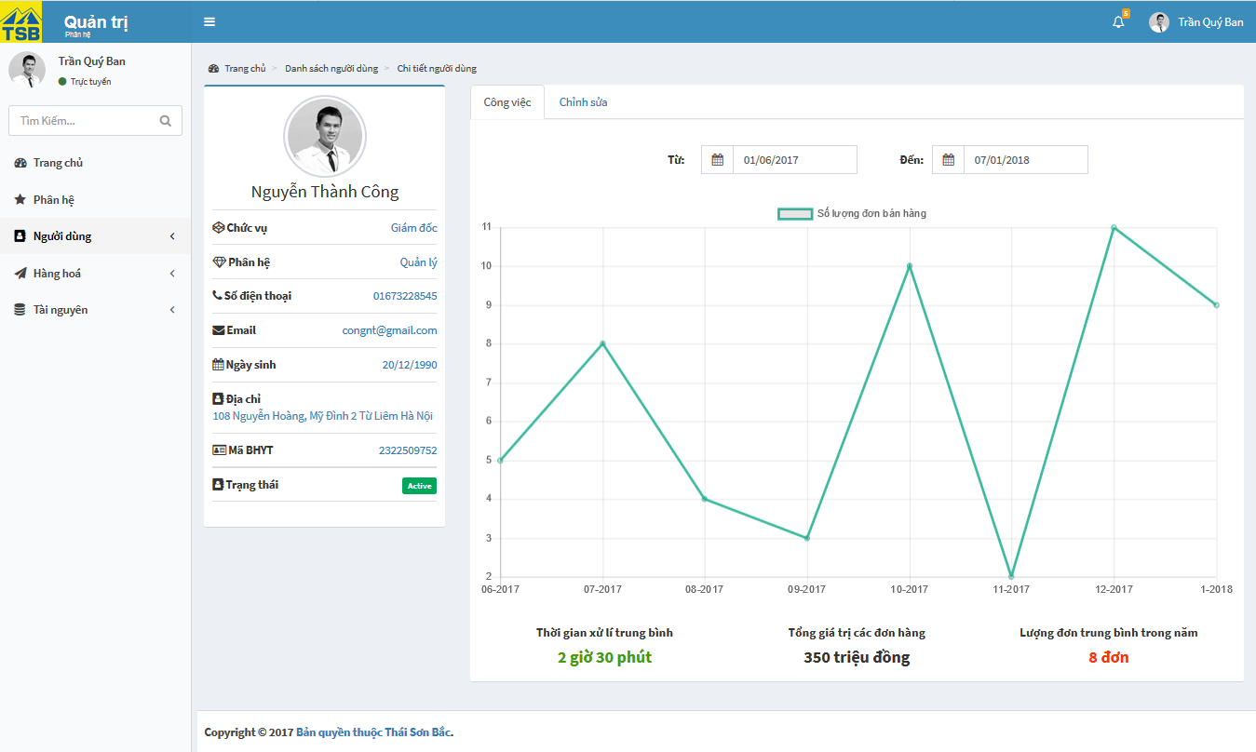

*Figure 3.76: View user screen*

|  |  |  |  |  |
| --- | --- | --- | --- | --- |
| **USE CASE-055 SPECIFICATION View user** | | | | |
| **Use-case No.** | <UC055> | **Use-case Version** | | <1.0> |
| **Use-case Name** | View user | | | |
| **Author** | AnhNTL | | | |
| **Date** | Jan 2nd,2018 | **Priority** | Normal | |
| **Actor:**  *Management, administrator*  **Summary:**  *User view detail user*  **Goal:**  *Display detail user*  **Triggers**  **Preconditions:**  *On “Danh sách người dùng đang hoạt động” click on user name or click on view button*  **Post Conditions:**  *Display “Chi tiết người dùng” page*  **Main Success Scenario:**   |  |  |  | | --- | --- | --- | | *Step* | *User action* | *System response* | | *1* | *On “Danh sách người dùng đang hoạt động” click on username* | *Display “Chi tiết người dùng” page* |   **Alternative Scenario:**   |  |  |  | | --- | --- | --- | | *Step* | *User action* | *System response* | | *1* | *On “Danh sách người dùng đang hoạt động” click on “Xem” button* | *Display “Chi tiết người dùng” page* |  |  |  |  | | --- | --- | --- | | *Step* | *User action* | *System response* | | *1* | *On “Danh sách người dùng ngưng hoạt động” click on “Xem” button* | *Display “Chi tiết người dùng” page* |  |  |  |  | | --- | --- | --- | | *Step* | *User action* | *System response* | | *1* | *On “Danh sách người dùng đang hoạt động” click on username* | *Display “Chi tiết người dùng” page* |   **Exceptions:**  **Business Rules:** | | | | |

*Table 3.118 Usecase view user*

Screen description:

- “Chi tiết người dùng” page

|  |  |  |  |  |  |  |
| --- | --- | --- | --- | --- | --- | --- |
| Field name | Description | Mandatory | Read only | Control type | Data type | Length |
| User avatar field | User avatar | Y | Y | Image upload | File | - |
| Name field | User name | Y | Y | Text field | Nvarchar | 50 |
| Phone field | User phone | Y | Y | Text field | Nvarchar | 50 |
| Email field | Supplier email | Y | Y | Text field | Nvarchar | 50 |
| Address field | User address | Y | Y | Text field | Nvarchar | MAX |
| BHYT field | BHYT of user | N | Y | Text field | Nvarchar | 50 |
| DOB field | Date of birth of customer | Y | Y | Datepicker | Date | 20 |
| Role field | Role of user | Y | Y | Dropbox | Nvarchar | 50 |
| Office field | Office of user | Y | Y | Dropbox | Nvarchar | 50 |
| “Công việc” tab | Tab for user task ( if have) | - | - | Tab | - | - |
| “Chỉnh Sửa” tab | Tab to edit user information | - | - | Tab | - | - |

*Table 3.119 Screen description view user*

###### View user list

Use case specification:

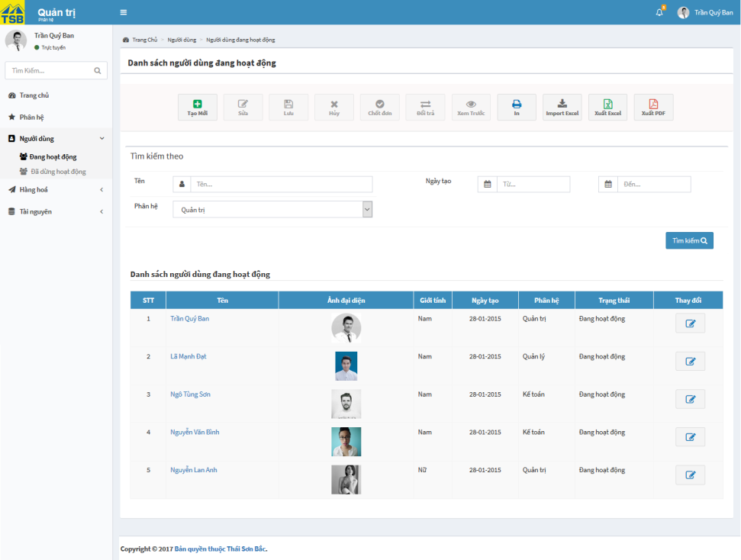

*Figure 3.77: View list of users*

|  |  |  |  |  |
| --- | --- | --- | --- | --- |
| **USE CASE-056 SPECIFICATION : View list of users** | | | | |
| **Use-case No.** | <UC056> | **Use-case Version** | | <1.0> |
| **Use-case Name** | View list of users | | | |
| **Author** | AnhNTL | | | |
| **Date** | Jan 2nd,2018 | **Priority** | Normal | |
| **Actor:**  *Management, administrator*  **Summary:**  *View list of users*  **Goal:**  *Display list of users page*  **Triggers**  **Preconditions:**  -Quản trị  *Click on user list page link on menu*  **Post Conditions:**  *Display user list page* *respectively*  **Main Success Scenario:**  *- Quản trị*   |  |  |  | | --- | --- | --- | | *Step* | *User action* | *System response* | | *1* | *Click on user list page link on menu* | *Display user list page* *respectively* |   **Alternative Scenario:**  **Exceptions:**  **Business Rules:**   * *Manager canot see users in Administrator role* * *Have 2 user list pages : use active and user deactive* | | | | |

*Table 3.120 Usecase view list of user*

Screen description:

|  |  |  |  |  |  |  |
| --- | --- | --- | --- | --- | --- | --- |
| Field name | Description | Mandatory | Read only | Control type | Data type | Length |
| “Tạo” button | Button of page | - | - | Button | - | - |
| “Xem trước” button | Button of page | - | - | Button | - | - |
| “In” button | Button of page | - | - | Button | - | - |
| “Xuất excel” button | Button of page | - | - | Button | - | - |
| “Xuất pdf” button | Button of page | - | - | Button | - | - |
| User name search field | User name for search | N | N | Text field | Nvarchar | 50 |
| Date create ( from) search field | Limit for search by date create | N | N | Datepicker | Date | 20 |
| Date create (to) search field | Limit for search by date create | N | N | Datepicker | Date | 20 |
| Role search field | Role for search | N | N | Dropbox | Nvarchar | 50 |
| Search button | Button of form | - | - | Button | - | - |
| User list table | User list table | - | - | Table | - | - |

*Table 3.121 Screen description list of user*

###### Search user

Use case specification

|  |  |  |  |  |
| --- | --- | --- | --- | --- |
| **USE CASE-057 SPECIFICATION : Search user** | | | | |
| **Use-case No.** | <UC057> | **Use-case Version** | | <1.0> |
| **Use-case Name** | Search user | | | |
| **Author** | AnhNTL | | | |
| **Date** | Jan 2nd, 2018 | **Priority** | Low | |
| **Actor:**  *Management, administrator*  **Summary:**  *Search user*  **Goal:**  *Display list users fit with conditions*  **Triggers**  **Preconditions:**  *On “Danh sách người dùng đang hoạt động” page or “Danh sách người dùng ngưng hoạt động” page , user select conditions*  **Post Conditions:**  *Display user user fir with conditions*  **Main Success Scenario:**   |  |  |  | | --- | --- | --- | | *Step* | *User action* | *System response* | | *1* | *On “Danh sách người dùng đang hoạt động” page or “Danh sách người dùng ngưng hoạt động” page , user select conditions* | *Validate* | | *2* | *Click “Tìm kiếm” button* | *Display user user fir with conditions* |   **Alternative Scenario:**  **Exceptions:**  **Business Rules:**  *Management cannot see user in administrator role* | | | | |

*Table 3.122 Usecase search user*

#### Stock management

##### Usecase diagram

*Figure 3.79: Stock management usercase diagram*

##### Usecase

###### Create purchase order

Use case specification:

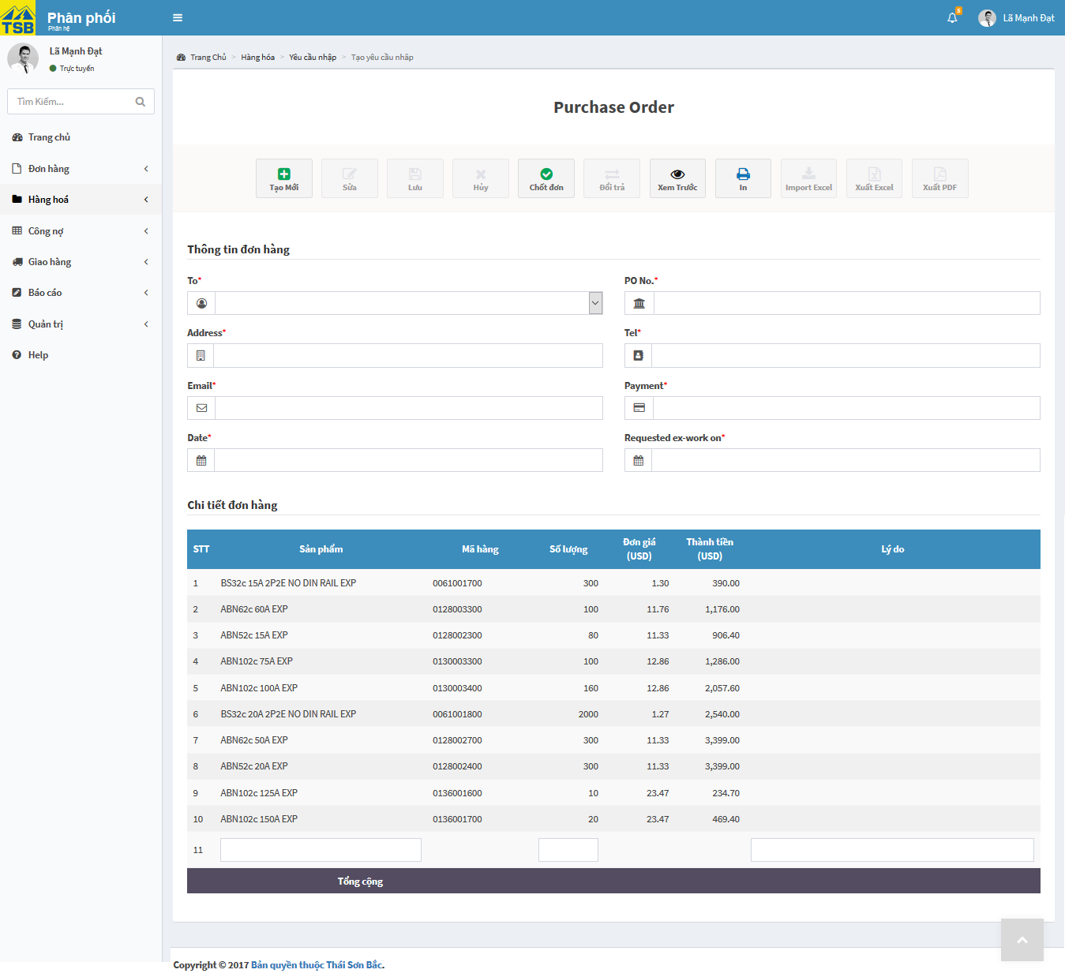

*Figure 3.80: Create purchase order screen*

|  |  |  |  |  |
| --- | --- | --- | --- | --- |
| **USE CASE-058 SPECIFICATION : Create purchase order** | | | | |
| **Use-case No.** | <UC058> | **Use-case Version** | | <1.0> |
| **Use-case Name** | Create purchase order | | | |
| **Author** | AnhNTL | | | |
| **Date** | Jan 2nd, 2018 | **Priority** | High | |
| **Actor:**  *Sellers, managers*  **Summary:**  *Create new purchase order*  **Goal:**  *New purchase order created*  **Triggers**  **Preconditions:**  *User click on “Tạo yêu cầu nhập” in tab “Hàng hoá” ->” Yêu cầu nhập” on left menu*  **Post Conditions:**  *Display created success message. Redirect to “Chi tiết yêu cầu nhập” page*  **Main Success Scenario:**   |  |  |  | | --- | --- | --- | | *Step* | *User action* | *System response* | | *1* | *User click on “Tạo yêu cầu nhập” in tab “Hàng hoá” ->” Yêu cầu nhập” on left menu* | *“Tạo yêu cầu nhập” page display* | | *2* | *Select supplier name* | *Auto fill supplier’s infomations* | | *3* | *Input product name* | *Suggest the product name* | | *4* | *Select product* |  | | *6* | *Input quantity* | *Calculate total price of that product and price of total order* | | *7* | *Click “Chốt đơn” button* | *Display pop-up to confirm* | | *8* | *Click “ Đồng ý” button* | *Send email request to supplier*  *Add purchase order to purchase order list*  *Display created success message*  *Redirect to “Chi tiết yêu cầu nhập” page* |   **Alternative Scenario:**  **Exceptions:**  **Business Rules:** | | | | |

*Table 3.123 Usecase create purchase order*

Screen description:

|  |  |  |  |  |  |  |
| --- | --- | --- | --- | --- | --- | --- |
| Field name | Description | Mandatory | Read only | Control type | Data type | Length |
| “Tạo mới” button | Button of form | - | - | Button | - | - |
| “Chốt đơn” button | Button of form | - | - | Button | - | - |
| “Xem trước” button | Button of form | - | - | Button | - | - |
| Supplier name field | Supplier name | Y | N | Texfield | Nvarchar | 50 |
| Supplier address field | Supplier name | Y | N | Texfield | Nvarchar | 50 |
| Supplier phone field | Supplier phone | Y | N | Texfield | Nvarchar | 50 |
| Supplier email field | Supplier email | Y | N | Texfield | Nvarchar | 50 |
| PO No field | PO No | Y | N | Texfield | Nvarchar | 50 |
| Date field | Date create | Y | N | Datepicker | Date | 20 |
| Payment field | Payment | Y | N | Texfield | Nvarchar | 50 |
| Requested ex-work on field | Requested ex-work on of purchase order | Y | N | Datepicker | Date | 20 |
| List product table | List product | - | - | Table | - | - |
| Product name field | Product name | Y | N | Texfield | Nvarchar | 50 |
| Product code field | Product code | Y | N | Texfield | Nvarchar | 50 |
| Quantity field | Quantity | Y | N | Input type=”number” | INT | - |

*Table 3.124 Screen description create purchase order*

###### View history purchase

Use case specification:

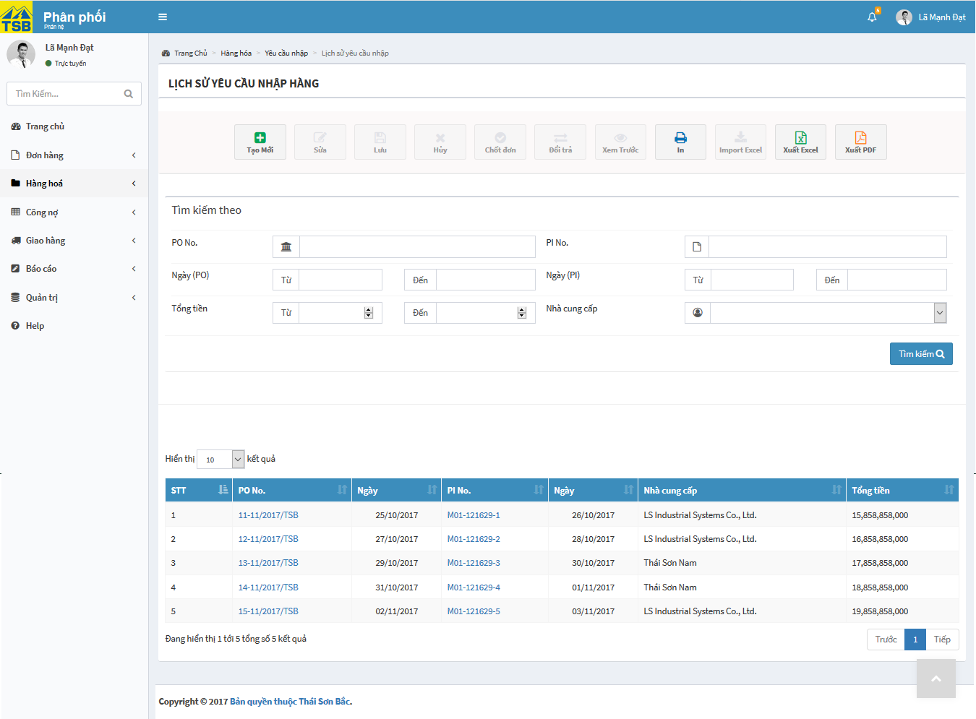

*Figure 3.81: View history purchase screen*

|  |  |  |  |  |
| --- | --- | --- | --- | --- |
| **USE CASE-059 SPECIFICATION : View history purchase** | | | | |
| **Use-case No.** | <UC059> | **Use-case Version** | | <1.0> |
| **Use-case Name** | View history purchase | | | |
| **Author** | AnhNTL | | | |
| **Date** | Jan 2nd, 2018 | **Priority** | High | |
| **Actor:**  *Sellers, managers*  **Summary:**  *User view history purchase*  **Goal:**  *Display purchase order list*  **Triggers**  **Preconditions:**  *User click “Lich sử yêu cầu nhập” in tab “Hàng hoá”->”Yêu cầu nhập” on left menu*  **Post Conditions:**  *Display “Lich sử yêu cầu nhập” page*  **Main Success Scenario:**   |  |  |  | | --- | --- | --- | | *Step* | *User action* | *System response* | | *1* | *User click “Lich sử yêu cầu nhập” in tab “Hàng hoá”->”Yêu cầu nhập” on left menu* | *Display “Lich sử yêu cầu nhập” page* |   **Alternative Scenario:**  **Exceptions:**  **Business Rules:** | | | | |

*Table 3.125 Usecase view history purchase*

Screen description:

|  |  |  |  |  |  |  |
| --- | --- | --- | --- | --- | --- | --- |
| Field name | Description | Mandatory | Read only | Control type | Data type | Length |
| “Tạo” button | Button of page | - | - | Button | - | - |
| “Xem trước” button | Button of page | - | - | Button | - | - |
| “In” button | Button of page | - | - | Button | - | - |
| “Xuất excel” button | Button of page | - | - | Button | - | - |
| “Xuất pdf” button | Button of page | - | - | Button | - | - |
| PO No search field | Field to input search value for purchase order serial | N | N | Text field | Nvarchar | 50 |
| PI No search field | Field to input search value for purchase invoice serial | N | N | Text field | Nvarchar | 50 |
| Customer search field | Field to input search value for supplier | N | N | Text field | Nvarchar | 50 |
| Create PO date – from filed | Field to input search value for create PO date | N | N | Datepicker | Date | 20 |
| Create PO date – to field | Field to input search value for create PO date | N | N | Datepicker | Date | 20 |
| Create Pi date – from filed | Field to input search value for create PI date | N | N | Datepicker | Date | 20 |
| Create PI date – to field | Field to input search value for create PI date | N | N | Datepicker | Date | 20 |
| Total price – from field | Field to input search value for total price | N | N | Input type = ”number” | Float | 20 |
| Total priced – to field | Field to input search value for total price | N | N | Input type = ”number” | Float | 20 |
| Type of order | Field to input search value for type of order | N | N | Dropbox | Nvarchar | 20 |
| Search button | Button of form | - | - | Button | - | - |
| Purchase order list table | Orders list | - | - | Table | - | - |

*Table 3.126 Screen description view history purchase*

###### View purchase order

Use case specification:

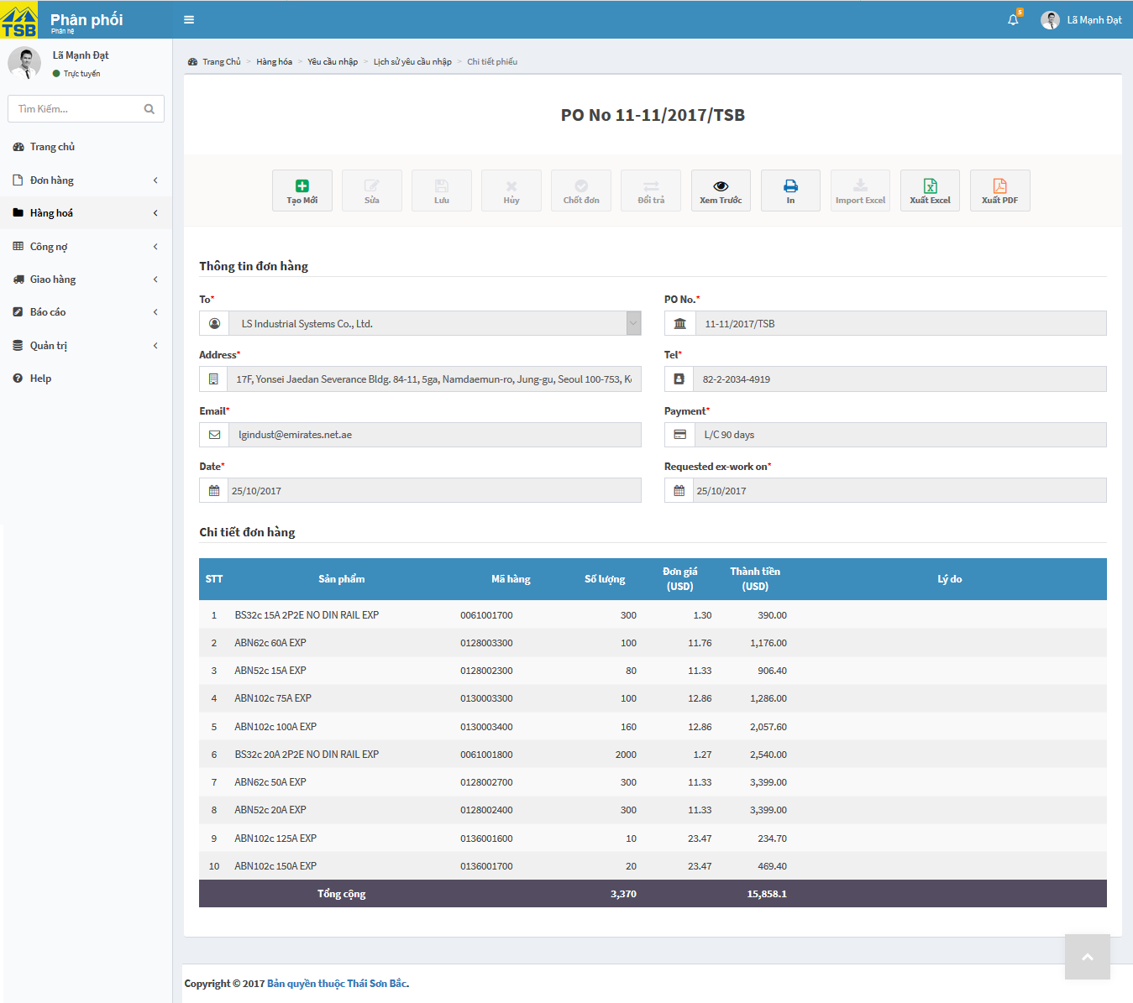

*Figure 3.82: View purchase order screen*

|  |  |  |  |  |
| --- | --- | --- | --- | --- |
| **USE CASE-060 SPECIFICATION :** **View purchase order** | | | | |
| **Use-case No.** | <UC060> | **Use-case Version** | | <1.0> |
| **Use-case Name** | View purchase order | | | |
| **Author** | AnhNTL | | | |
| **Date** | Jan 2nd, 2018 | **Priority** | High | |
| **Actor:**  *Sellers, managers*  **Summary:**  *User view detail purchase order*  **Goal:**  *Display detail purchase order*  **Triggers**  **Preconditions:**  *On “Lịch sử yêu cầu nhập” page, user click on PO No*  **Post Conditions:**  *Display “Chi tiết yêu cầu nhập” page*  **Main Success Scenario:**   |  |  |  | | --- | --- | --- | | *Step* | *User action* | *System response* | | *1* | *On “Lịch sử yêu cầu nhập” page, user click on PO No* | *Display “Chi tiết yêu cầu nhập” page* |   **Alternative Scenario:**  **Exceptions:**  **Business Rules:** | | | | |

*Table 3.127 Usecase view purchase order*

Screen description:

|  |  |  |  |  |  |  |
| --- | --- | --- | --- | --- | --- | --- |
| Field name | Description | Mandatory | Read only | Control type | Data type | Length |
| “Tạo mới” button | Button of form | - | - | Button | - | - |
| “In” button | Button of form | - | - | Button | - | - |
| “Xem trước” button | Button of form | - | - | Button | - | - |
| “Xuất excel” button | Button of form | - | - | Button | - | - |
| “Xuất pdf” button | Button of form | - | - | Button | - | - |
| Supplier name field | Supplier name | Y | Y | Texfield | Nvarchar | 50 |
| Supplier address field | Supplier name | Y | Y | Texfield | Nvarchar | 50 |
| Supplier phone field | Supplier phone | Y | Y | Texfield | Nvarchar | 50 |
| Supplier email field | Supplier email | Y | Y | Texfield | Nvarchar | 50 |
| PO No field | PO No | Y | Y | Texfield | Nvarchar | 50 |
| Date field | Date create |  | Y | Texfield | Nvarchar | 50 |
| Payment field | Payment | Y | Y | Texfield | Nvarchar | 50 |
| Requested ex-work on field | Requested ex-work on of purchase order | Y | Y | Datepicker | Date | 20 |
| List product table | List product | - | - | Table | - | - |

*Table 3.128 Screen description view purchase order*

###### Create purchase invoice

Use case specification:

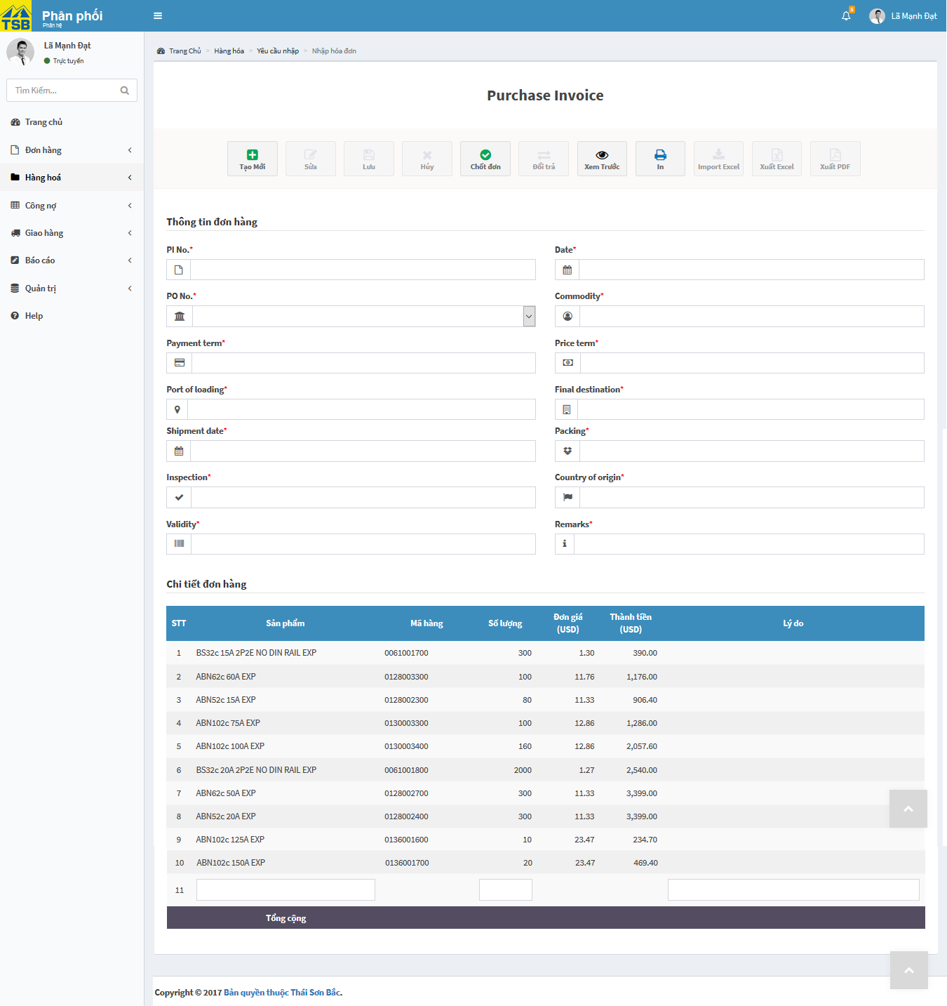

*Figure 3.83: Create purchase invoice screen*

|  |  |  |  |  |
| --- | --- | --- | --- | --- |
| **USE CASE-061 SPECIFICATION : Create purchase invoice** | | | | |
| **Use-case No.** | <UC061> | **Use-case Version** | | <1.0> |
| **Use-case Name** | Create purchase invoice | | | |
| **Author** | AnhNTL | | | |
| **Date** | Jan 2nd, 2018 | **Priority** | High | |
| **Actor:**  *Sellers, managers*  **Summary:**  *Create new purchase invoice*  **Goal:**  *New purchase invoice created*  **Triggers**  **Preconditions:**  *User click on “Nhập hoá đơn” on menu*  **Post Conditions:**  *Display created success message. Redirect to “Chi tiết hoá đơn” page*  **Main Success Scenario:**   |  |  |  | | --- | --- | --- | | *Ste* | *User action* | *System response* | | *1* | *Select PI* | *Auto fill PO information* | | *2* | *Input another field* | *Validate* | | *3* | *Input product name* | *Suggest the product name* | | *4* | *Select product* | *Auto fill product price* | | *5* | *Input quantity* | *Calculate total price of that product and price of total order* | | *6* | *Input reason ( if have)* | *Validate* | | *7* | *Click “Chốt đơn” button* | *Display pop-up to confirm* | | *8* | *Click “Đồng ý” button* | *Add purchase invoice for purchase order*  *Display created success message*  *Redirect to “Chi tiết hoá đơn” page* |   **Alternative Scenario:**  **Exceptions:**  **Business Rules:** | | | | |

*Table 3.129 Usecasse create purchase invoice*

Screen description:

|  |  |  |  |  |  |  |
| --- | --- | --- | --- | --- | --- | --- |
| Field name | Description | Mandatory | Read only | Control type | Data type | Length |
| “Chốt đơn” button | Button of form | - | - | Button | - | - |
| “Xem trước” button | Button of form | - | - | Button | - | - |
| PI No field | PI No | Y | N | Texfield | Nvarchar | 50 |
| PO No field | PO No | Y | N | Texfield | Nvarchar | 50 |
| Date field | Date create PI | Y | N | Datepicker | Date | 20 |
| Payment field | Payment | Y | N | Texfield | Nvarchar | 50 |
| Commodity field | Commodity of the purchase | Y | N | Texfield | Nvarchar | MAX |
| Payment term field | Payment of the purchase | Y | N | Texfield | Nvarchar | MAX |
| Price term field | Price of the purchase | Y | N | Texfield | Nvarchar | MAX |
| Port of loading field | Port of loading of the purchase | Y | N | Texfield | Nvarchar | MAX |
| Final destination field | Final destination of the purchase | Y | N | Texfield | Nvarchar | MAX |
| Shipment date field | Shipment of the purchase | Y | Y | Datepicker | Date | 20 |
| Packing field | Packing of the purchase | Y | N | Texfield | Nvarchar | MAX |
| Inspection | Inspection of the purchase | Y | N | Texfield | Nvarchar | MAX |
| Country of origin field | Country of the purchase | Y | N | Texfield | Nvarchar | MAX |
| Validity field | Validity of the purchase | Y | N | Texfield | Nvarchar | MAX |
| Remarks field | Remark for the purchase | Y | N | Texfield | Date | 20 |
| List product table | List product | - | - | Table | - | - |
| Product name field | Product name | Y | N | Texfield | Nvarchar | 50 |
| Product code field | Product code | Y | N | Texfield | Nvarchar | 50 |
| Quantity field | Quantity | Y | N | Input type=”number” | INT | - |
| Reason field | Reason if have problem with product | N | N | Texfield | Nvarchar | MAX |

*Table 3.130 Screen description create purchase invoice*

###### View detail purchase invoice

3.3.2.9.2.5.1 Use case specification:

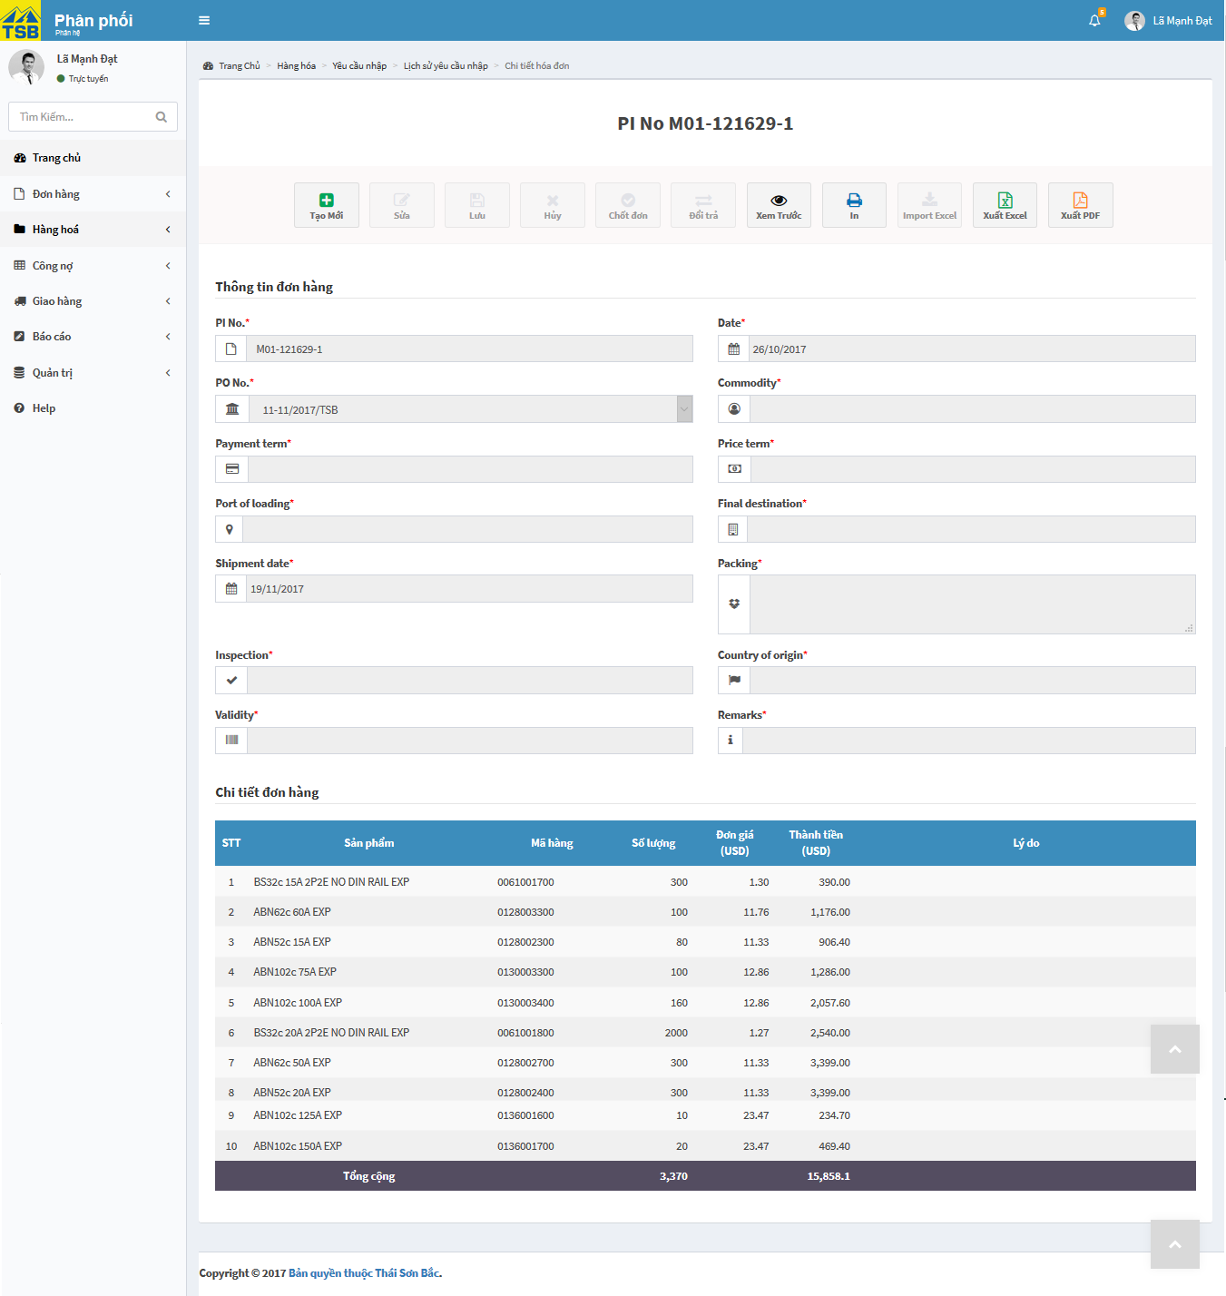

*Figure 3.84: View purchase invoice screen*

|  |  |  |  |  |
| --- | --- | --- | --- | --- |
| **USE CASE-062 SPECIFICATION : View purchase invoice** | | | | |
| **Use-case No.** | <UC062> | **Use-case Version** | | <1.0> |
| **Use-case Name** | View purchase invoice | | | |
| **Author** | AnhNTL | | | |
| **Date** | Jan 2nd, 2018 | **Priority** | High | |
| **Actor:**  *Sellers, managers*  **Summary:**  *User view detail purchase invoice*  **Goal:**  *Display detail purchase invoice*  **Triggers**  **Preconditions:**  *On “Lịch sử yêu cầu nhập” page, user click on PI No*  **Post Conditions:**  *Display “Chi tiết hoá đơn” page*  **Main Success Scenario:**   |  |  |  | | --- | --- | --- | | *Step* | *User action* | *System response* | | *1* | *On “Lịch sử yêu cầu nhập” page, user click on PI No* | *Display “Chi tiết hoá đơn” page* |   **Alternative Scenario:**  **Exceptions:**  **Business Rules:** | | | | |

*Table 3.131 Usecase view purchase invoice*

Screen description:

|  |  |  |  |  |  |  |
| --- | --- | --- | --- | --- | --- | --- |
| Field name | Description | Mandatory | Read only | Control type | Data type | Length |
| “Tạo mới” button | Button of form | - | - | Button | - | - |
| “Xem trước” button | Button of form | - | - | Button | - | - |
| “In” button | Button of form | - | - | Button | - | - |
| “Xuất excel” button | Button of form | - | - | Button | - | - |
| “Xuất pdf” button | Button of form | - | - | Button | - | - |
| PI No field | PI No | Y | N | Texfield | Nvarchar | 50 |
| PO No field | PO No | Y | N | Texfield | Nvarchar | 50 |
| Date field | Date create PI | Y | N | Datepicker | Date | 20 |
| Payment field | Payment | Y | N | Texfield | Nvarchar | 50 |
| Commodity field | Commodity of the purchase | Y | N | Texfield | Nvarchar | MAX |
| Payment term field | Payment of the purchase | Y | N | Texfield | Nvarchar | MAX |
| Price term field | Price of the purchase | Y | N | Texfield | Nvarchar | MAX |
| Port of loading field | Port of loading of the purchase | Y | N | Texfield | Nvarchar | MAX |
| Final destination field | Final destination of the purchase | Y | N | Texfield | Nvarchar | MAX |
| Shipment date field | Shipment of the purchase | Y | Y | Datepicker | Date | 20 |
| Packing field | Packing of the purchase | Y | N | Texfield | Nvarchar | MAX |
| Inspection | Inspection of the purchase | Y | N | Texfield | Nvarchar | MAX |
| Country of origin field | Country of the purchase | Y | N | Texfield | Nvarchar | MAX |
| Validity field | Validity of the purchase | Y | N | Texfield | Nvarchar | MAX |
| Remarks field | Remark for the purchase | Y | N | Texfield | Date | 20 |
| List product table | List product | - | - | Table | - | - |

*Table 3.132 Screen description view purchase invoice*

###### Create new stock in

Use case specification:

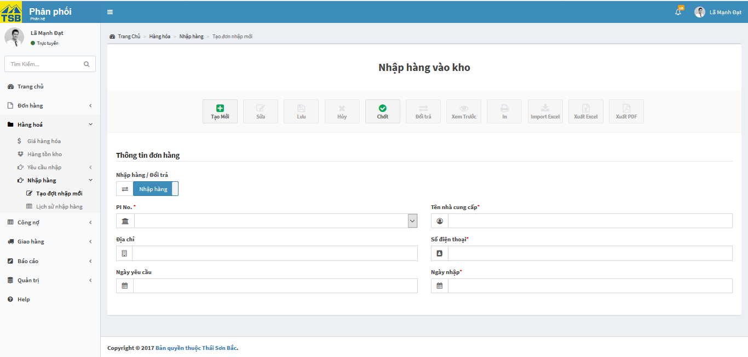

*Figure 3.85: Create new stock in screen*

|  |  |  |  |  |
| --- | --- | --- | --- | --- |
| **USE CASE-063 SPECIFICATION : Create new stock in** | | | | |
| **Use-case No.** | <UC063> | **Use-case Version** | | <1.0> |
| **Use-case Name** | Create new stock in | | | |
| **Author** | AnhNTL | | | |
| **Date** | Jan 2nd, 2018 | **Priority** | High | |
| **Actor:**  *Sellers, managers*  **Summary:**  *Create new stock in*  **Goal:**  *New stock in created*  **Triggers**  **Preconditions:**  *User click on “Tạo yêu cầu nhập” in tab “Hàng hoá” -> “Nhập hàng” on left menu*  **Post Conditions:**  *Display created success message. Redirect to “Chi tiết yêu cầu nhập” page*  **Main Success Scenario:**   |  |  |  | | --- | --- | --- | | *Step* | *User action* | *System response* | | *1* | *User click on “Tạo yêu cầu nhập” in tab “Hàng hoá” -> “Nhập hàng” on left menu* | *Display “Tạo đợt nhập kho” page* | | *2* | *Select type of the stock in ( stock in for purchase order or stock in for order returned)* |  | |  | *Select Order id or PO number* | *Auti fill informations of PO or order* | | *3* | *Input quantity of product stock in and reason ( if have)* | *Validate* | | *4* | *Click “Chốt” button* | *Display confirm* | | *5* | *Click “OK” button* | *Add to list of warehouse in*  *Display create success message*  *Redirect to “Chi tiết đợt nhập hàng” page* |   **Alternative Scenario:**  **Exceptions:**  **Business Rules:**  *Stock in have 2 reason: for order returned and for PO*  *Quantity stock in cannot larger than quantity in order or quantity in PO* | | | | |

*Table 3.13*

*3 Usecase create new stock in*

Screen description:

|  |  |  |  |  |  |  |
| --- | --- | --- | --- | --- | --- | --- |
| Field name | Description | Mandatory | Read only | Control type | Data type | Length |
| “Tạo mới” button | Button of form | - | - | Button | - | - |
| “Chốt đơn” button | Button of form | - | - | Button | - | - |
| “Xem trước” button | Button of form | - | - | Button | - | - |
| Reason stock in field | Reason stock in (for PO or for order) | Y | N | Toggle | Boolean | - |
| Serial field | Order id or PI No | Y | N | Texfield | Nvarchar | 50 |
| Name field | Name of supplier or customer | Y | N | Texfield | Nvarchar | 50 |
| Address field | Address of supplier or customer | Y | N | Texfield | Nvarchar | 50 |
| Phone field | Phone of supplier or customer | Y | N | Texfield | Nvarchar | 50 |
| Date create field | Date created of order or PO | Y | N | Datepicker | Date | 20 |
| Stock in date field | Stock in date | Y | N | Datepicker | Date | 20 |
| Product list table | Product list | - | - | Table | - | - |
| Quantity fields | Quantity stock in of each product | N | N | Input type=”number” | INT | - |
| Reason fields | Reason stock in of each product | N | N | Texfield | Nvarchar | 50 |

*Table 3.134 Screen description create new stock in*

###### View stock in

Use case specification:

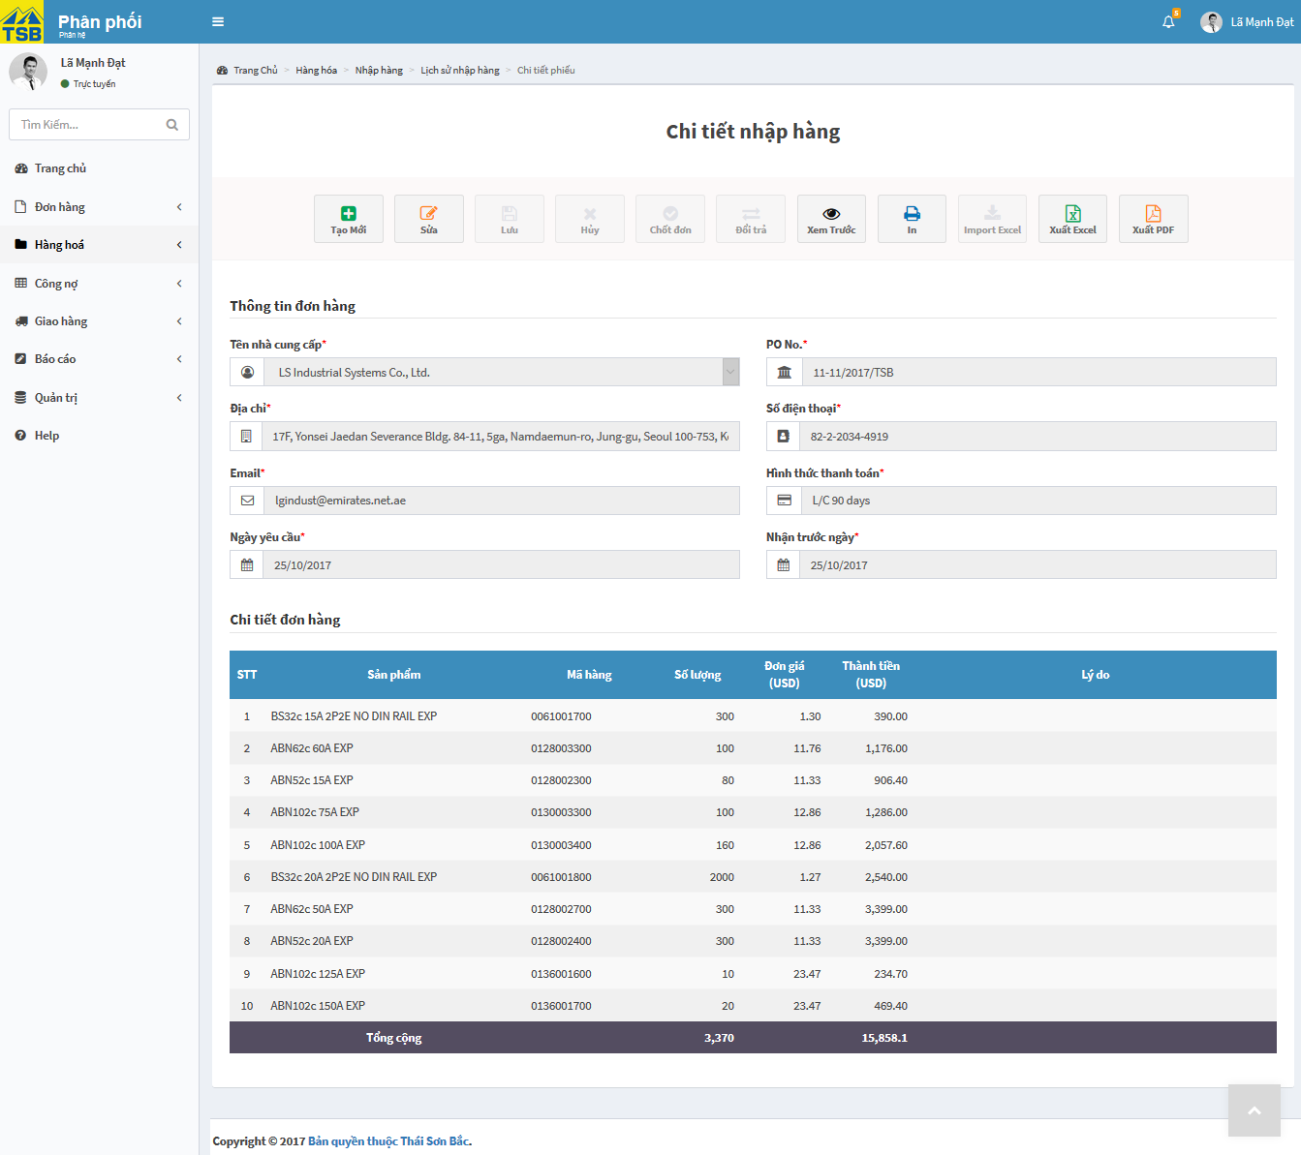

*Figure 3.86: View stock in screen*

|  |  |  |  |  |
| --- | --- | --- | --- | --- |
| **USE CASE-064 SPECIFICATION : View stock in** | | | | |
| **Use-case No.** | <UC064> | **Use-case Version** | | <1.0> |
| **Use-case Name** | View stock in | | | |
| **Author** | AnhNTL | | | |
| **Date** | Jan 2nd, 2018 | **Priority** | High | |
| **Actor:**  *Sellers, managers*  **Summary:**  *User view detail stock in*  **Goal:**  *Display detail stock in*  **Triggers**  **Preconditions:**  *On “Lịch sử nhập hàng” page, user click on order id or PO number*  **Post Conditions:**  *Display “Chi tiết nhập hàng” page*  **Main Success Scenario:**   |  |  |  | | --- | --- | --- | | *Step* | *User action* | *System response* | | *1* | *On “Lịch sử nhập hàng” page, user click on order id or PO number* | *Display “Chi tiết nhập hàng” page* |   **Alternative Scenario:**  **Exceptions:**  **Business Rules:** | | | | |

*Table 3.135 Usecase view stock in*

Screen description:

|  |  |  |  |  |  |  |
| --- | --- | --- | --- | --- | --- | --- |
| Field name | Description | Mandatory | Read only | Control type | Data type | Length |
| “Tạo mới” button | Button of form | - | - | Button | - | - |
| “In” button | Button of form | - | - | Button | - | - |
| “Xem trước” button | Button of form | - | - | Button | - | - |
| “Xuất excel” button | Button of form | - | - | Button | - | - |
| “Xuất pdf” button | Button of form | - | - | Button | - | - |
| Reason stock in field | Reason stock in ( for PO or for order ) | - | - | Toggle | Boolean | - |
| Serial field | Order id or PI No | Y | Y | Texfield | Nvarchar | 50 |
| Name field | Name of supplier or customer | Y | Y | Texfield | Nvarchar | 50 |
| Address field | Address of supplier or customer | Y | Y | Texfield | Nvarchar | 50 |
| Phone field | Phone of supplier or customer | Y | Y | Texfield | Nvarchar | 50 |
| Date create field | Date created of order or PO | Y | Y | Datepicker | Date | 20 |
| Stock in date field | Stock in date | Y | Y | Datepicker | Date | 20 |
| Product list table | Product list | - | - | Table | - | - |

*Table 3.136 Screen description view stock in*

###### View history stock in

Use case specification:

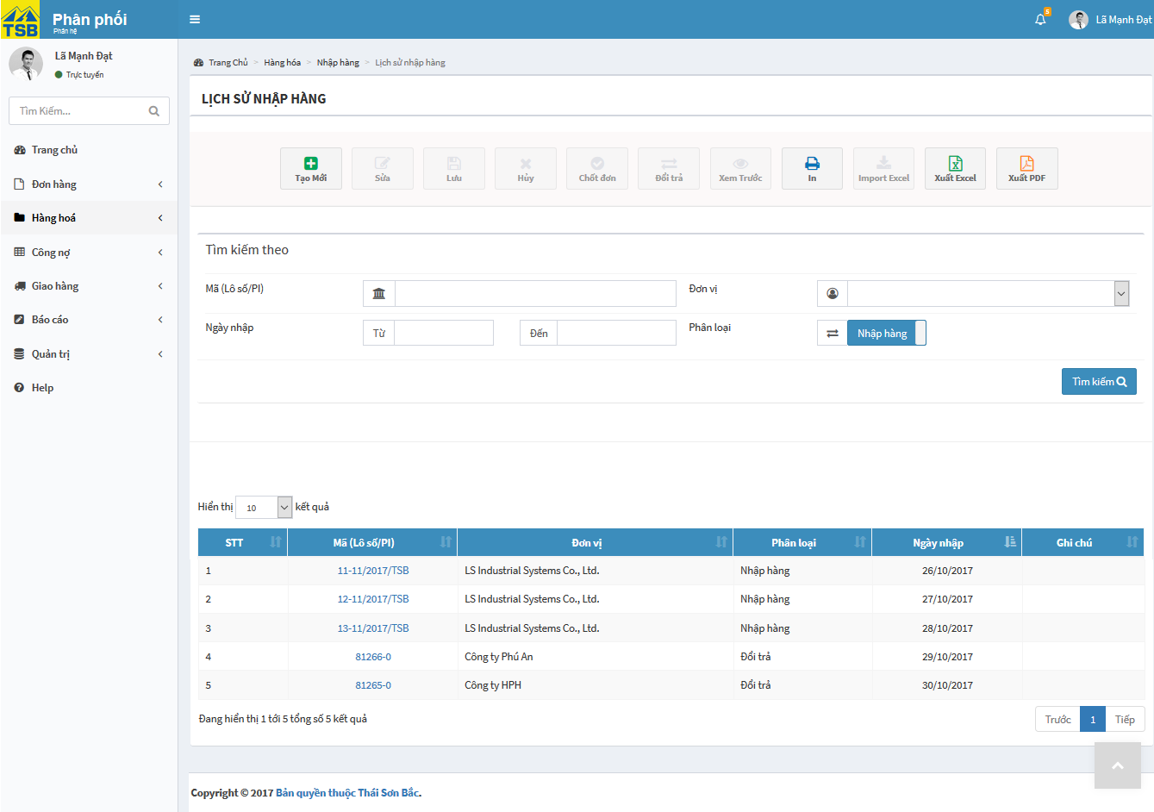

*Figure 3.87: View history stock in screen*

|  |  |  |  |  |
| --- | --- | --- | --- | --- |
| **USE CASE-065 SPECIFICATION : View history stock in** | | | | |
| **Use-case No.** | <UC065> | **Use-case Version** | | <1.0> |
| **Use-case Name** | View history stock in | | | |
| **Author** | AnhNTL | | | |
| **Date** | Jan 2nd, 2018 | **Priority** | High | |
| **Actor:**  *Sellers, managers*  **Summary:**  *User view history stock in*  **Goal:**  *Display stock in list*  **Triggers**  **Preconditions:**  *User click “Lịch sử nhập hàng” in tab “Hàng hoá”->”Nhập hàng” on left menu*  **Post Conditions:**  *Display “Lịch sử nhập hàng” page*  **Main Success Scenario:**   |  |  |  | | --- | --- | --- | | *Step* | *User action* | *System response* | | *1* | *User click “Lich sử nhập hàng” in tab “Hàng hoá”->”Nhập hàng” on left menu* | *Display “Lịch sử nhập hàng” page* |   **Alternative Scenario:**  **Exceptions:**  **Business Rules:** | | | | |

*Table 3.137 Usecase view history stock in*

Screen description:

|  |  |  |  |  |  |  |
| --- | --- | --- | --- | --- | --- | --- |
| Field name | Description | Mandatory | Read only | Control type | Data type | Length |
| Serial search field | Order id or PO No | N | N | Text field | Nvarchar | 50 |
| Name search field | Name of customer or supplier | N | N | Text field | Nvarchar | 50 |
| Create date – from filed | Field to input search value for create date | N | N | Datepicker | Date | 20 |
| Create date – to field | Date stock in | N | N | Datepicker | Date | 20 |
| Search button | Button of form | - | - | Button | - | - |
| Stock in list table | Orders list | - | - | Table | - | - |
| “Tạo” button | Button of page | - | - | Button | - | - |
| “ Xem trước” button | Button of page | - | - | Button | - | - |
| “In” button | Button of page | - | - | Button | - | - |
| “Xuất excel” button | Button of page | - | - | Button | - | - |
| “Xuất pdf” button | Button of page | - | - | Button | - | - |

*Table 3.138 Screen description history stock in*

###### Search stock in

Use case specification:

|  |  |  |  |  |
| --- | --- | --- | --- | --- |
| **USE CASE-066 SPECIFICATION : Search stock in** | | | | |
| **Use-case No.** | <UC066> | **Use-case Version** | | <1.0> |
| **Use-case Name** | Search stockin | | | |
| **Author** | AnhNTL | | | |
| **Date** | Jan 2nd, 2018 | **Priority** | High | |
| **Actor:**  *Sellers, managers*  **Summary:**  *User search stock in*  **Goal:**  *Display list of warehouse in match with search request*  **Triggers**  **Preconditions:**  *In “Lịch sử nhập hàng” page , user input search value*  **Post Conditions:**  *Display list of warehouse in match with search request*  **Main Success Scenario:**   |  |  |  | | --- | --- | --- | | *Step* | *User action* | *System response* | | *1* | *In “Lịch sử nhập hàng” page , user input search value* | *Validate* | | *2* | *Click “Tìm kiếm” button* | *Display list of warehouse in match with search request* |   **Alternative Scenario:**  **Exceptions:**  **Business Rules:** | | | | |

*Table 3.139 Usecase search stock in*

###### Search purchase

Use case specification:

|  |  |  |  |  |
| --- | --- | --- | --- | --- |
| **USE CASE-067 SPECIFICATION : Search purchase** | | | | |
| **Use-case No.** | <UC067> | **Use-case Version** | | <1.0> |
| **Use-case Name** | Search purchase | | | |
| **Author** | AnhNTL | | | |
| **Date** | Jan 2nd, 2018 | **Priority** | High | |
| **Actor:**  *Sellers, managers*  **Summary:**  *User search order*  **Goal:**  *Display list of purchase match with search request*  **Triggers**  **Preconditions:**  *In “Lịch sử yêu cầu nhập” page , user input search value*  **Post Conditions:**  *Display list of purchases match with search request*  **Main Success Scenario:**   |  |  |  | | --- | --- | --- | | *Step* | *User action* | *System response* | | *1* | *In “Lịch sử yêu cầu nhập” page , user input search value* | *Validate* | | *2* | *Click “Tìm kiếm” button* | *Display list of purchases match with search request* |   **Alternative Scenario:**  **Exceptions:**  **Business Rules:** | | | | |

*Table 3.140 Usecase search purchase*

#### System setting

##### Usecase diagram



*Figure 4.3-88: System setting usercase diagram*

##### Usecase

###### View decentralization

Use case specification:

|  |  |  |  |  |
| --- | --- | --- | --- | --- |
| **USE CASE-068 SPECIFICATION : View decentralization** | | | | |
| **Use-case No.** | <UC068> | **Use-case Version** | | <1.0> |
| **Use-case Name** | View decentralization | | | |
| **Author** | AnhNTL | | | |
| **Date** | Jan 2nd, 2018 | **Priority** | High | |
| **Actor:**  *Administrator*  **Summary:**  *User view decentralization*  **Goal:**  *Display decentralization page*  **Triggers:**  **Preconditions:**  *Click on decentralization link on menu*  **Post Conditions:**  *Display decentralization page*  **Main Success Scenario:**   |  |  |  | | --- | --- | --- | | *Step* | *User action* | *System response* | | *1* | *Click on decentralization link on menu* | *Click on decentralization link on menu* |   **Alternative Scenario:**  **Exceptions:**  **Business Rules:**  *When user click on decentralization name, table list functions that decentralization can user and table list user of that decentralization will be display and user can modify* | | | | |

*Table 3.141 Usecase view decentralization*

Screen description:

|  |  |  |  |  |  |  |
| --- | --- | --- | --- | --- | --- | --- |
| Field name | Description | Mandatory | Read only | Control type | Data type | Length |
| Table of decentralization | Table of decentralization | - | - | Table | - | - |
| Table of list function | Table of list function | - | - | Table | - | - |
| Table of lis user | Table of list user | - | - | Table | - | - |
| “ Xem trước” button | Button of page | - | - | Button | - | - |
| “In” button | Button of page | - | - | Button | - | - |
| “Xuất excel” button | Button of page | - | - | Button | - | - |
| “Xuất pdf” button | Button of page | - | - | Button | - | - |

*Table 3.142 Screen description view decentralization*

###### View list of functions

Use case specification:

|  |  |  |  |  |
| --- | --- | --- | --- | --- |
| **USE CASE-069 SPECIFICATION : View list of functions** | | | | |
| **Use-case No.** | <UC069> | **Use-case Version** | | <1.0> |
| **Use-case Name** | View list of functions | | | |
| **Author** | AnhNTL | | | |
| **Date** | Jan 2nd, 2018 | **Priority** | High | |
| **Actor:**  *Administrator*  **Summary:**  *User view list of functions*  **Goal:**  *Display list of functions*  **Triggers**  **Preconditions:**  *User click on list of functions link on menu*  **Post Conditions:**  *Display list of pages page*  **Main Success Scenario:**   |  |  |  | | --- | --- | --- | | *Step* | *User action* | *System response* | | *1* | *User click on list of functions link on menu* | *Display list of functions page* |   **Alternative Scenario:**  **Exceptions:**  **Business Rules:**  *User can change status of pages* | | | | |

*Table 3.143 Usecase view list of function*

Screen description:

|  |  |  |  |  |  |  |
| --- | --- | --- | --- | --- | --- | --- |
| Field name | Description | Mandatory | Read only | Control type | Data type | Length |
| Table of list functions | Table of list functions | - | - | Table | - | - |
| Name of function field | Name of function | N | N | Texfiled | Nvarchar | 50 |
| Category of function field | Category of function | N | N | Dropbox | Nvarchar | 50 |
| Status of function field | Status of function | N | N | Dropbox | Nvarchar | 50 |
| “Tìm kiếm” button | Button of page | - | - | Button | - | - |

*Table 3.144 Screen description view list of functions*

###### View list of files uploaded

Use case specification:

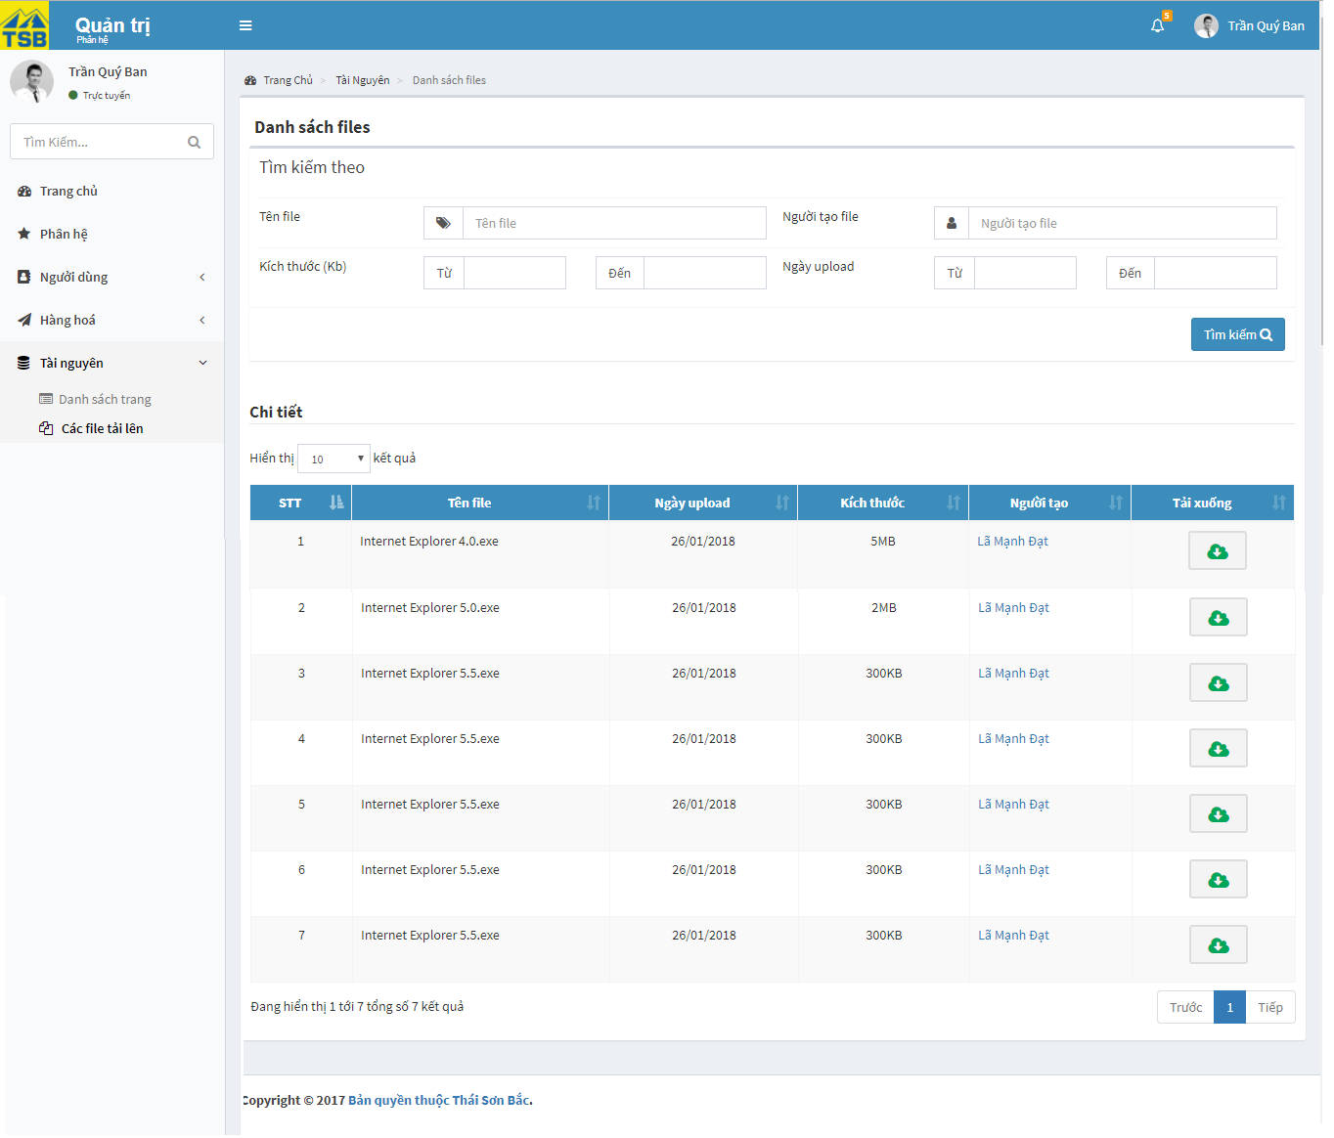

*Figure 3.89: View list of files uploaded screen*

|  |  |  |  |  |
| --- | --- | --- | --- | --- |
| **USE CASE-070 SPECIFICATION : View list of files uploaded** | | | | |
| **Use-case No.** | <UC070> | **Use-case Version** | | <1.0> |
| **Use-case Name** | View list of file uploaded | | | |
| **Author** | AnhNTL | | | |
| **Date** | Jan 2nd, 2018 | **Priority** | High | |
| **Actor:**  *Administrator*  **Summary:**  *User view list of files uploaded*  **Goal:**  *Display list of files uploaded*  **Triggers**  **Preconditions:**  *User click on list of files upload link on menu*  **Post Conditions:**  *Display list of files uploaded page*  **Main Success Scenario:**   |  |  |  | | --- | --- | --- | | *Step* | *User action* | *System response* | | *1* | *User click on list of files uploaded link on menu* | *Display list of files uploaded page* |   **Alternative Scenario:**  **Exceptions:**  **Business Rules:**  *User can click download button or click file name to download file* | | | | |

*Table 3.145 Usecase view list of files uploaded*

Screen description:

|  |  |  |  |  |  |  |
| --- | --- | --- | --- | --- | --- | --- |
| Field name | Description | Mandatory | Read only | Control type | Data type | Length |
| Table of list files uploaded | Table of list file upload | - | - | Table | - | - |
| Name of file field | Name of file | N | N | Texfiled | Nvarchar | 50 |
| User create file field | User create file filed | N | N | Texfiled | Nvarchar | 50 |
| Size of file field | Size of file | N | N | Texfiled | Input type=”number” | 50 |
| Date upload file field | Date upload file | N | N | Datepicker | Datetime | 20 |
| “Tìm kiếm” button | Button of page | - | - | Button | - | - |

*Table 3.146 Screen description view list of files uploaded*

### Non-functional specification

#### Reliability

- Database backed up regularly and can be recovered if have any problem occurs

#### Security

- System must provide protect methods to protect Sellers information and user information from outside. User password also private with administrator

- Prevent SQL injection attacks

#### Maintainability

- Coding standard and naming conventions

- All errors must be logged, prepare for fix bugs and maintenance

- If any components are reuse, the documentations of those components must also be include

- All code must be clearly commented, including class, methods documentations

#### Performance

- Delay time between sending request and receive response need short to not annoy users

- The system can work with at least 100 users at the same time

# Software Design Description (SDD)

## Overview

This document constructs the software design for Thai Son Bac Distribution Management System . Include system architecture design, web application architecture, detail design and database design.

System architecture design describes overall architecture of system.

Web application architecture describes architecture for web.

Detail design describes static and dynamic structure for each component, including class diagrams, class explanations and sequence diagram of the main use cases.

Database design contains ERD and Data Description for each table in database.

All diagrams are drawn according to [[1]](https://msdn.microsoft.com/en-us/library/dd409389.aspx) , [[2]](https://www.ibm.com/developerworks/rational/library/dec04/bell/) , [[3]](https://msdn.microsoft.com/en-us/library/dd409465.aspx)

## Overall System Architectural

Figure 4.1: Overall System Architecture

User: include 5 kinds of user: Sellers, managers, accountant, warehouse, administrator. User will interact with system via web browser and via normal protocols ( HTTP, HTTPS). System send request to web server and web server queries data from database to response requests

## Architectural Layer Design

* **System layer design**
* 

*Figure 4.2: Architecture layer design*

* **Sellers**



*Figure 4.3: Architecture layer design Sellers*

* **Warehouse**



*Figure 4.4: Architecture layer design warehouse*

* Accountance



*Figure 4.5: Architecture layer design accountant*

* Managers



*Figure 4.6: Architecture layer design managers*

* Administrator



*Figure 4.7: Architecture layer design administration*

## Software detailed design

### Activity process

This section includes 5 main process of Thai Son Bac Distribution Managenent System: order, request purchase, stock in, current debt, and supplier debt.

##### Order

- Definition: this is process of an order from start to finish.

- Business rule:



*Figure 4.8: Business rule of order*

- Explanation: When Sellers or managers create order, system will check quantity of that product. If product not enough, creator must decision for that order ( delete that product, stop order, save order to list of order waiting, borrow product from another order which contain that product,…). For each step, order has respective status. If have problem prevent accountant from issuance invoice, order status will be “respective status for that step + warning”. Order in list of waiting orders when to date has been determined will change status and move to list of in progressing orders as normal order. If order is returned, order will change status to returned and system will notification for Sellers or managers update order

##### Request purchase

- Definition: this process occurs when need request purchase

- Business rule:



*Figure 4.9: Business rule of request purchase*

- Explanation: When need request purchase, Seller or manager will create a purchase order and send to supplier. Supplier will reply a purchase invoice, Seller or manager will import PI for respectively PO. After stock in for that PO, transaction will be added for that supplier.

##### Stock in

- Definition: this action occurs when have stock in

- Business rule:

*Figure 4.10: Business rule of stock in*

- Explanation: Have 2 reasons for stock in: stock in for PO and stock in for the order returned. If stock in for PO, user select PI No, input quantity of items in list items displayed. If stock in for the order returned, user select order and input quantity of items returned and reason returned

##### Customer Debt

- Definition: this is process for customer debt

- Business rule:



*Figure 4.11: Business rule of customer debt*

- Explanation: to add transaction for customer has 2 reasons: add transaction for order and add transaction for customer’s transaction. Firstly, add for order: when order was confirmed done, system will auto add debt for customer. Secondly, add for customer’s transaction: transaction be adding if customer has any new transaction, in that case, user will input description, additional debt, VAT and pay for this transaction.

##### Supplier Debt

- Definition: this is process for customer debt

- Business rule:



*Figure 4.12: Business rule of Supplier debt*

- Explanation: transaction be add if supplier have any new transaction, in that case, user will input description, additional debt, VAT and pay for this transaction.

### Context diagram

* Order management system



Figure 4.13: Order management system context diagram

* Stock management system



Figure 4.14: Stock management system context diagram

* Debt management system



Figure 4.15: Debt management system context diagram

* Product management system



Figure 4.16: Product management system context diagram

* Report system



Figure 4.17: Report system context diagram

### Detail description

#### Sellers

##### Order

###### Class Diagram

* Create and handle order



Figure 4.18: Create and handle order class diagram

* One-time delivery order and multiple-time delivery class diagram



*Figure 4.19: One-time delivery order and multiple-time delivery order*

* Order list class diagram



*Figure 4.20: Order list class diagram*

###### Class Diagram Explanation

- Attributes

|  |  |  |  |
| --- | --- | --- | --- |
| Attribute | Type | Visibility | Description |
| Order_ID | String | public | ID of order |
| Customer_ID | int | public | ID of customer |
| Date_created | DateTime | public | Time to create order |
| Date_completed | DateTime? | public | Time to complete order |
| Rate | int? | public | Year to apply price |
| Tax_code | String | public | Tax code of customer |
| Status_ID | byte? | public | Status of order |
| User_ID | int | public | User created order |
| Address_delivery | String | public | Address for delivery |
| Address_invoice_issuance | String | public | Invoice issuance of address |
| Sub_total | decimal | public |  |
| VAT | decimal? | public |  |
| Order_discount | byte? | public |  |
| Total_price | decimal? | public |  |
| Note | String | public |  |
| Customer_transaction | ICollection<Customer_transaction> | public | List of customer transaction |
| Edit_history | ICollection<Edit_history> | public | List of edit history |
| Order_detail_status | ICollection<Order_detail_status> | public | List of order detail status |
| Order_items | ICollection<Order_items> | public | List of order items |
| Order_part | ICollection<Order_part> | public | List of order part |

*Table 4.1 Attribute order list*

- Methods

* Create order

|  |  |  |  |  |
| --- | --- | --- | --- | --- |
| Name : createOrder(Order_total order) | | | | |
| Purpose : create order | | | | |
| No | **Parameter** | **Type** | **In/Out** | **Description** |
| 1 | Order | Order_total | In | Order to create |
| 2 | Order_ID | String | Out | Order id of created order |

*Table 4.2 Method create order*

* Update order

|  |  |  |  |  |
| --- | --- | --- | --- | --- |
| Name : updateOrder(Order_total order) | | | | |
| Purpose : update order | | | | |
| No | **Parameter** | **Type** | **In/Out** | **Description** |
| 1 | Order | Order_total | In | Order to update |

*Table 4.3 Method update order*

|  |  |  |  |  |
| --- | --- | --- | --- | --- |
| Name : getOrder(String orderId) | | | | |
| Purpose : get order | | | | |
| No | **Parameter** | **Type** | **In/Out** | **Description** |
| 1 | Order_total | Order_total | Out | Order to return |
| 2 | orderId | String | In | Order id to get order |

*Table 4.4 Method update order*

* Get order list

|  |  |  |  |  |
| --- | --- | --- | --- | --- |
| Name : getLstOrder() | | | | |
| Purpose : get order list | | | | |
| No | **Parameter** | **Type** | **In/Out** | **Description** |
| 1 | List<Order_total> | List<Order_total> | Out | Order list to return |

*Table 4.5 Get order list*

###### Sequence Diagram

* Create order



*Figure 4.21: Create order sequence diagram*

* View detail order



*Figure 4.22: View detail order sequence diagram*

* View order list

 *Figure 4.23: View order list sequence diagram*

##### Product

###### Class Diagram

* Product list class diagram



*Figure 4.24: Product list class diagram*

* Product price class diagram



*Figure 4.25: Product price class diagram*

* Create and update product class diagram



*Figure 4.26: Add new product class diagram*

* Inventory class diagram



*Figure 4.21 Inventory class diagram*

###### Class Diagram Explanation

- Attributes

|  |  |  |  |
| --- | --- | --- | --- |
| Attribute | Type | Visibility | Description |
| Product_ID | Int | public |  |
| Product_code | String | public |  |
| Product_name | String | public |  |
| Product_parameters | String | public |  |
| Supplier_ID | String | public |  |
| Category_ID | String | public |  |
| Quantity_in_carton | int? | public | Quantity for each box |
| Overview | String | public |  |
| Specification | String | public |  |
| TAX | float? | public | Tax money |
| CIF_USD | decimal? | public | CIF in USD |
| CIF_VND | decimal? | public | CIF in VND |
| Price_before_VAT_VND | decimal? | public |  |
| Price_before_VAT_USD | decimal? | public |  |
| VAT | int? | public |  |
| Quantities_in_inventory | int? | public | Left quantity |
| Status | int? | public |  |
| Category | Category | public |  |
| History_price | ICollection<History_price> | public | List of history price |
| Sub_category | Sub_category | public |  |
| Product_media | ICollection<Product_media> | public | List of product media |

*Table 4.6 Attribute product*

- Methods

* Create product

|  |  |  |  |  |
| --- | --- | --- | --- | --- |
| Name : insertProduct(Product item) | | | | |
| Purpose : create product | | | | |
| No | **Parameter** | **Type** | **In/Out** | **Description** |
| 1 | item | Product | In | Product to create |
| 2 | checkResult | int | Out | Result to check success or not |

*Table 4.7 Method create product*

* Get product

|  |  |  |  |  |
| --- | --- | --- | --- | --- |
| Name : getProduct(int? id) | | | | |
| Purpose : get product | | | | |
| No | **Parameter** | **Type** | **In/Out** | **Description** |
| 1 | Product | Product | Out | Product to return |
| 2 | id | Int? | In | Product id to get product |

*Table 4.8 Method get product*

* Get product list

|  |  |  |  |  |
| --- | --- | --- | --- | --- |
| Name : getListProduct() | | | | |
| Purpose : get product list | | | | |
| No | **Parameter** | **Type** | **In/Out** | **Description** |
| 1 | List<Product> | List<Product> | Out | Product list to return |

*Table 4.9 Get product list*

###### Sequence Diagram

* Product list



*Figure 4.22: Product list sequence diagram*

* View inventory



*Figure 4.23: Product list sequence diagram*

* View detail product



*Figure 4.24: Product list sequence diagram*

##### Debt

###### Class Diagram

* Customer debt list class diagram



*Figure 4.25: Customer debt list class diagram*

* Detail customer debt



*Figure 4.26: Detail customer debt class diagram*

* Add customer transaction



*Figure 4.27: Add customer transaction class diagram*

* Supplier debt list class diagram



*Figure 4.28: Supplier debt list class diagram*

* Detail supplier debt



*Figure 4.29 Detail supplier debt class diagram*

* Add supplier transaction



*Figure 4.30: Add supplier transaction class diagram*

###### Class Diagram Explanation

- Attributes

|  |  |  |  |
| --- | --- | --- | --- |
| Attribute | Type | Visibility | Description |
| Transaction_id | Int | public | Id of supplier transaction |
| Date_created | DateTime? | public | Created date |
| Supplier_id | Int | public | Supplier’s id |
| Customer_id | Int | public | Customer’s id |
| Old_debt | Double | public | Value of old debt |
| Sub_total | Double | public | Value of money using purchasing products |
| Total | Double | public |  |
| Pay | Double | public | Value of money paid |
| Debt | Double | public | Value of current debt |
| User_id | int | public | User of created transaction |
| Customer_transaction | ICollection<Customer_transaction> | public | List of customer transaction |
| Supplier_transaction | ICollection<Supplier_transaction> | public | List of supplier transaction |

*Table 4.10 Attribute customer debt*

- Methods

* view customer debt list

|  |  |  |  |  |
| --- | --- | --- | --- | --- |
| Name : getCustomerDebt() | | | | |
| Purpose : get list all of customer’s debt | | | | |
| No | **Parameter** | **Type** | **In/Out** | **Description** |
| 1 | Customer_transaction | List<Customer_transaction> | out | List of customer transaction |

*Table 4.11 Method view customer debt list*

* view detail customer transaction

|  |  |  |  |  |
| --- | --- | --- | --- | --- |
| Name : getDetailCustomerDebt(string customerId) | | | | |
| Purpose : get detail of customer’s debt | | | | |
| No | **Parameter** | **Type** | **In/Out** | **Description** |
| 1 | customerId | String | In | Id of customer |
| 2 | Customer_transaction | List<Customer_transaction> | Out | List of customer’s transaction |

*Table 4.12 Method view detail customer transaction*

* add customer debt

|  |  |  |  |  |
| --- | --- | --- | --- | --- |
| Name : addNewCustomerDebt(Customer_transaction cus) | | | | |
| Purpose : get list all of customer’s debt | | | | |
| No | **Parameter** | **Type** | **In/Out** | **Description** |
| 1 | cus | Customer_transaction | In | Customer transaction’s information to insert |
| 2 | cusId | Int | Out | Customer transaction id created |

*Table 4.13 Method add new customer debt*

* view supplier debt list

|  |  |  |  |  |
| --- | --- | --- | --- | --- |
| Name : getSupplierDebt() | | | | |
| Purpose : get list all supplier’s debt | | | | |
| No | **Parameter** | **Type** | **In/Out** | **Description** |
| 1 | supplier_transaction | List<Supplier_transaction> | out | List of supplier transaction |

*Table 4.14 Method get supplier debt*

* view detail supplier transaction

|  |  |  |  |  |
| --- | --- | --- | --- | --- |
| Name : getDetailSupplierDebt(string customerId) | | | | |
| Purpose : get detail of supplier’s debt | | | | |
| No | **Parameter** | **Type** | **In/Out** | **Description** |
| 1 | supplierId | String | In | Id of supplier |
| 2 | Supplier_transaction | List<Supplier_transaction> | Out | List of supplier’s transaction |

*Table 4.15 Method view detail supplier transaction*

* add supplier debt

|  |  |  |  |  |
| --- | --- | --- | --- | --- |
| Name : addNewSupplierDebt(Supplier_transaction sup) | | | | |
| Purpose : add new supplier debt | | | | |
| No | **Parameter** | **Type** | **In/Out** | **Description** |
| 1 | sup | Supplier_transaction | In | Supplier transaction’s information to insert |
| 2 | supId | Int | Out | Supplier transaction id created |

*Table 4.16 Method add supplier debt*

###### Sequence Diagram

* Handle customer debt



*Figure 4.31: Handle customer debt sequence diagram*

* Customer debt list



*Figure 4.32: Customer debt list sequence diagram*

##### Stock

###### Class Diagram

* PO



*Figure 4.33: PO class diagram*

* PI



*Figure 4.34: PI class diagram*

###### Class Diagram Explanation

- Attributes

|  |  |  |  |
| --- | --- | --- | --- |
| Attribute | Type | Visibility | Description |
| Stock_in_ID | int | public |  |
| Order_part_ID | String | public |  |
| Description | String | public |  |
| Date_import | DateTime? | public |  |
| Purchase_invoice_ID | int? | public |  |
| Note | String | public |  |
| PO_ID | int | public |  |
| User_ID | int | public | User created stock in |
| PO_no | String | public |  |
| Supplier_ID | int? | public |  |
| Date_create | DateTime? | public |  |
| Date_request_ex_work | DateTime? | public |  |
| Total_price | decimal? | public |  |
| Payment | String | public |  |
| Detail_stock_in | ICollection<Detail_stock_in> | public | List of stock in items |
| PO_Items | ICollection<PO_Items> | public | List of po items |
| Purchase_invoice | ICollection< Purchase_invoice > | public | List of purchase invoice |

*Table 4.17 Attributes stock*

- Methods

* Create stock in

|  |  |  |  |  |
| --- | --- | --- | --- | --- |
| Name : createStockIn(Stock_in model) | | | | |
| Purpose : create stock in | | | | |
| No | **Parameter** | **Type** | **In/Out** | **Description** |
| 1 | Model | Stock_in | In | Stock in to create |

*Table 4.18 Method create stock in*

* Create PO

|  |  |  |  |  |
| --- | --- | --- | --- | --- |
| Name : createPO(PO po) | | | | |
| Purpose : create PO | | | | |
| No | **Parameter** | **Type** | **In/Out** | **Description** |
| 1 | po | PO | In | PO to create |
| 2 | PO_ID | int | Out | ID of PO |

*Table 4.19 Method create PO*

* Get stock in

|  |  |  |  |  |
| --- | --- | --- | --- | --- |
| Name : getStockIn(int id) | | | | |
| Purpose : get stock in | | | | |
| No | **Parameter** | **Type** | **In/Out** | **Description** |
| 1 | Stock_in | Stock_in | Out | Stock in to return |
| 2 | id | int | In | Stock id to get stock |

*Table 4.20 Method get stock in*

* Get PO list

|  |  |  |  |  |
| --- | --- | --- | --- | --- |
| Name : getLstPO() | | | | |
| Purpose : get PO list | | | | |
| No | **Parameter** | **Type** | **In/Out** | **Description** |
| 1 | List<PO> | List<PO> | Out | PO list to return |

*Table 4.21 Method get PO list*

* Get PO

|  |  |  |  |  |
| --- | --- | --- | --- | --- |
| Name : getPO(int id) | | | | |
| Purpose : get PO | | | | |
| No | **Parameter** | **Type** | **In/Out** | **Description** |
| 1 | PO | PO | Out | PO to return |
| 2 | id | int | In | PO id to get PO |

*Table 4.22 Method Get PO*

* Get PI list

|  |  |  |  |  |
| --- | --- | --- | --- | --- |
| Name : getLstPI() | | | | |
| Purpose : get PI list | | | | |
| No | **Parameter** | **Type** | **In/Out** | **Description** |
| 1 | List<Purchase_invoice> | List<Purchase_invoice> | Out | Purchase invoice list to return |

*Table 4.23 Method get PI list*

* Get PI

|  |  |  |  |  |
| --- | --- | --- | --- | --- |
| Name : getPI(int? id) | | | | |
| Purpose : get PI | | | | |
| No | **Parameter** | **Type** | **In/Out** | **Description** |
| 1 | Purchase_invoice | Purchase_invoice | Out | PI to return |
| 2 | id | int? | In | PI id to get PI |

*Table 4.24 Method get PI*

* Create PI

|  |  |  |  |  |
| --- | --- | --- | --- | --- |
| Name : createPI(Purchase_invoice pi) | | | | |
| Purpose : create PI | | | | |
| No | **Parameter** | **Type** | **In/Out** | **Description** |
| 1 | pi | Purchase_invoice | In | PI to create |

*Table 4.25 Method create PI*

###### Sequence Diagram

* Create PI

*Figure 4.35: Create PI sequence diagram*

* Create PO

*Figure 4.36: Create PO sequence diagram*

##### Customer

###### Class Diagram

* Customer



*Figure 4.37: Customer class diagram*

###### Class Diagram Explanation

- Attributes

|  |  |  |  |
| --- | --- | --- | --- |
| Attribute | Type | Visibility | Description |
| Customer_name | String | public |  |
| Customer_ID | int | public |  |
| Tax_code | String | public |  |
| Date_Created | DateTime? | public |  |
| Media_ID | int? | public |  |
| Phone | String | public |  |
| Rank | String | public |  |
| Current_debt | decimal? | public |  |
| Delivery_address | String | public |  |
| Export_invoice_address | String | public |  |
| Status | int? | public |  |
| Mail | String | public |  |
| Customer_transaction | ICollection<Customer_transaction> | public | List of customer transaction |

*Table 4.26 Attributes customer*

- Methods

* Update customer

|  |  |  |  |  |
| --- | --- | --- | --- | --- |
| Name : editCustomer(Customer customer) | | | | |
| Purpose : update customer | | | | |
| No | **Parameter** | **Type** | **In/Out** | **Description** |
| 1 | customer | Customer | In | Customer to update |

*Table 4.27 Method update customer*

* Create customer

|  |  |  |  |  |
| --- | --- | --- | --- | --- |
| Name : addCustomer(Customer customer) | | | | |
| Purpose : add customer | | | | |
| No | **Parameter** | **Type** | **In/Out** | **Description** |
| 1 | customer | Customer | In | Customer to add |
| 2 | Customer_ID | int | Out | ID of customer |

*Table 4.28 Method create customer*

* Get customer

|  |  |  |  |  |
| --- | --- | --- | --- | --- |
| Name : getCustomerById(int id) | | | | |
| Purpose : get customer | | | | |
| No | **Parameter** | **Type** | **In/Out** | **Description** |
| 1 | Customer | Customer | Out | Customer to return |
| 2 | Id | int | In | Customer id to get customer |

*Table 4.29 Method get customer*

* Get customer list

|  |  |  |  |  |
| --- | --- | --- | --- | --- |
| Name : getCustomer() | | | | |
| Purpose : get customer list | | | | |
| No | **Parameter** | **Type** | **In/Out** | **Description** |
| 1 | List<Customer> | List<Customer> | Out | Customer list to return |

*Table 4.30 Method get customer list*

###### Sequence Diagram

* Create customer



*Figure 4.38: Create customer sequence diagram*

* Detail customer



*Figure 4.39: Detail customer sequence diagram*

* Customer list



*Figure 4.40: Customer list sequence diagram*

##### Supplier

###### Class Diagram

* Supplier



*Figure 4.41: Supplier class diagram*

###### Class Diagram Explanation

- Attributes

|  |  |  |  |
| --- | --- | --- | --- |
| Attribute | Type | Visibility | Description |
| Supplier_name | String | public |  |
| Supplier_ID | int | public |  |
| Date_created | DateTime? | public |  |
| Mail | String | public |  |
| Media_ID | int? | public |  |
| Tax_code | String | public |  |
| Status | int? | public |  |
| Phone | String | public |  |
| Supplier_address | String | public |  |
| Current_debt | decimal? | public |  |
| Supplier_transaction | ICollection<Supplier_transaction> | public | List of supplier transaction |

*Table 4.31 Attributes supplier*

- Methods

* Add supplier

|  |  |  |  |  |
| --- | --- | --- | --- | --- |
| Name : addSupplier(Supplier supplier) | | | | |
| Purpose : add supplier | | | | |
| No | **Parameter** | **Type** | **In/Out** | **Description** |
| 1 | supplier | Supplier | In | Supplier to add |

*Table 4.32 Method add supplier*

* Update supplier

|  |  |  |  |  |
| --- | --- | --- | --- | --- |
| Name : editSupplier(Supplier supplier) | | | | |
| Purpose : update supplier | | | | |
| No | **Parameter** | **Type** | **In/Out** | **Description** |
| 1 | supplier | Supplier | In | Supplier to update |

*Table 4.33 Method update supplier*

* Get supplier

|  |  |  |  |  |
| --- | --- | --- | --- | --- |
| Name : getSupplierById(int? id) | | | | |
| Purpose : get supplier | | | | |
| No | **Parameter** | **Type** | **In/Out** | **Description** |
| 1 | Supplier | Supplier | Out | Supplier to return |
| 2 | Id | int | In | Supplier id to get supplier |

*Table 4.34 Method get supplier*

* Get supplier list

|  |  |  |  |  |
| --- | --- | --- | --- | --- |
| Name : getSupplier() | | | | |
| Purpose : get supplier list | | | | |
| No | **Parameter** | **Type** | **In/Out** | **Description** |
| 1 | List<Supplier> | List<Supplier> | Out | Supplier list to return |

*Table 4.35 Method get supplier list*

###### Sequence Diagram

* Detail supplier



*Figure 4.42: Detail supplier sequence diagram*

##### Report

###### Class Diagram

* Revenue report



*Figure 4.43: Revenue report class diagram*

* Detail revenue report

*Figure 4.44: Detail revenue report class diagram*

* Customer debt report

*Figure 4.45: Customer debt class diagram*

* Supplier debt report



*Figure 4.46: Supplier debt class diagram*

* Detail purchase of product report



*Figure 4.47: Detail purchase of product report class diagram*

* Sales activities report

*Figure 4.48: Sales activities report class diagram*

###### Class Diagram Explanation

- Attributes

|  |  |  |  |
| --- | --- | --- | --- |
| Attribute | Type | Visibility | Description |
| categoryName | String | public |  |
| totalQuantity | int | public |  |
| numberSold | int | public |  |
| nhapVon | decimal | public |  |
| totalQuantity | int | public |  |
| productName | String | public |  |
| xuatVon | decimal | public |  |
| productID | int | public |  |
| categoryName | String | public |  |
| banChoKhach | decimal | public |  |
| totalPrice | decimal | public |  |
| loiNhuan | decimal | public |  |
| displayTime | String | public |  |

*Table 4.36 Attributes sale activities report*

- Methods

* Get category list

|  |  |  |  |  |
| --- | --- | --- | --- | --- |
| Name : getLstCate() | | | | |
| Purpose : get category list | | | | |
| No | **Parameter** | **Type** | **In/Out** | **Description** |
| 1 | List<Category> | List<Category> | Out | Category list to return |

*Table 4.37 Method get category list*

* Get supplier

|  |  |  |  |  |
| --- | --- | --- | --- | --- |
| Name : getSupplier(int? id) | | | | |
| Purpose : get supplier | | | | |
| No | **Parameter** | **Type** | **In/Out** | **Description** |
| 1 | Supplier | Supplier | Out | Supplier to return |
| 2 | id | int? | In | Supplier id to get supplier |

*Table 4.38 Method get supplier*

* Get customer list

|  |  |  |  |  |
| --- | --- | --- | --- | --- |
| Name : getLstCustomer() | | | | |
| Purpose : get customer list | | | | |
| No | **Parameter** | **Type** | **In/Out** | **Description** |
| 1 | List<Customer> | List<Customer> | Out | Customer list to return |

*Table 4.39 Method get customer list*

* Get order total list

|  |  |  |  |  |
| --- | --- | --- | --- | --- |
| Name : getLstOrder() | | | | |
| Purpose : get order total list | | | | |
| No | **Parameter** | **Type** | **In/Out** | **Description** |
| 1 | List<Order_total> | List<Order_total> | Out | Order total list to return |

*Table 4.40 Method get order total list*

* Get order item list

|  |  |  |  |  |
| --- | --- | --- | --- | --- |
| Name : getLstOrderItem() | | | | |
| Purpose : get order item list | | | | |
| No | **Parameter** | **Type** | **In/Out** | **Description** |
| 1 | List<Order_items> | List<Order_items> | Out | Order item list to return |

*Table 4.41 Method get order items list*

###### Sequence Diagram

* Customer debt report



*Figure 4.49: Customer debt report sequence diagram*

* Supplier debt report



*Figure 4.50: Supplier debt report sequence diagram*

* Linechart total and revenue 2 month



*Figure 4.51: Linechart total and revenue 2 month sequence diagram*

* Sale report



*Figure 4.52: Sale report sequence diagram*

* Top product



*Figure 4.53: Top product sequence diagram*

##### Account

###### Class Diagram

* Login



*Figure 4.54: Login class diagram*

###### Class Diagram Explanation

- Attributes

|  |  |  |  |
| --- | --- | --- | --- |
| Attribute | Type | Visibility | Description |
| Account_name | String | public |  |
| Account_ID | int | public |  |
| Role_ID | byte? | public |  |
| Password | String | public |  |
| User_ID | int? | public |  |
| Account_Status | String | public |  |
| Date_Created | DateTime? | public |  |
| User | User | public |  |
| Notes | ICollection<Notes> | public | List of note |
| Account_role | ICollection<Account_role> | public | List of account role |

*Table 4.42 Attribute login*

- Methods

* Add account

|  |  |  |  |  |
| --- | --- | --- | --- | --- |
| Name : insertNewAccount(Account acc) | | | | |
| Purpose : add account | | | | |
| No | **Parameter** | **Type** | **In/Out** | **Description** |
| 1 | acc | Account | In | Account to add |
| 2 | Account_ID | int | Out | ID of account |

*Table 4.43 Method add account*

* Get account

|  |  |  |  |  |
| --- | --- | --- | --- | --- |
| Name : getByName(String account_name) | | | | |
| Purpose : get account | | | | |
| No | **Parameter** | **Type** | **In/Out** | **Description** |
| 1 | Account | Account | Out | Account to return |
| 2 | account_name | String | In | Account name to get Account |

*Table 4.44 Method get account*

###### Sequence Diagram

* Login



*Figure 4.55: Login sequence diagram*

* Forgot account



*Figure 4.56: Forgot password sequence diagram*

#### Management

##### Order

###### Class Diagram

* User list



*Figure 4.57: User list class diagram*

* Detail user



*Figure 4.58: Detail user class diagram*

* Create user



*Figure 4.59: Create user class diagram*

###### Class Diagram Explanation

- Attributes

|  |  |  |  |
| --- | --- | --- | --- |
| Attribute | Type | Visibility | Description |
| User_Id | int | public | Id of user |
| User_name | String | public | Name of user |
| Office_id | Byte | public | User’s office |
| Date_of_birth | DateTime? | public | User’s birth date |
| User_address | String | public | User’s address |
| Phone | String | public | User’s phone |
| Mail | String | public | User’s email |
| Insurance_code | String | public | User’s insurance code |
| Role_id | byte | public | User’s role |
| Date_created | DateTime? | public | Created user date |
| Avatar_Id | String | public | Id of media (image) |
| Status | int | public | User’s status(active or not) |

*Table 4.45 Attribute user*

*- Methods*

* Create user

|  |  |  |  |  |
| --- | --- | --- | --- | --- |
| Name : createNewUser(User user) | | | | |
| Purpose : create new user in system | | | | |
| No | **Parameter** | **Type** | **In/Out** | **Description** |
| 1 | user | User | In | User to create |
| 2 | User_id | Int | Out | User id of created user |

*Table 4.46 Method create user*

* Edit user

|  |  |  |  |  |
| --- | --- | --- | --- | --- |
| Name : updateUser(User user) | | | | |
| Purpose : update user’s information | | | | |
| No | **Parameter** | **Type** | **In/Out** | **Description** |
| 1 | user | User | In | User to update data |

*Table 4.47 Method edit user*

* View detail user

|  |  |  |  |  |
| --- | --- | --- | --- | --- |
| Name : getDetailUser(string userId) | | | | |
| Purpose : view detail of user | | | | |
| No | **Parameter** | **Type** | **In/Out** | **Description** |
| 1 | userId | string | In | User’s id to get detail |
| 2 | user | User | Out | User’s information |

*Table 4.48 Method view detail user*

* View list active users

|  |  |  |  |  |
| --- | --- | --- | --- | --- |
| Name : getAllActiveUser() | | | | |
| Purpose : get list users with status is active | | | | |
| No | **Parameter** | **Type** | **In/Out** | **Description** |
| 1 | lstActive | List<User> | Out | List all of user wher status is active |

*Table 4.49 Method view list active users*

* View list deactive users

|  |  |  |  |  |
| --- | --- | --- | --- | --- |
| Name : getAllDeactiveUser() | | | | |
| Purpose : get list users with status is deactive | | | | |
| No | **Parameter** | **Type** | **In/Out** | **Description** |
| 1 | lstDeactive | List<User> | Out | List all of user wher status is deactive |

*Table 4.50 Method list deactive users*

* Search user

|  |  |  |  |  |
| --- | --- | --- | --- | --- |
| Name : getListSearchUser(User user) | | | | |
| Purpose : get list users with status is deactive | | | | |
| No | **Parameter** | **Type** | **In/Out** | **Description** |
| 1 | user | User | In | User’s information to search |
| 2 | lstUser | List<User> | Out | List all users following searching conditions |

*Table 4.51 Method search user*

###### Sequence Diagram

* Create user



*Figure 4.60: Create user sequence diagram*

* View user



*Figure 4.61: View user sequence diagram*

#### Warehouse

##### Order

###### Class Diagram

* Order list



*Figure 4.62: Order list class diagram*

* Detail order



*Figure 4.63: View detail class diagram*

###### Class Diagram Explanation

- Attributes

|  |  |  |  |
| --- | --- | --- | --- |
| Attribute | Type | Visibility | Description |
| Order_ID | String | public | ID of order |
| Customer_ID | Int | public | ID of customer |
| Date_created | DateTime | public | Time to create order |
| Date_completed | DateTime? | public | Time to complete order |
| Rate | int? | public | Year to apply price |
| Tax_code | String | public | Tax code of customer |
| Status_ID | byte? | public | Status of order |
| User_ID | Int | public | User created order |
| Address_delivery | String | public | Address for delivery |
| Address_invoice_issuance | String | public | Invoice issuance of address |
| Sub_total | decimal | public |  |
| VAT | decimal? | public |  |
| Order_discount | byte? | public |  |
| Total_price | decimal? | public |  |
| Note | String | public |  |
| Customer_transaction | ICollection<Customer_transaction> | public | List of customer transaction |
| Edit_history | ICollection<Edit_history> | public | List of edit history |
| Order_detail_status | ICollection<Order_detail_status> | public | List of order detail status |
| Order_items | ICollection<Order_items> | public | List of order items |
| Order_part | ICollection<Order_part> | public | List of order part |

*Table 4.52 Attribute add warehouse order*

- Methods

* Update order

|  |  |  |  |  |
| --- | --- | --- | --- | --- |
| Name : updateOrder(Order_total order) | | | | |
| Purpose : update order | | | | |
| No | **Parameter** | **Type** | **In/Out** | **Description** |
| 1 | Order | Order_total | In | Order to update |

*Table 4.53 Method update order*

* Get order

|  |  |  |  |  |
| --- | --- | --- | --- | --- |
| Name : getOrder(String orderId) | | | | |
| Purpose : get order | | | | |
| No | **Parameter** | **Type** | **In/Out** | **Description** |
| 1 | Order_total | Order_total | Out | Order to return |
| 2 | orderId | String | In | Order id to get order |

*Table 4.54 Method get order*

* Get order list

|  |  |  |  |  |
| --- | --- | --- | --- | --- |
| Name : getLstOrder() | | | | |
| Purpose : get order list | | | | |
| No | **Parameter** | **Type** | **In/Out** | **Description** |
| 1 | List<Order_total> | List<Order_total> | Out | Order list to return |

*Table 4.55 Method get order list*

###### Sequence Diagram



*Figure 4.64: Order list sequence diagram*

#### Accountant

##### Order

###### Class Diagram

* Order list



*Figure 4.65: Order list sequence diagram*

* Detail order



*Figure 4.66: Order detail class diagram*

###### Class Diagram Explanation

- Attributes

|  |  |  |  |
| --- | --- | --- | --- |
| Attribute | Type | Visibility | Description |
| Order_ID | String | public | ID of order |
| Customer_ID | Int | public | ID of customer |
| Date_created | DateTime | public | Time to create order |
| Date_completed | DateTime? | public | Time to complete order |
| Rate | int? | public | Year to apply price |
| Tax_code | String | public | Tax code of customer |
| Status_ID | byte? | public | Status of order |
| User_ID | Int | public | User created order |
| Address_delivery | String | public | Address for delivery |
| Address_invoice_issuance | String | public | Invoice issuance of address |
| Sub_total | decimal | public |  |
| VAT | decimal | public |  |
| Order_discount | byte? | public |  |
| Total_price | decimal? | public |  |
| Note | String | public |  |
| Customer_transaction | ICollection<Customer_transaction> | public | List of customer transaction |
| Edit_history | ICollection<Edit_history> | public | List of edit history |
| Order_detail_status | ICollection<Order_detail_status> | public | List of order detail status |
| Order_items | ICollection<Order_items> | public | List of order items |
| Order_part | ICollection<Order_part> | public | List of order part |

*Table 4.56 Attribute account order*

- Methods

* Update order

|  |  |  |  |  |
| --- | --- | --- | --- | --- |
| Name : updateOrder(Order_total order) | | | | |
| Purpose : update order | | | | |
| No | **Parameter** | **Type** | **In/Out** | **Description** |
| 1 | Order | Order_total | In | Order to update |

*Table 4.57 Method update order*

* Get order

|  |  |  |  |  |
| --- | --- | --- | --- | --- |
| Name : getOrder(String orderId) | | | | |
| Purpose : get order | | | | |
| No | **Parameter** | **Type** | **In/Out** | **Description** |
| 1 | Order_total | Order_total | Out | Order to return |
| 2 | orderId | String | In | Order id to get order |

*Table 4.58 Method get order*

* Get order list

|  |  |  |  |  |
| --- | --- | --- | --- | --- |
| Name : getLstOrder() | | | | |
| Purpose : get order list | | | | |
| No | **Parameter** | **Type** | **In/Out** | **Description** |
| 1 | List<Order_total> | List<Order_total> | Out | Order list to return |

*Table 4.59 Method get order list*

###### Sequence Diagram

* Handle order

 *Figure 4.67 Sequence diagram handled order*

#### Administrator

## Database Design or Data Structures

### Entity Relationship diagram



Figure 4.68: Entity relationship diagram

### Data Description

|  |  |  |  |
| --- | --- | --- | --- |
| **Table** | **Status** | | |
| **Description** | **Contain status of order** | | |
| **Attributes** | **Data type** | **Allow null** | **Description** |
| Status_ID (Primary key) | TINYINT | NO | Primary key |
| Status_name | NVARCHAR(50) | NO |  |

*Table 4.60 Data description table status*

|  |  |  |  |
| --- | --- | --- | --- |
| **Table** | **Delivery_Method** | | |
| **Description** | **Contain list methods to deliver** | | |
| **Attributes** | **Data type** | **Allow null** | **Description** |
| Method_ID (Primary key) | TINYINT | NO | Primary key |
| Method_name | NVARCHAR(50) | NO |  |

*Table 4.61 Data description table delivery_method*

|  |  |  |  |
| --- | --- | --- | --- |
| **Table** | **Functions** | | |
| **Description** | **Contain list functions** | | |
| **Attributes** | **Data type** | **Allow null** | **Description** |
| Function_ID (Primary key) | TINYINT | NO | Primary key |
| Function_name | NVARCHAR(MAX) | NO |  |

*Table 4.62 Data description table function*

|  |  |  |  |
| --- | --- | --- | --- |
| **Table** | **Role_detail** | | |
| **Description** | **Contain role list** | | |
| **Attributes** | **Data type** | **Allow null** | **Description** |
| Attributes | Data type | Allow null | Description |
| Role_ID (Primary key) | TINYINT | NO | Primary key |
| Role_name | NVARCHAR(50) | NO |  |

*Table 4.63 Data description table Role_detail*

|  |  |  |  |
| --- | --- | --- | --- |
| **Table** | **Role_Function** | | |
| **Description** | **Contain list functions assign for role** | | |
| **Attributes** | **Data type** | **Allow null** | **Description** |
| Role_Function_ID (Primary key) | TINYINT | NO | Primary key |
| Role_ID | TINYINT | NO | Foreign key reference table Role_detail (Role_ID) |
| Function_ID | VARCHAR(20) | NO | Foreign key reference table Functions(Function_ID) |
| Permission | NVARCHAR(10) | NO |  |

*Table 4.64 Data description table Role_Function*

|  |  |  |  |
| --- | --- | --- | --- |
| **Table** | **Media** | | |
| **Description** | **Contain media for account, product,…** | | |
| **Attributes** | **Data type** | **Allow null** | **Description** |
| Media_ID (Primary key) | INT | NO | Primary key,set auto increment (1,1) |
| Media_name | NVARCHAR(50) | NO |  |
| Location | NVARCHAR(MAX) | NO |  |
| Upload_by | INT | NO | Foreign key reference table User(User_ID) |
| Date_upload | DATE | NO |  |

*Table 4.65 Data description table media*

|  |  |  |  |
| --- | --- | --- | --- |
| **Table** | **Office** | | |
| **Description** | **Contain office list** | | |
| **Attributes** | **Data type** | **Allow null** | **Description** |
| Office_ID (Primary key) | TINYINT | NO | Primary key |
| Office_name | NVARCHAR(50) | NO |  |
| Role_ID | TINYINT | NO | Foreign key reference table Role_detail (Role_ID) |

*Table 4.66 Data description table office*

|  |  |  |  |
| --- | --- | --- | --- |
| **Table** | **User** | | |
| **Description** | **Contain users information** | | |
| **Attributes** | **Data type** | **Allow null** | **Description** |
| User_ID(Primary key) | INT | NO | Primary key,set auto increment (1,1) |
| User_name | NVARCHAR(100) | NO |  |
| Office_ID | TINYINT | NO | Foreign key reference table Office (Office_ID) |
| Date_of_birth | DATE | YES |  |
| User_Address | VARCHAR(MAX) | YES |  |
| Phone | VARCHAR(11) | NO | Phone is numberic,check constraint LIKE '%[0-9]%', length from 10 to 11 numberic |
| Mail | VARCHAR(50) | NO | Mail check constraint LIKE' %[@]%' |
| Insurance_Code | VARCHAR(20) | YES | Inssurance_Code length is 13 |
| Role_ID | TINYINT | NO | Foreign key reference table Role_detail (Role_ID) |
| Date_created | DATE | NO |  |
| Avatar_ID | VARCHAR(10) | NO | Foreign key reference table Media (Media_ID) |
| Status | INT | NO |  |

*Table 4.67 Data description table user*

|  |  |  |  |
| --- | --- | --- | --- |
| **Table** | **KPI_emp** | | |
| **Description** | **Contain kpi for employees** | | |
| **Attributes** | **Data type** | **Allow null** | **Description** |
| KPI_ID(Primary key) | VARCHAR(10) | NO | Primary key |
| User_ID | INT | NO | Foreign key reference table User(User_ID) |
| Date_from | DATE | NO |  |
| Date_to | DATE | NO |  |
| Target_name | NVARCHAR(50) | NO |  |
| Target_detail | MONEY | NO |  |

*Table 4.68 Data description table KPI_emp*

|  |  |  |  |
| --- | --- | --- | --- |
| **Table** | **Exchange_rate** | | |
| **Description** | **Contain exchange_rate** | | |
| **Attributes** | **Data type** | **Allow null** | **Description** |
| Change_ID (Primary key) | INT | NO | Primary key,set auto increment (1,1) |
| User_ID | INT | NO | Foreign key reference table User (User_ID) |
| Price | MONEY | NO | Price > 0 |
| Date_change | DATE | NO |  |

*Table 4.69 Data description table Exchange_rate*

|  |  |  |  |
| --- | --- | --- | --- |
| **Table** | **Account** | | |
| **Description** | **Contain account of user information** | | |
| **Attributes** | **Data type** | **Allow null** | **Description** |
| Account_ID (Primary key) | INT | NO | Primary key |
| Account_name | VARCHAR (30) | NO |  |
| Password | VARCHAR (50) | NO | Encode MD5 |
| User_ID | INT | NO | Foreign key reference table User (User_ID) |
| Role_ID | TINYINT | NO | Foreign key reference table Role_detail(Role_ID) |
| Account_Status | NVARCHAR(10) | NO | Account_Status contain "0" or "1" |
| Date_Created | DATE | NO |  |

*Table 4.70 Data description table account*

|  |  |  |  |
| --- | --- | --- | --- |
| **Table** | **Account_role** | | |
| **Description** | **Contain role of account** | | |
| **Attributes** | **Data type** | **Allow null** | **Description** |
| Account_role_ID (Primary key) | INT | NO | Primary key,set auto increment (1,1) |
| Account_ID | INT | NO | Foreign key reference table Account (Account (ID) |
| Role_ID | TINYINT | NO | Foreign key reference table Role_detail(Role_ID) |

*Table 4.71 Data description table Account_role*

|  |  |  |  |
| --- | --- | --- | --- |
| **Table** | **Category** | | |
| **Description** | **Contain category list** | | |
| **Attributes** | **Data type** | **Allow null** | **Description** |
| Category_ID (Primary key) | VARCHAR(10) | NO | Primary key |
| Category_name | NVARCHAR(200) | NO |  |
| Status | INT | NO | Status contain "0" or "1" |

*Table 4.72 Data description table category*

|  |  |  |  |
| --- | --- | --- | --- |
| **Table** | **Sub_category** | | |
| **Description** | **Contain sub-category list** | | |
| **Attributes** | **Data type** | **Allow null** | **Description** |
| Sub_category_ID (Primary key) | VARCHAR(10) | NO | Primary key |
| Category_ID | VARCHAR(10) | NO | Foreign key reference table Category (Category_ID) |
| Sub_category_name | NVARCHAR(200) | NO |  |
| Status | INT | NO | Status contain "0" or "1" |

*Table 4.73 Data description table Sub_category*

|  |  |  |  |
| --- | --- | --- | --- |
| **Table** | **Product** | | |
| **Description** | **Contain product list** | | |
| **Attributes** | **Data type** | **Allow null** | **Description** |
| Product_ID (Primary key) | INT | NO | Primary key,set auto increment (1,1) |
| Product_code | VARCHAR(50) | NO |  |
| Product_name | NVARCHAR(MAX) | NO |  |
| Product_parameters | NVARCHAR(100) | NO |  |
| Supplier_ID | VARCHAR(255) | NO | Foreign key reference table Supplier (Supplier_ID) |
| Category_ID | VARCHAR(10) | NO | Foreign key reference table Category (Category_ID) |
| Sub_category_ID | VARCHAR(10) | NO | Foreign key reference table Sub_category (Sub_category_ID) |
| Quantity_in_carton | INT | NO |  |
| Overview | NVARCHAR(MAX) | NO |  |
| Specification | NVARCHAR(MAX) | NO |  |
| CIF_USD | MONEY | NO | CIF_USD >= 0 |
| CIF_VND | MONEY | NO | CIF_VND > =0 |
| TAX | FLOAT (4) | NO |  |
| Price_before_VAT_VND | MONEY | NO | Price_before _VAT_VND >= 0 |
| Price_before_VAT_USD | MONEY | NO | Price_before _VAT_USD >= 0 |
| VAT | INT | NO |  |
| Quantities_in_inventory | INT | NO | Quantities_in_inventory >= 0 |
| Status | INT | NO | Status contain "0" or "1" |

*Table 4.74 Data description table product*

|  |  |  |  |
| --- | --- | --- | --- |
| **Table** | **Product_media** | | |
| **Description** | **Contain media id of product** | | |
| **Attributes** | **Data type** | **Allow null** | **Description** |
| Product_media_ID (Primary key) | INT | NO | Primary key,set auto increment (1,1) |
| Product_ID | INT | NO | Foreign key reference table Product (Product_ID) |
| Media_ID | INT | NO | Foreign key reference table Media(Media_ID) |

*Table 4.75 Data description table Product_media*

|  |  |  |  |
| --- | --- | --- | --- |
| **Table** | **Order_total** | | |
| **Description** | **Contain order total** | | |
| **Attributes** | **Data type** | **Allow null** | **Description** |
| Order_ID (Primary key) | VARCHAR(10) | NO | Primary key |
| Customer_ID | INT | NO | Foreign key reference table Customer(Customer_ID) |
| Date_created | DATE | NO |  |
| Date_completed | DATE | NO |  |
| Rate | INT | NO |  |
| Tax_code | VARCHAR(20) | YES | Tax_code is numberic string |
| Status_ID | TINYINT | NO | Foreign key reference table Status(Status_ID) |
| User_ID | INT | NO | Foreign key reference table User (User_ID) |
| Address_delivery | NVARCHAR(MAX) | NO |  |
| Address_invoice_issuance | NVARCHAR(MAX) | NO |  |
| Sub_total | MONEY | NO | Sub_total >= 0 |
| VAT | MONEY | NO | VAT >= 0 |
| Order_discount | TINYINT | YES | Order_discount >= 0 |
| Total_price | MONEY | NO | Total_price >= 0 |
| Note | NVARCHAR(MAX) | YES |  |

*Table 4.76 Data description table order_total*

|  |  |  |  |
| --- | --- | --- | --- |
| **Table** | **Order_part** | | |
| **Description** | **Contain order parts of order total** | | |
| **Attributes** | **Data type** | **Allow null** | **Description** |
| Order_ID | VARCHAR(10) | NO | Foreign key reference table Order_total (Order_ID) |
| Part_ID | TINYINT | YES |  |
| Order_part_ID (Primary key) | VARCHAR(10) | NO | Primary key |
| Customer_ID | INT | NO | Foreign key reference table Customer (Customer_ID) |
| Date_created | DATE | NO |  |
| Date_completed | DATE | NO |  |
| Invoice_number | VARCHAR(10) | NO | Invoice_number is numberic string |
| VAT | MONEY | NO | VAT >= 0 |
| Status_ID | TINYINT | NO | Foreign key reference table Status (Status_ ID) |
| Total_price | MONEY | NO | Total_price >= 0 |
| Sellers_user_ID | INT | NO | Foreign key reference table User(User_ID) |
| Stocker_user_ID | INT | NO | Foreign key reference tableUser(User_ID) |
| Shipper_ID | INT | YES | Foreign key reference table User(User_ID) |
| DeliverMethod_ID | TINYINT | NO | Foreign key reference table Delivery_Method(Method_ID) |
| Driver_ID | VARCHAR(10) | YES | Foreign key reference tableUser(User_ID) |
| Date_reveice_invoice | DATE | NO |  |
| Date_reveice_ballot | DATE | NO |  |
| Date_take_invoice | DATE | NO |  |
| Date_take_ballot | DATE | NO |  |
| Request_stockout_date | DATE | NO |  |
| Note | NVARCHAR(MAX) | YES |  |

*Table 4.77 Data description table order_part*

|  |  |  |  |
| --- | --- | --- | --- |
| **Table** | **Order_items** | | |
| **Description** | **Contain items of order total and order part** | | |
| **Attributes** | **Data type** | **Allow null** | **Description** |
| Order_items_ID (Primary key) | INT | NO | Primary key,set auto increment (1,1) |
| Order_part_ID | VARCHAR(10) | YES |  |
| Order_ID | VARCHAR(10) | NO | Foreign key reference table Order_total (Order_ID) |
| Product_ID | INT | NO | Foreign key reference table Product (Product_ID) |
| Quantity | INT | NO | Quantities > = 0 |
| Price | MONEY | NO | Price >= 0 |
| Discount | TINYINT | YES | Discount >= 0 |
| Box | FLOAT (4) | NO | Box >= 0 |
| Note | NVARCHAR(MAX) | YES |  |

*Table 4.78 Data description table order_items*

|  |  |  |  |
| --- | --- | --- | --- |
| **Table** | **Edit_history** | | |
| **Description** | **Contain history edit of order** | | |
| **Attributes** | **Data type** | **Allow null** | **Description** |
| Edit_history_ID (Primary key) | INT | NO | Primary key,set auto increment (1,1) |
| Order_ID | VARCHAR(10) | NO | Foreign key reference table Order_total (Order_ID) |
| Edit_code | TINYINT | NO |  |
| Product_ID | INT | NO | Foreign key reference table Product(Product_ID) |
| Quantity_change | INT | NO |  |
| Date_change | DATE | NO |  |
| User_ID | INT | NO | Foreign key reference table User (User_ID) |

*Table 4.79 Data description table history_edit*

|  |  |  |  |
| --- | --- | --- | --- |
| **Table** | **Order_detail_status** | | |
| **Description** | **Contain detail status of order** | | |
| **Attributes** | **Data type** | **Allow null** | **Description** |
| Order_detail_status_ID (Primary key) | INT | NO | Primary key,set auto increment (1,1) |
| Order_ID | VARCHAR(10) | NO | Foreign key reference table Order_total (Order_ID) |
| Order_part_ID | VARCHAR(10) | NO | Foreign key reference table Order_part (Order_part_ID) |
| Status_ID | TINYINT | NO | Foreign key reference table Status(Status_ID) |
| Date_change | DATETIME | NO |  |
| User_ID | INT | NO | Foreign key reference table User (User_ID) |

*Table 4.80 Data description table order_detail_status*

|  |  |  |  |
| --- | --- | --- | --- |
| **Table** | **Customer** | | |
| **Description** | **Contain customers's information** | | |
| **Attributes** | **Data type** | **Allow null** | **Description** |
| Customer_ID (Primary key) | INT | NO | Primary key, set auto increament (1,1) |
| Customer_name | NVARCHAR(50) | NO |  |
| Media_ID | INT | YES | Foreign key reference table Media (Media_ID) |
| Delivery_address | NVARCHAR (MAX) | NO |  |
| Export_invoice_address | NVARCHAR (MAX) | NO |  |
| Phone | VARCHAR(20) | NO | Phone is numberic,check constraint LIKE '%[0-9]%', length from 10 to 11 numberic |
| Mail | VARCHAR(50) | NO | Mail check constraint LIKE' %[@]%' |
| Tax_code | VARCHAR(20) | NO | Tax_code is numberic string |
| Rank | NVARCHAR(20) | NO |  |
| Date_Created | DATE | NO |  |
| Current_debt | MONEY | NO |  |
| Status | INT | NO | Status contain "0" or "1" |
| **Table** | **KPI_customer** | | |
| **Description** | **Contain kpi for customer** | | |
| **Attributes** | **Data type** | **Allow null** | **Description** |
| KPI_ID (Primary key) | VARCHAR(10) | NO | Primary key |
| Customer_ID | INT | NO | Foreign key reference table Customer (Customer_ID) |
| Date_from | DATE | NO |  |
| Date_to | DATE | NO |  |
| Target_name | NVARCHAR(50) | NO |  |
| Target_detail | MONEY | NO | Target_detail >= 0 |

*Table 4.81 Data description table KPI_customer*

|  |  |  |  |
| --- | --- | --- | --- |
| **Table** | **Customer_transaction** | | |
| **Description** | **Contain customer transaction** | | |
| **Attributes** | **Data type** | **Allow null** | **Description** |
| Transaction_ID (Primary key) | INT | NO | Primary key, set auto increment (1,1) |
| Date_Created | DATE | NO |  |
| Customer_ID | INT | NO | Foreign key reference table Customer (Customer_ID) |
| Order_ID | VARCHAR(10) | YES | Foreign key reference table Order_total (Order_ID) |
| Description | NVARCHAR(MAX) | YES |  |
| Sub_total | MONEY | NO | Sub_total >= 0 |
| VAT | MONEY | NO | VAT >= 0 |
| Total | MONEY | NO | Total >= 0 |
| Pay | MONEY | NO | Pay >= 0 |
| Debt | MONEY | NO |  |
| Old_debt | MONEY | NO |  |
| User_ID | INT | NO | Foreign key reference table User (User_ID) |
| Sub_total | NVARCHAR(MAX) | YES |  |

*Table 4.82 Data description table Customer_transaction*

|  |  |  |  |
| --- | --- | --- | --- |
| **Table** | **Supplier** | | |
| **Description** | **Contain suppliers's information** | | |
| **Attributes** | **Data type** | **Allow null** | **Description** |
| Supplier_ID (Primary key) | INT | NO | Primary key, set auto increment (1,1) |
| Supplier_name | NVARCHAR(50) | NO |  |
| Media_ID | INT | YES | Foreign key reference table Media (Media_ID) |
| Supplier_address | NVARCHAR(MAX) | NO |  |
| Phone | VARCHAR(20) | NO | Phone is numberic,check constraint LIKE '%[0-9]%', length from 10 to 11 numberic |
| Mail | VARCHAR(50) | NO | Mail check constraint LIKE' %[@]%' |
| Tax_code | VARCHAR(20) | NO | Tax_code is numberic string |
| Date_Created | DATE | NO |  |
| Current_debt | MONEY | NO |  |
| Status | INT | NO | Status contain "0" or "1" |

*Table 4.83 Data description table supplier*

|  |  |  |  |
| --- | --- | --- | --- |
| **Table** | **PO** | | |
| **Description** | **Contain PO list** | | |
| **Attributes** | **Data type** | **Allow null** | **Description** |
| PO_ID (Primary key) | INT | NO | Primary key, set auto increment (1,1) |
| PO_no | VARCHAR(20) | NO |  |
| Supplier_ID | INT | NO | Foreign key reference table Supplier (Supplier_ID) |
| Date_create | DATE | NO |  |
| Date_request_ex_work | DATE | NO |  |
| Payment | NVARCHAR(50) | NO |  |
| User_ID | INT | NO | Foreign key reference table User (User_ID) |
| Total_price | MONEY | NO | Total_price >= 0 |

*Table 4.84 Data description table PO*

|  |  |  |  |
| --- | --- | --- | --- |
| **Table** | **PO_Items** | | |
| **Description** | **Contain list items of PO** | | |
| **Attributes** | **Data type** | **Allow null** | **Description** |
| PO_Items_ID (Primary key) | INT | NO | Primary key, set auto increment (1,1) |
| PO_ID | INT | NO | Foreign key reference table PO (PO_ID) |
| Product_ID | INT | NO | Foreign key reference table Product (Product_ID) |
| Quantity | INT | NO | Quantity >= 0 |
| Price | MONEY | NO | Price >= 0 |
| NOTE | NVARCHAR(MAX) | YES |  |

*Table 4.85 Data description table PO_Items*

|  |  |  |  |
| --- | --- | --- | --- |
| **Table** | **Purchase_invoice** | | |
| **Description** | **Contain PI list** | | |
| **Attributes** | **Data type** | **Allow null** | **Description** |
| Purchase_invoice_ID (Primary key) | INT | NO | Primary key, set auto increment (1,1) |
| Purchase_invoice_no | VARCHAR(20) | NO |  |
| PO_ID | INT | NO | Foreign key reference table PO (PO_ID) |
| Supplier_ID | INT | NO | Foreign key reference table Supplier (Supplier_ID) |
| Date_requested | DATE | NO |  |
| Total_price | MONEY | NO | Total_price >= 0 |
| Commodity | VARCHAR(20) | NO |  |
| Payment_term | NVARCHAR(20) | NO |  |
| Price_term | NVARCHAR(MAX) | NO |  |
| Shipment_date | DATE | NO |  |
| Post_of_Loading | NVARCHAR(30) | NO |  |
| Final_destination | NVARCHAR(30) | NO |  |
| Packing | NVARCHAR(MAX) | NO |  |
| Inspection | NVARCHAR(MAX) | NO |  |
| Country_of_origin | NVARCHAR(MAX) | NO |  |
| Validity | NVARCHAR(MAX) | NO |  |
| Remarks | NVARCHAR(MAX) | NO |  |

*Table 4.86 Data description table Purchase invoice*

|  |  |  |  |
| --- | --- | --- | --- |
| **Table** | **Purchase_invoice_Items** | | |
| **Description** | **Contain list items of PI** | | |
| **Attributes** | **Data type** | **Allow null** | **Description** |
| Purchase_invoice_Items_ID (Primary key) | INT | NO | Primary key, set auto increment (1,1) |
| Purchase_invoice_ID | INT | NO | Foreign key reference table Purchase_invoice (Purchase_invoice_ID) |
| Product_ID | INT | NO | Foreign key reference table Product (Product_ID) |
| Quantity | INT | NO | Quantity >= 0 |
| Price | MONEY | NO | Price >= 0 |
| NOTE | NVARCHAR(MAX) | YES |  |

*Table 4.87 Data description table Purchase_invoicce_Items*

|  |  |  |  |
| --- | --- | --- | --- |
| **Table** | **Stock_in** | | |
| **Description** | **Contain stock in list** | | |
| **Attributes** | **Data type** | **Allow null** | **Description** |
| Stock_in_ID (Primary key) | INT | NO | Primary key, set auto increment (1,1) |
| Order_part_ID | VARCHAR(10) | YES | Foreign key reference table Order_part (Order_part_ID) |
| Purchase_invoice_ID | INT | YES | Foreign key reference table Purchase_invoice (Purchase_invoice_ID) |
| Description | NVARCHAR (MAX) | YES |  |
| Date_import | DATE | NO |  |
| User_ID | INT | NO | Foreign key reference table User (User_ID) |
| Note | NVARCHAR(MAX) | YES |  |

*Table 4.88 Data description table stock in*

|  |  |  |  |
| --- | --- | --- | --- |
| **Table** | **Detail_stock_in** | | |
| **Description** | **Contain list items of stock in** | | |
| **Attributes** | **Data type** | **Allow null** | **Description** |
| Detail_stock_in_ID (Primary key) | INT | NO | Primary key, set auto increment (1,1) |
| Stock_in_ID | INT | NO | Foreign key reference table Stock_in (Stock_in_ID) |
| Product_ID | INT | NO | Foreign key reference table Product (Product_ID) |
| Quantities | INT | NO | Quantities >= 0 |
| Note | NVARCHAR(MAX) | YES |  |

*Table 4.89 Data description table detail_stock_in*

|  |  |  |  |
| --- | --- | --- | --- |
| **Table** | **Stock_out** | | |
| **Description** | **Contain stock out list** | | |
| **Attributes** | **Data type** | **Allow null** | **Description** |
| Stock_out_ID(Primary key) | INT | NO | Primary key |
| Order_part_ID | VARCHAR(10) | YES | Foreign key reference table Order_part (Order_part_ID) |
| Purchase_invoice_ID | INT | YES | Foreign key reference table Purchase_invoice (Purchase_invoice_ID) |
| Description | NVARCHAR(MAX) | YES |  |
| Date_export | DATE | NO |  |
| User_ID | INT | NO | Foreign key reference table User (User_ID) |
| NOTE | NVARCHAR(MAX) | YES |  |

*Table 4.90 Data description table Stock out*

|  |  |  |  |
| --- | --- | --- | --- |
| **Table** | **Detail_stock_out** | | |
| **Description** | **Contain list items of stock out** | | |
| **Attributes** | **Data type** | **Allow null** | **Description** |
| Detail_stock_out_ID (Primary key) | INT | NO | Primary key, set auto increment (1,1) |
| Stock_out_ID | INT | YES | Foreign key reference table User (User_ID) |
| Product_ID | INT | NO | Foreign key reference table Product (Product_ID) |
| Purchase_invoice_ID | INT | YES | Foreign key reference table Purchase_invoice (Purchase_invoice_ID) |
| Quantities | INT | NO | Quantities >= 0 |
| Note | NVARCHAR(MAX) | YES |  |

*Table 4.91 Data description table Detail_stock_out*

|  |  |  |  |
| --- | --- | --- | --- |
| **Table** | **History_price** | | |
| **Description** | **Contain history price of product** | | |
| **Attributes** | **Data type** | **Allow null** | **Description** |
| History_code (Primary key) | VARCHAR(10) | NO | Primary key |
| Product_ID | INT | NO | Foreign key reference table Product (Product_ID) |
| Date_change | DATE | NO |  |
| CIF | MONEY | NO | CIF >= 0 |
| TAX | MONEY | NO | TAX >= 0 |
| Price_before_VAT_VND | MONEY | NO | Price_before_VAT_VND >= 0 |
| Price_before_VAT_USD | MONEY | NO | Price_before_VAT_USD >= 0 |
| VAT | MONEY | NO | VAT >= 0 |
| User_ID | INT | NO | Foreign key reference table User (User_ID) |

*Table 4.92 Data description table history price*

|  |  |  |  |
| --- | --- | --- | --- |
| **Table** | **KPI_supplier** | | |
| **Description** | **Contain kpi of supplier** | | |
| **Attributes** | **Data type** | **Allow null** | **Description** |
| KPI_ID (Primary key) | VARCHAR(10) | NO | Primary key |
| Supplier_ID | INT | NO | Foreign key reference table Supplier (Supplier_ID) |
| Date_from | DATE | NO |  |
| Date_to | DATE | NO |  |
| Target_name | NVARCHAR(50) | NO |  |
| Target_detail | MONEY | NO | Target_detail >= 0 |

*Table 4.93 Data description table KPI_supplier*

|  |  |  |  |
| --- | --- | --- | --- |
| **Table** | **Supplier_transaction** | | |
| **Description** | **Contain supplier transaction** | | |
| **Attributes** | **Data type** | **Allow null** | **Description** |
| Transaction_ID (Primary key) | INT | NO | Primary key, set auto increment (1,1) |
| Date_Created | DATE | NO |  |
| Supplier_ID | INT | NO | Foreign key reference table Supplier (Supplier_ID) |
| Purchase_invoice_ID | INT | NO | Foreign key reference table Purchase_invoice (Purchase_invoice_ID) |
| Old_debt | MONEY | NO |  |
| Description | NVARCHAR(MAX) | YES |  |
| Sub_total | MONEY | NO | Sub_total >=0 |
| VAT | TINYINT | NO | VAT >=0 |
| Total | MONEY | NO | Total >= 0 |
| Pay | MONEY | NO | Pay >= 0 |
| Debt | MONEY | NO |  |
| User_ID | INT | NO | Foreign key reference table User (User_ID) |
| Note | NVARCHAR (MAX) | YES |  |

*Table 4.94 Data description table supplier_transaction*

|  |  |  |  |
| --- | --- | --- | --- |
| **Table** | **Notification** | | |
| **Description** | **Contain notification of account and role** | | |
| **Attributes** | **Data type** | **Allow null** | **Description** |
| Notif_ID (Primary key) | INT | NO | Primary key, set auto increment (1,1) |
| Notif_date | DATETIME | NO |  |
| User_ID | INT | NO | Foreign key reference table User (User_ID) |
| Role_ID | TINYINT | NO | Foreign key reference table Role_detail (Role_detail_ID) |
| Content | NVARCHAR(MAX) | NO |  |
| Link | NVARCHAR(MAX) | NO |  |
| Status | INT | NO | Contain "0" or "1" |

*Table 4.95 Data description table notification*

|  |  |  |  |
| --- | --- | --- | --- |
| **Table** | **Note** | | |
| **Description** | **Contain note of account** | | |
| **Attributes** | **Data type** | **Allow null** | **Description** |
| Note_ID (Primary key) | INT | NO | Primary key, set auto increment (1,1) |
| Account_ID | INT | NO | Foreign key reference table Account (Account_ID) |
| Date_Created | DATE | NO |  |
| Contents | NVARCHAR (MAX) | NO |  |

*Table 4.96 Data description table note*

## References

[1] : https://msdn.microsoft.com/en-us/library/dd409465.aspx

[2] : https://www.ibm.com/developerworks/rational/library/dec04/bell/

[3]: https://msdn.microsoft.com/en-us/library/dd409465.aspx

# Software Test Documentation (STD)

## INTRODUCTION

### Purpose

The purpose of this document is prepare plan for testing Thai Son Bac Distribution Management System base on Software Requirements Specification and Software Design Description, make sure that the system complies with requirement. This document has 6 sections:

* Introduction: contains purpose of document, background information, scope of testing, constraints and risk list.
* Requirement: List items (use cases, functional requirements, non-functional requirements) that have been identified as targets for testing.
* Test strategy: Identify test types, test stage and tools will be used.
* Resource: contains information about human resource and system.
* Test milestones: describe milestones for testing.
* Deliverable: is list date for delivery.
* Test Design
* Defect log
* Test report

### Background information

Thai Son Bac Distribution Management System is a website replace for the current manual distribution management system of Thai Son Bac company. System is an website include 5 modules: managers module, Sellers module, warehouse module, accountant module module and administrator module. And following main functions:

* Order: Create, tracking and handle orders.
* Warehouse: Manage, search product, warehouse management.
* Debt: Customer debt and Supplier debt manage and handle.
* Report: Sale report, customer and supplier report.
* Administrator: customer, supplier, staff Administrator

## Test plan

### Scope of testing

#### In scope

In phase 1 , functional items and non-functional items will be verifies and passed by Bobo team via test stage following this list functions:

* Order management
* Debt management
* Stock management
* Product management
* Report
* User management
* Customer management
* Supplier management
* Account management
* System setting

Testing for this project will consist:

* Functional Test : UNIT test, Integration test, system test and acceptance test
* Non-functional Test: Performance profiling test, Stress test

#### Scope

* List function below will not be tested because limited time of capstone project
* System management
* Category management
* Stress test and Performance profiling test will not be tested for this version

### Constraints

- Test execution only can be performed after system pass UNIT test

- Time for test depends on time finish develop

### Risk list

* Time to test short
* Time of project phase different with time of capstone in university
* Members not in same city

### Requirements for Test

Developer will perform unit test to ensure that all functions are working as expected. Tester will be undertaking the responsibility of testing and validating the operation of the part that developed. The functions developed require completing design and execution of function

The listing below identifies those items (use cases, functional requirements, non-functional requirements) that have been identified as targets for testing. This list represents what will be tested.

#### Functional items:

* Order management
* Debt management
* Warehouse management
* Import – Export management
* Delivery management
* Report
* User management
* Customer management
* Supplier management
* System management
* Account management
* Settings
* Export

#### Non-functional items

* UI is clear and friendly
* System full functions and easy to use
* High performance

### Test strategy

#### Test types

##### Functional Testing

###### Function Testing

Function testing of the target-of-test should focus on any requirements for test that can be traced directly to use cases or business functions and business rules.  The goals of these tests are to verify proper data acceptance, processing, and retrieval, and the appropriate implementation of the business rules.  This type of testing is based upon black box techniques: that is verifying the application and its internal processes by interacting with the application via the Graphical User Interface (GUI) and analyzing the output or results.  Identified below is an outline of the testing recommended for each application:

|  |  |
| --- | --- |
| Test Objective: | Ensure proper target-of-test functionality, including navigation, data entry, processing, and retrieval. |
| Technique: | Execute each use case, use-case flow, or function, using valid and invalid data, to verify the following:  -    The expected results occur when valid data is used.  -    The appropriate error or warning messages are displayed when invalid data is used.  -    Each business rule is properly applied. |
| Completion Criteria: | -   All planned tests have been executed.  -   All identified defects have been addressed. |
| Special Considerations: | Identify or describe those items or issues (internal or external) that impact the implementation and execution of function test |

*Table 5.1 Function testing*

###### User Interface Testing

User Interface (UI) testing verifies a user’s interaction with the software.  The goal of UI testing is to ensure that the User Interface provides the user with the appropriate access and navigation through the functions of the target-of-test.  In addition, UI testing ensures that the objects within the UI function as expected and conform to corporate or industry standards.

|  |  |
| --- | --- |
| Test Objective: | Verify the following:  •   Navigation through the target-of-test properly reflects business       functions and requirements, including window-to-window, field-to-field, and use of access methods (tab keys, mouse movements, accelerator keys)  •    Window objects and characteristics, such as menus, size, position, state, and focus conform to standards. |
| Technique: | Create or modify tests for each window to verify proper navigation and object states for each application window and objects. |
| Completion Criteria: | Each window successfully verified to remain consistent with benchmark version or within acceptable standard |
| Special Considerations: | Not all properties for custom and third party objects can be accessed. |

*Table 5.2 User interface testing*

###### Data and Database Integrity Testing

The databases and the database processes should be tested as a subsystem within the Project. These subsystems should be tested without the target-of-test’s User Interface as the interface to the data.  Additional research into the Database Management System (DBMS) needs to be performed to identify the tools and techniques that may exist to support the testing identified below.

|  |  |
| --- | --- |
| Test Objective: | Ensure database access methods and processes function properly and without data corruption. |
| Technique: | •     Invoke each database access method and process, seeding each with valid and invalid data or requests for data.  •    Inspect the database to ensure the data has been populated as intended, all database events occurred properly, or review the returned data to ensure that the correct data was retrieved for the correct reasons |
| Completion Criteria: | All database access methods and processes function as designed and without any data corruption. |
| Special Considerations: | •    Testing may require a DBMS development environment or drivers to enter or modify data directly in the databases.  •    Processes should be invoked manually.  •   Small or minimally sized databases (limited number of records) should be used to increase the visibility of any non-acceptable events. |

*Table 5.3 Data and database integrity testing*

##### Performance testing

###### Performance Profiling

Performance profiling is a performance test in which response times, transaction rates, and other time-sensitive requirements are measured and evaluated.  The goal of Performance Profiling is to verify performance requirements have been achieved. Performance profiling is implemented and executed to profile and tune a target-of-test's performance behaviors as a function of conditions such as workload or hardware configurations.

Note:  Transactions below refer to “logical business transactions”.  These transactions are defined as specific use cases that an actor of the system is expected to perform using the target-of-test, such as add or modify a given contract.

|  |  |
| --- | --- |
| Test Objective: | Verify performance behaviors for designated transactions or business functions under the following conditions:  •    normal anticipated workload  •    anticipated worst case workload |
| Technique: | •    Use Test Procedures developed for Function or Business Cycle Testing.  •    Modify data files to increase the number of transactions or the scripts to increase the number of iterations each transaction occurs.  •    Scripts should be run on one machine (best case to benchmark single user, single transaction) and be repeated with multiple clients (virtual or actual, see Special Considerations below). |
| Completion Criteria: | •    Single Transaction or single user:  Successful completion of the test scripts without any failures and within the expected or required time allocation per transaction.  •    Multiple transactions or multiple users:  Successful completion of the test scripts without any failures and within acceptable time allocation. |
| Special Considerations: | Comprehensive performance testing includes having a background workload on the server.  There are several methods that can be used to perform this, including:  •   “Drive transactions” directly to the server, usually in the form of Structured Query Language (SQL) calls.  •    Create “virtual” user load to simulate many clients, usually several hundred.  Remote Terminal Emulation tools are used to accomplish this load. This technique can also be used to load the network with “traffic”.  •    Use multiple physical clients, each running test scripts to place a load on the system.  Performance testing should be performed on a dedicated machine or at a dedicated time.  This permits full control and accurate measurement.  The databases used for Performance Testing should be either actual size or scaled equally. |

*Table 5.4Performance Profiling*

###### Stress Testing

Stress testing is a type of performance test implemented and executed to find errors due to low resources or competition for resources. Low memory or disk space may reveal defects in the target-of-test that aren't apparent under normal conditions. Other defects might result from competition for shared resources like database locks or network bandwidth. Stress testing can also be used to identify the peak workload the target-of-test can handle.

|  |  |
| --- | --- |
| Test Objective: | Verify that the target-of-test functions properly and without error under the following stress conditions:  •    little or no memory available on the server (RAM and DASD)  •    maximum actual or physically capable number of clients connected or simulated  •    multiple users performing the same transactions against the same data or accounts  •    worst-case transaction volume or mix (see Performance Testing above).  Notes: The goal of Stress Testing might also be stated as identify and document the conditions under which the system FAILS to continue functioning properly. |
| Technique: | •    Use tests developed for Performance Profiling or Load Testing.  •    To test limited resources, tests should be run on a single machine, and RAM and DASD on server should be reduced or limited.  •    For remaining stress tests, multiple clients should be used, either running the same tests or complementary tests to produce the worst-case transaction volume or mix. |
| Completion Criteria: | All planned tests are executed and specified system limits are reached or exceeded without the software failing or conditions under which system failure occurs is outside of the specified conditions. |
| Special Considerations: | •    Stressing the network may require network tools to load the network with messages or packets.  •    The DASD used for the system should temporarily be reduced to restrict the available space for the database to grow.  •    Synchronization of the simultaneous clients accessing of the same records or data accounts. |

Table 5.5 Stress testing

#### Test stage

| Type of Tests | Stage of Test | | | |
| --- | --- | --- | --- | --- |
| Unit | Integration | System | Acceptance |
| Function Test | X | X | X |  |
| User Interface Test |  | X | X |  |
| Performance profiles of individual components | X | X |  |  |
| Stress Test |  | X | X |  |
| Data and Database Integrity Testing |  | X | X |  |

Table 5.6 Test stage

#### Tools

|  |  |  |  |
| --- | --- | --- | --- |
| Purpose | Tool | Vendor/In-house | Version |
| UNIT Test | MS Visual Studio |  | 2015 |
| User Interface Test | Chrome |  | 63.0.3239 |
| User Interface Test | Mozilla Firefox |  | 59.0.2 |
| Data and Database Integrity Testing | MS SQL Server |  | 2008, 2017 |

Table 5.7 Tools

### Resource

#### Human Resource

This table shows the staffing assumptions for the project.

|  |  |
| --- | --- |
| Worker/Doer | Specific Responsibilities/Comments |
| HanhLM | Manage Test resource and assign test tasks  Create Test plan, test design , test case  Excute test |
| AnhNTL | Review test plan  Review test result  Excute test  Report test result |
| CuongNM | Excute test  Report test result |
| AnhNN | Excute test  Report test result |
| ThuongTX | Create test case  Excute test  Report test result |

Table 5.8 Human resource

#### System

* Hardware :

|  |  |
| --- | --- |
| **Processor** | Intel core i5 or higher |
| **Memory** | Minimum 4GB RAM |
| **Hard disk** | 10GB available hard-disk space for installation |

Table 5.9 Hardware

* Software

|  |  |
| --- | --- |
| Microsoft Windows | Windows 10 |
| IDE | Visual Studio 2015 |
| Web Server | IIS 10.0 |
| DBMS | Microsoft SQL Server 2008 or higher |
| Framework | .NET Framework 4.5 , Entity Framework 6.2.0, ASP .NET MVC 5.2.4 |
| Architecture tool | Microsoft Visio |
| Browers | Chrome, FireFox |

Table 5.10 Software testing

### Test milestones

Testing of version 1.0 should incorporate test activities for each of the test efforts identified in the previous sections. Separate project milestones, which should be identified to communicate project status accomplishments (after test, after integrated, before release)

### Deliverables

| No | Deliverables | Delivered Date | Delivered by | Delivered to |
| --- | --- | --- | --- | --- |
|  | <Test cases> | May 5th, 2018 | HanhLM |  |
|  | <Test procedures> | May 5th, 2018 | HanhLM |  |
|  | <Defect log> | May 5th, 2018 | HanhLM |  |
|  | <Defect reports> | May 5th, 2018 | HanhLM |  |

## Test Design

Reference to [TSB_TestDesign_ver_1.0_EN](refer/TSB_TestDesign_ver_1.0_EN.xls)

## Test Case

* UI Test case : Contain in [TSB_TestCase_UI](refer/TSB_TestCase_UI.xls)
* Function Test case : Contain in [TSB_TestCase ver 1.0](refer/TSB_TestCase%20ver%201.0.xls)

## Test Defect

* Prototype defect : Contain in [TSB_Prototype_DMS](refer/TSB_Prototype_DMS.xls)
* Function defect : Contain in [TSB_Backend_ver 2.0](refer/TSB_Backend_ver%202.0%20.xls)

## Test Report

* UI Test

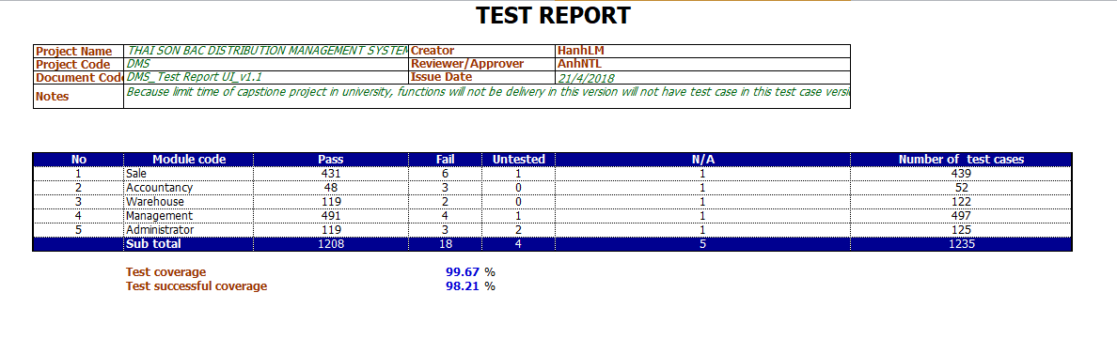

*Figure 5.1: UI test report*

* Function Test

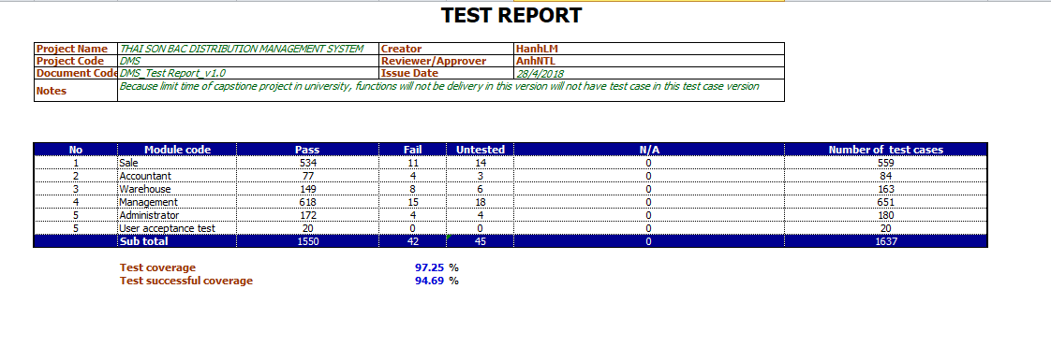

*Figure 5.2: Function test report*

* User acceptance test

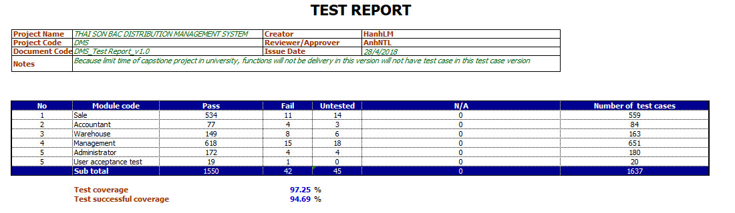

Figure 5.3 Report user acceptance test

# Software User’s Manual (SUM)

## User’s Guide

### Purposes

This document is intended to guide users who are exactly employees of Thai Son Bac company to use and operate our system.

### Detailed Guidelines

#### Login

Users using Google Chrome or Firefox browser typing thaisonbacdms.com link to the login page to the system.

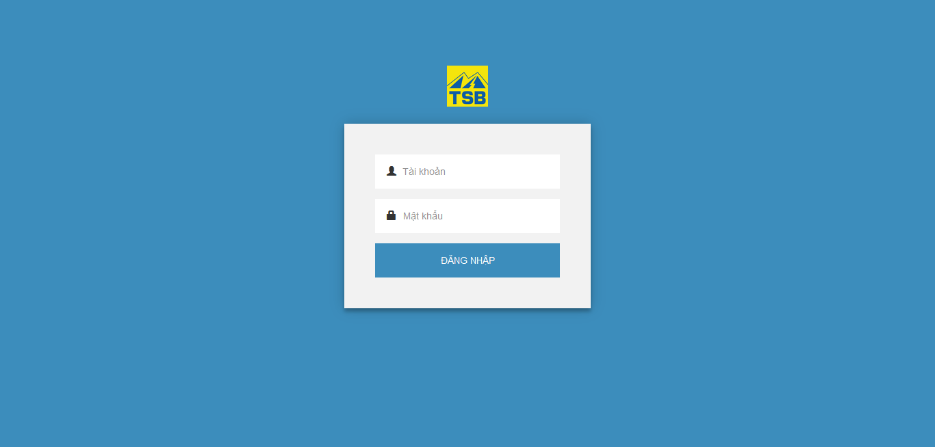

*Figure 6.1: Login screen*

User fill in correct account name and password to sign in system.

#### Logout

To sign out system user click on the user icon from right corner screen. After user click button “Thoát”, user signed out the system successfully. Then user will be directed to login page.

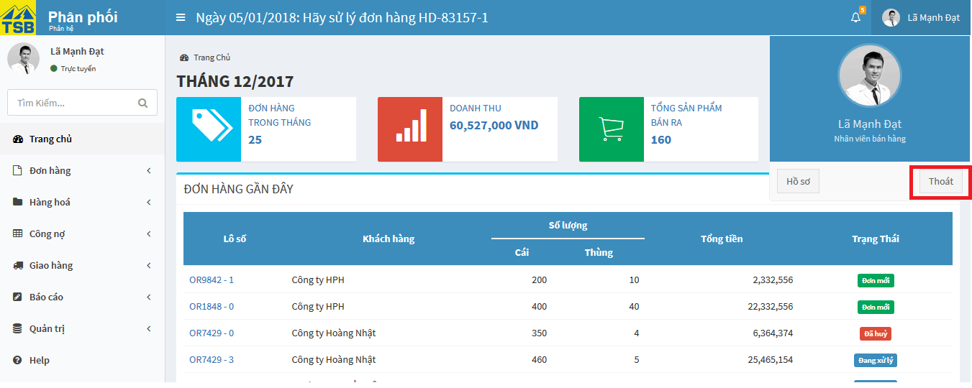

*Figure 6.2: Logout screen*

#### Change password

To change password user click on the user icon from right corner screen. After user click button “Hồ sơ” , user will be directed to user information page.

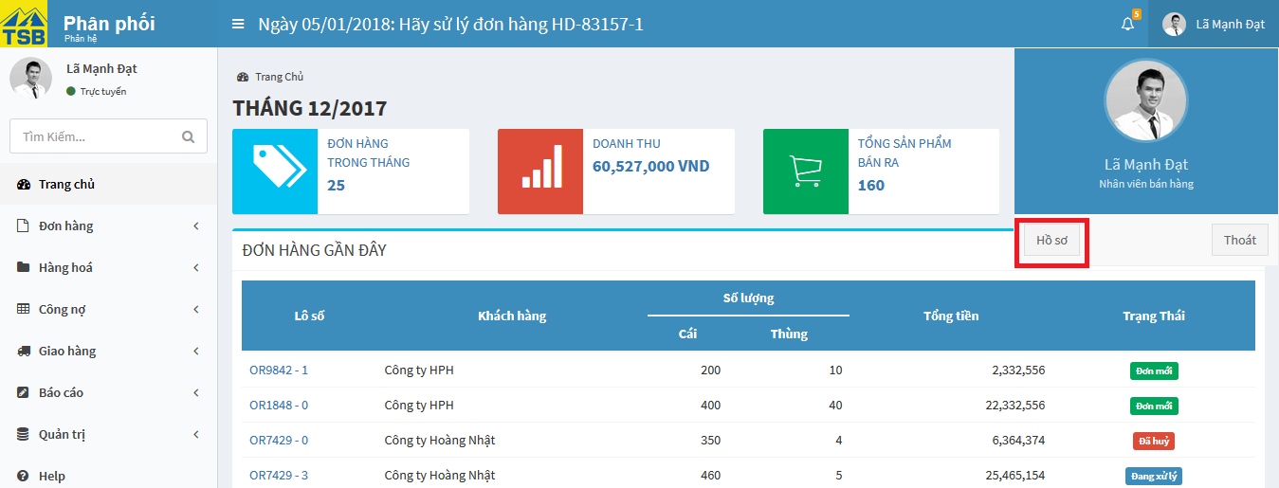

*Figure 6.3: Homepage screen*

On user information page, user click on tab “Chỉnh sửa”. User information is display. To change password, user fill new password in “Mật khẩu” fields into “Thông tin tài khoản” part. Then click button “Đổi mật khẩu”, after system display notification message “Mật khẩu thay đổi thành công” that mean user change password successfully. From that user can sign in system with new password.

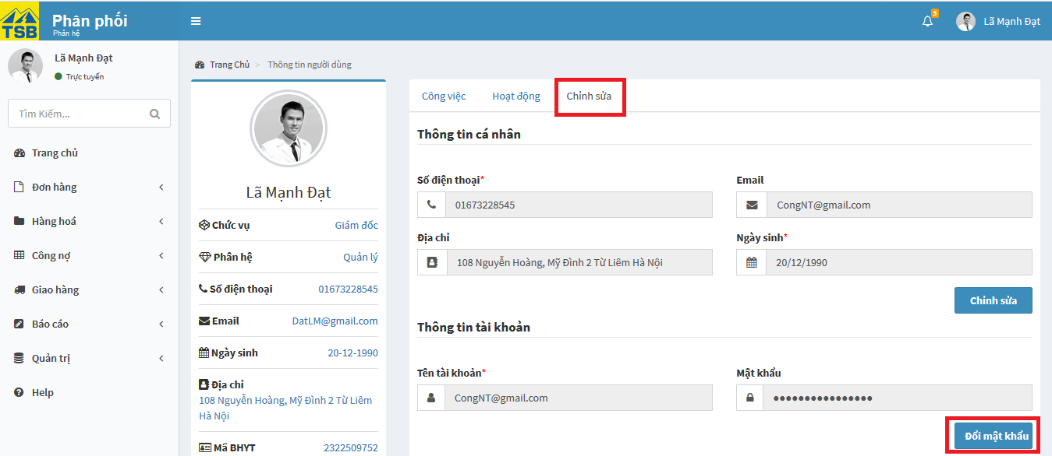

*Figure 6.4: Change password screen*

#### Notification

To view user notification, user click on bell icon in right corner. System display recent notification. To view all notification user click on “Xem tất cả”. The “Chi tiết thông báo” page display.

*Figure 6.5: Notification screen*

#### View profile

To view user profile click on the user icon from right corner screen.



*Figure 6.6: Homepage screen*

After user click button “Hồ sơ” , user will be directed to user information page.

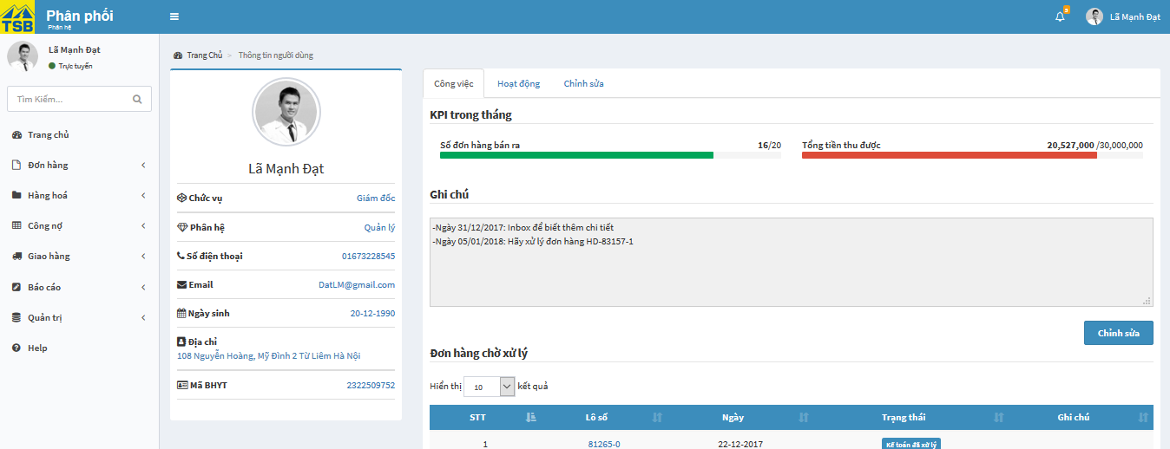

*Figure 6.7: View profile screen*

#### Edit user information

To edit or update user information, user click on the user icon from right corner screen. After user click button “Hồ sơ” , user will be directed to user information page.



*Figure 6.8: Homepage screen*

On user information page, user click on tab “Chỉnh sửa”. User information is display. To edit information, user fill all fields need to edit or update into “Thông tin cá nhân” part. Then click button “Chỉnh sửa”, after system display notification message “Lưu thay đổi thành công” that mean user change information successfully. 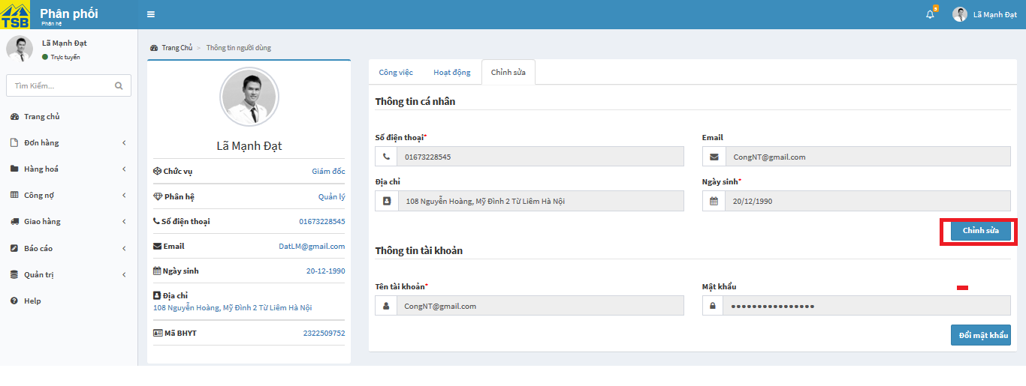

*Figure 6.9: Edit user screen*

#### Set-up order

To set-up order, user click “Lập phiếu” into tab “Đơn hàng” in left menu.

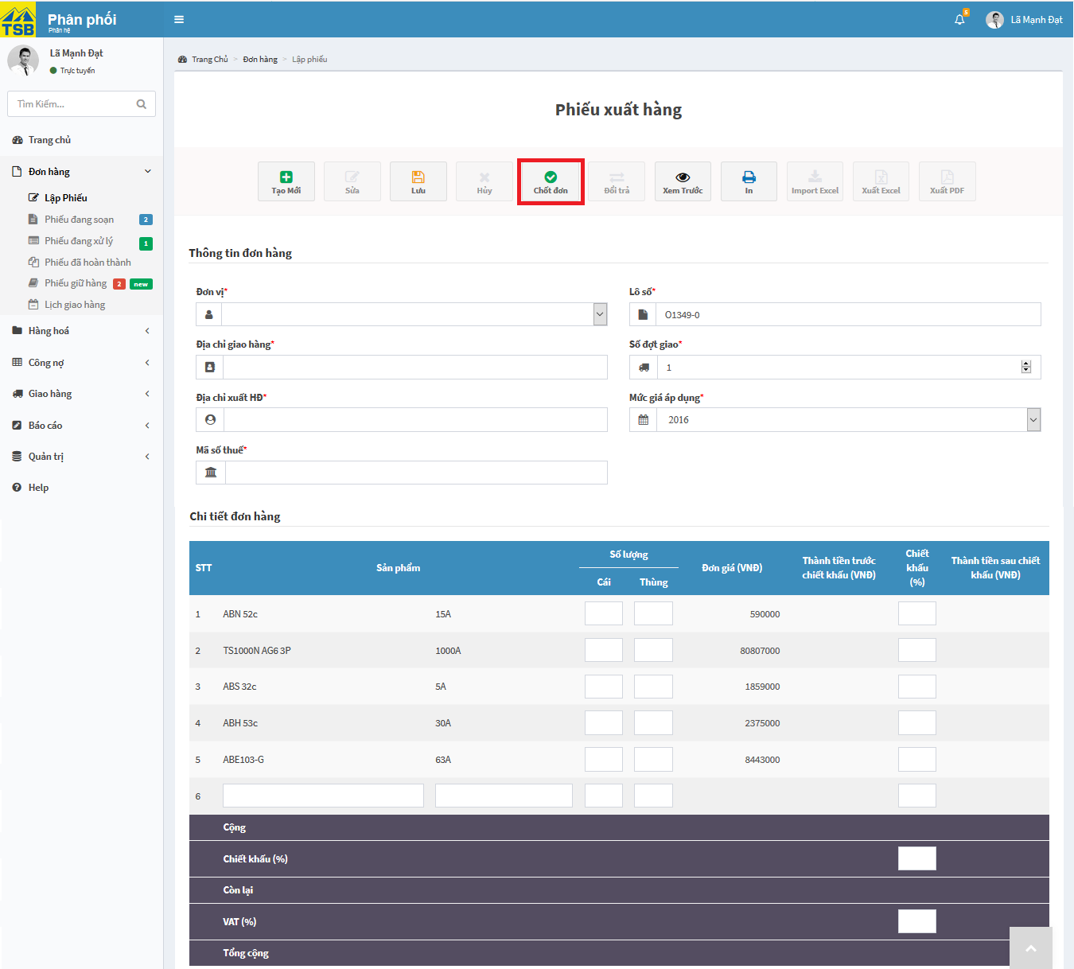

*Figure 6.10: Set-up order screen*

After fill all fields need to set-up order, user click button “Chốt đơn”. Then system display confirm message “Xác nhận chốt đơn” user click button “OK”. After system display notification message “Lập phiếu thành công” that means user set up order successfully.

#### Save order to creating order list

To save draft order, user click “Lập phiếu” into tab “Đơn hàng” in left menu.

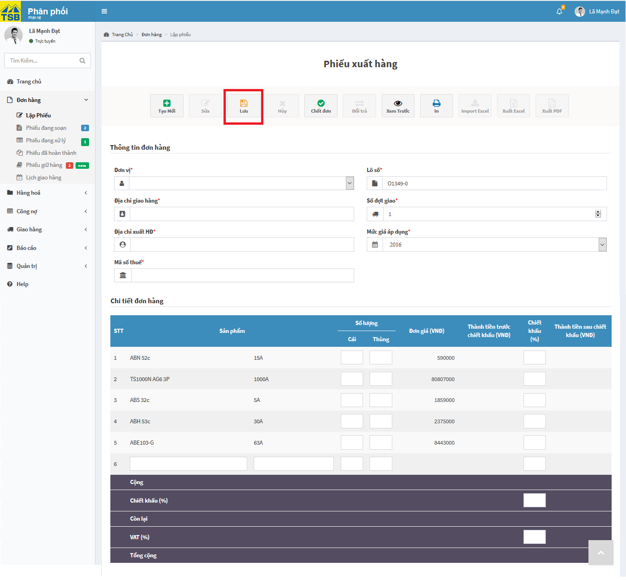

*Figure 6.11: Save draft order screen*

After fill all fields need to save draft order, user click button “Lưu”. Then system display confirm message “Xác nhận lưu” user click button “OK”. After system display notification message “ Lưu thành công” that mean user set draft order successfully.

#### Edit order

To edit order, user click button “Sửa” on order user need to edit. User will be directed edit order page.

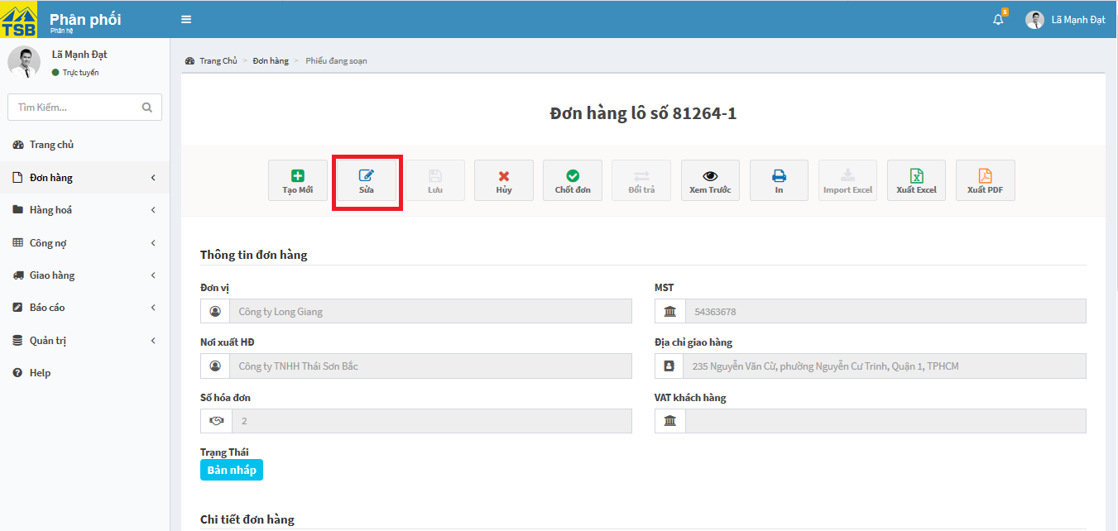

*Figure 6.12: Order detail screen*

On edit order page, user edit all fields need to edit or update. Then click on button ”Chốt đơn”. System display confirm message “Xác nhận chỉnh sửa” user click on button “OK”. After system handled, system will display message “Lưu thay đổi thành công” that mean order edited successfully.

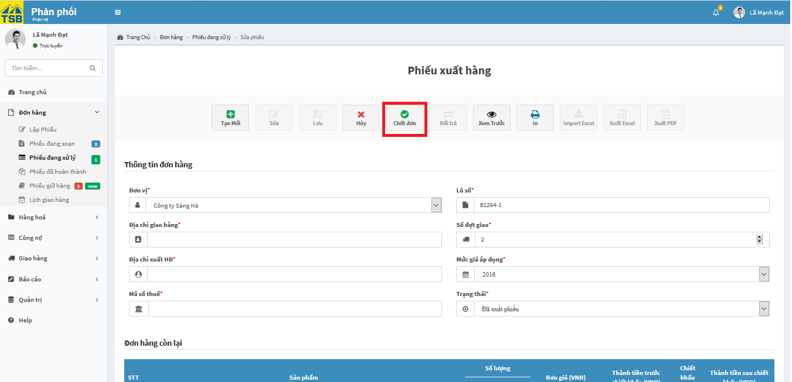

*Figure 6.13: Edit order screen*

To handling order, user login by accountant account, then user click on lot number need to handle on list of order need to be handled. User will be directed order detail page.

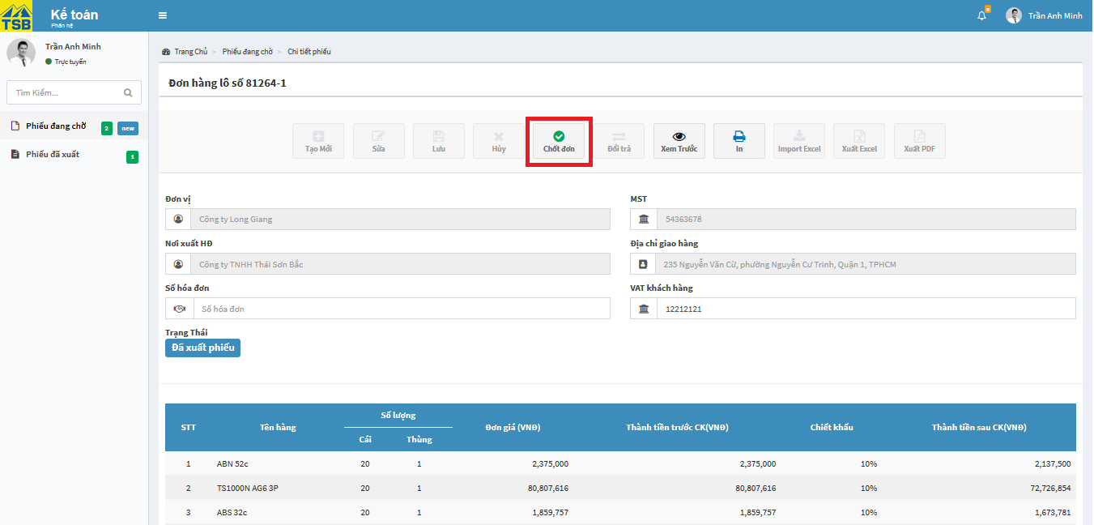

*Figure 6.14: Order handling of accountant screen*

On order detail page, user click on button”Chốt đơn”. System display confirm message “Xác nhận chốt đơn” user click on button “OK”. After system handled, system will display message “Chốt đơn thành công” that mean order is handled successfully.

#### Order handling of warehouse

To handling order, user login by warehouse account, then user click on lot number need to handle on list of order need to be handled. User will be directed order detail page.

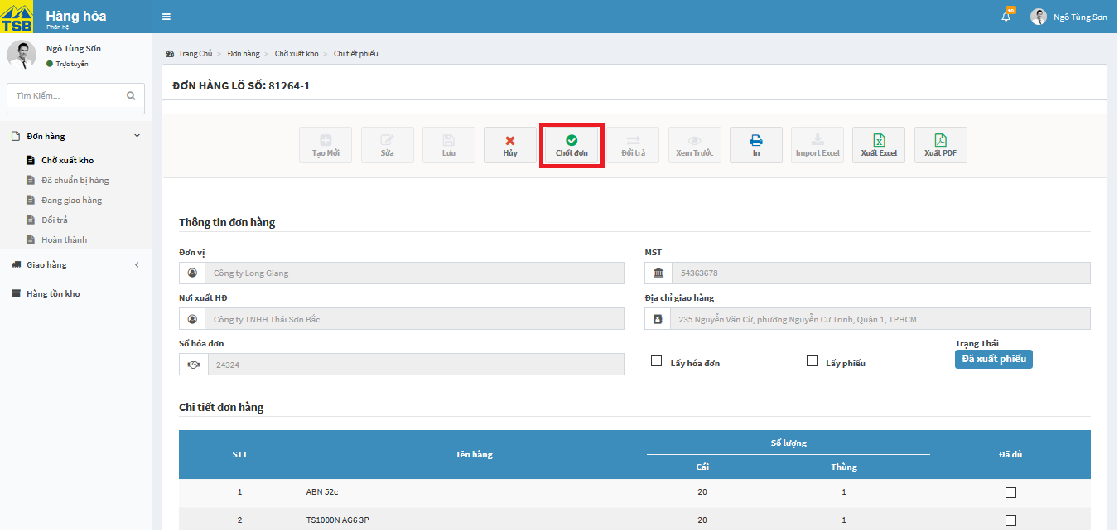

*Figure 6.15: Order handling of warehouse screen*

On order detail page, user click on button”Chốt đơn”. System display confirm message “Xác nhận chốt đơn” user click on button “OK”. After system handled, system will display message “Chốt đơn thành công” that mean order is handled successfully.

#### View order for accountant

To view order detail, user login by accountant account, then user click on lot number need to handle on list of order need to be handled. User will be directed order detail page.

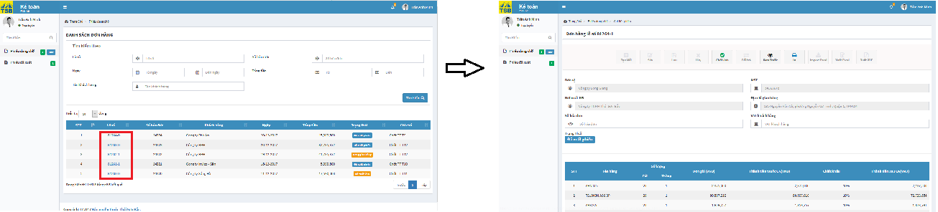

*Figure 6.16: View order for accountant screen*

#### View order for stock out of warehouse detail

To view order detail, user login by warehouse account, then user click on lot number need to handle on list of order need to be handled. User will be directed order detail page.

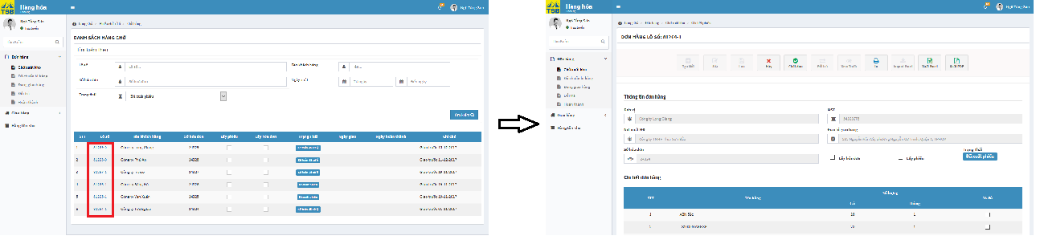

*Figure 6.17: View order for stock out of warehouse detail screen*

#### View order for delivery of warehouse detail

To view order is prepared of warehouse detail, user login by warehouse account, then user click on “Đã chuẩn bị hàng” into tab “Đơn hàng” in left menu.

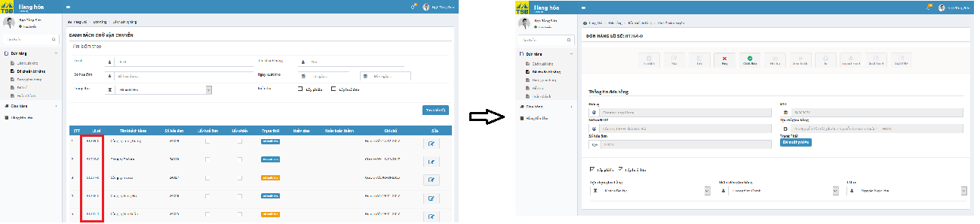

*Figure 6.18: View order for delivery of warehouse detail screen*

On “Danh sách chờ vận chuyển” page, user click on lot number need to view detail. User will be directed order detail.

#### View lists are shipping of warehouse

To view lists are shipping of warehouse, user login by warehouse account, then user click on “Đang giao hàng” into tab “Đơn hàng” in left menu

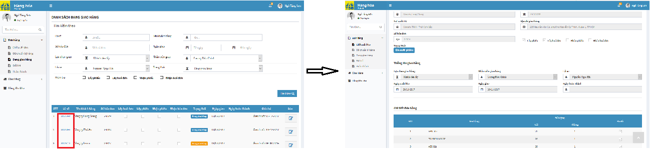

*Figure 6.19: View lists are shipping of warehouse screen*

On “Danh sách đang giao hàng” page, user click on lot number need to view detail. User will be directed order detail.

#### View order is being prepared detail

To view order is being prepared detail, user login by Seller or manager account, then user click on “Phiếu đang soạn” into tab “Đơn hàng” in left menu

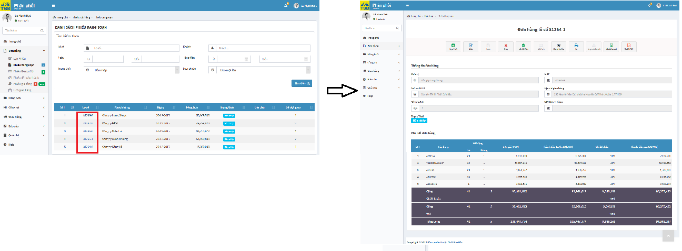

*Figure 6.20: View order is being prepared detail screen*

On “Danh sách phiếu đang soạn” page, user click on lot number need to view detail. User will be directed order detail.

#### View history edit of order

On history edit of order display all order information: time of process, history edit and edit information… Each time you edit, an edit time tab will appear. When user click the edit tab of the time, the edit contents will appear.

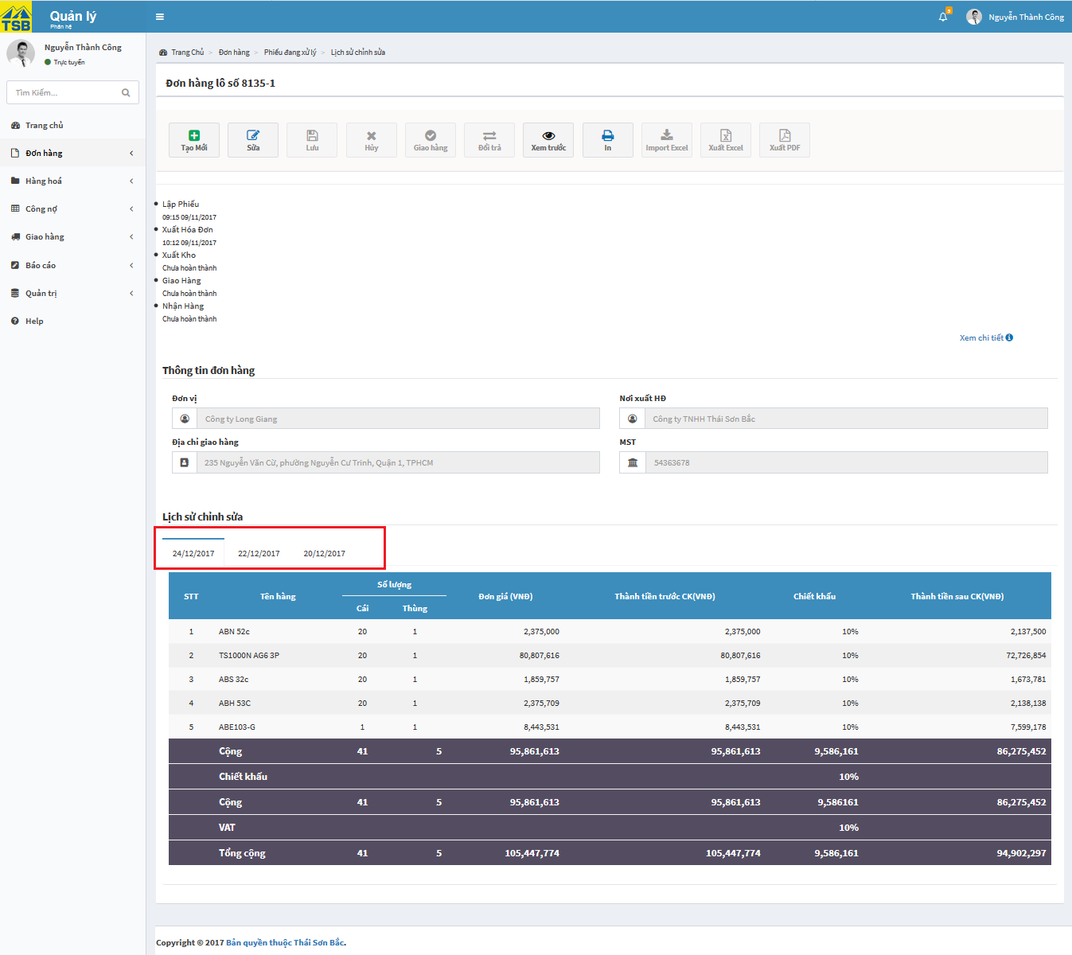

*Figure 6.21: View history edit of order screen*

#### Cancel order

To cancel order, user find order detail need to cancel

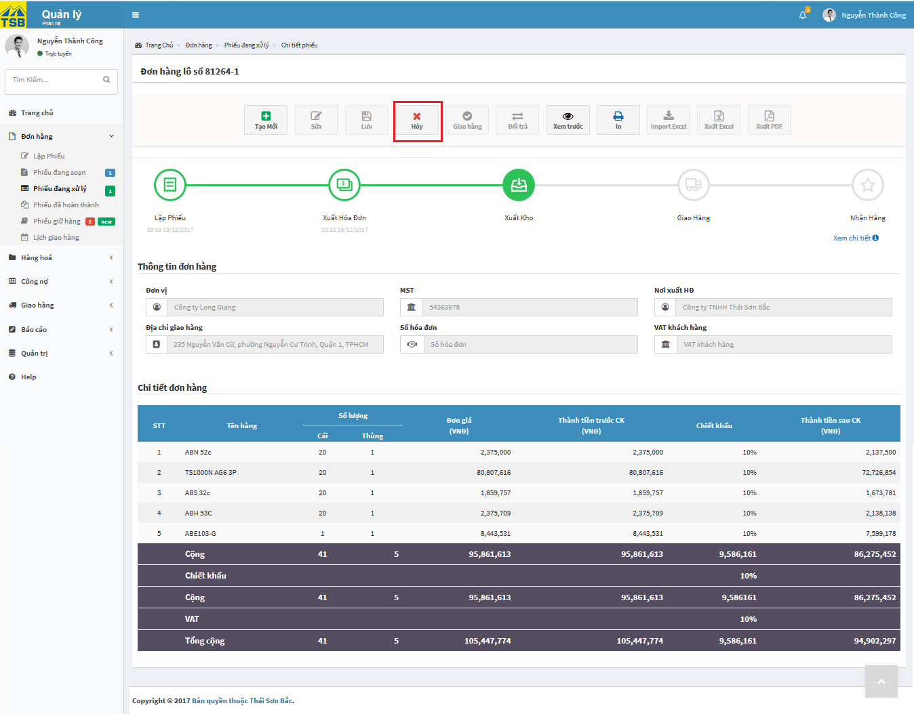

*Figure 6.22: Cancel order screen*

To cancel an order, user click on button “Hủy”. The system will display confirm message “Xác nhận hủy đơn hàng” and user must be fill reason cancel an order then click on button “Hủy”. After system handle process, the system will display notification message “Hủy đơn hàng thành công” that means order is cancelled successfully.

#### View detail progress

To view process detail, user find to order detail need to view.

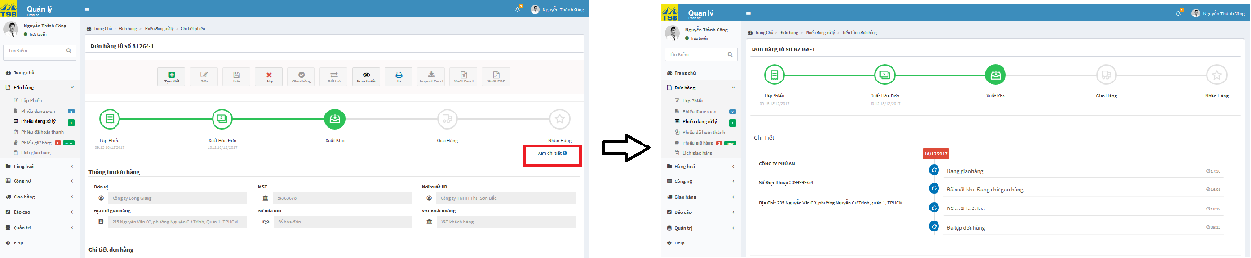

*Figure 6.23: View detail progress screen*

On order detail, in the process bar user click on link “Xem chi tiết”. User will be directed the process detail page.

#### View timeline of product

To view timeline of product, user login by Seller or manager account, then user click on view timeline product link on pop-up notify not enough quantity in stock. User will be directed timeline product code.



*Figure 6.24: View timeline of product screen*

#### View timeline of orders

To view order timeline of orders, user login by Seller or manager account, then user click on “Lịch giao hàng” into tab “Đơn hàng” in left menu. User will be directed timeline delivery.



*Figure 6.25: View timeline of orders screen*

#### View list of orders are being prepared

To view list of order is being prepared, user login by Seller or manager account, then user click on “Phiếu đang soạn” into tab “Đơn hàng” in left menu. User will be directed list of orders are being prepared.

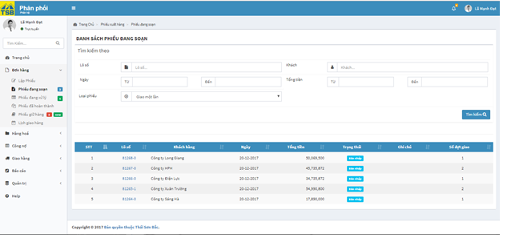

*Figure 6.26: View list of orders are being prepared screen*

#### View list of orders are being handled

To view list of orders are being handled, user login by Seller or manager account, then user click on “Phiếu đang xử lý” into tab “Đơn hàng” in left menu. User will be directed list of orders are being handled.



*Figure 6.27: View list of order are being handled screen*

#### View list of orders completed

To view list of orders completed, user login by Seller or manager account, then user click on “Phiếu đã hoàn thành” into tab “Đơn hàng” in left menu. User will be directed list of orders completed.

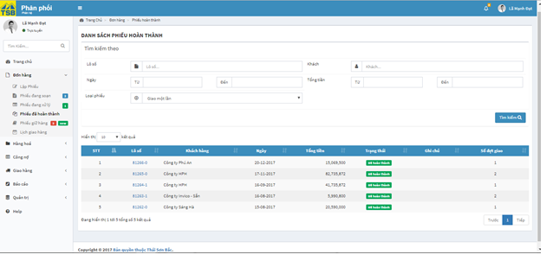

*Figure 6.28: View list of orders completed screen*

#### View list of orders canceled

To view list of orders canceled user login by Seller or manager account, then user click on “Phiếu bị hủy” into tab “Đơn hàng” in left menu. User will be directed list of orders canceled.

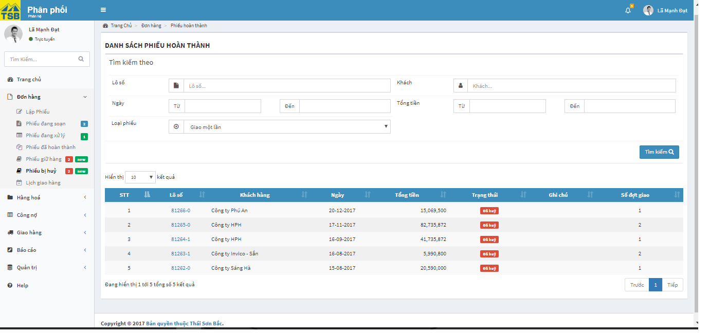

*Figure 6.29: View list of orders canceled screen*

#### View list of orders are held

To view list of orders are held, user login by Seller or manager account, then user click on “Phiếu giữ hàng” into tab “Đơn hàng” in left menu. User will be directed list of orders are being held.

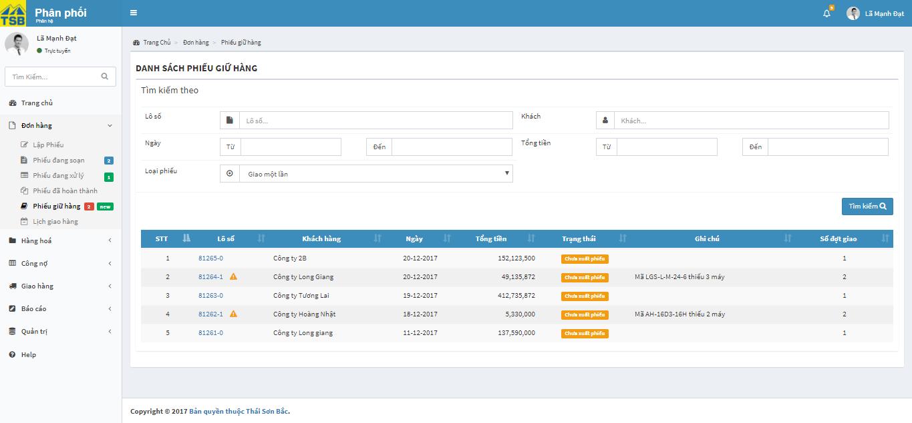

Figure 6.30: View list of orders are held screen

#### View list of orders are waiting stock out

To view list of orders are waiting stock out, user login by warehouse account, then user click on “Phiếu đã hoàn thành” into tab “Đơn hàng” in left menu. User will be directed list of orders are waiting stock out.

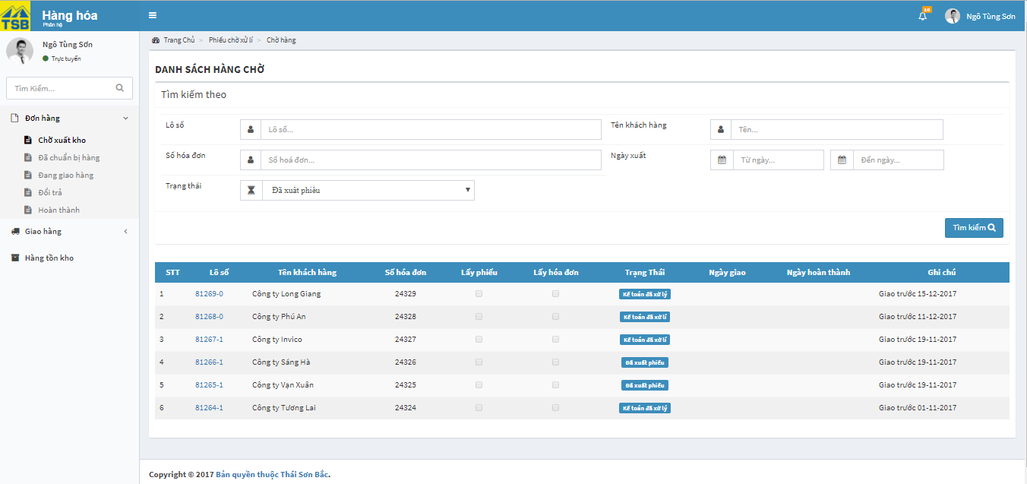

*Figure 6.31: View list of orders are waiting stock-out screen*

#### View list of orders are waiting delivery

To view list of orders are waiting delivery, user login by warehouse account, then user click on “Đã chuẩn bị hàng” into tab “Đơn hàng” in left menu. User will be directed list of orders are waiting delivery.

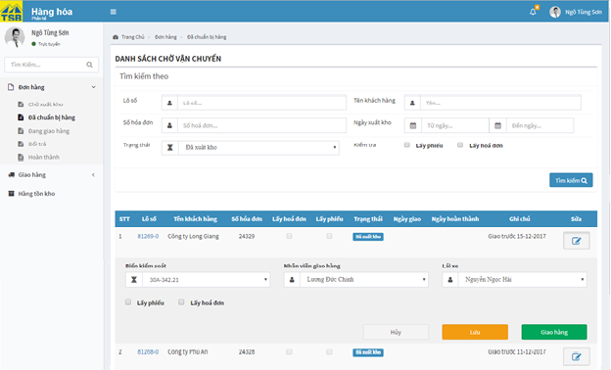

*Figure 6.32: View list of orders are waiting delivery screen*

#### View list of orders are being delivered

To view list of orders are being delivered, user login by warehouse account, then user click on “Đang giao hàng” into tab “Đơn hàng” in left menu. User will be directed list of orders are being delivered.

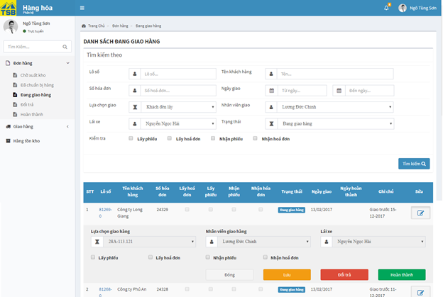

*Figure 6.33: View list of order are being delivered screen*

#### View list of orders returned

To view list of orders retuned, user login by warehouse account, then user click on “Đổi trả” into tab “Đơn hàng” in left menu. User will be directed list of orders are returned.

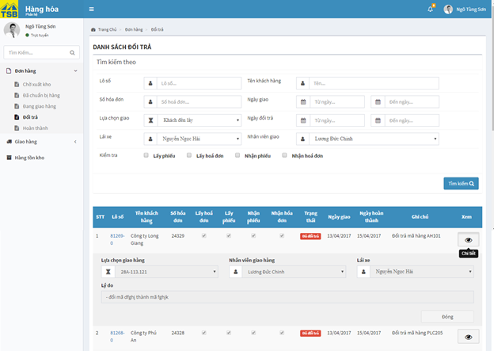

*Figure 6.35: View list of order returned screen*

#### View list of orders completed

To view list of orders completed, user login by warehouse account, then user click on “Hoàn thành” into tab “Đơn hàng” in left menu. User will be directed list of orders completed.

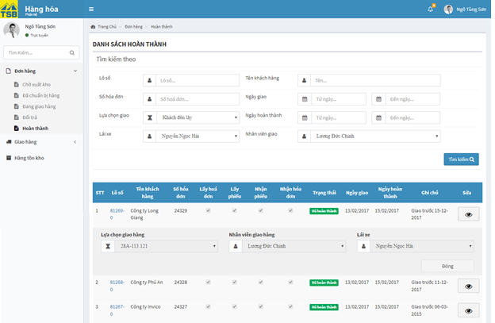

*Figure 6.35: View list of orders completed screen*

#### View list of order are waiting

To view list of orders are waiting, user login by accountant role then click on “Phiếu đang chờ” into tab “Đơn hàng” in left menu. User will be directed list of orders are waiting.

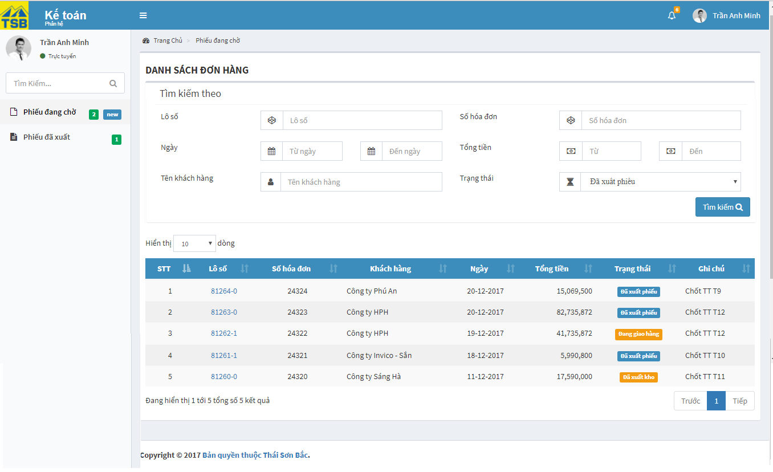

*Figure 6.36: View list of order are waiting screen*

#### View list of order handled

To view list of orders handled, user login by accountant role then click on “Phiếu đã xuất” into tab “Đơn hàng” in left menu. User will be directed list of orders handled.

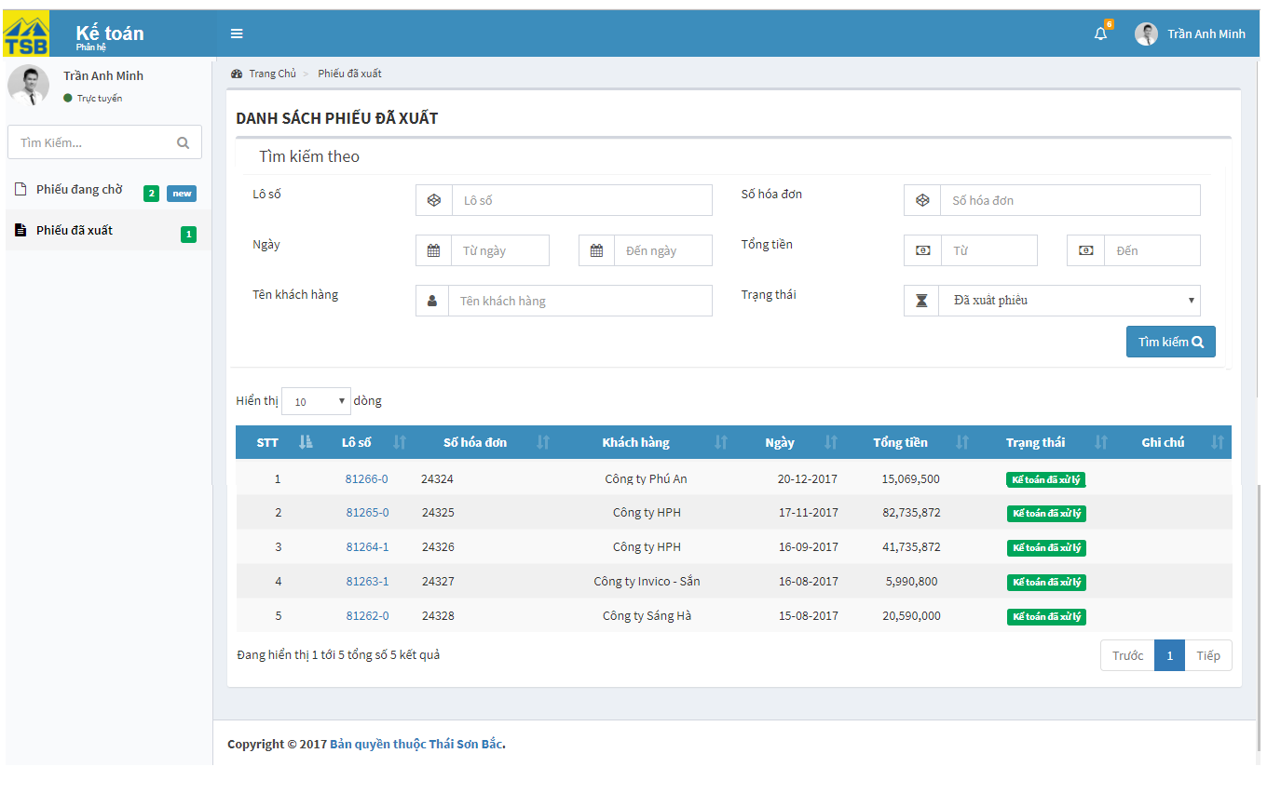

*Figure 6.37: View list of order handled screen*

#### Search order

To search order, user type anything inside search fields, as long as list of suggest will be display. If any suggest matches order you are looking for then click on it, this should display directly to the order you need. Then, user click on button “Tìm kiếm”

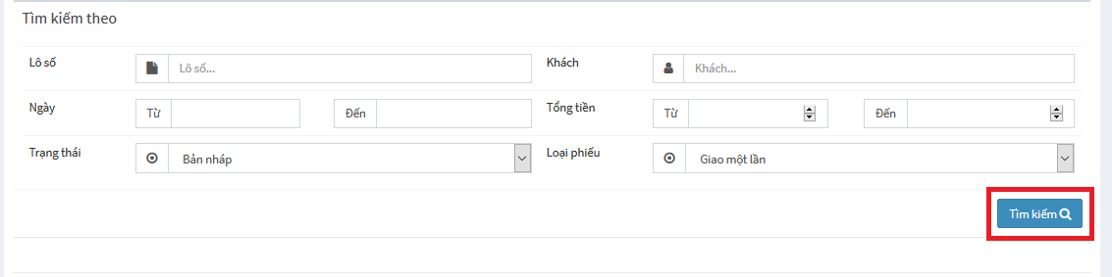

*Figure 6.38: Search order screen*

Search result with matches search keyword, will display in data table.

#### View list of customer debt

To view list of customer debt, user click on “Công nợ khách hàng” into tab “Công nợ” in left menu. User will be directed list of customer debt. User can be search customer debt by customer name or approximate debt. User can type anything inside customer name field, as long as list of suggest will be display. If any suggest matches order you are looking for then click on it, then user click on button “Tìm kiếm”.

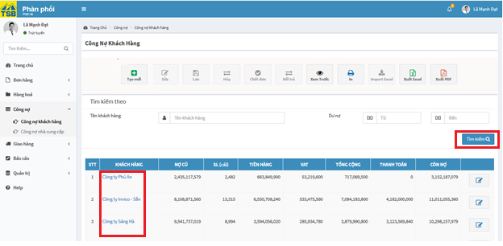

*Figure 6.39: View list of customer debt screen*

#### Customer debt handling

On list of customer debt page, user click on link customer name. Then user will be directed customer debt detail.

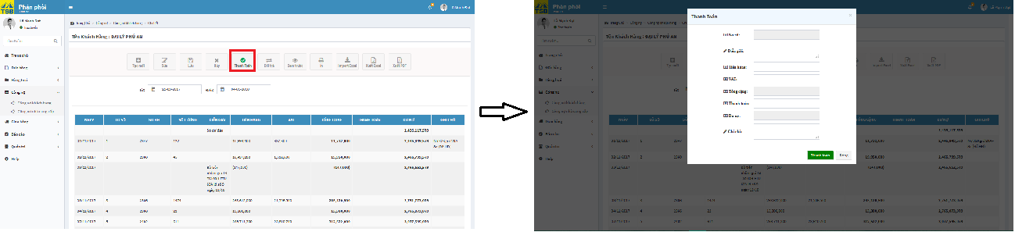

*Figure 6.40: Customer debt handling screen*

On pop up payment, user fill all required fields, then user click on button” Thanh toán”. After the system check valid data, the system will display confirm message “Xác nhận thanh toán”, user click on button “Xác nhận”. System receive handling then display notification message “Thanh toán thành công” that mean payment handling successfully.

#### View customer debt detail

On list of customer debt page, user click on link customer name. Then user will be directed customer debt detail.

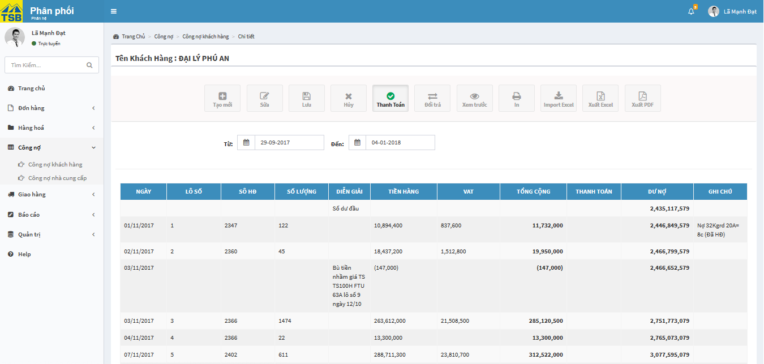

*Figure 6.41: View customer debt detail screen*

User can be search customer debt by the time.

#### View list of supplier debt

To view list of supplier debt, user click on “Công nợ nhà cung cấp” into tab “Công nợ” in left menu. User will be directed list of supplier debt. User can type anything inside supplier name field, as long as list of suggest will be display. If any suggest matches order you are looking for then click on it, then user click on button “Tìm kiếm”.

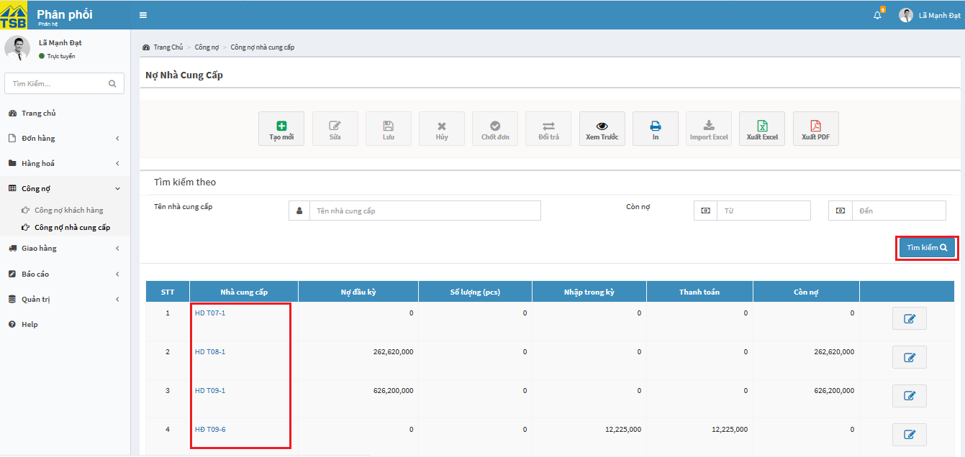

*Figure 6.42: View list of supplier debt screen*

#### Supplier debt handling

On list of supplier debt page, user click on link supplier name. Then user will be directed supplier debt detail.

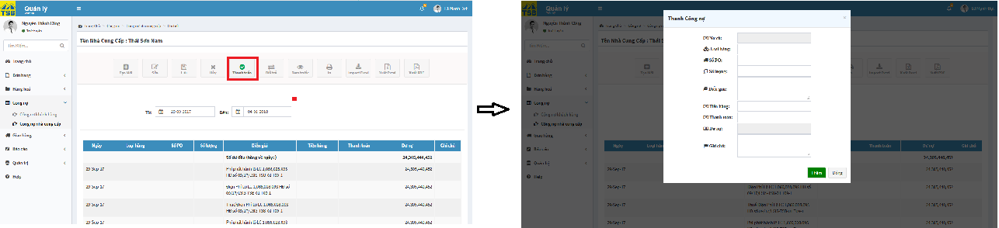

*Figure 6.43: Supplier debt handling screen*

On pop up payment, user fill all required fields, then user click on button” Thanh toán”. After the system check valid data, the system will display confirm message “Xác nhận thanh toán”, user click on button “Xác nhận”. System receive handling then display notification message “Thanh toán thành công” that mean payment handling successfully.

#### View supplier debt detail

On list of supplier debt page, user click on link supplier name. Then user will be directed supplier debt detail.

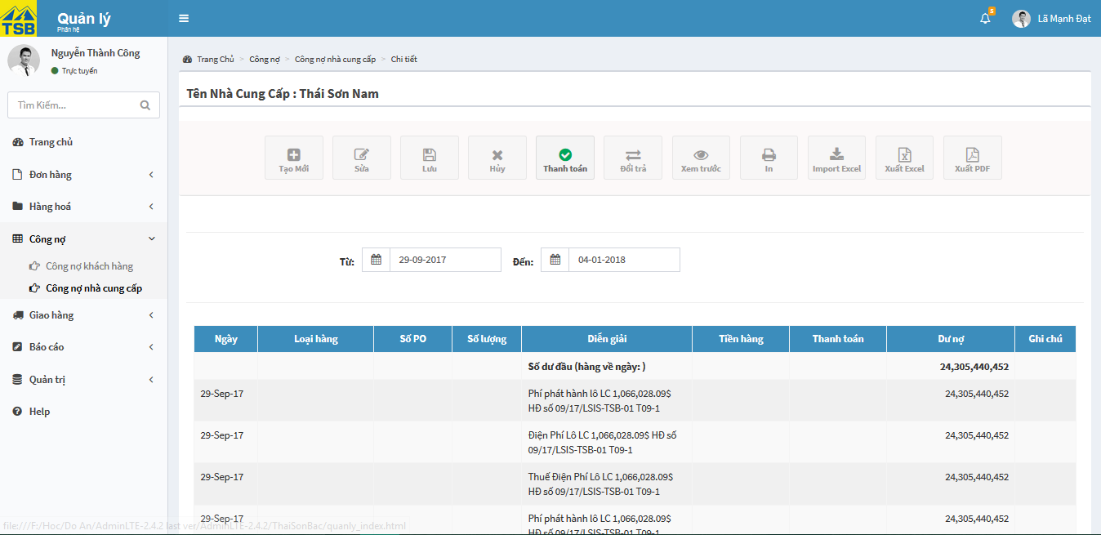

*Figure 6. 44: View supplier debt detail screen*

User can be search supplier debt by the time.

#### Create new customer debt

On list of customer debt page, user click on button “Tạo mới”. The pop up add new customer debt display

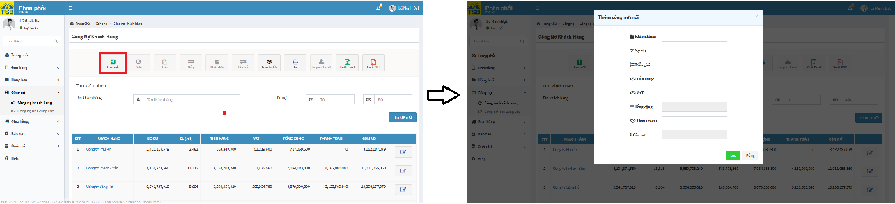

*Figure 6.45: Create new customer debt screen*

On pop up add new, user fill all required fields, then user click on button” OK”. After the system check valid data, if customer haven’t yet created, the system display message “Xác nhận tạo khách hàng và thêm công nợ mới”. Else customer have created, the system display message “Xác nhận thêm công nợ”. Then user click on button “Lưu”. System receive handling then display notification message “Thêm mới công nợ thành công” that mean user add new debt successfully.

#### Create new supplier debt

On list of supplier debt page, user click on button “Tạo mới”. The pop up add new supplier debt display

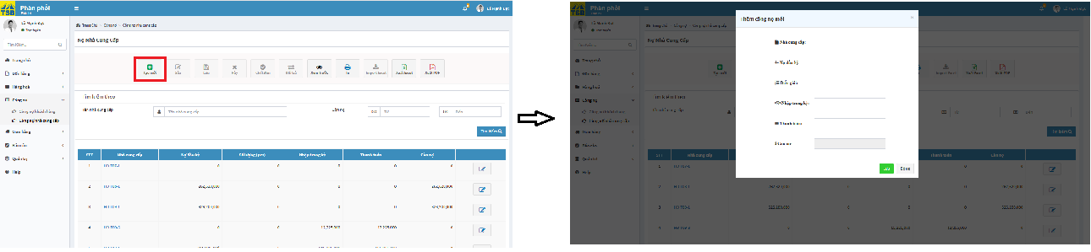

*Figure 6.46: Create new supplier debt screen*

On pop up add new, user fill all required fields, then user click on button” OK”. After the system check valid data, if supplier haven’t yet created, the system display message “Xác nhận tạo nhà cung cấp và thêm công nợ mới”. Else supplier have created, the system display message “Xác nhận thêm công nợ”. Then user click on button “Lưu”. System receive handling then display notification message “Thêm mới công nợ thành công” that mean user add new debt successfully.

#### View products are trading list

To view list of product are trading, user click on “Sản phẩm đang kinh doanh” into tab “Sản phẩm” into tab “Hàng hóa” in left menu. User will be directed list of products are trading. User can be search product by product name or category…. User can type anything inside product name field, as long as list of suggest will be display. If any suggest matches order you are looking for then click on it, then user click on button “Tìm kiếm”.

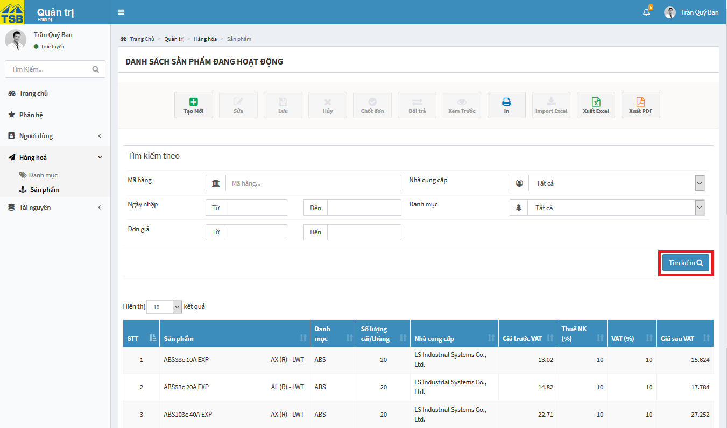

*Figure 6.47: View list of products are trading screen*

#### View products stopped trading list

To view list of product are trading, user click on “Sản phẩm ngừng kinh doanh” into tab “Sản phẩm” into tab “Hàng hóa” in left menu. User will be directed list of products are trading. User can be search product by product name or category…. User can type anything inside product name field, as long as list of suggest will be display. If any suggest matches order you are looking for then click on it, then user click on button “Tìm kiếm”.

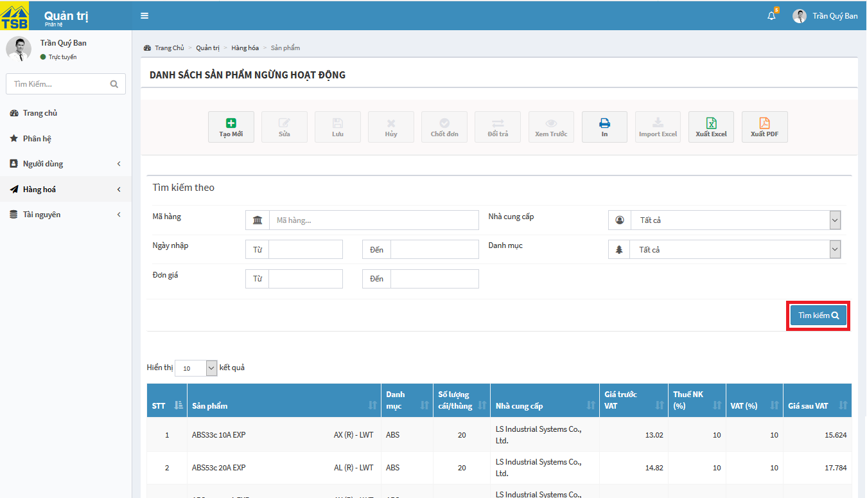

*Figure 6.48: View list of products stopped trading screen*

#### View list of products price

To view list of products price, user click on “Giá sản phẩm” into tab “Hàng hóa” in left menu. User will be directed list of products price. User can be search product by product code or category…. User can type anything inside product name field, as long as list of suggest will be display. If any suggest matches order you are looking for then click on it, then user click on button “Tìm kiếm”.

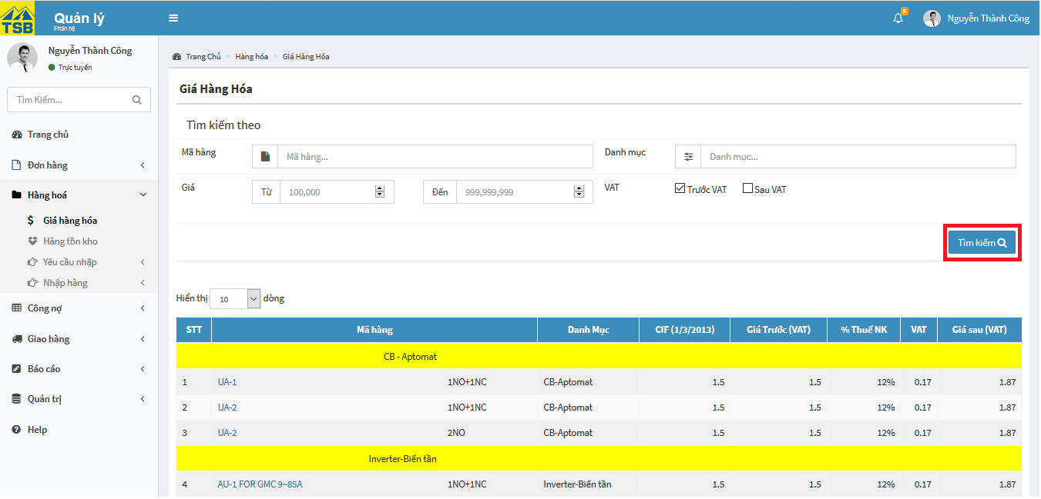

*Figure 6.49: View list of products price screen*

#### View inventory

To view inventory, user click on “Hàng tồn kho” into tab “Hàng hóa” in left menu. User will be directed list of inventory. User can be search product by product code or category…. User can type anything inside product name field, as long as list of suggest will be display. If any suggest matches order you are looking for then click on it, then user click on button “Tìm kiếm”.

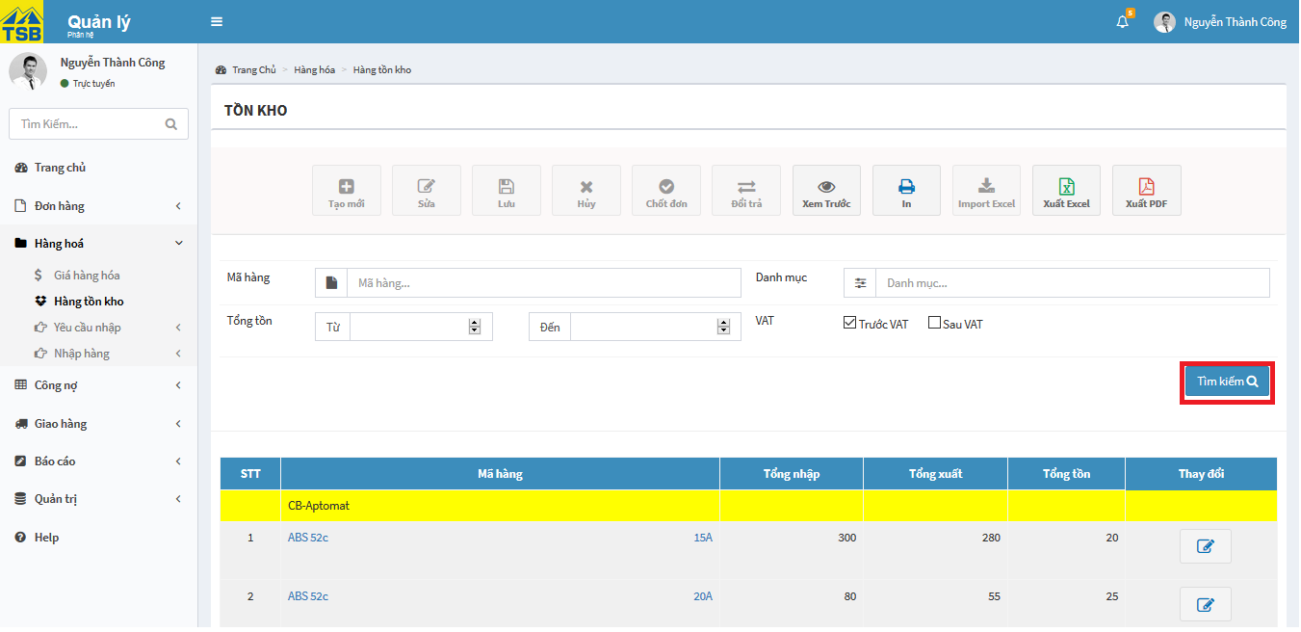

*Figure 6.50: View inventory screen*

#### View product detail

To view product detail, user click on “Sản phẩm” into tab “Hàng hóa” into tab “Quản trị”. User will be directed list of product.

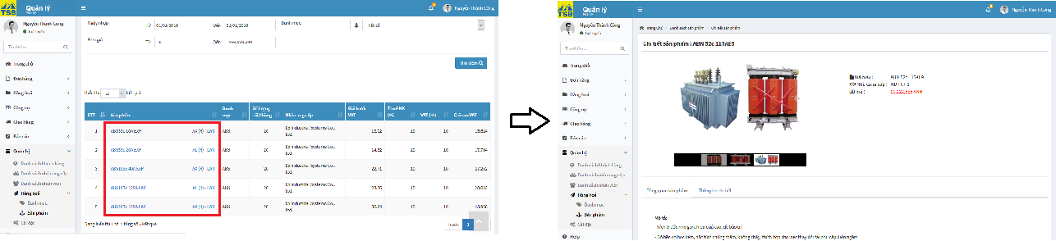

*Figure 6.51: View product detail screen*

On list of product, user click on link of product user need to view. User will be directed product detail. On product detail user can see all product information such as: description, supplier, price…

#### Create new product

To create new product, user click on “Sản phẩm” into tab “Hàng hóa” into tab “Quản trị”. User will be directed list of product. On list of product, to add new product user click on button “Tạo mới”. User will be directed the add new product page.

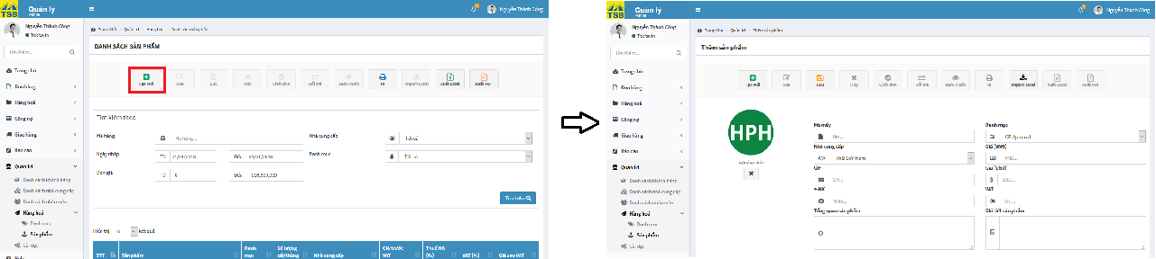

*Figure 6.52 : Create new product screen*

On the add new product, user fill all required fields to create product and load picture about product. Then, user click on button “Lưu”, system receives handle check valid data after that display confirm message “Xác nhận tạo sản phẩm mới”, user click on button “OK”. After the system saved information about product successfully will display notification message “Thêm sản phẩm mới thành công”.

#### Edit product

To edit product information, user click on “Sản phẩm” into tab “Hàng hóa” into tab “Quản trị”. User will be directed list of product. On the list of product, user click on button “Sửa”. User will be directed the edit product page.

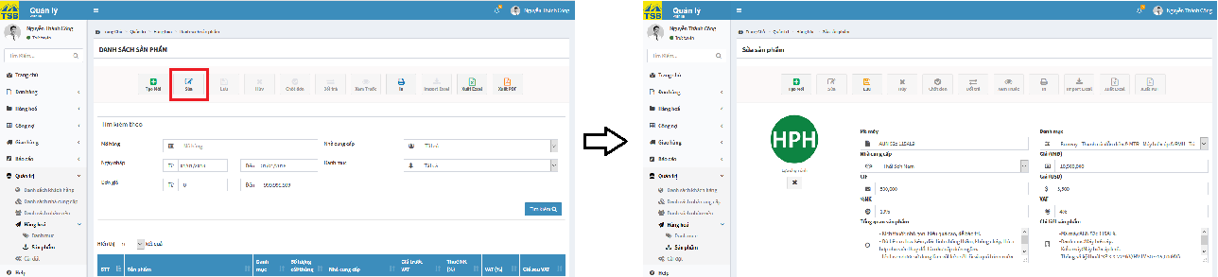

*Figure 6.53: Edit product screen*

On the edit product page, user edit or update product information into all fields need to edit or update and remember fill all required fields. Then, click on button “Lưu”, the system receives handle check valid data after that display confirm message “Xác nhận chỉnh sửa”, user click on button “OK”. After the system save information product. Successfully will display notification message “Chỉnh sửa sản phẩm thành công”.

#### View category

To view category, user click on “Danh mục” into tab “Hàng hóa” into tab “Quản trị”. User will be directed list of category. On the list of category, user click on link of category name, list of sub-category of category display. To view list of product belong sub-category, user click on link of sub-category, list of product will be displayed in data table.



*Figure 6.54:View category screen*

#### Create new category

To create new category, user click on “Danh mục” into tab “Hàng hóa” into tab “Quản trị”. User will be directed list of category. On list of category, user click on button “Tạo mới”. User will be directed create new category page.

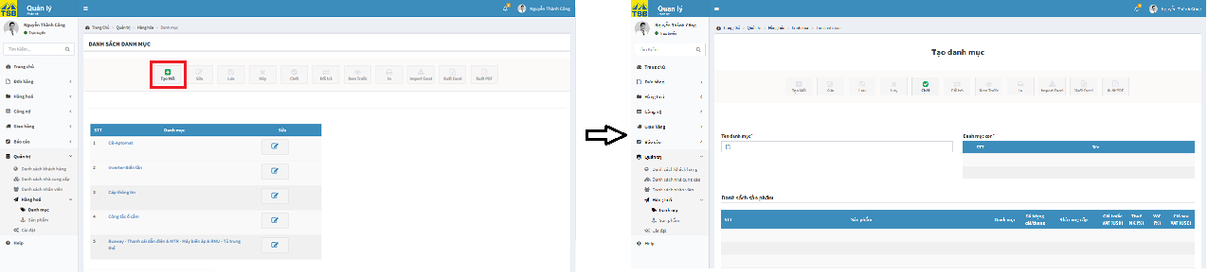

*Figure 6.55: Create new category screen*

On create new category page, user fill category name then fill all sub category of category. Then, user click on button “Lưu”, the system receive handle check valid data after that the system display confirm message “Xác nhận lưu thông tin”. User click on button “OK” after system save category information successfully, system will be displayed notification message “Tạo mới danh mục thành công”.

#### Create new sub-category

To create new sub category, user click on “Danh mục” into tab “Hàng hóa” into tab “Quản trị”. User will be directed list of category.

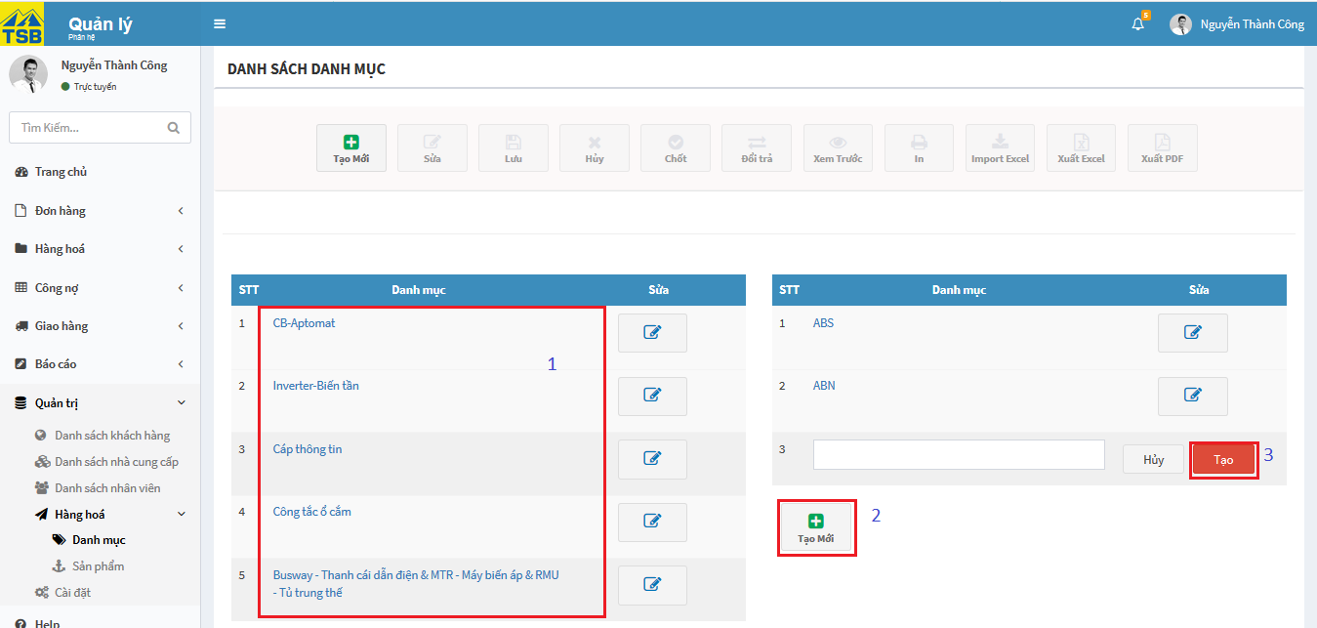

*Figure 6.56: Create new sub-category screen*

On list category, user click on link of category which user need to add sub- category, list of sub-category of category display. User click on button “Tạo mới”, on table data displayed field for user fill name of new sub-category. After fill sub-category name, user click on button “Tạo”. The system receives handle check valid data after that system displayed confirm message “Xác nhận lưu thông tin”. User click on button “OK” after system save new sub-category information successfully, system will be displayed notification message “Tạo danh mục con thành công”.

#### Edit category

To edit category information, user click on “Danh mục” into tab “Hàng hóa” into tab “Quản trị”. User will be directed list of category. On the list of product, user click on button “Sửa”. All fields of category can be edit display.

If user edit or update category information after that click on button “Sửa”. The system receive handle and check valid data then display confirm message “Xác nhận chỉnh sửa”. User click on button “OK” after system save edit information successfully, system display notification message “Lưu thay đổi thành công”.

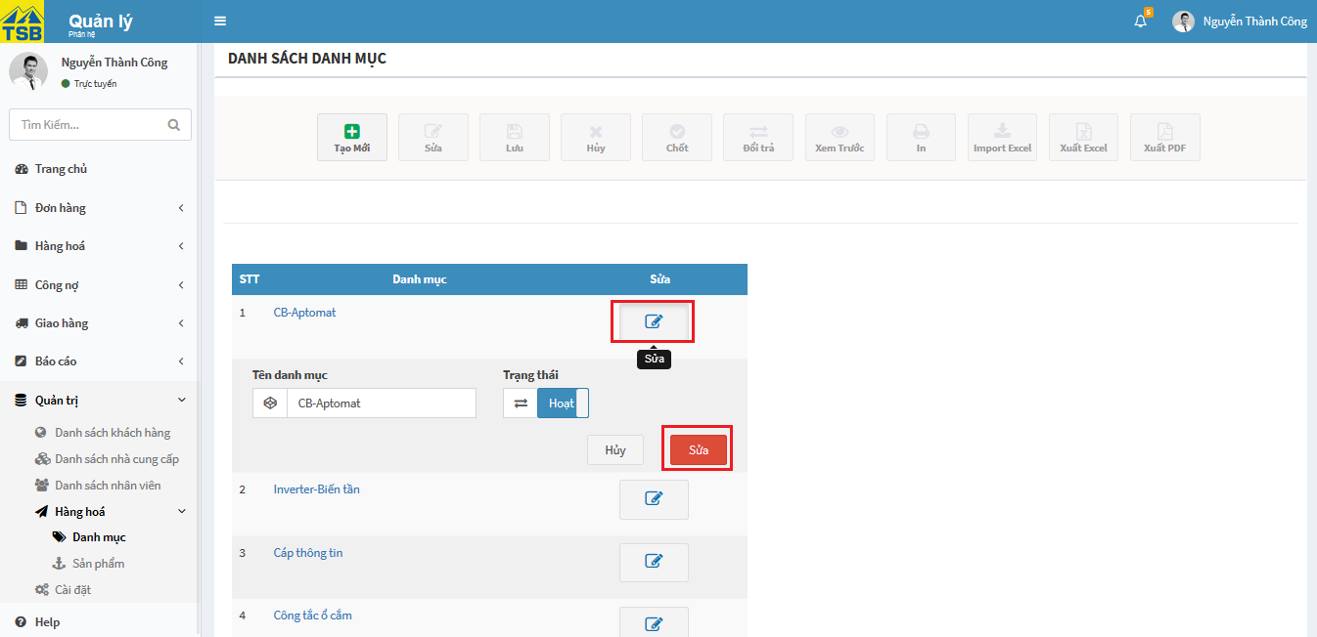

*Figure 6.57: Edit category screen*

If user want to edit activity status category, user click button change status to “Ngừng hoạt động” after that click on button “Sửa”. The system receive then display confirm message “Xác nhận ngừng hoạt động”. User read carefully the message content then click on button “OK” after system save edit information successfully, system display notification message “Lưu thay đổi thành công”.

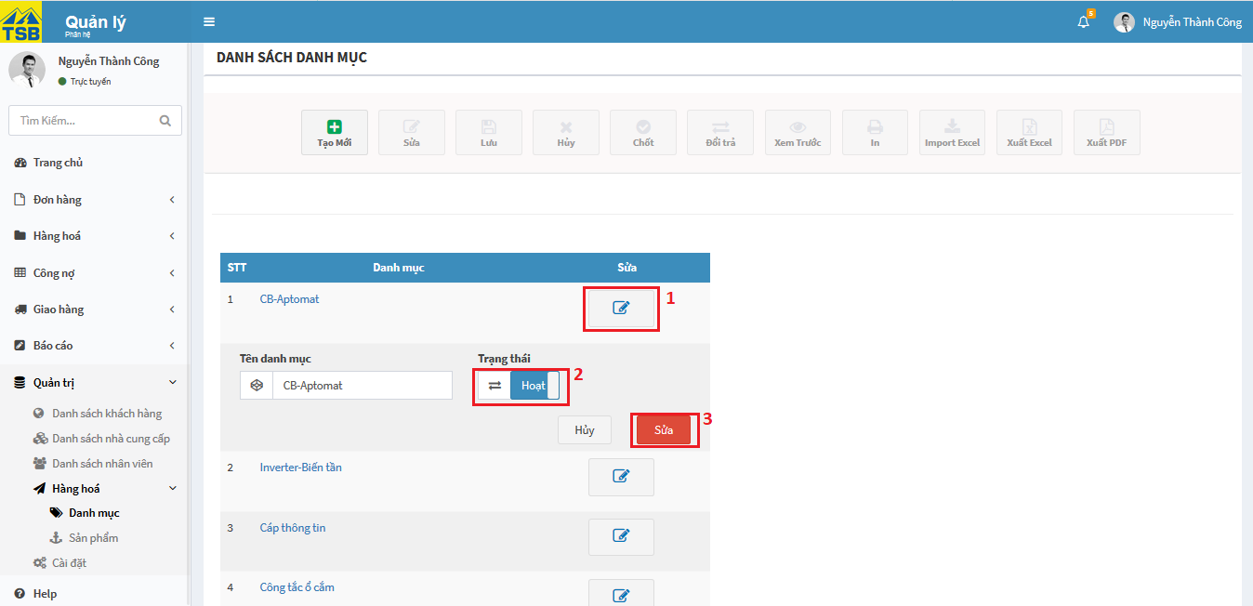

*Figure 6.58: Edit status category screen*

#### Edit sub-category

To edit sub-category information, user click on “Danh mục” into tab “Hàng hóa” into tab “Quản trị” in left menu. User will be directed list of category. On the list of product, user click on link of category name contain sub-category user want to be edited then list of sub-category display, user click on button “Sửa”. All fields of sub-category can be edit display.

If user edit or update sub-category information after that click on button “Sửa”. The system receive handle and check valid data then display confirm message “Xác nhận chỉnh sửa”. User click on button “OK” after system save edit information successfully, system display notification message “Lưu thay đổi thành công”.

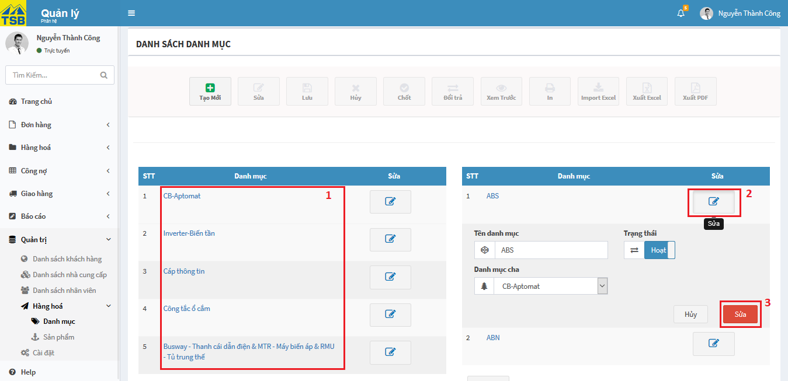

*Figure 6.59: Edit sub-category screen*

If user want to edit activity status sub-category, user click button change status to “Ngừng hoạt động” after that click on button “Sửa”. The system receives then display confirm message “Xác nhận ngừng hoạt động”. User read carefully the message content then click on button “OK” after system save edit information successfully, system display notification message “Lưu thay đổi thành công”.

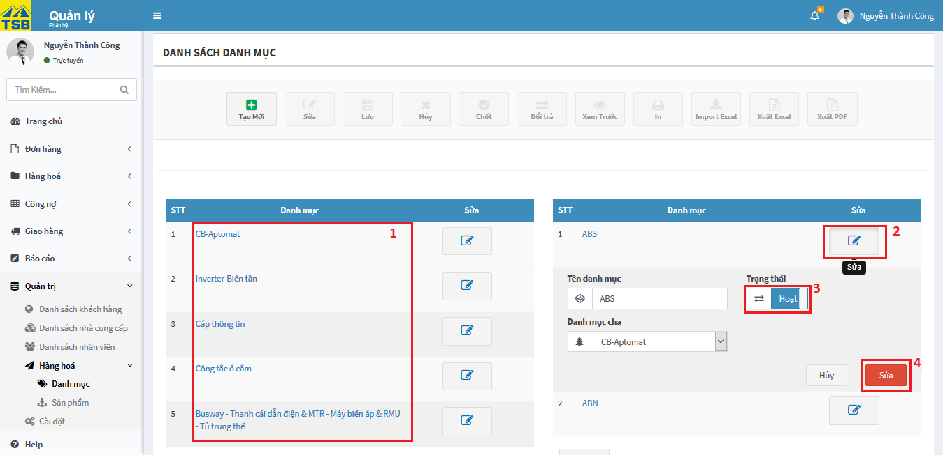

*Figure 6.60:Edit status sub-category screen*

#### Search product

To search product, user type anything inside product code fields, as long as list of suggest will be display. If any suggest matches product you are looking for then click on it, this should display directly to the product you need. Or user can search by supplier, category or about price of product. Then, user click on button “Tìm kiếm”

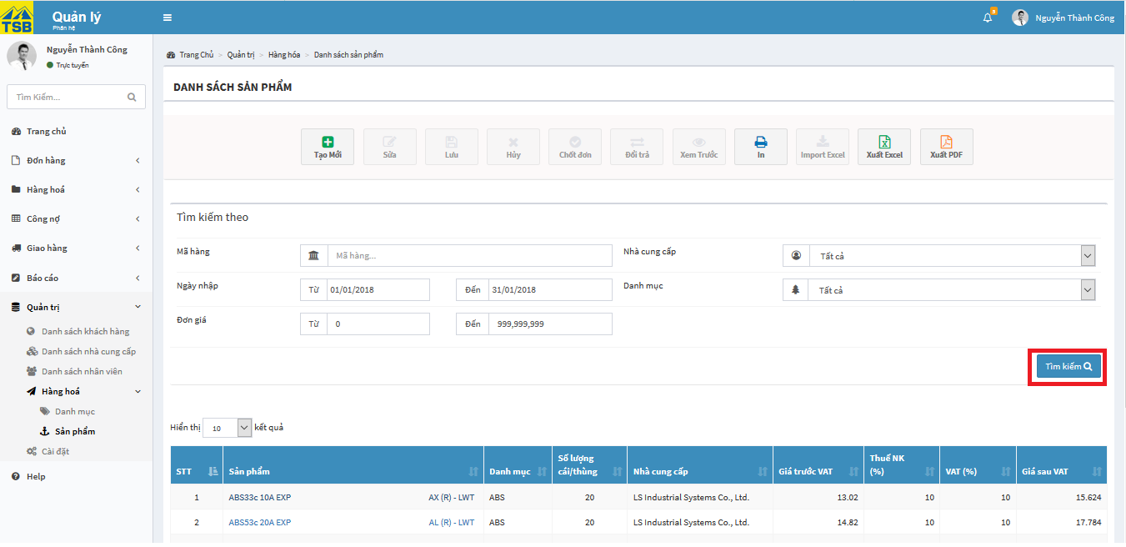

*Figure 6.61: Search product screen*

Search result with matches search keyword, will display in data table.

#### View revenue report

To view revenue report, user login by Sellers, managers account, user click on “Doanh thu” into tab “Báo cáo” in left menu. User will be directed revenue report. User can see revenue report by weekly, monthly, yearly.

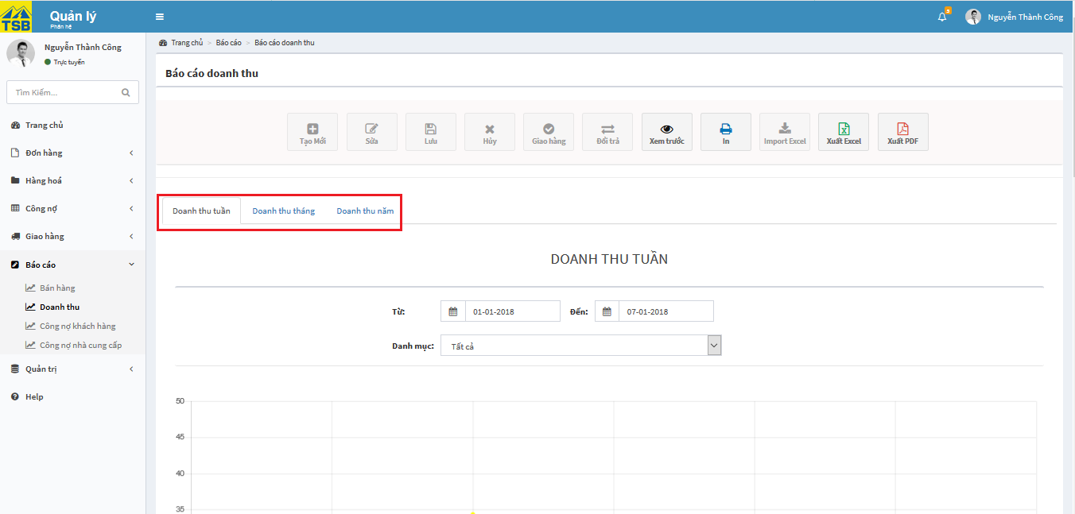

*Figure 6.62: View revenue report screen*

#### View revenue detail report

To view revenue detail report, user log in by Sellers, managers account, the click on link “Xem chi tiết” in revenue detail. User will be directed revenue detail page.

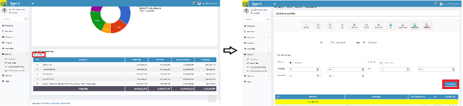

*Figure 6.63: View revenue detail report screen*

On revenue detail page, user can search revenue by product code, category. User fill product code, category or turnover…

#### View customer debt report

To view customer debt report, user login by Sellers or managers account, user click on “Công nợ khách hàng” into tab “Báo cáo” in left menu. User will be directed customer debt report page.

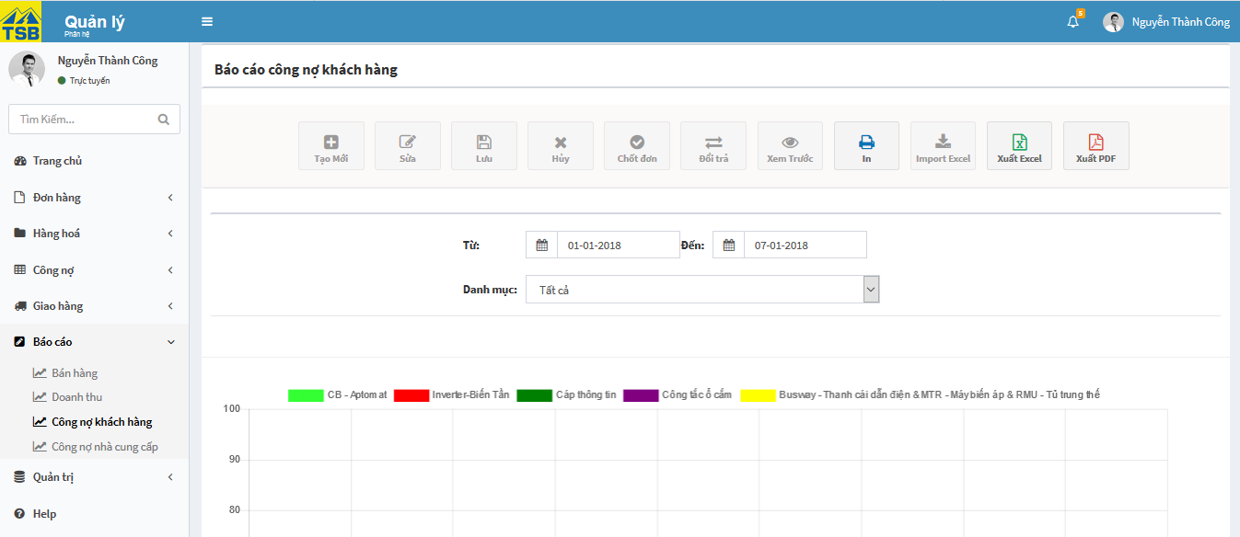

*Figure 6.64: View customer debt report screen*

On customer debt report page, user can see total debt of each customer according to each category of products and top 10 customers have the highest debt. User choose view by category of product or date. To view customer debt detail, on list of customer debt user click on link customer name. User will be directed customer debt detail. User choose view by category of product.

#### View supplier debt report

To view supplier debt report, user login by Sellers or managers account, user click on “Công nợ nhà cung cấp” into tab “Báo cáo” in left menu. User will be directed supplier debt report page.

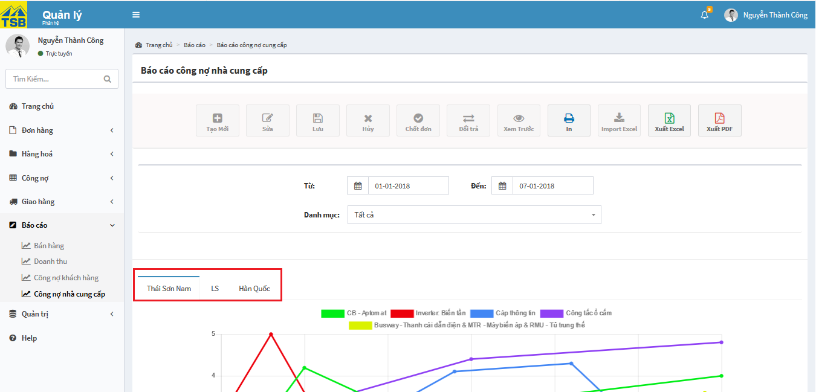

*Figure 6.65: View supplier debt report screen*

On supplier debt report page, user can see total debt of each supplier according to each category of products and import product detail. User choose view by category of product or date. On the page will display many tabs per tab is of each supplier. To view user click on supplier tab need to view reports related to that supplier.

#### View purchased of supplier detail

On supplier debt report page, to view purchased of supplier detail user click on link “Xem chi tiết” in import product detail part. User will be directed purchased of supplier detail.

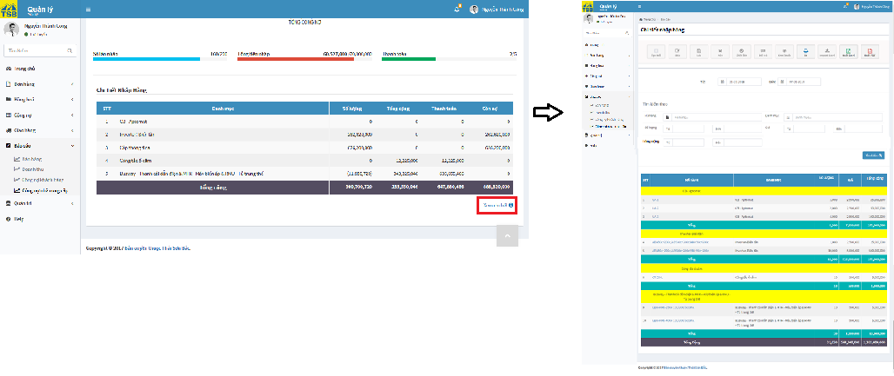

*Figure 6.66: View purchase of supplier detail screen*

#### View indicators in month

User login by Sellers or managers account, then user click on “Trang chủ” in left menu. User will be direct indicators in month page. On page user can see recent order, compare revenue 2 recent months and top selling.

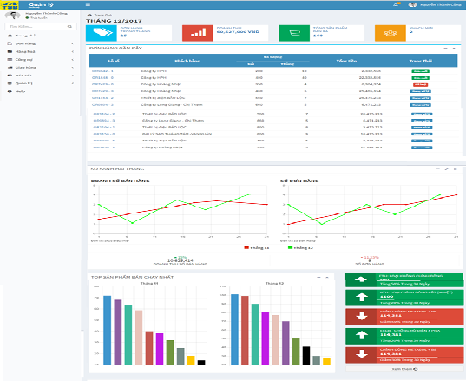

*Figure 6.67: View indicators in month screen*

#### View Sales activities report

To view sale activities report, user login by Sellers, managers account, user click on “Bán hàng” into tab “Báo cáo” in left menu. User will be direct selling report page. User can see selling report by date.

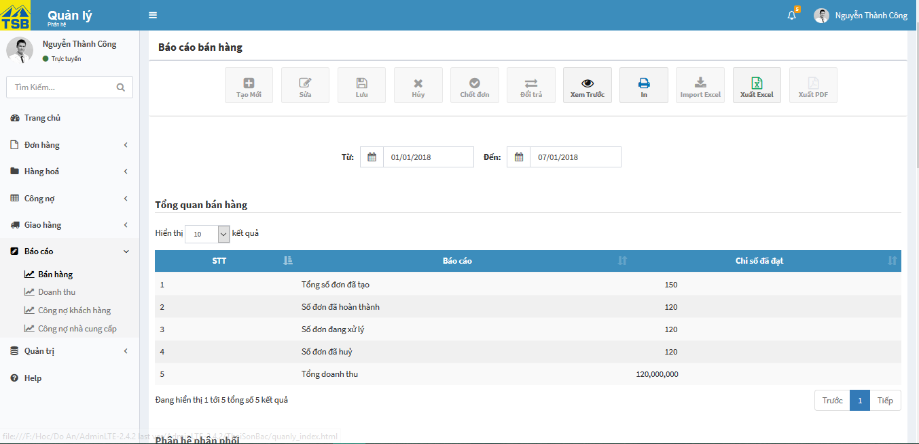

*Figure 6.68: View Sales activities report screen*

#### Search revenue detail

On revenue report have 3 parts contain weekly revenue, monthly revenue, and yearly revenue.

On weekly revenue, user can search by category and date. Users select the time period user want to find and select the appropriate category. The report will display the statistics for that time period and the categories that the user selects.

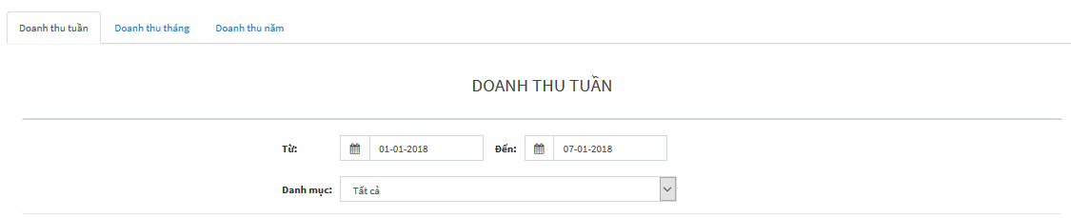

*Figure 6.69: Search weekly revenue screen*

On monthly revenue, user can search by category, month and year. Users select month and year user want to find and select the appropriate category. The report will display the statistics for that time period and the categories that the user selects.

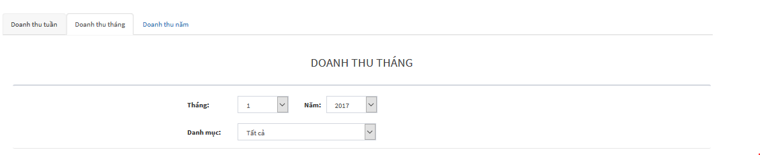

*Figure 6.70: Search monthly revenue screen*

On yearly revenue, user can search by category and year. Users select year user want to find and select the appropriate category. The report will display the statistics for that time period and the categories that the user selects.

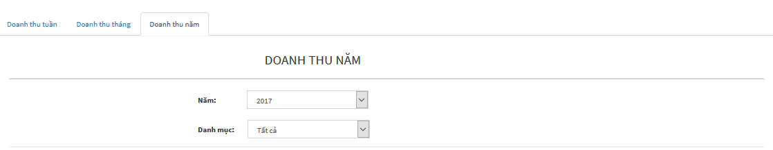

*Figure 6.71: Search yearly revenue screen*

#### Search product purchase

To search product purchase, user type anything inside product code fields, as long as list of suggest will be display. If any suggest matches product you are looking for then click on it, this should display directly to the product you need. Or user can search by category or about price of product. Then, user click on button “Tìm kiếm”

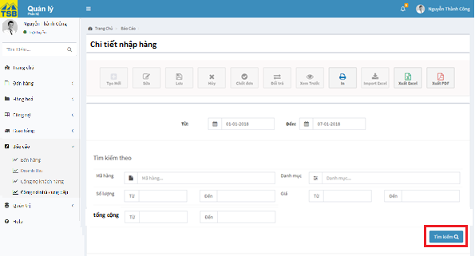

*Figure 6.72: Search product purchase screen*

Search result with matches search keyword, will display in data table.

#### Create customer

To create customer, user click on “Danh sách khách hàng” into tab “Quản trị” in left menu. User will be directed list of customer page. On list of customer, user click on button “Tạo mới”. User will be direct create new customer page.

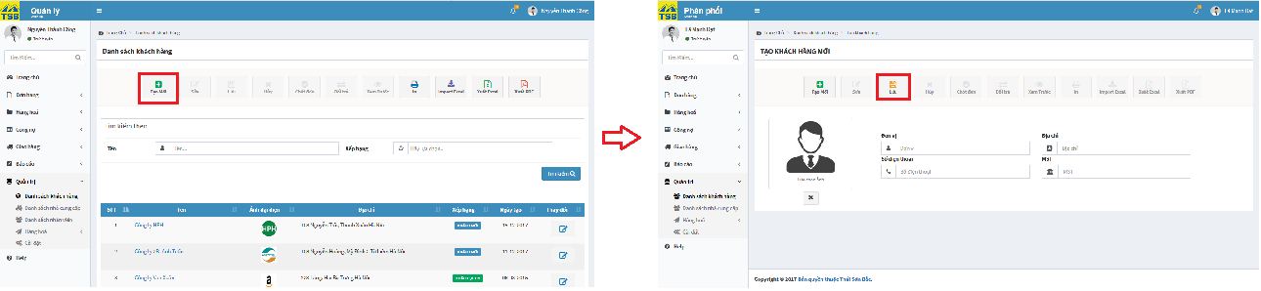

*Figure 6.73: Create customer screen*

On create new customer, user fill all required fields, then click on button “Lưu”. The system will receive handle check valid data after that system will display confirm message “Xác nhận tạo mới thông tin khách hàng”. User click on button “OK”, after system save customer information successfully the system display notification message “Tạo mới thành công”.

#### Edit customer

To edit customer, user click on “Danh sách khách hàng” into tab “Quản trị” in left menu. User will be directed list of customer page. On list of customer, user click on link of customer name, that user want to edit. User will be direct customer detail page.

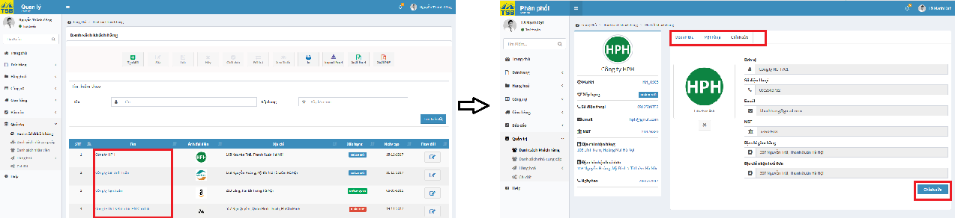

*Figure 6.74: Edit customer screen*

On customer detail page, user click on “Chỉnh sửa” tab, then click on button “Chỉnh sửa”. All fields can be edited display. User fill all fields need to edit or update and remember that fill required fields, then click on button “Lưu”. The system will receive handle check valid data after that system will display confirm message “Xác nhận chỉnh sửa thông tin khách hàng”. User click on button “OK”, after system save customer information successfully the system display notification message “Chỉnh sửa thành công”.

#### View customer

To view customer, user click on “Danh sách khách hàng” into tab “Quản trị” in left menu. User will be directed list of customer page. On list of customer, user click on link of customer name. User will be direct customer detail page.

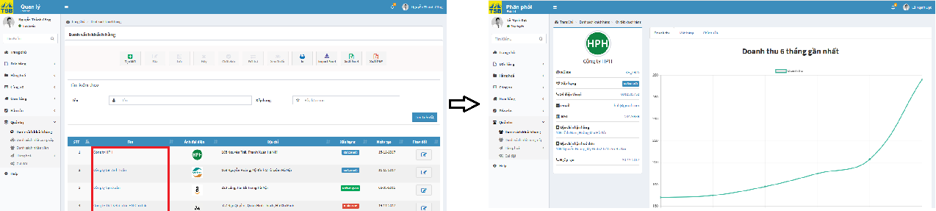

*Figure 6.75: View customer screen*

#### View list of customer

To view customer, user click on “Danh sách khách hàng” into tab “Quản trị” in left menu. User will be directed list of customer page.

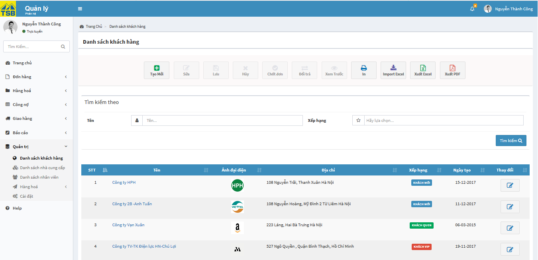

*Figure 6.76: View list of customer screen*

#### Search customer

To search customer, user type anything inside customer name fields, as long as list of suggest will be display. If any suggest matches customer you are looking for then click on it, this should display directly to the customer you need. Or user can search by raking of customer. Then, user click on button “Tìm kiếm”

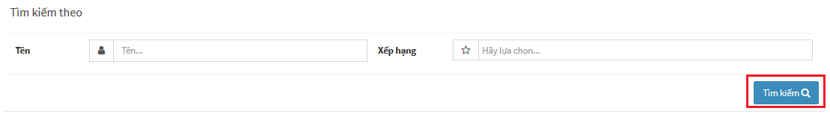

*Figure 6.77: Search customer screen*

Search result with matches search keyword, will display in data table.

#### Create supplier

To create supplier, user click on “Danh sách nhà cung cấp” into tab “Quản trị” in left menu. User will be directed list of supplier page. On list of supplier, user click on button “Tạo mới”. User will be direct create new supplier page.

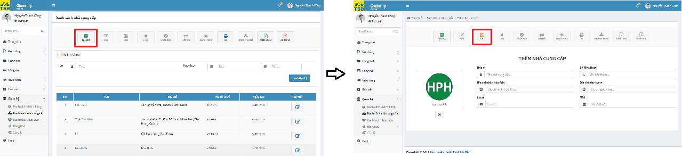

*Figure 6.78: Create supplier screen*

On create new supplier, user fill all required fields, then click on button “Lưu”. The system will receive handle check valid data after that system will display confirm message “Xác nhận tạo mới thông tin nhà cung cấp”. User click on button “OK”, after system save supplier information successfully the system display notification message “Tạo mới thành công”.

#### Edit supplier

To edit supplier, user click on “Danh sách nhà cung cấp” into tab “Quản trị” in left menu. User will be directed list of supplier page. On list of supplier, user click on button edit. All fields can be edited displayed.

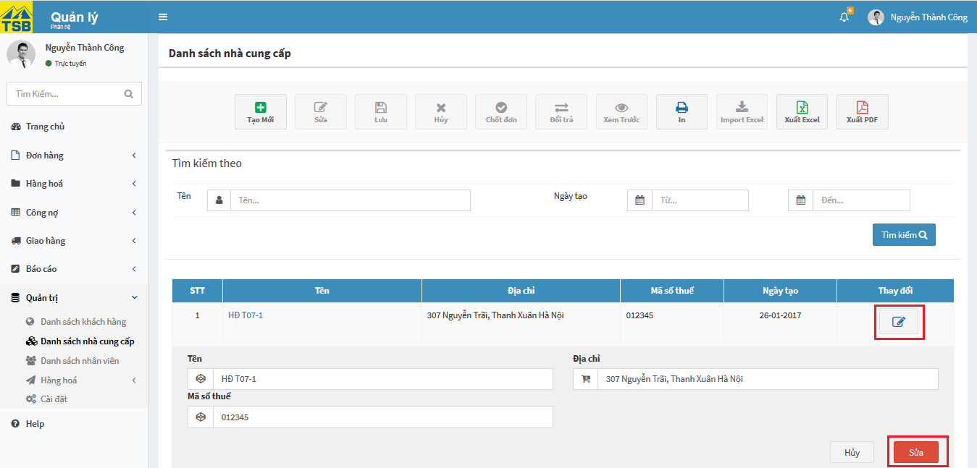

*Figure 6.79: Edit supplier screen*

User fill all fields need to edit or update and remember that fill required fields, then click on button “Sửa”. The system will receive handle check valid data after that system will display confirm message “Xác nhận chỉnh sửa thông tin nhà cung cấp”. User click on button “OK”, after system save supplier information successfully the system display notification message “Chỉnh sửa thành công”.

#### View supplier

To view supplier, user click on “Danh sách nhà cung cấp” into tab “Quản trị” in left menu. User will be directed list of supplier page. On list of supplier, user click on link of supplier name. User will be direct supplier detail page.

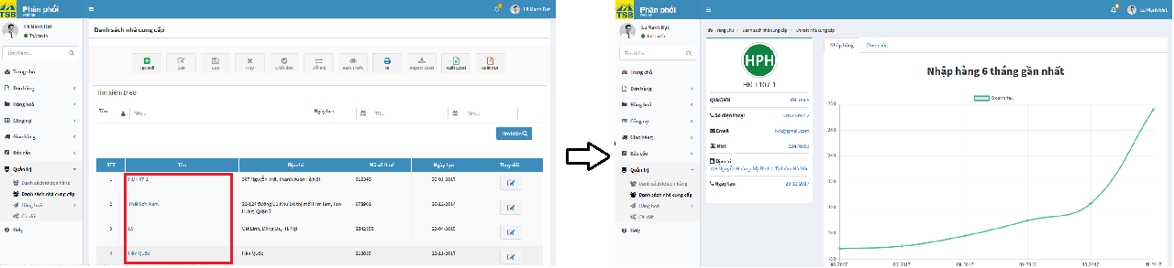

*Figure 6.80: View supplier screen*

#### View list of supplier

To view supplier, user click on “Danh sách nhà cung cấp” into tab “Quản trị” in left menu. User will be directed list of supplier page.

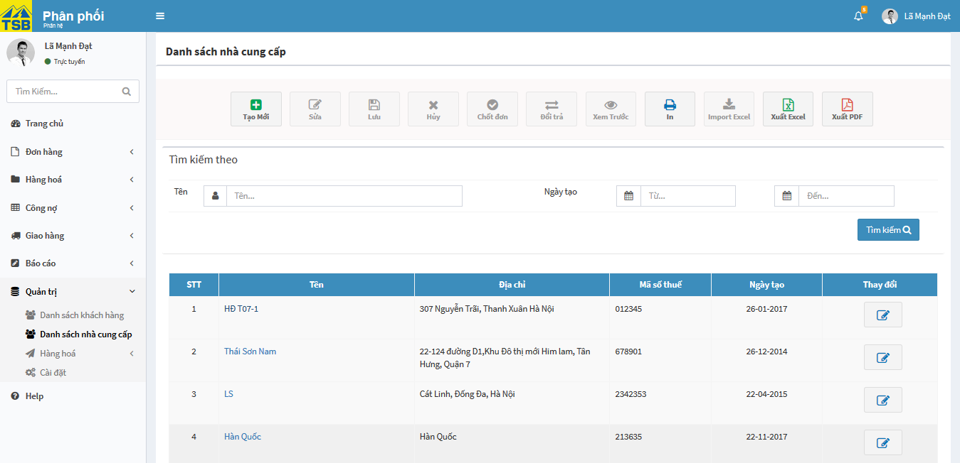

*Figure 6.81: View list of supplier*

#### Search supplier

To search supplier, user type anything inside supplier name fields, as long as list of suggest will be display. If any suggest matches supplier you are looking for then click on it, this should display directly to the supplier you need. Or user can search by created date of supplier. Then, user click on button “Tìm kiếm”

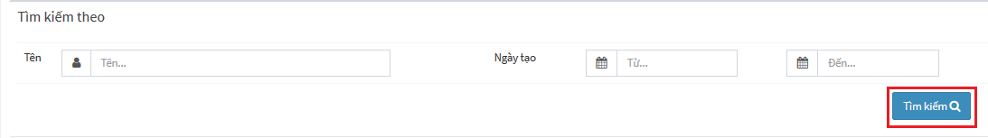

*Figure 6.82: Search supplier screen*

Search result with matches search keyword, will display in data table.

#### Create user

To create user, user click on “Đang hoạt động” into tab “Người dùng” in left menu. User will be directed list of user page. On list of user, user click on button “Tạo mới”. User will be direct create new user page.

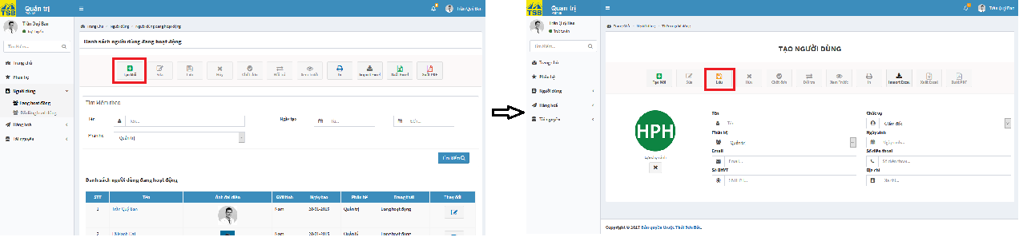

*Figure 6.83: Create user screen*

On create new user, user fill all required fields, then click on button “Lưu”. The system will receive handle check valid data after that system will display confirm message “Xác nhận tạo mới thông tin người dùng”. User click on button “OK”, after system save user information successfully the system display notification message “Tạo mới thành công”.

#### Edit user

To edit user, user click on “Đang hoạt động” into tab “Người dùng” in left menu. User will be directed list of user page. On list of user, user click on link of user name, that user want to edit. User will be direct user detail page.

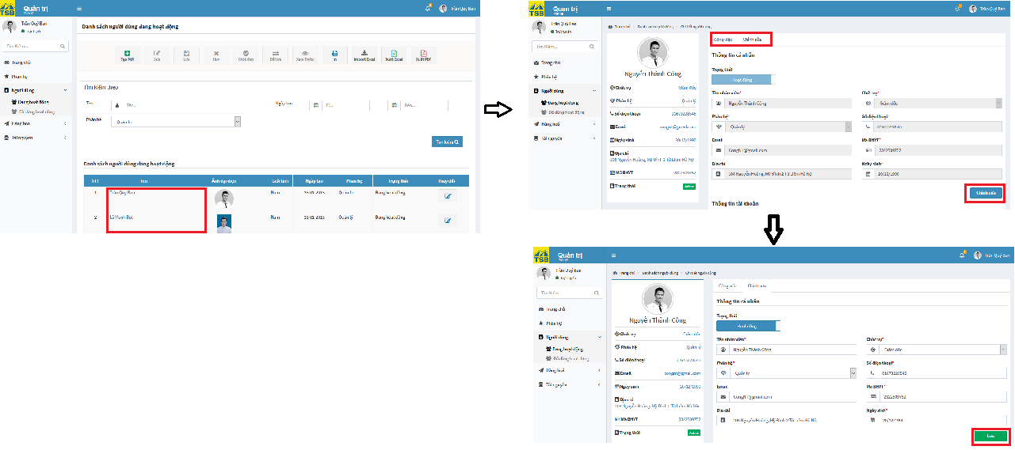

*Figure 6.84: Edit user screen*

On user detail page, user click on “Chỉnh sửa” tab, then click on button “Chỉnh sửa”. All fields can be edited display. User fill all fields need to edit or update and remember that fill required fields, then click on button “Lưu”. The system will receive handle check valid data after that system will display confirm message “Xác nhận chỉnh sửa thông tin người dùng”. User click on button “OK”, after system save user information successfully the system display notification message “Chỉnh sửa thành công”.

#### View user

To view list of user active, user login by Administrator account. Then user click on “Đang hoạt động” into tab “Người dùng”. User will be directed list of user. On list of user, user click on link of user name need to view detail. User will be direct user detail.

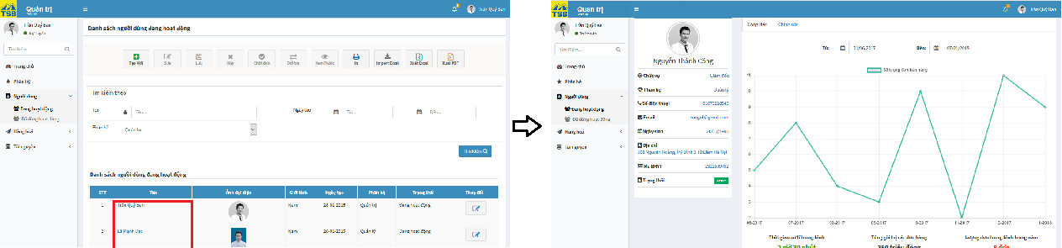

*Figure 6.85: View user screen*

#### View list of user active

To view list of user active, user login by Administrator account. Then user click on “Đang hoạt động” into tab “Người dùng”. User will be directed list of user active.

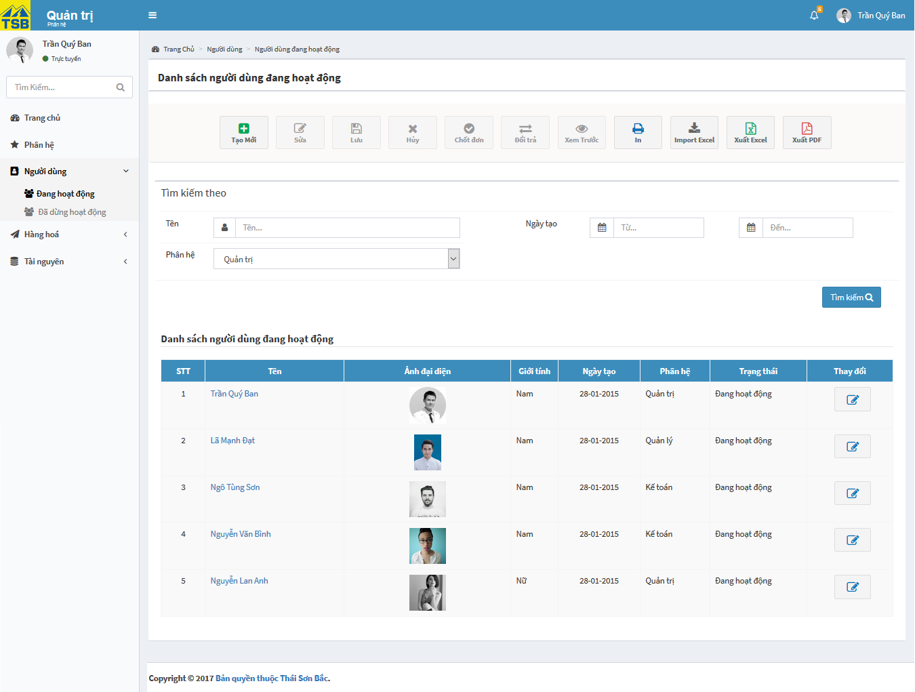

*Figure 6.86: View list of user active screen*

#### View list of user deactive

To view list of user deactive, user login by Administrator account. Then user click on “Đã dừng hoạt động” into tab “Người dùng”. User will be directed list of user deactive.

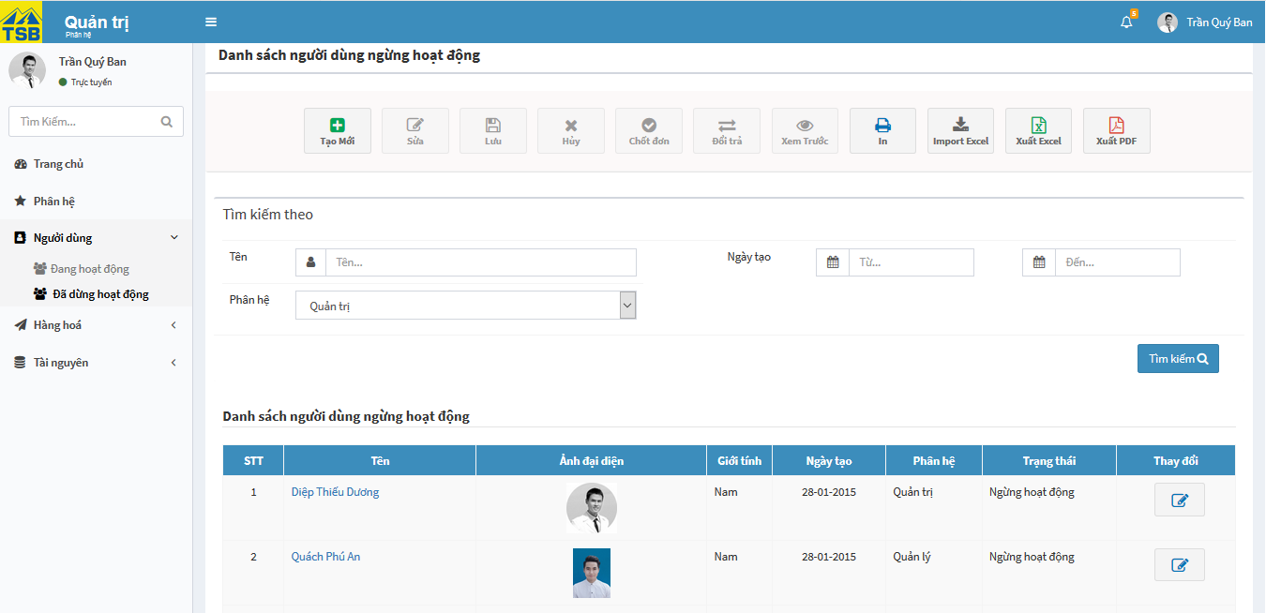

*Figure 6.87: View list of user deactive screen*

#### Search user

To search user, user type anything inside user name fields, as long as list of suggest will be display. If any suggest matches user you are looking for then click on it, this should display directly to the user you need. Or user can search by created date of user and module. Then, user click on button “Tìm kiếm”

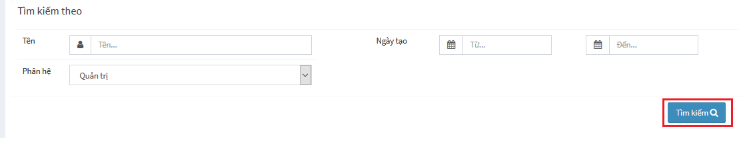

*Figure 6.88: Search user screen*

Search result with matches search keyword, will display in data table.

#### Create purchase order

To create purchaseorder, user click on “Tạo yêu cầu nhập” into tab “Yêu cầu nhập” into tab “Hàng hóa” in left menu. User will be directed create purchase order page.

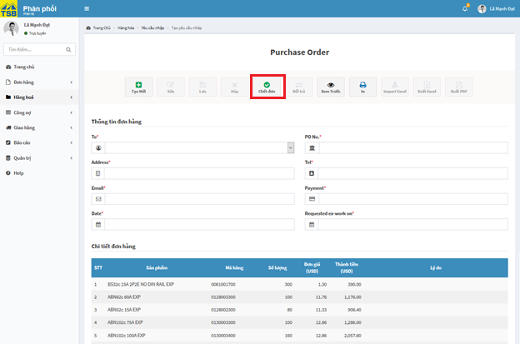

*Figure 6.89: Create purchase order screen*

On create purchase order page, user fill all required fields, then click on button “Chốt đơn”. The system will receive handle check valid data after that system will display confirm message “Xác nhận tạo mới”. User click on button “OK”, after system save order information successfully the system display notification message “Tạo mới thành công”.

#### View history purchase order

To view history purchase order, user click on “Lịch sử yêu cầu nhập” into tab “Yêu cầu nhập” into tab “Hàng hóa” in left menu. User will be directed history purchase order.

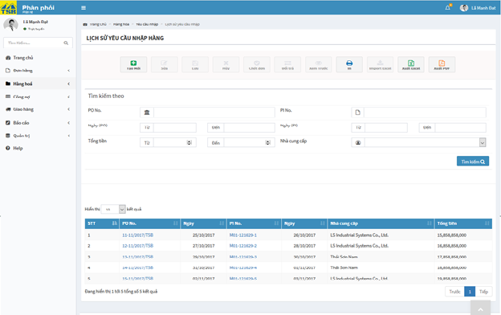

*Figure 6.90: History purchase order screen*

#### View purchase order

To view history purchase order, user click on “Lịch sử yêu cầu nhập” into tab “Yêu cầu nhập” into tab “Hàng hóa” in left menu. User will be directed history purchase order. On history purchase order, user click on link of purchase order no. User will be direct purchase order detail.

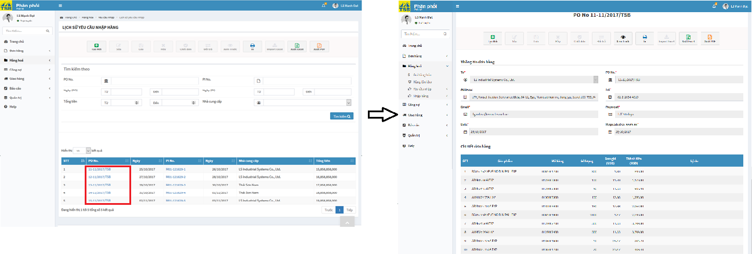

*Figure 6.91: View purchase order screen*

#### Create purchase invoice

To create purchaseinvoice, user click on “Nhập hóa đơn” into tab “Yêu cầu nhập” into tab “Hàng hóa” in left menu. User will be directed create purchase invoice page.

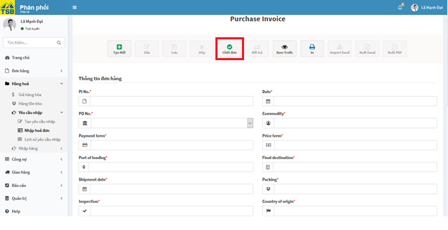

*Figure 6.92: Create purchase invoice screen*

On create purchase invoice page, user fill all required fields, then click on button “Chốt đơn”. The system will receive handle check valid data after that system will display confirm message “Xác nhận tạo mới”. User click on button “OK”, after system save invoice information successfully the system display notification message “Tạo mới thành công”.

#### View purchase invoice

To view history purchase invoice, user click on “Lịch sử yêu cầu nhập” into tab “Yêu cầu nhập” into tab “Hàng hóa” in left menu. User will be directed history purchase order. On history purchase order, user click on link of purchase invoice no. User will be direct purchase invoice detail.

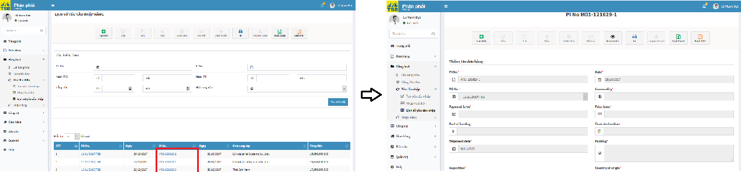

*Figure 6.93: View purchase invoice screen*

#### Create new stock in

To create stock-in, user click on “Tạo đợt nhập mới” into tab “Nhập hàng” into tab “Hàng hóa” in left menu. User will be directed the “Nhập hàng vào kho” page.

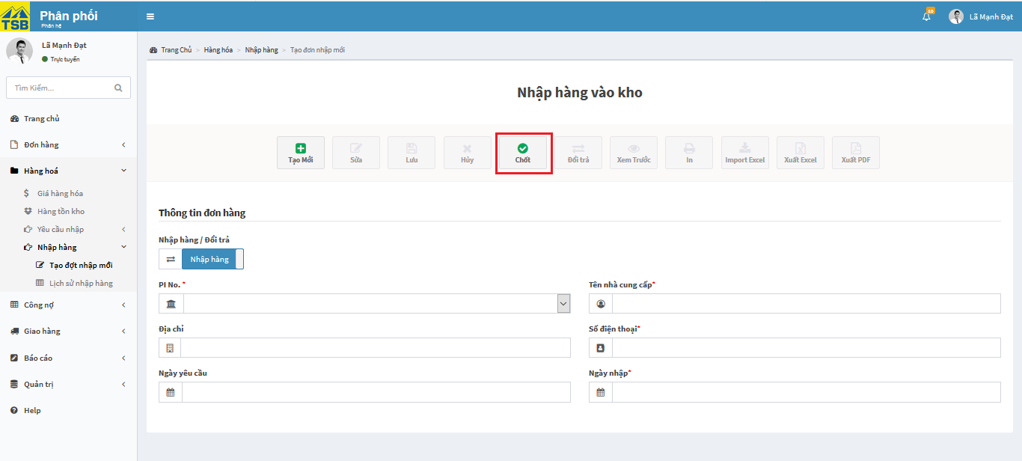

*Figure 6.94: Create new stock-in screen*

On create the “Nhập hàng vào kho” page, user fill all required fields, then click on button “Chốt”. The system will receive handle check valid data after that system will display confirm message “Xác nhận nhập hàng”. User click on button “OK”, after system save stock-in information successfully the system display notification message “Nhập hàng thành công”.

#### View stock in

To view stock-in, user click on “Lịch sử nhập hàng” into tab “Nhập hàng” into tab “Hàng hóa” in left menu. User will be directed the “Lịch sử nhập hàng” page. On the “Lịch sử nhập hàng” page, user click on link of purchase invoice no. User will be direct import product detail.

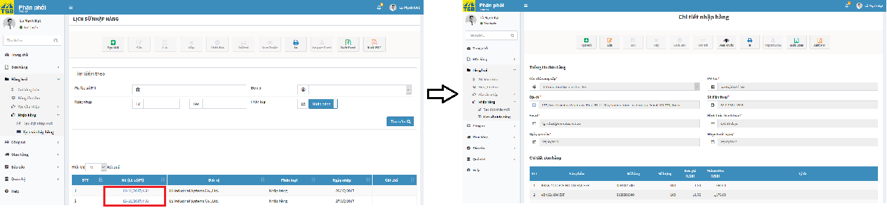

*Figure 6.95:View stock-in screen*

#### View history stock in

To view stock-in, user click on “Lịch sử nhập hàng” into tab “Nhập hàng” into tab “Hàng hóa” in left menu. User will be directed the “Lịch sử nhập hàng” page.

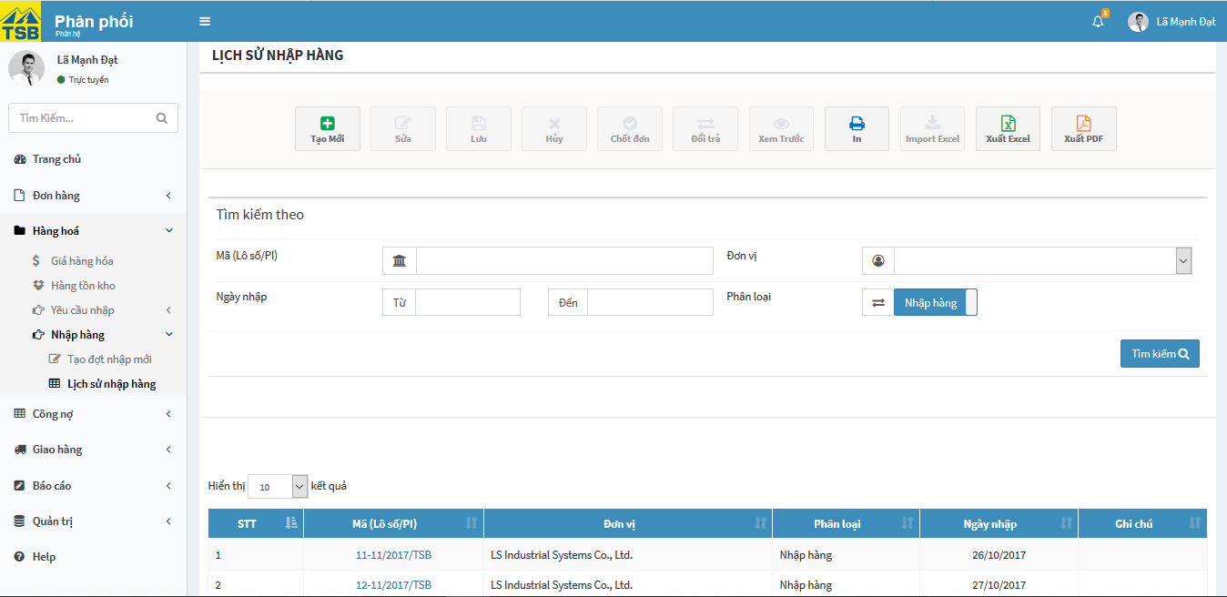

*Figure 6.96: View history stock-in screen*

#### Search stock-in

To search stock-in, user type anything inside “Mã (Lô số PI)” fields, as long as list of suggest will be display. If any suggest matches PI No you are looking for then click on it, this should display directly to the PI No you need. Or user can search by supplier, import date and type. Then, user click on button “Tìm kiếm”.

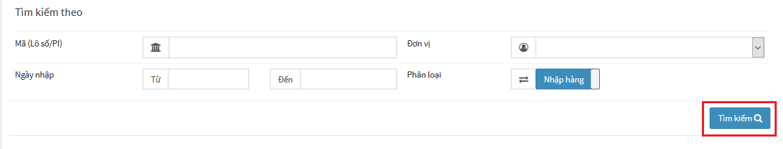

*Figure 6.97:Search stock-in screen*

Search result with matches search keyword, will display in data table.

#### Search purchase order

To search purchase order, user type anything inside “PO No” or “PI No” fields, as long as list of suggest will be display. If any suggest matches “PO No” or “PI No” you are looking for then click on it, this should display directly to the “PO No” or “PI No” you need. Or user can search by created PO date, PI date and total money and supplier. Then, user click on button “Tìm kiếm”.

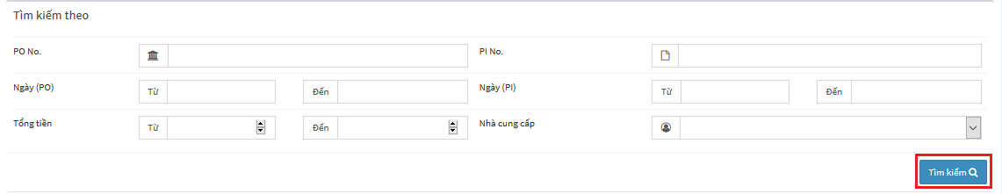

*Figure 6.98: Search purchase order screen*

Search result with matches search keyword, will display in data table